Michael Benko
September 18, 2026
Module 7.2 Assignment – Movies: Update & Delete
The output screenshots were taken in sections due to space constraints.

Py file outputs
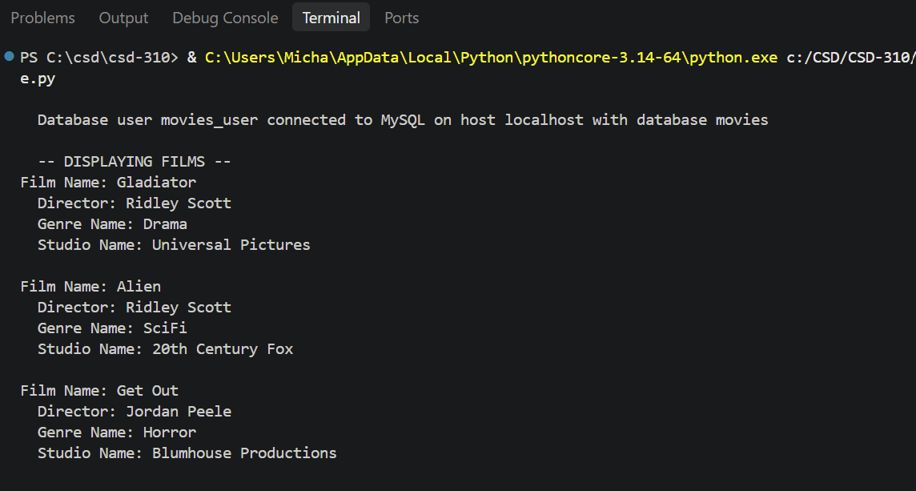

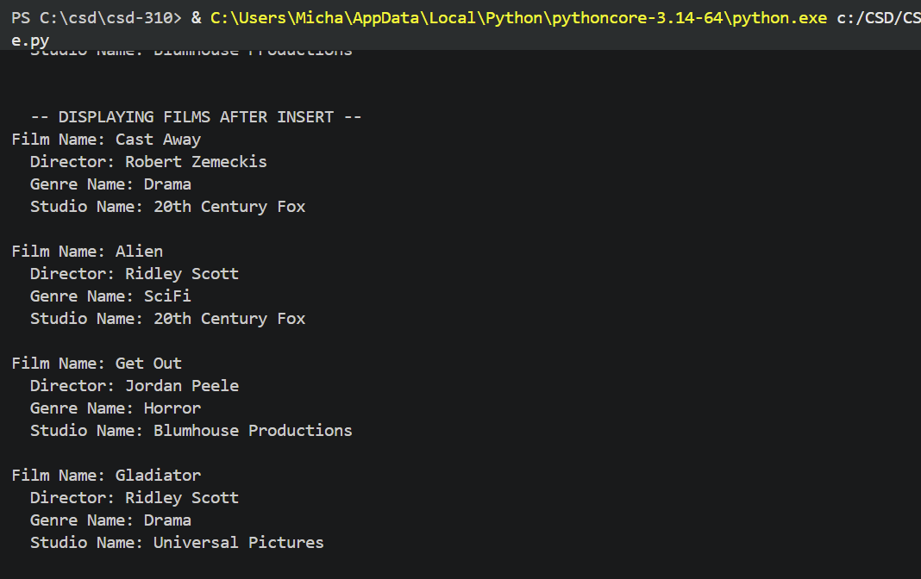

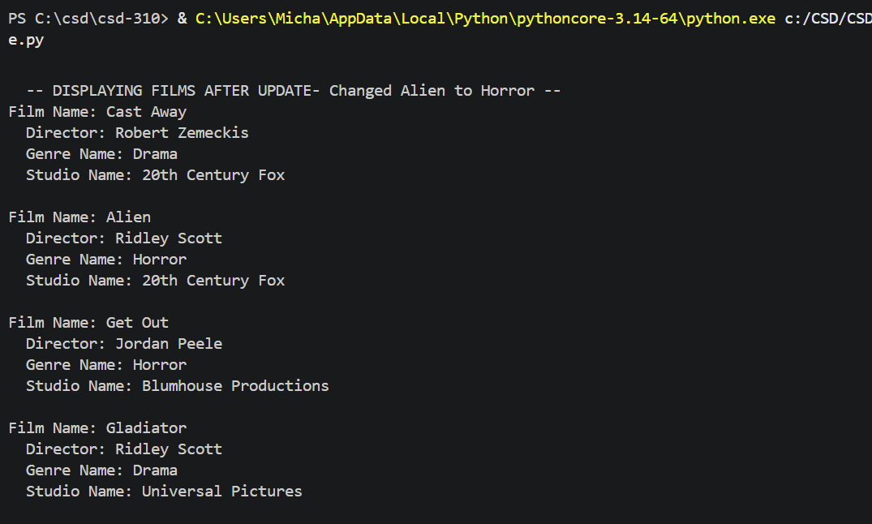

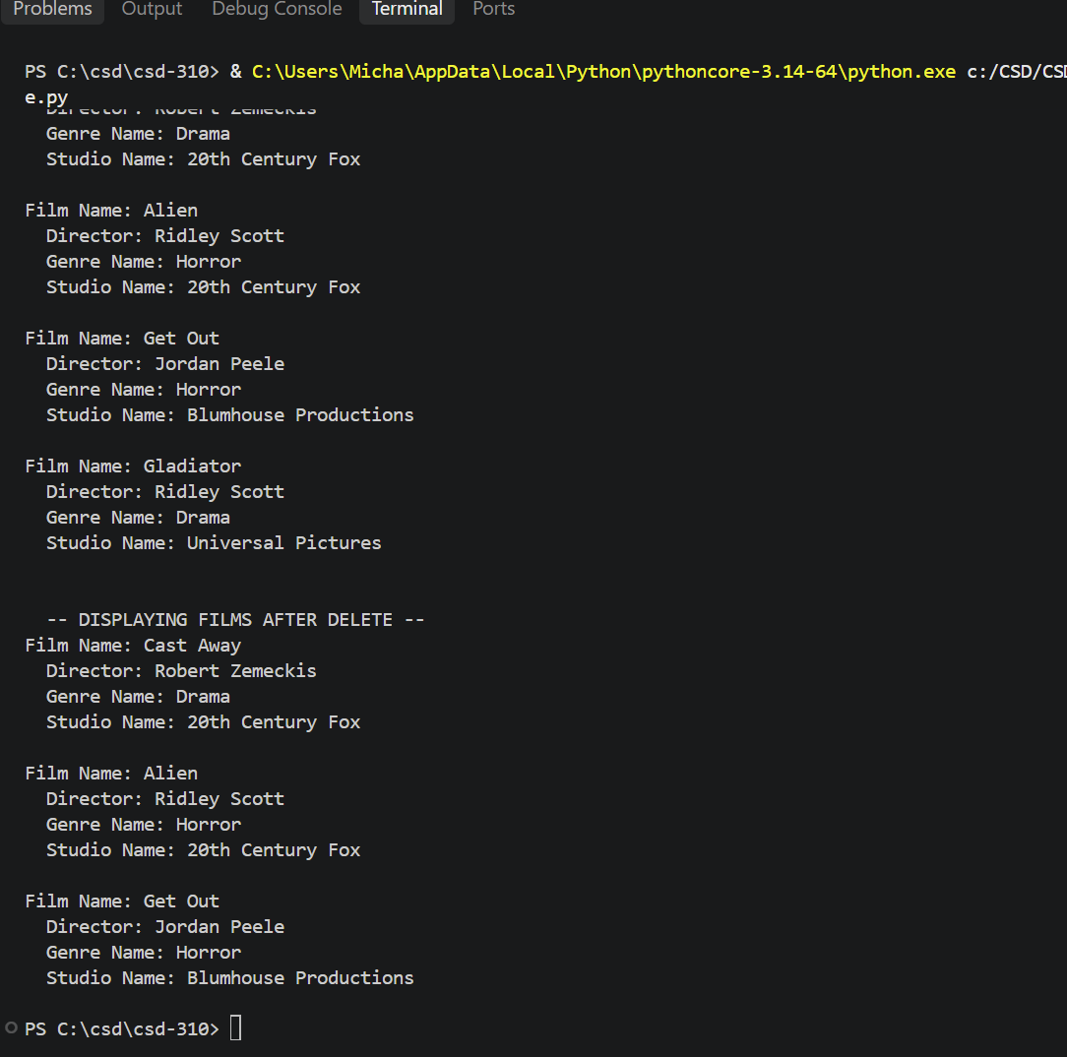

GitHub repository
https://github.com/TheRealMikeBenko/csd-310

