Michael Benko
August 26, 2026
Module 3.2 Assignment – Brownfield + Flowchart(s)

Chohan Flowchart

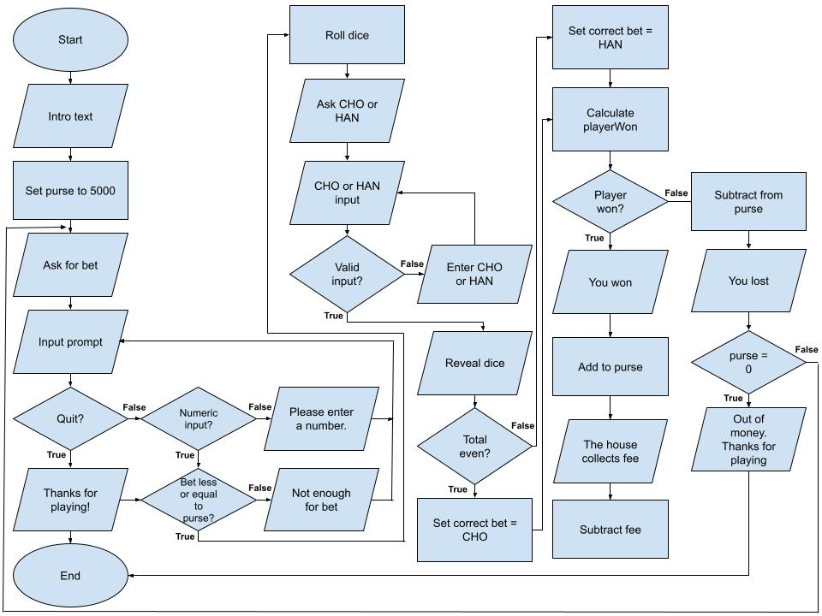

Debug
The following screenshots show the debug process for the Module 4.2 assignment from CSD 205.
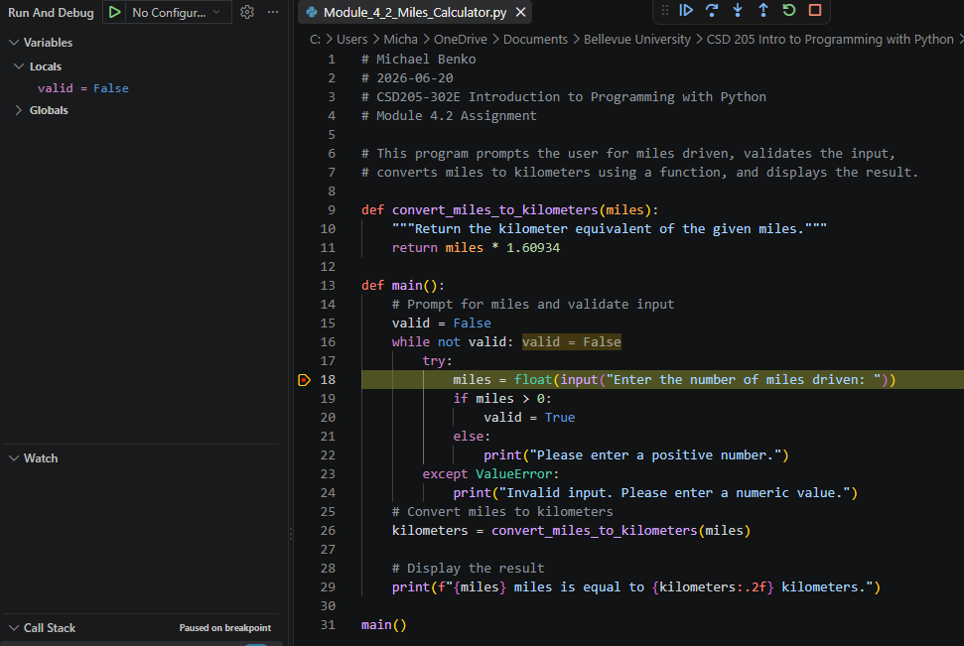
1 of 4
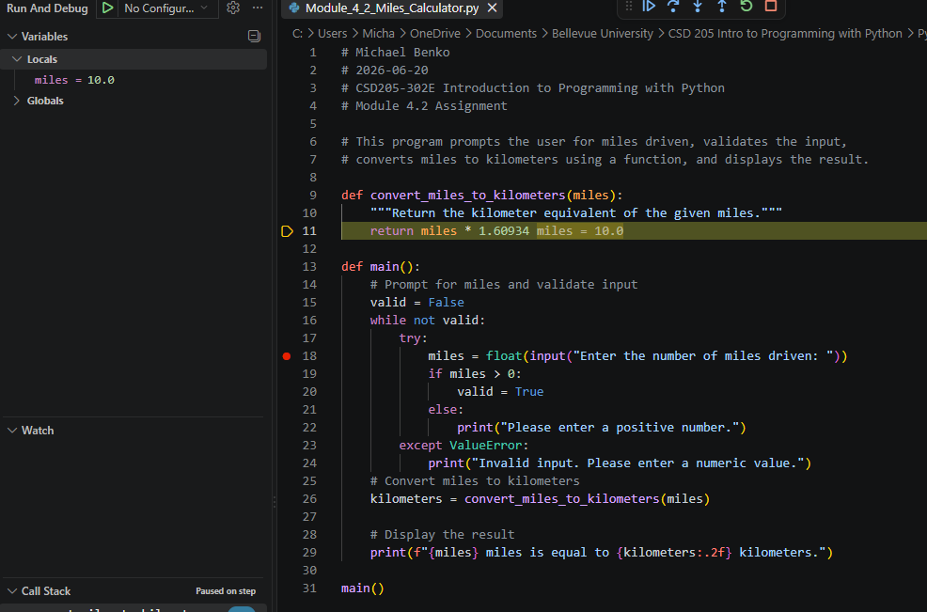
2 of 4
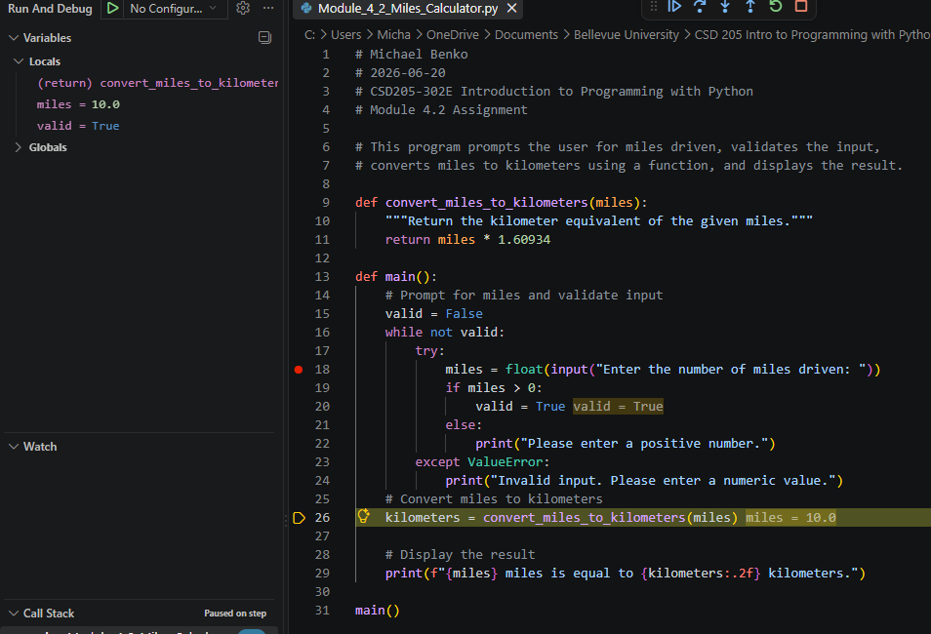
3 of 4
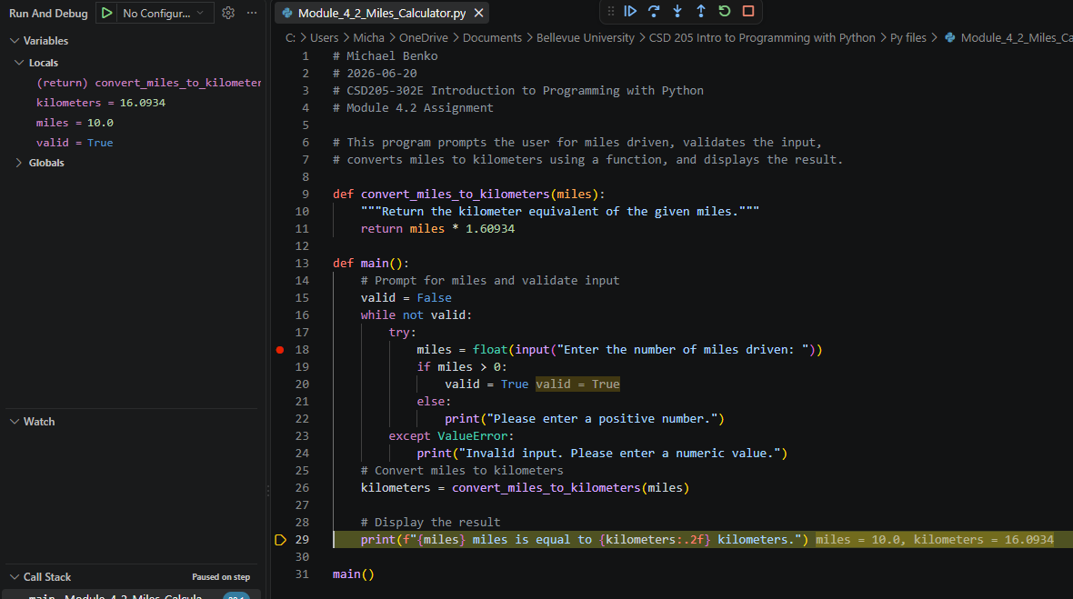
4 of 4

