Michael Benko
September 19, 2026
Module 7.2 Assignment – Test Cases

city_functions.py results
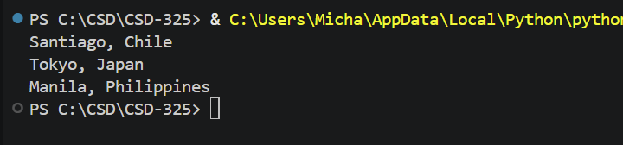

test_cities.py results
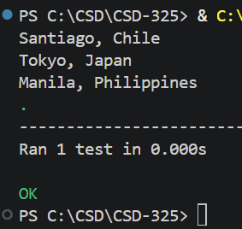

test_cities.py results after adding population to city_functions.py
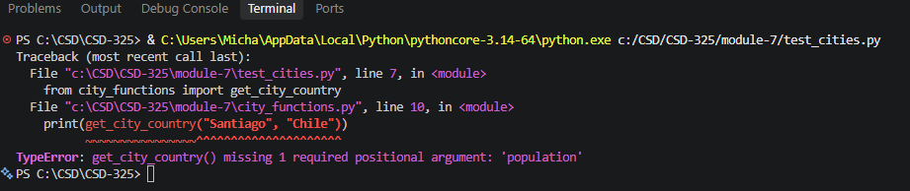

city_functions.py modified so that the population parameter is optional
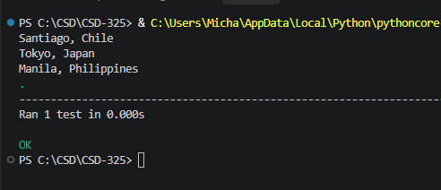
city_functions.py modified to require language
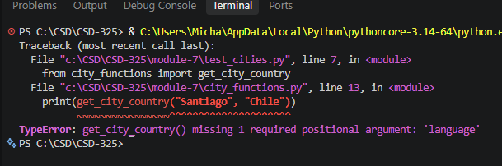

city_functions.py modified so that the language parameter is optional
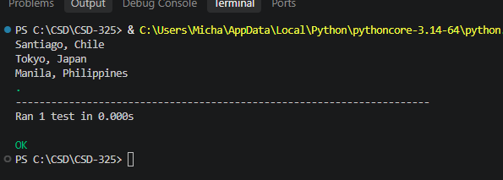

Final output showing the results of all combinations
