Michael Benko
August 22, 2026
Module 2.2 Assignment – Documented Debugging + Flowchart(s)

Flowchart
The following flowchart is for a program written for the Module 4.2 assignment from CSD 205.
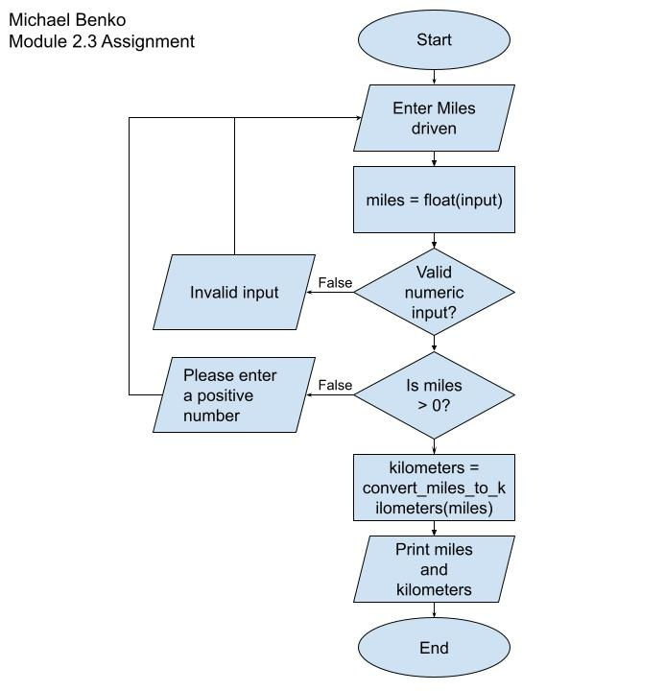
Debug
The following screenshots show the debug process for the Module 4.2 assignment from CSD 205.
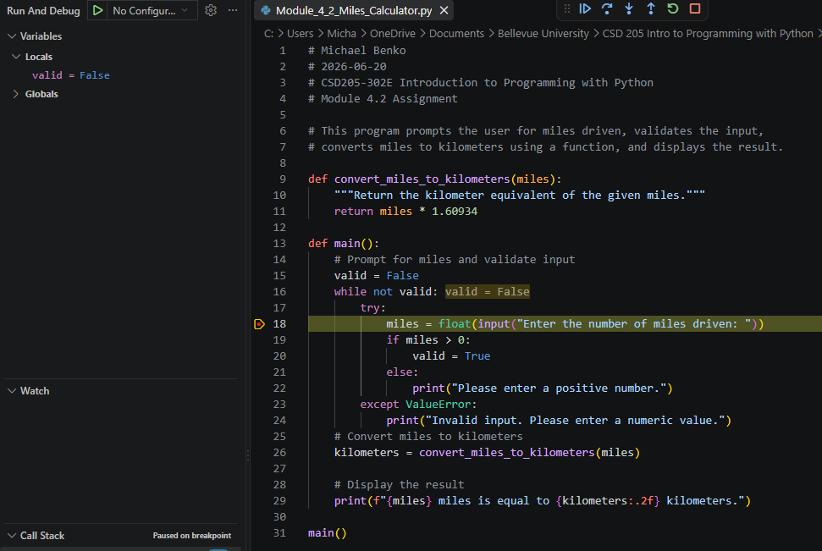
1 of 4
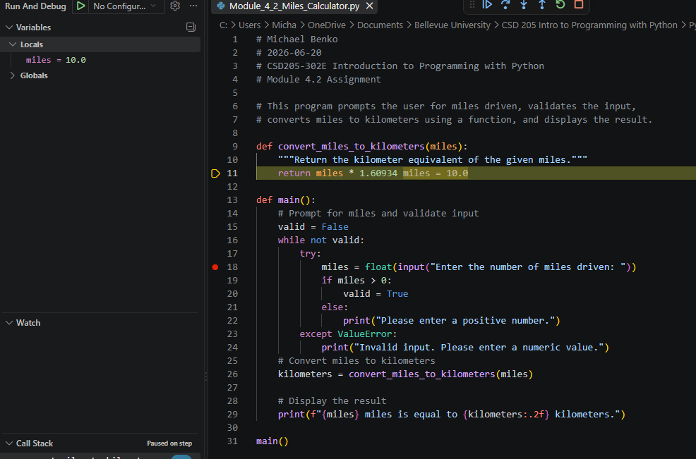
2 of 4
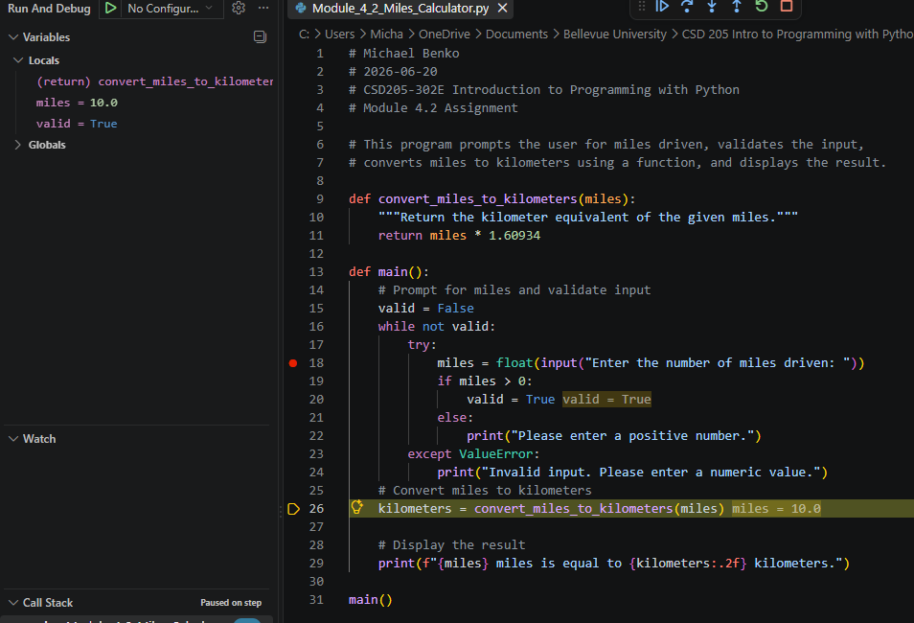
3 of 4
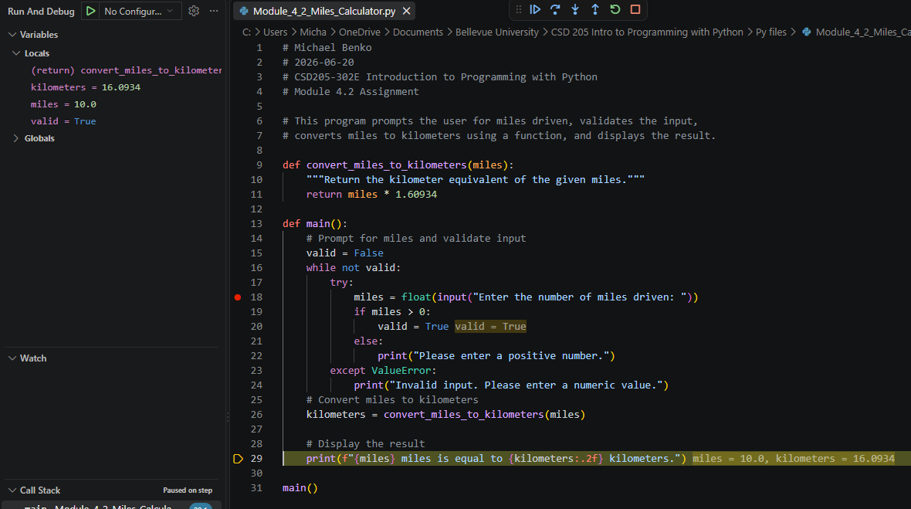
4 of 4

