Michael Benko
September 19, 2026
Module 8.2 Assignment – JSON Practice

Flowchart of the JSON program
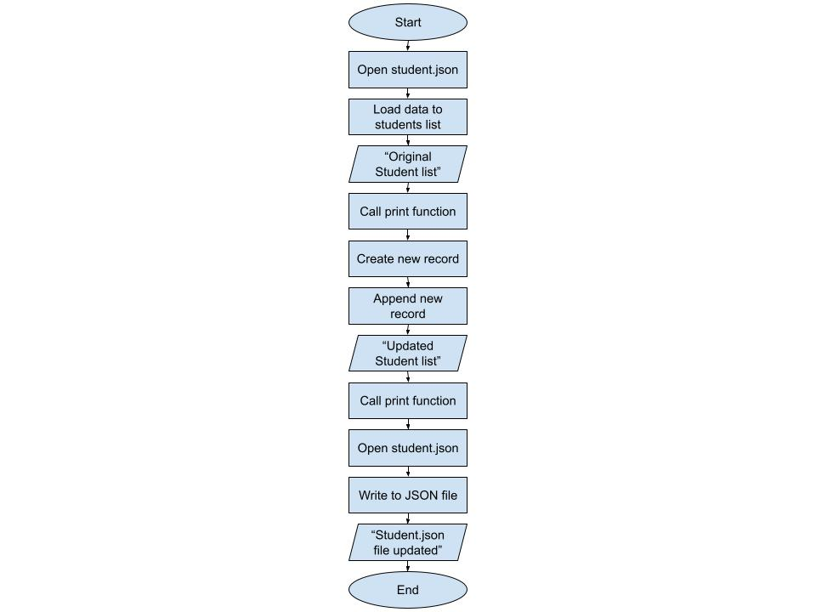

Reading the student.json file from Python
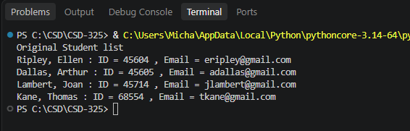
Appending to the student list in Python
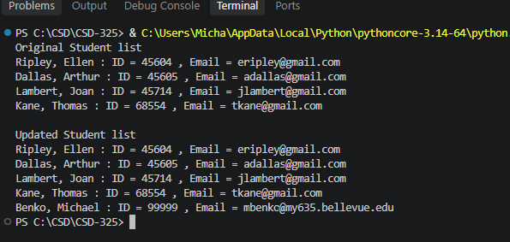

The student.json file updated with Python
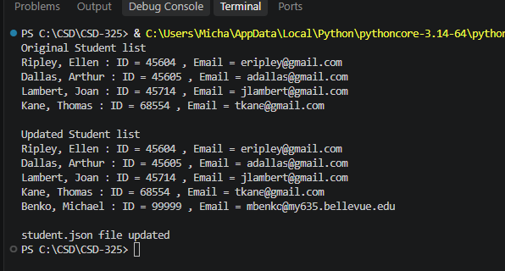

Contents of the JSON file
[
{
"F_Name": "Ellen",
"L_Name": "Ripley",
"Student_ID": 45604,
"Email": "eripley@gmail.com"
},
{
"F_Name": "Arthur",
"L_Name": "Dallas",
"Student_ID": 45605,
"Email": "adallas@gmail.com"
},
{
"F_Name": "Joan",
"L_Name": "Lambert",
"Student_ID": 45714,
"Email": "jlambert@gmail.com"
},
{
"F_Name": "Thomas",
"L_Name": "Kane",
"Student_ID": 68554,
"Email": "tkane@gmail.com"
},
{
"F_Name": "Michael",
"L_Name": "Benko",
"Student_ID": 99999,
"Email": "mbenko@my635.bellevue.edu"
}
]

