Michael Benko
September 22, 2026
Module 9.2 Assignment – APIs

API connection test
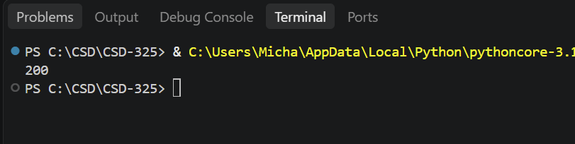

Formatted astronauts output (1 of 2)
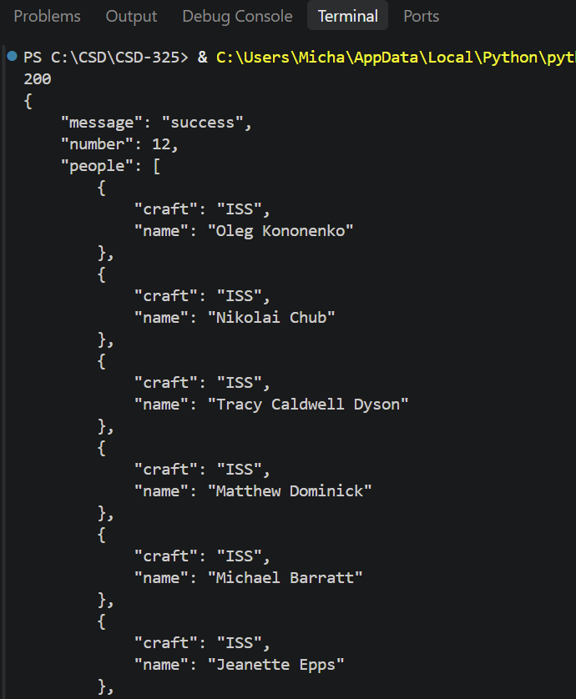

Formatted astronauts output (2 of 2)
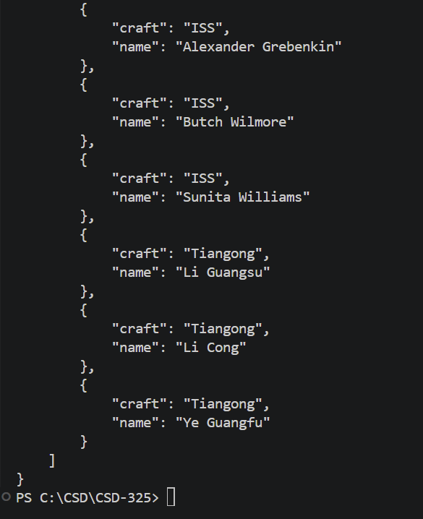

Formatted Ice and Fire output (1 of 2)
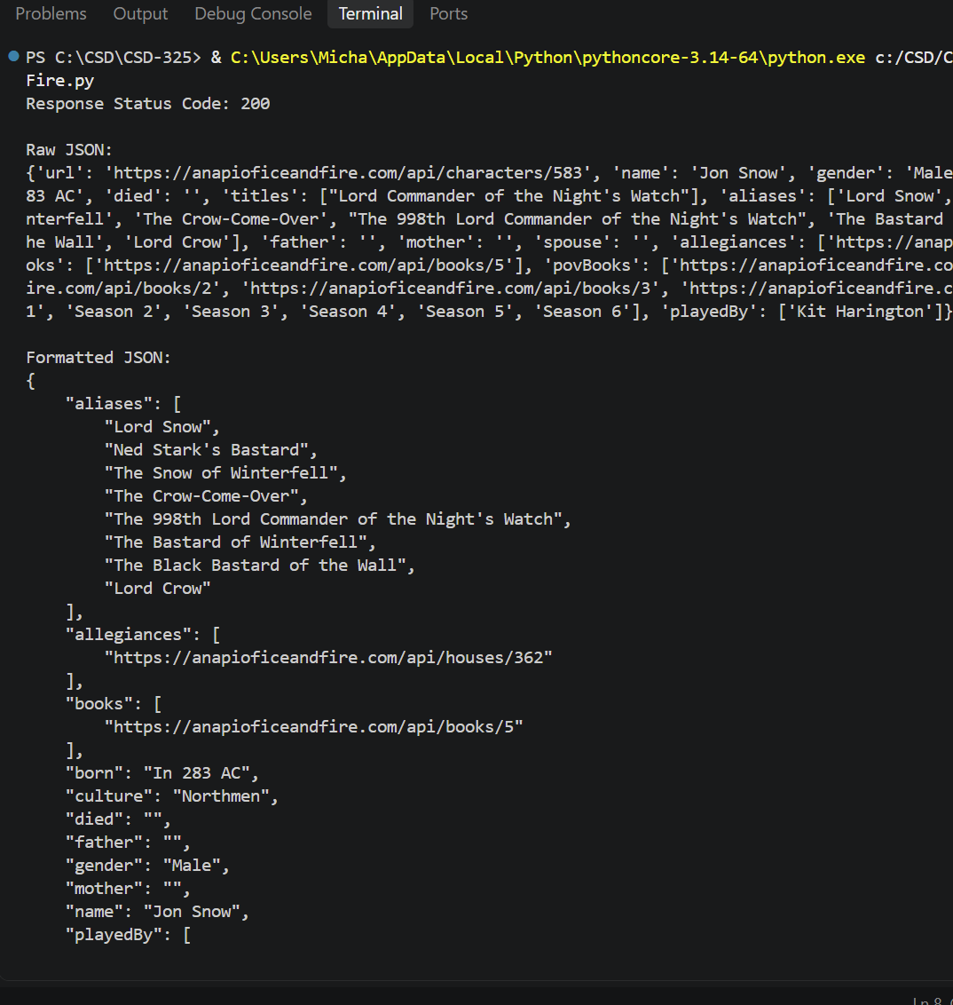

Formatted Ice and Fire output (2 of 2)
