Figure 1: System Execution Lifecycle and Cascading Pixel Logic for forestfiresim.py
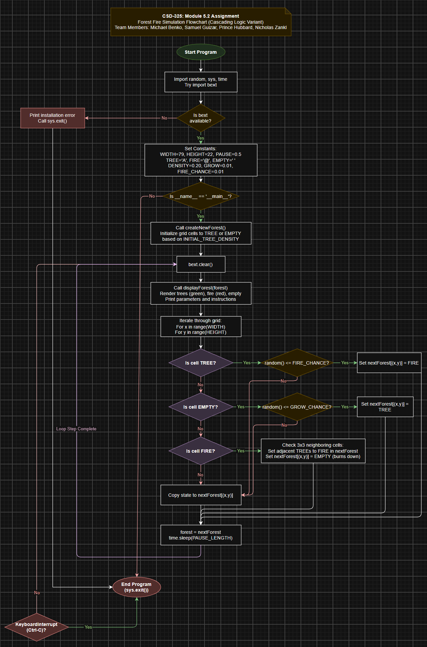

Program Logic and Flowchart Mapping Analysis
The flowchart for forestfiresim.py maps the full execution lifecycle of the simulation, tracing every step from initial environment setup to real-time grid evaluation and process termination. The diagram aligns directly with the script's architectural layers in a continuous, logical progression.

Environment Setup & Dependency Verification
Execution begins at the Start Program oval and proceeds into the environment setup phase. The script attempts to import required libraries including random, sys, time, and bext. The Is bext available? decision diamond maps the try-except ImportError block. If bext is missing, the diagram follows the No path to display installation instructions and trigger sys.exit(). If bext is verified, the diagram follows the Yes path to the Set Constants block, where grid parameters (WIDTH, HEIGHT), state symbols (TREE, FIRE, EMPTY), and probabilities (INITIAL_TREE_DENSITY, GROW_CHANCE, FIRE_CHANCE) are instantiated. Immediately following constant initialization, the Is __name__ == '__main__'? decision node acts as Python’s standard module guard check. Executing the script directly routes down the Yes branch into main(), whereas importing the script as a library routes down the No branch directly to the End Program node to prevent accidental execution.

Initialization & Screen Setup
Moving into main(), the process box Call createNewForest() represents the function that populates the initial two-dimensional coordinate dictionary. Each cell evaluates a random probability roll against INITIAL_TREE_DENSITY ($20\%$) to assign either a TREE ('A') or EMPTY (' ') state. Once populated, the bext.clear() process box executes a terminal screen wipe, setting up a clean canvas before entering the primary double-buffered evaluation loop.

Live Simulation & Cascading Evaluation Loop
The main simulation loop opens at Call displayForest(forest), which repositions the terminal cursor to (0, 0) via bext.goto(0, 0) and renders the current frame character-by-character using green for trees and red for fires. Following display, the nested coordinate loop (For x, For y) evaluates every pixel sequentially. To model Python’s if-elif-else control structure cleanly without overlapping paths, the decision diamonds are arranged in a cascading vertical sequence:
First, Is cell TREE? inspects whether the active coordinate contains 'A'. On a Yes result, execution moves right to evaluate random() <= FIRE_CHANCE ($1\%$ chance of a lightning strike). A successful roll sets nextForest[(x,y)] = FIRE, whereas an unsuccessful roll routes into the default state copy block. If the cell is not a tree, the No path falls straight down into Is cell EMPTY?. On a Yes result, execution moves right to evaluate random() <= GROW_CHANCE ($1\%$ growth chance). A successful roll sets nextForest[(x,y)] = TREE, while an unsuccessful roll routes to the default state copy block. If the cell is neither a tree nor empty, the No path falls straight down to Is cell FIRE?. On a Yes result, execution triggers the neighbor inspection process, checking all eight surrounding coordinates (x + ix, y + iy). Any adjacent TREE in forest is marked as FIRE in nextForest, and the original burning tree transitions to EMPTY. Finally, if a cell evaluates to No across all condition checks, execution drops straight down into Copy state to nextForest[(x,y)], preserving the cell's existing state.

Buffer Swap & Program Exit
Once all grid coordinates finish evaluation, execution enters the forest = nextForest / time.sleep(PAUSE_LENGTH) process box. Live states are updated simultaneously across the double-buffered frame, and execution pauses for 0.5 seconds. The Loop Step Complete connector routes from the swap block back up to bext.clear(), closing the frame cycle and starting the next render loop. This loop continues indefinitely until the user presses Ctrl-C, where the red KeyboardInterrupt (Ctrl-C)? decision diamond catches the signal and routes execution cleanly to End Program (sys.exit()).

