Michael Benko
August 10, 2026
Module 1.2 Assignment – GitHub Repository Setup
Local directory
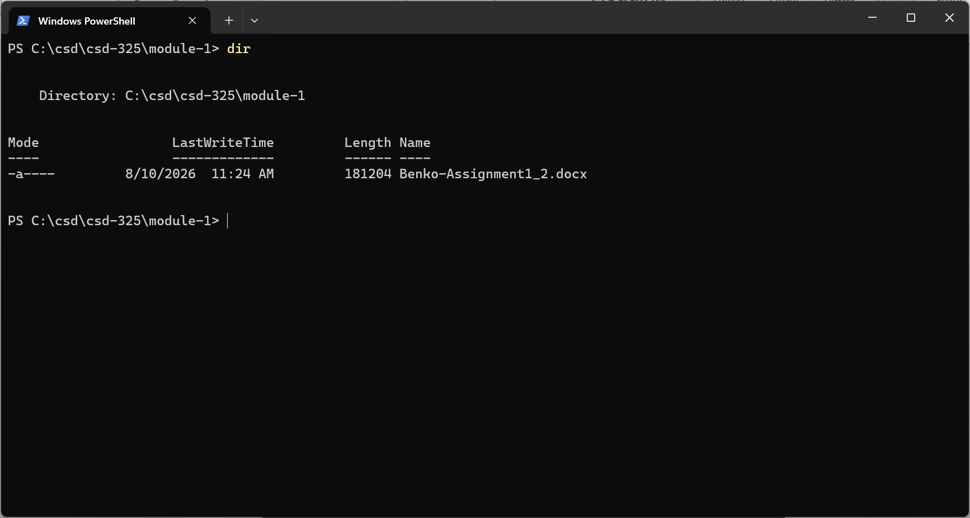

Link to GitHub repository

https://github.com/TheRealMikeBenko/csd-325.git

GitHub repository
