Michael Benko
September 5, 2026
Module 4.2 Assignment – High/Low Temperatures

Sitka Weather Flowchart - Original
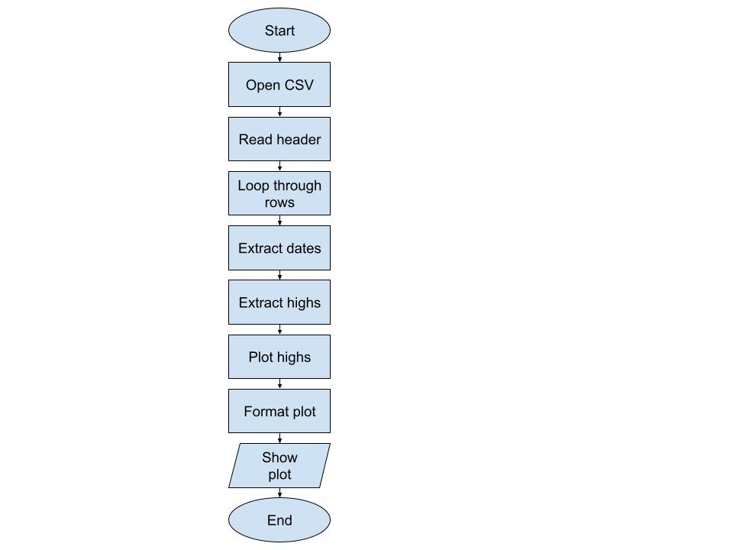
Sitka Weather Flowchart (revised) – With lows and menu options
