Michael Benko
October 30, 2026
Module 3.2 Assignment – GitHub Pages

Validation of the index.html file
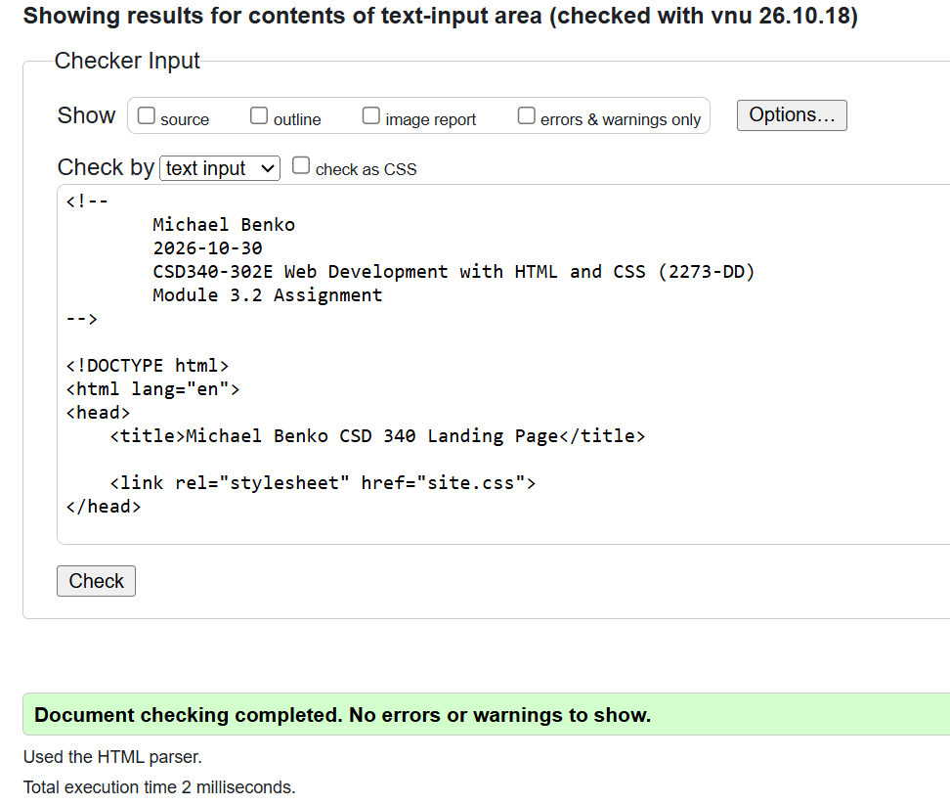

Validation of the site.css file
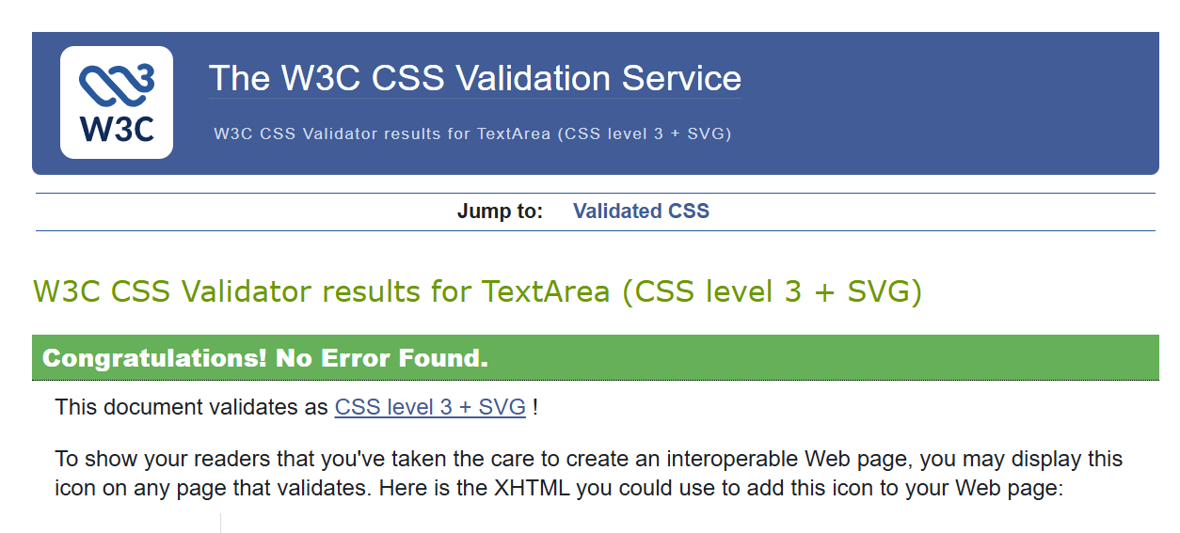
The index.html file opened in the browser
