Michael Benko
October 19, 2026
Module 1.2 Assignment – GitHub Repository Setup

Link to GitHub repository
https://github.com/TheRealMikeBenko/csd-340.git

Local directory
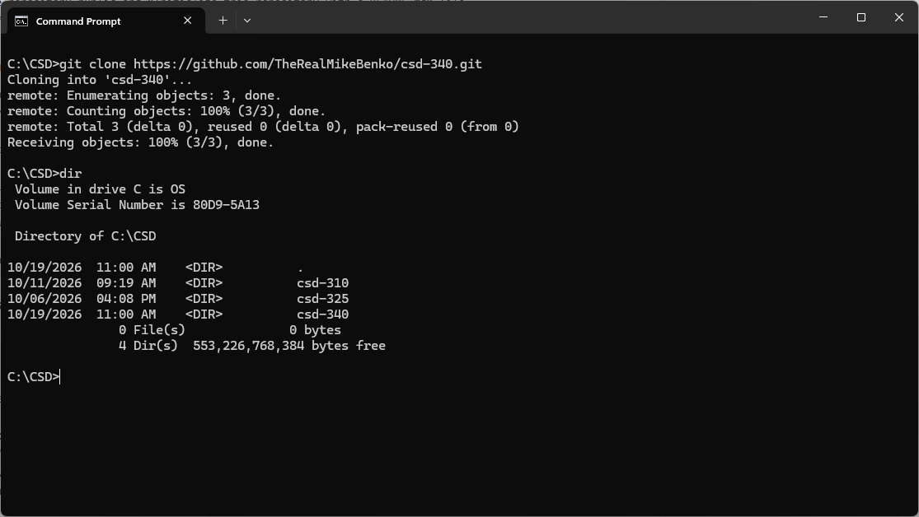

GitHub repository
