Michael Benko
October 21, 2026
Module 1.3 Assignment – Building a Web Page Exercise, Part 1

Errors with unmodified markup
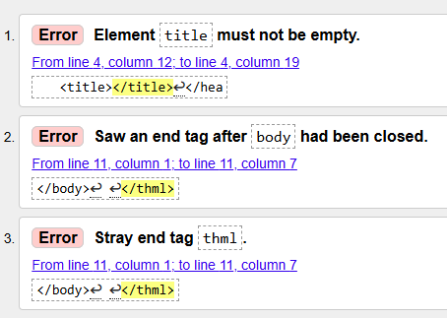

Errors corrected in markup
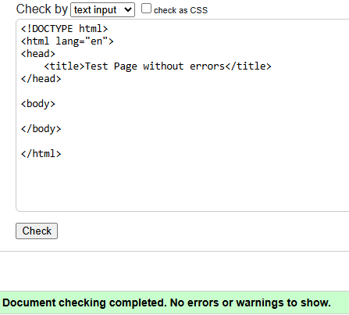
Modified markup to meet assignment requirements
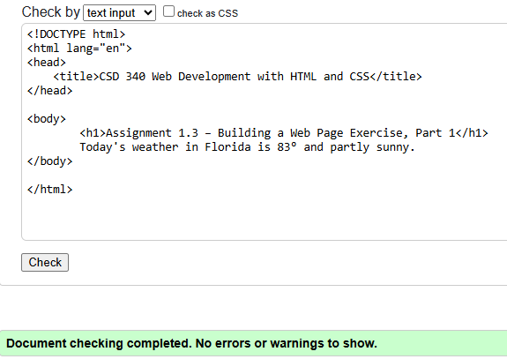

HTML file opened in the browser
