Michael Benko
October 19, 2026
Module 1.2 Assignment – GitHub Repository Setup

Local directory
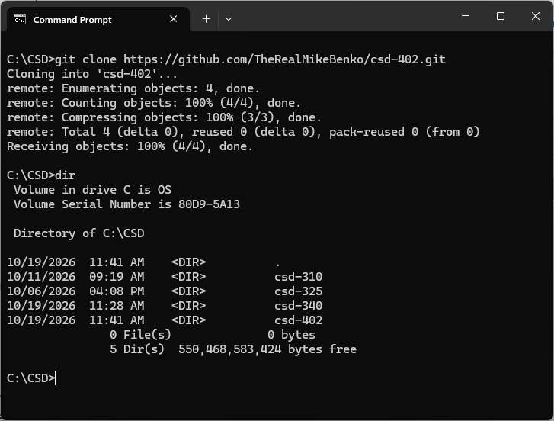
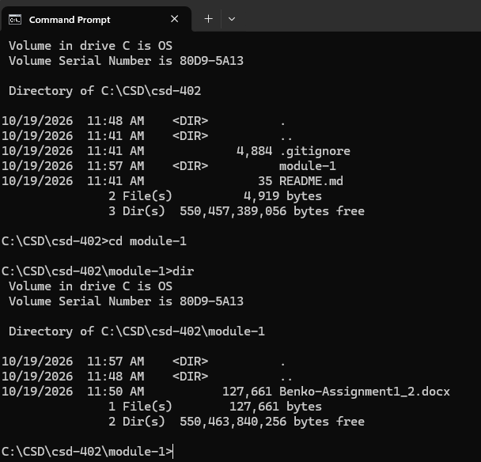

GitHub repository
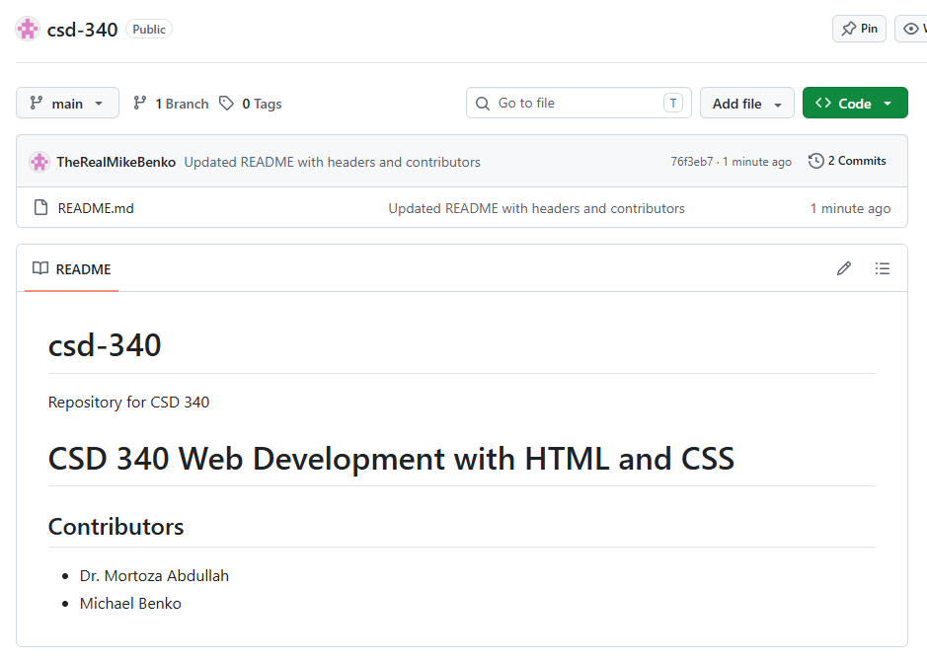
Link to GitHub repository
https://github.com/TheRealMikeBenko/csd-402.git

