Michael Benko
October 24, 2026
Module 1.3 Assignment – Installation of Java and JavaFX

Java installation verification
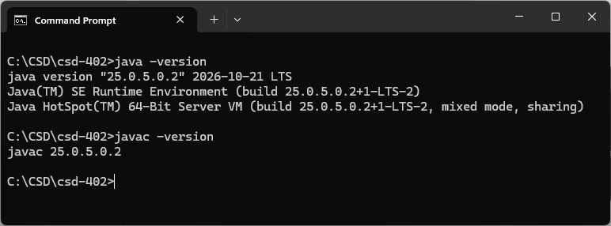

JavaFX location


