Header–
Logo
Main Fork of the Salmon River, Idaho
Nestled deep in the Frank Church Wilderness of No Return winds the Salmon river. The Salmon was given the nickname long ago as the River of No Return by the people living near it because of the number of folks that came to visit and fell so in love with the rugged beauty of the river that they never left.
Herds of elk and deer graze on the hillsides around the river and bear and bighorn sheep are also commonly sighted. The river corridor is also lined with awe inspiring ponderosa pine which tower over the sandy beaches in the campsites and provide shelter from sun or rain when needed.
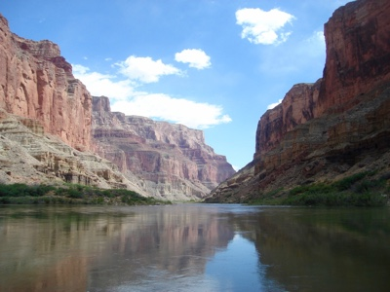
Footer
Image

