##$$KK

SEdit v2.0 General Information

SEdit v2.0 was inspired on a Friday night when Spring Break began and sedition’s regular posse had all left for other states. Like the greats, JV and BF, sedition is from Indiana so there isn’t much to do around here. I was bored and downloaded my SEdit version beta7 and looked at the horrible user interface on it. I decided I could do a better job now (2 years later) and began rewriting SEdit from scratch.

The bulk of SEdit v2.0 was written before the weekend was over, and written in a manner that every single tool from the old SEdit could be implemented in a quick and easy manner. Although SEdit v2.0 is written using some ASM, most of it is in ANSI C and may be open-sourced in the future.
##$$KK

ARC Map Information

I’ve included the following information about the map file format for you aspiring programmers out there. I used the following information when writing both SEdits, so I know they’ll prove useful.

ARC Map Header Format

Data Type Field Name Description
Unsigned Short Format_ID Constant value 0x4278
Unsigned Short Header_Size Size of header (not including Format ID)
Unsigned Char Version Version of file (currently 3)
Unsigned Short Width Width of map
Unsigned Short Height Height of map
Unsigned Char MaxPlayers Maximum number of players allowed on map at one time
Unsigned Char HoldingTime Holding time in seconds
Unsigned Char NumTeams Number of teams used
Unsigned Char GameObjective 0=CTF, 1=Toggle Switches
Unsigned Char LaserDamage Laser damage (0-4)
Unsigned Char SpecialDamage Special damage (0-4)
Unsigned Char Recharge Energy recharge rate (0-4)
Boolean (Char) Missiles_Enabled Missiles Enabled?
Boolean (Char) Mortars_Enabled Mortars Enabled?
Boolean (Char) Bouncys_Enabled Bouncies Enabled?
Unsigned Short PowerupPosCount Total powerups in map
Unsigned Char SimulPowerups Max powerups to display at once
Unsigned Char SwitchCount Number of switches
Unsigned Char[NumTeams] FlagCounts Number of flags per team
Unsigned Char[NumTeams] FlagPoleCounts Number of poles per team

Unsigned Char[NumTeams][FlagPoleCounts[0..NumTeams-1]]
FlagPoleBases Flag type accepted at each flag pole
Word NameLen Length of Name string
Char[NameLen] Name Extended name of map
Word DescLen Length of Description string
Char[DescLen] Desc Description of map
Unsigned Char NeutralCount Number of neutral flags in the map

Note: All multi-byte values stored in little endian (80x86) format

ARC Map Data

Following the the map header is the actual map data itself. The map data can either be compressed (arc map version 3), or it can be stored tile by tile in the file. Each map currently is 256x256 tiles, however, there may be support later on to create maps of different size, as the header does allow that specification.

Compressed data is created using ZLIB (which can be downloaded and compiled to create the libraries). SEdit v2.0 uses the maximum compression setting in the library just in case some map makers understand the viewing window algorithm. The more tiles that are repeated in a row, the further a file will be compressed, so try to get your map on the lower-right or lower-left bounds of the map.

Each tile is stored as a WORD (unsigned short – 16 bits, 2 bytes). If the upper most bit of the WORD is 1, then the tile is an animation. In an animation, the lower 8 bits of the WORD is the index, and the lower 7 bits of the high byte in the WORD (bits 9-15) represent the offset of the animation. Unfortunately this setup allows for only 256 unique animations.

However, if the upper bit of the WORD is 0, then the lower 15 bits of WORD represent the tile index. Since the current tiles.bmp is 640x1600 and tiles are 16x16 there are 4000 possible tiles. At 40 tiles per line, you can get the x,y ordered pair of the upper-left corner of a tile by doing ((tile%40)*16, (tile/40)*16).
#$$KK

Edit Tool
Most of the work in SEdit will be done using the edit tool. The edit tool on the toolbar is the button that looks like the standard windows mouse pointer. Edit is used to place tiles (in blocks or singly), or animations into the map area.

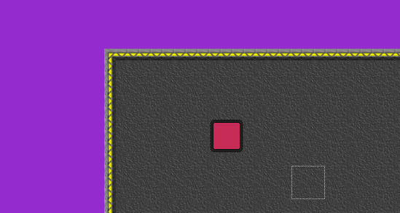
The edit tool is being used to place a 3x3 block of tiles in the map area.
##$$KK

Select Tool
The select tool is used by SEdit to group a block of tiles in a map together. Several tools in SEdit require a selection block, because the effects they provide are not applied to the entire map. Examples of these tools are cut, copy, paste, mirror, rotate, delete, and fill selection. In future releases of SEdit it may be possible to move or resize selection boxes using the mouse. At that time, it will be possible to paste without having a selection box. In addition, the following tools also create selection boxes of their own: bridge, bunker, holding pen.

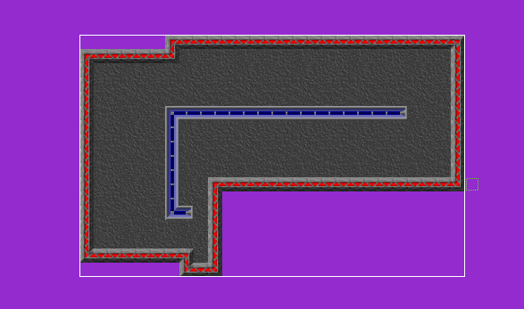
The select tool has been used to select the walled in area and the transparent tiles.

# sedit_default
$ General Information
K General Information
# arc_map_info
$ ARC Map Information
K ARC Map Information
#edit_tool
$ Edit
K Edit Tool
# select_tool
$ Select
K Select Tool

