## WEB222 - Assignment 2: JavaScript Objects

## Due date

Sat, Oct 5, 2019 - 11:59pm

Grade value: 5% of your final course grade

## Objective

Practice JavaScript String, Array and customized objects.

## Specifications

Complete the two parts of the assignment as specified below.

**Part A**

Write a JavaScript program to perform the following tasks.

Open a Firefox Scratchpad. Create comment line(s) for each of the Steps in assignment2a.js using block comments, indicating the start point of each Steps. e.g.

/*****************************

* Step 1

*****************************/

To run all JavaScript code in Scratchpad, click on the ***Run*** button. To run a part of the code, highlight the part of code and click on the ***Run*** button . You’re requested to keep a **Web Console** open to monitor console logs and run-time errors when running JavaScript code. Variable values will be kept in memory after a piece of code is run. So, usually, you need to initialize variables to ensure the part of code can repeatedly give the same result.

Here, we will introduce you to the [Mockaroo service](https://mockaroo.com/): https://mockaroo.com

*Need some mock data to test your app?  
Mockaroo lets you generate up to 1,000 rows of realistic test data in CSV, JSON, SQL, and Excel formats.*

Problem solved.

Use the image below for Field Name, Type and Options. Generate only 10 rows of JSON data.

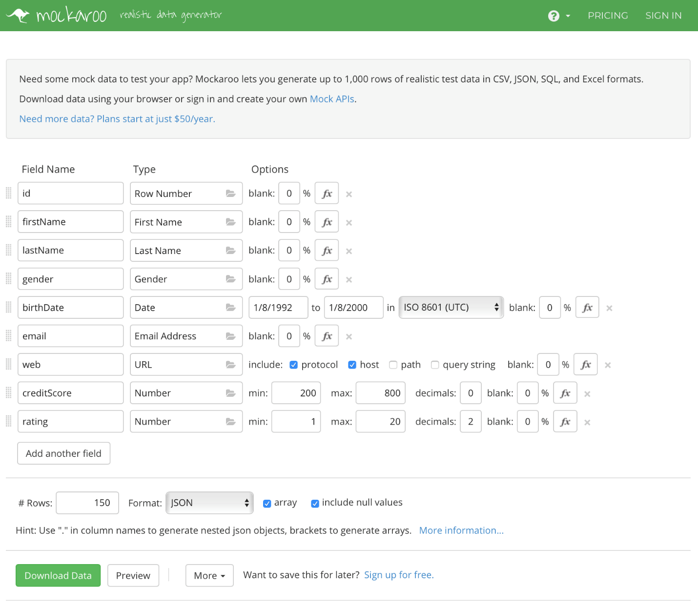

**Use the data for this part (A)**

The data comes to your system as a standard download. Open it for editing. Copy it.

In your code in scratchpad, assign the JSON data as the value of a new variable as an array.

**var** people **=** *// your pasted JSON goes here*

Don’t forget the statement’s trailing semicolon.

Now you have a rich body of data, with which you can do the standard data manipulation tasks.

**Task 1**

Create a function named **capNotFirstLetter** using the function declaration syntax. The function receives a single parameter of String type. Update / change the first letter of the string to lower case and other letters to upper case. The function returns the updated String. Hint: use the property and methods of String object – length, substr(from, length), substring(from, to) , toUpperCase() and/or toLowerCase().

**Task 2**

Copy the array to a new array, with something like this:

**var** data **=** people.map(p **=>** p);

Using the function written in Step 1, Update / change the first letter of the string to lower case and other letters to upper case for all FirstName objects in the array. Log the array in the web console.

**Task 3**

Using an appropriate method, filter out those objects with creditScore >400 and assign the array into a new variable. Log the new variable in the web console. **Do not use loop for this task.**

**Task 4**

Sort the data array by birth date and log the sorted array in the web console.

Save your file as assignment2a.js .

**Part B**

Download JavaScript file **assignment2b.js** from MySeneca/Blackboard under the **Assignments** section**.** The file contains some given code, including an array (named **courses**) of course objects and a prototype object (named **student**) for creating student objects. Do not change the given code. Write your code beneath the given code and complete the following tasks:

**Task 1:**

1. Remove the last course object form the given array **courses** and store the removed object to a variable.
2. Output a message to web console to show the course which was removed from the array. Please see the screenshot of outputs on the browse console below.
3. Create 4 course objects which should have the same properties as what the objects (in the course array) have. Store the 4 course objects in the variables **ibc233**, **oop244**, **web222** and **dbs201,** and the object properties should have appropriate values.
4. Add these course objects in the array **courses**.
5. Use for loop to loop through the course array and output the information of the course objects in the array to web console. Please refer the screenshot below.

**Task 2:**

1. Create 4 student objects based on the given prototype **student**. Give appropriate property values for all student objects.
2. Create an array named **students** and add all the student objects into the array.
3. Use the **forEach** method to iterate the array students and output the information of the student objects to the web console. Please refer the screen below.
4. Save your JavaScript code to file **assignment2b.js**.

Click the image to open it full-size in a new tab/window.

[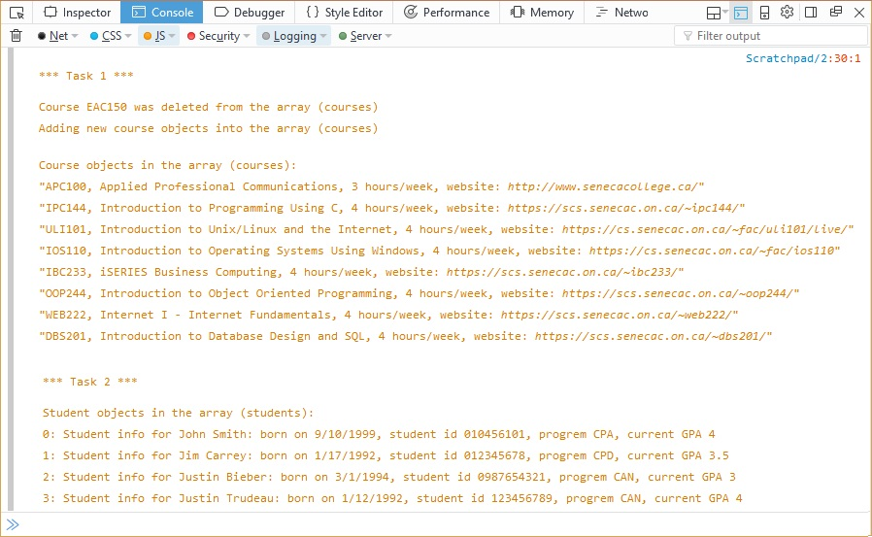](https://scs.senecac.on.ca/~wei.song/web222/assignments/images/A2b-output2.jpg)

## Assignment submission

* Add the following declaration at the top of your **assignment2a.js** and **assignment2b.js** files (failure to do this step will result in zero mark assigned to your assignment 2):

/*******************************************************************************

* WEB222 – Assignment 2

* I declare that this assignment is my own work in accordance with Seneca

* Academic Policy. No part of this assignment has been copied manually or

* electronically from any other source (including web sites) or distributed to

* other students.

*

* Name: _____________________ Student ID: ______________ Date: _______________

*

******************************************************************************/

* Compact your files **assignment2a.js, assignment2b.js** into a zip file named **assignment2-<your name>.zip**.
* Submit the zip file to the Blackboard (My.Seneca).

## Important note

* **NO LATE SUBMISSIONS for assignments. Late submissions will not be accepted and will receive a grade of zero (0).**
* **After the end (11:00PM) of the due date/time, the assignment submission link on the Blackboard will no longer be available.**
* **Allow enough time to upload. Do not wait for the last moment since there are transmission time/queuing delay/processing time etc. from your machine to the blackboard server.**