**SAN DIEGO COUNTY RAINFALL AND STREAM LEVEL INFORMATION SYSTEM TUTORIAL**

San Diego County’s online Rainfall and Stream Level Information System -- also known as the ALERT (Automatic Local Evaluation in Real Time) System -- provides rainfall, stream level, lake level, and weather information throughout the San Diego County region. This tutorial is designed to aid users in navigating the San Diego County ALERT System website to find information pertinent to their specific area of interest.

The ALERT System is accessed through <http://sandiego.onerain.com>.

**THE HOME PAGE**

Above the title “San Diego County Rainfall and Stream Level Information System”, you will sometimes find information about the system shaded in light blue background. This may include information about new features added to the website, new stations added to the network, notifying you about problems with the network.

Below the title, there is a small section reserved for the notification of watches and warnings from the National Weather Service (NWS), called “NWS Public Alerts”. Most times this will have no entries, but during periods of inclement weather, there may be one or more watches, warnings, or advisories displayed. Clicking on the links in this section will not open up a new tab on the browser, so to get back to the flood warning website, you will need to click the “back” button on the browser.

**Maps and Summaries**

In the **Maps and Summaries** section, there are four colored tabs. The first two tabs give summaries of rainfall and stream levels. The Rainfall Summary report will list summaries of rain totals for each station, from the most recent 15-minute total all the way up to the last 12 months. For the Stream Level Summaries, you can choose to list all of the streams or select individual watersheds. For the Rainfall Maps tab, you are presented with a choice of 24 hour rain totals for the entire county or individual watersheds. The Stream Maps tab presents you with a choice of displaying the current water levels for the entire county or for individual watersheds.

Below the Maps and Summaries tabs on the left half of the page are clickable links to the NWS pages of weather radar, satellite loops, weather discussion, and weather forecasts. On the right half of the page are clickable links for the 7-day forecast for the coastal region, mountain region, and desert region. Clicking on the forecast graphics pulls up additional information, including extended forecast, high and low tides, state of the moon, and sunrise/sunset times.

**The Navigation Bar**

Near the top of the home page, below the San Diego County Flood Control District logo, is the navigation bar which looks like the image below on standard computers,

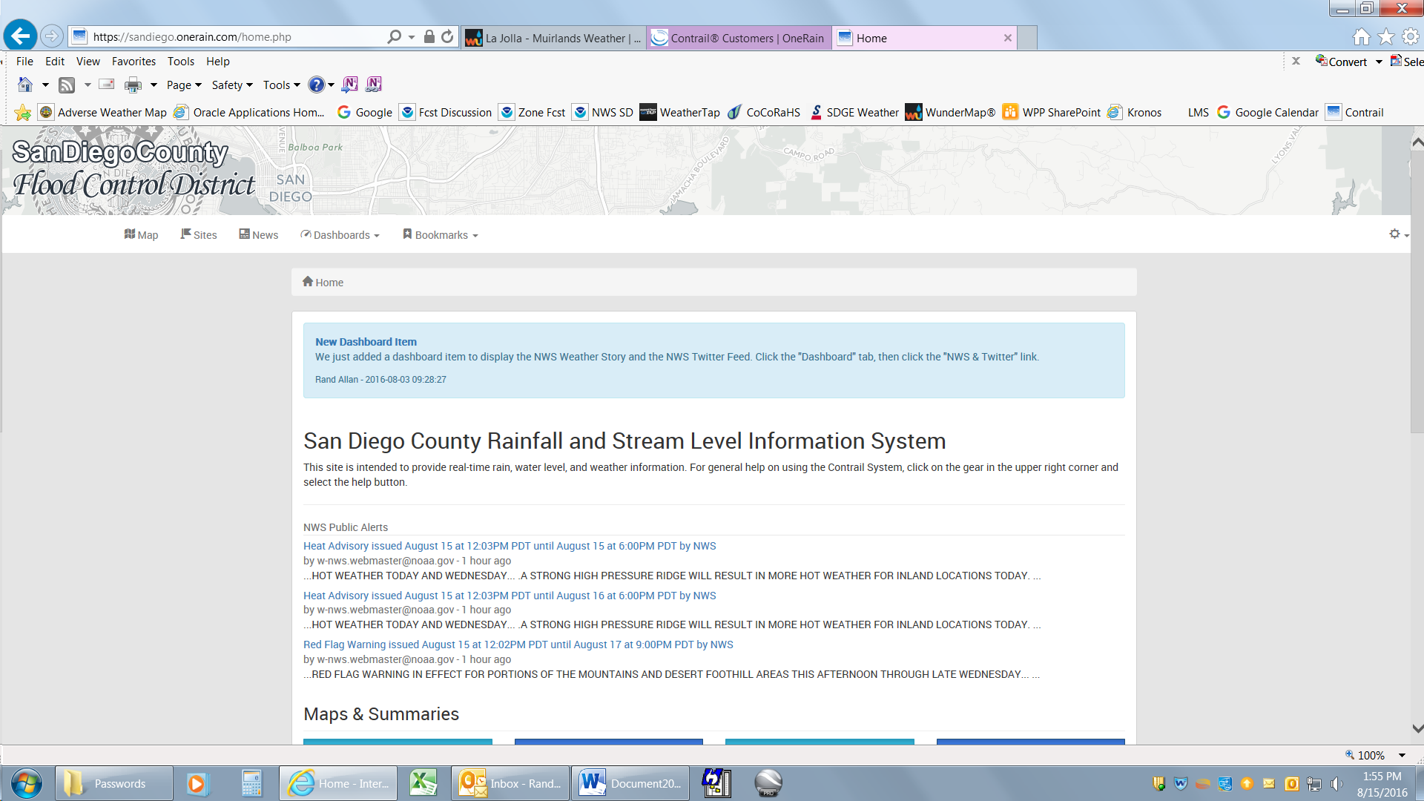

The navigation bar provides users with alternative methods of finding data. The most useful, perhaps, being the “Map”, “Dashboards” and “Bookmarks” menus.

**Map**

The map is a “Pan and Zoom” type, meaning that you can use the mouse to zoom in and out of the image, and by clicking and holding the left mouse button, you can “pull” the map around to view different portions of the county. The map can zoom down to street level or zoom out to a county level.

At the base of the map is the following graphic:  
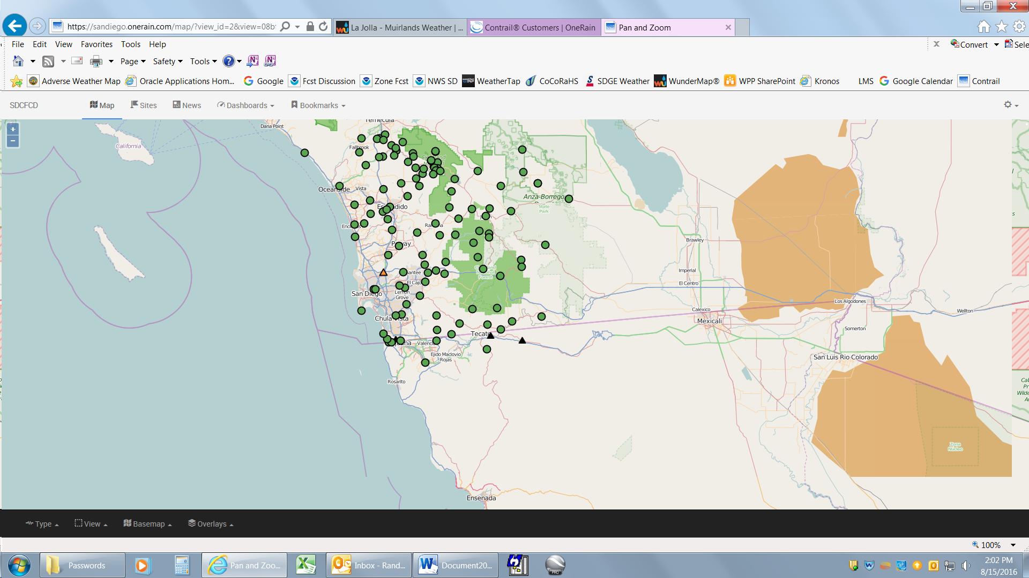

The user can focus on particular display types, areas of interest, or gage types by using the filters “Type”, “BaseMap”, “Overlays”, and “View”.

* **Views** are subsets of stations grouped by watersheds (San Luis Rey, San Diego, Sweetwater, etc.) or system types (ALERT, ALERT2, USGS, TIDES, etc.). ALERT and ALERT2 are system types maintained by the San Diego County Flood Control District (SDCFCD).
* **Type** displays the various sensor types available within the chosen View.
* **Basemap** allows you display the map background in various styles (standard street map, satellite, USGS topography, etc.).
* **Overlays** allows you to choose additional layers to place on the background, such as a NWS updating radar display.

Clicking on **SDCFCD** on the navigation bar while in map mode sends you back to the Home page.

**Sites**

Selecting “Sites” from the navigation bar takes you to a list of all data collection sites available on the ALERT system website. This list is mostly useful if you know the name of the site that you are interested in. Scrolling down and clicking on a station will bring up information on the site, such as earth coordinates, elevation, images related to the site, and boxes or graphics of the available sensors. Clicking on a sensor box or graph will enable you to see a more detailed graph, view the data, and download the available data to a spreadsheet.

Rainfall Frequency Chart  
Rainfall data collected by the Flood Control District, as well as data collected by the NWS, was used by NOAA to produce detailed rainfall frequency maps. They have created an interactive website, <http://hdsc.nws.noaa.gov/hdsc/pfds/pfds_map_cont.html?bkmrk=ca>, that will create a table of rainfall frequencies for a point location with rainfall events ranging from 5 minutes to 60 days and event frequencies ranging from 1-year to 1000-year frequencies. On our flood warning website, these tables, located in the Images Box of each site as a clickable image, provide a quick reference for the observed rainfall event frequency at each of our raingage sites.

To determine the rainfall frequency of a storm event at a given site, select the site from the dropdown list of the Sites tab on the Home page, go to the Rain Increment sensor, select the graph, adjust the time period of the graph to highlight the desired storm event, then select the option Daily, Hourly, 15-minute, 5-minute, or 1-minute. Locate the peak observation. Go to the table to identify the calculated frequency. For example, if you were looking for the 1-hour frequency, identify the peak one hour reading on the graph, go to the y-axis of the frequency table to locate one-hour, then go across to find the closest rainfall total to your observed reading. Go up to the corresponding header on the top of the chart, and that is approximately the statistical frequency for your observed rainfall. Numbers that fall in between two rainfall frequencies on the table can be estimated.

For information on how the frequency charts were created, refer to the NOAA website.  
  
There is a misperception about the terminology about the frequency of an event. A 50-year event does not mean that the event will occur on the average once every 50 years. It means that a 50-year event at a given location has a 1/50, or 2%, probability of occurring in any given year. A 1-year storm event has a 1/1, or 100%, probability of occurring in any given year. A 1000-year storm has a 1/1000, or 0.1%, probability of occurrence in any given year.

**Breadcrumbs**

Note the little graphic below the Navigation bar:  
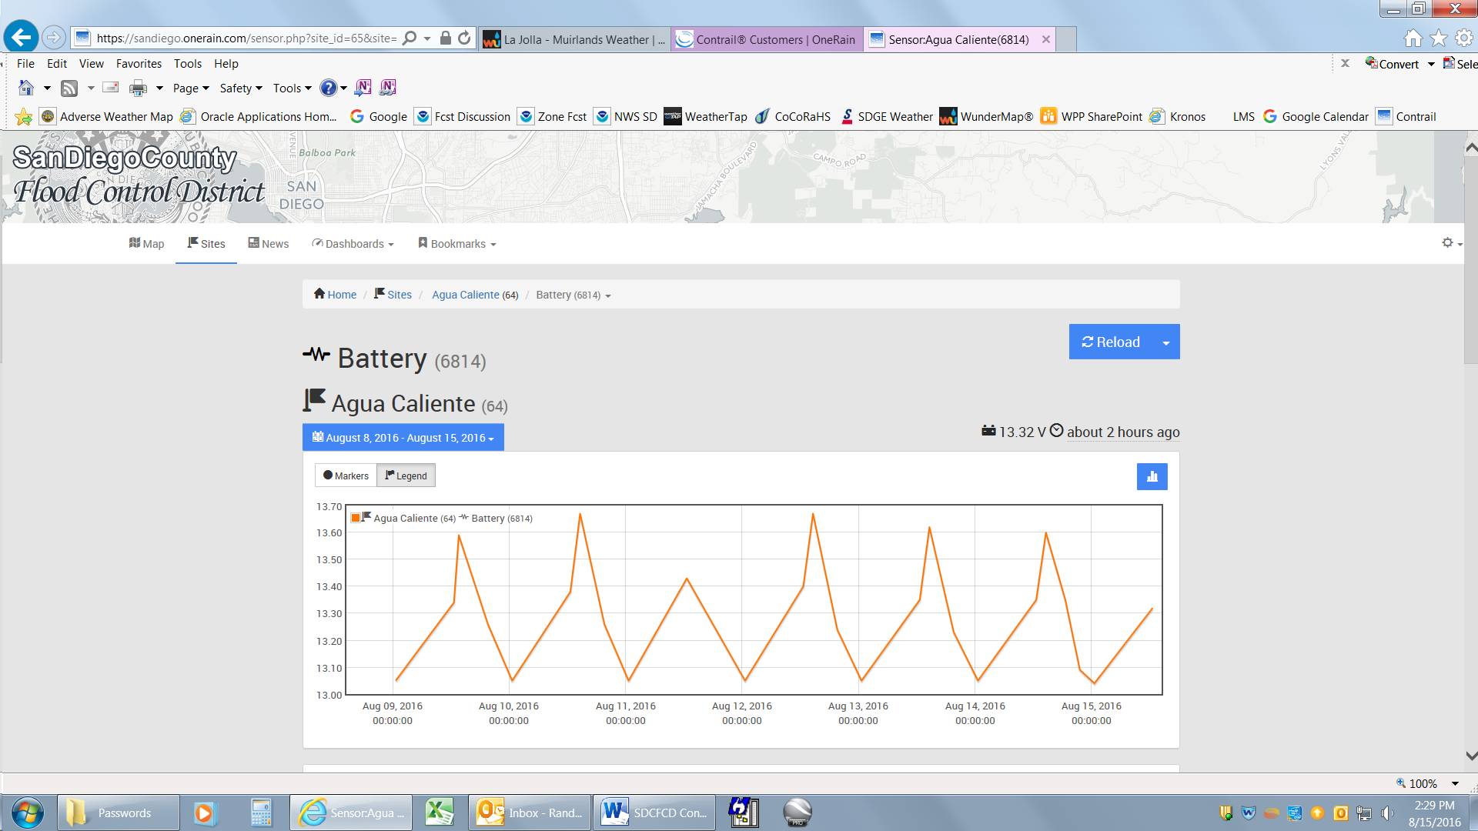  
This is called a “Breadcrumb”. It is a quick way to navigate back one or more steps to a previous display, kind of like following the breadcrumbs back to your home in the fable, “Hansel and Gretel”.

**Dashboards**

A dashboard is a way of gathering specific type of information together to provide a visual display of information needed to assess various types of risk. Rain dashboards group rain sensors by watershed and provide frequency estimates during periods of intense rainfall. Stream dashboards can group graphic displays of stations from the headwaters of a watershed to the outlet. Webcam dashboards can group all of the webcams together to allow a viewer to see the flood potential of low water crossings at a glance. To view a dashboard, select “Dashboards” from the navigation bar. A list of available dashboards will drop down. Select the desired dashboard from the list.

**Bookmarks**

From the Bookmarks pull-down menu on the navigation bar at the top of the page, users can access additional information, such as links to the County website, the Public Works website, the Flood Control District website, the NWS website, and links to other websites related to weather and flood information.

**A word regarding the “Reload” button**

Although the maps will automatically update once every 5 minutes, pages that display data or graphs do not automatically refresh by default as data is added to the database. Most of these pages include a blue button labeled “Reload” near the top of the page that can be used to refresh the page with current data. Additionally, if you wish to keep a particular page open in your browser, you can select an automatic refresh rate by using the pull-down menu next to the blue “Reload” button. Timed signals from weather stations (temperature, RH, air pressure, winds), are sent approximately once an hour. During active rainy periods, rain and stream data will appear in the database within 2 to 5 minutes of when it is observed.

**News**

“News” on the Navigation Bar is just what it implies…anything related to the Flood Warning System that we consider newsworthy. It could be anything from announcement of a new capability of the website, to announcing a new station, taking a station down for long-term rebuild, to upgrading the network.

**Downloading Historical Data**

Data from any of the stations and their sensors can be downloaded to a spreadsheet for analysis. It should be pointed out that the data is provisional (USGS, NOAA, and SDG&E data do not belong to SDCFCD, and ALERT data owned by SDCFCD may not be edited in a timely manner), and if you want officially edited data (rainfall), you should contact Flood Control at 858-495-5557 or email [rand.allan@sdcounty.ca.gov](mailto:rand.allan@sdcounty.ca.gov).

To retrieve data from a station, click the **Sites** tab in the upper left corner of the home page. This will bring up a list of available stations. When you click on the desired station, a list of sensors for that station will display on the monitor. If you want historical rain data, select **Rain Increment**, as this is the sensor where that data is loaded. A graph of the last 7 days of data will display as well as the data that went into the display of that map. The blue bar above the graph allows you to select the date range to display. Once you have selected your date range to display and click the **Apply** button, the graph and selected data will display. To download the data to a spreadsheet, scroll down to the data and click the blue download button above the start of data and follow the directions.