Linux Administration Midterm

1. sudo apt-get update
sudo apt-get upgrade

2. Command used: :g/add\|make\|comment/d

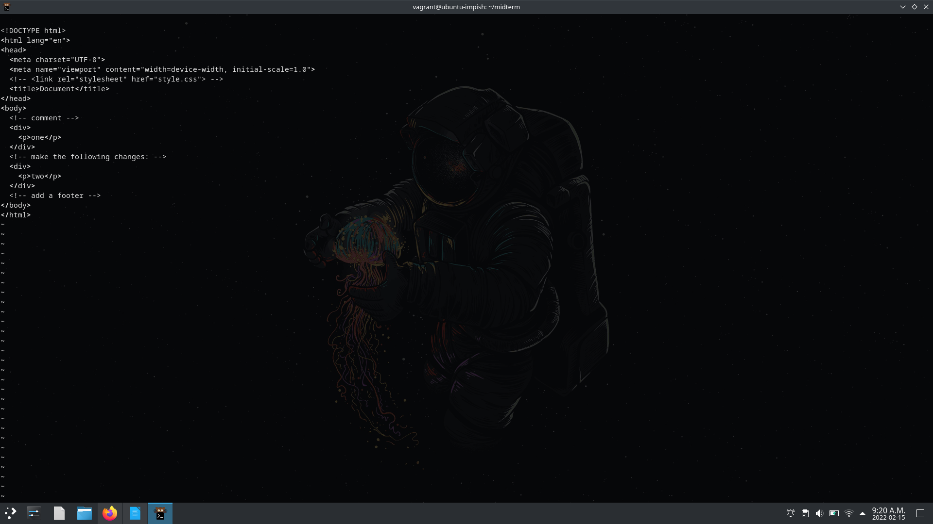

3. file: passwd

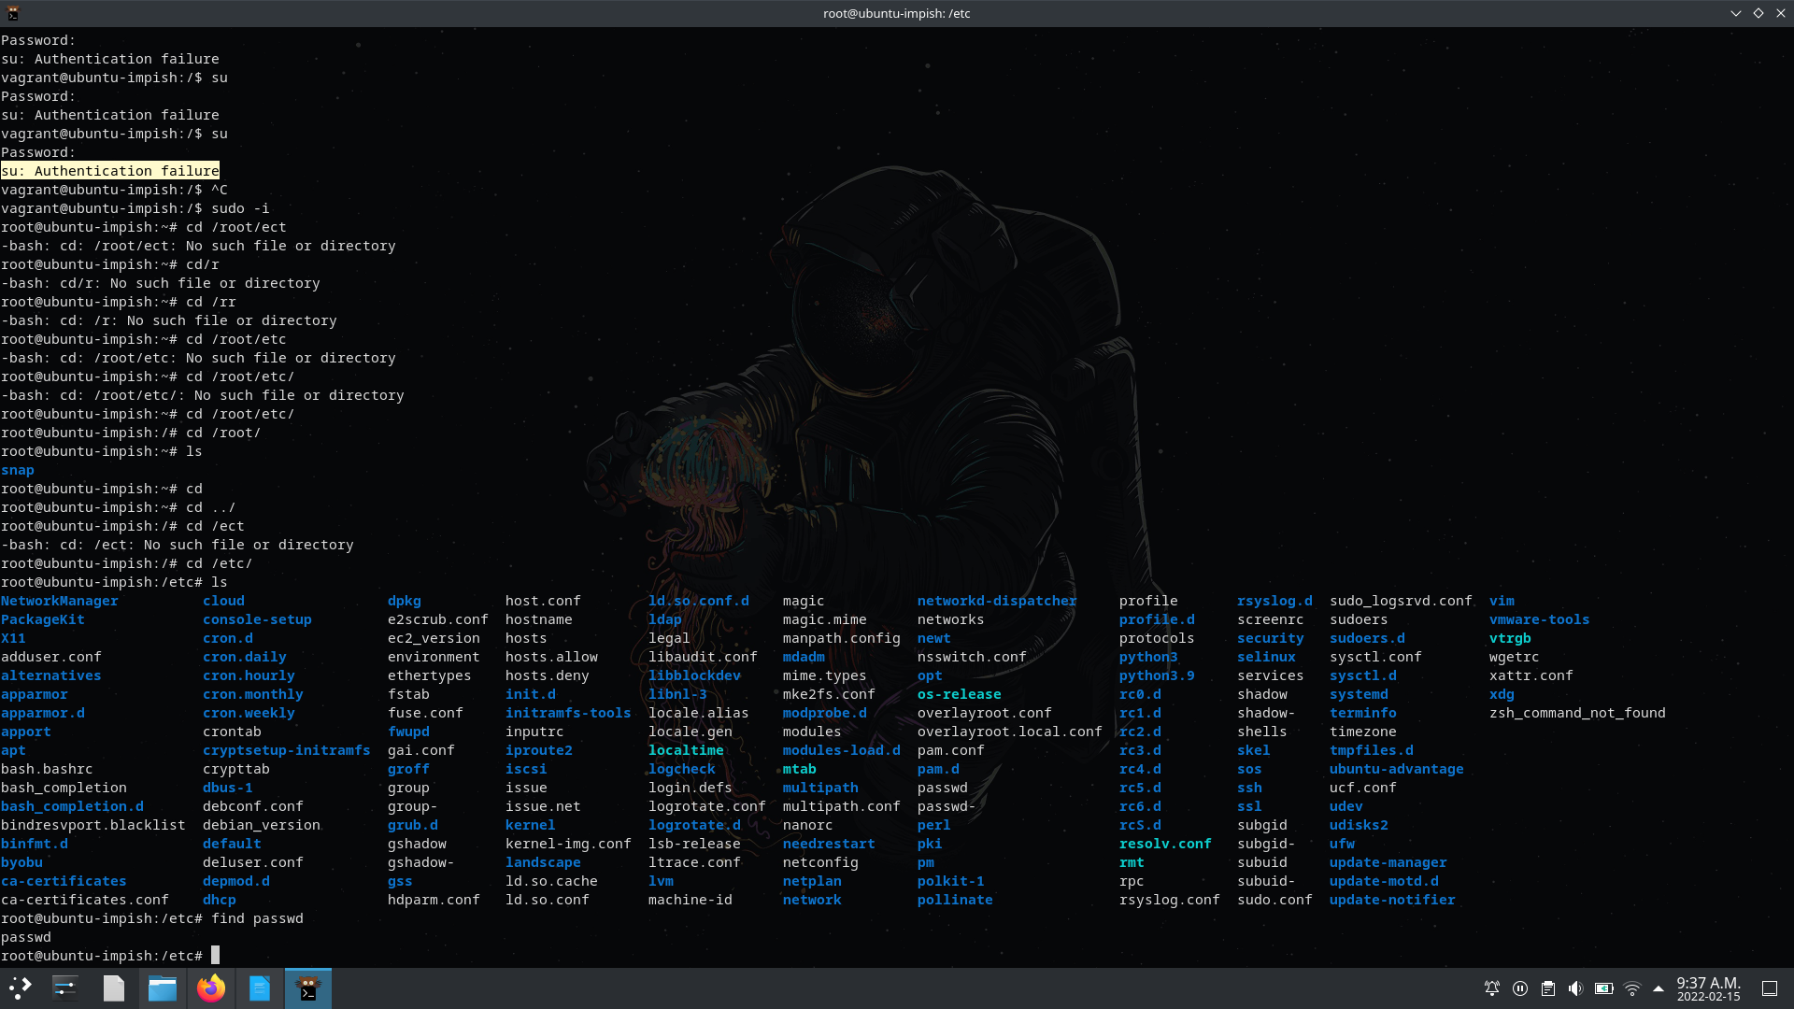

4.

5.

6.
9.

10.
