# Notes on UX Research Methods & Usability Testing (Nielson Norman Group)

The original YouTube playlist can be found [here](https://www.youtube.com/playlist?list=PLJOFJ3Ok_idtiMTz8fAiF1ElcKJM7Rncj).

**Disclaimer:** The following content is neither sponsored nor endorsed by the [Nielson Norman Group](http://nngroup.com/). Rather [TheRisingTilde](https://medium.com/the-rising-tilde) has provided these notes as an educational resource to be accompanied with the original playlist.

## User Testing

* You (the software engineer or the business) are never the user → you know too much.
* Cheap → can be done in a few days with just five users.
* Convincing.
* How to do user testing:
  + Get representative users
  + Get users to perform realistic tasks - they need to try and accomplish something with the intended design.
  + Shut up and let the users do the testing

## Discovery: Common misconceptions

* Not a synonym for user research: learning about all aspects of a problem to understand it and frame it appropriately
* Discovery needs user research: If no research, you might end up stating what you already know or think you already know.
* Discovery is not a one-person job: Can’t always work on technology and business requirements while user research is still in progress. This way, only one person understands the problem space.
* Not a validation exercise: Discovery is to learn something you don’t know. Don’t validate solutions via users.
* Discovery is not a design sprint: Workshopping and ideating is not a discovery. Also, the goal of discovery is not to produce a high-fidelity prototype.
* A real discovery:
  + Involves user research
  + Explores available technologies
  + Defines the problems to be solved
  + Uncovers successful outcomes
  + Involves a multidisciplinary team
  + A mindset that we don’t know all the answers

## Remote moderated usability testing.

* User unmoderated testing:
  + Give users tasks and wait for data to be collected.
  + Faster, easier, and cheaper than in-person testing
  + The testing tool does the job of the facilitator - administers tasks to a user.
  + But does not capture reactions, nor can we ask probing questions.
* User moderated testing uses a facilitator to run the session:
  + Higher quality and more detailed testing

## Formative vs. Summative Usability Evaluation

* Formative: Tells you what aspects of your design work and don’t work and tells you why
  + Heuristic reviews, cognitive walkthrough, usability testing
  + The goal is to understand what precisely is working and not working, and why?
  + Used frequently to support iterations through the design process:

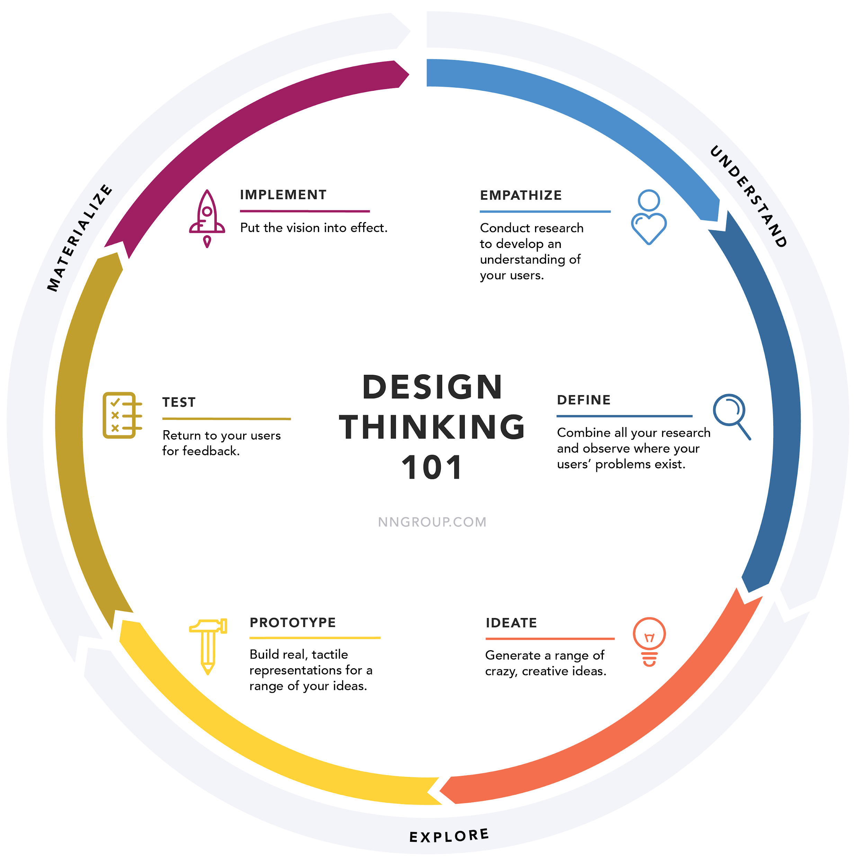

* + Use early on in the design process
* Summative: Tells you overall how your design works - compared to your competitors and benchmark
  + Carried out when you have a complete design or a shipped product
  + Customers use systems without assistance and grade it
  + Metrics, e.g., Satisfaction, ease of use, net promoter score
  + How usable or satisfying your UX is
  + It tells you how iterations compare to each other
  + Need a large representative sample
  + Isn’t helpful if you want to evaluate your product quickly

## 5 Steps for Effective Diary Studies in Customer Journey Research

1. Planning and preparation
   * Recruit customers to record their experiences.
2. Pre-study brief - explain to customers what type of data you need.
3. Logging period - monitor insights as they come in to fully understand the context of their experience
4. Post-study interview
5. Analyze findings - look for points of friction, find opportunities to improve
   * This helps finds contextual information about the consumer journey.

## Usability Testing with Five users

* Not going to learn much more with subsequent users.
* But there are some types of research like quantitative usability studies:
  + Where the goal is to drive metrics
  + Need large n to get a good statistical significance
* Find the number of users based on the best ROI:
  + How good you are at deriving insights and design recommendations from observations of user behavior.
    - in a situation where it’s relatively easy to understand what the user is doing - can get away with a smaller number of users
  + How efficient is your team at taking in these recommendations and designing a new product to work on
    - If in a slow-moving organization, then you need to be certain with your insights → a larger number of users
    - A fast-moving team (with paper prototypes, etc.) can do with fewer users.
  + Aim to keep getting test users until some form of generalization/repeated behavior is observed among users → no new/limited insights
* Information foraging: “hunt” for more insightful feedback once you’re done with one iteration of feedback (for a prototype)
  + Leads to the discovery of new and exciting problems with contemporary designs

## UX Research Cheat Sheet

* Discovery: Validate and discard assumptions
  + Field studies
  + Diary studies
  + User Interviews
  + Stakeholder interviews
  + Constraint inventory
* Explore: Understand the user space and how you can satisfy your user’s needs
  + Competitive Analysis
  + Persona Building
  + Journey Mapping
  + Design reviews
  + Task analysis
  + Card sorting
* Testing: Make sure the systems we design work well for the user
  + Qualitative testing
  + Benchmark testing
  + Accessibility evaluation
* Listening:
  + Surveys
  + Analytics Reviews
  + Search log reviews
  + Usability bug reviews
  + FAQ reviews

## How to Test Visual Design

* Assess both opinion and behavior
* Comparing multiple versions of the design to increase the test’s sensitivity and makes it easier to understand the differences and what caused them.
  + A/B test
  + Usability testing

## User Testing Facilitation Techniques

* Echo: Clarify what the users meant if he/she says something incoherent or unclear
* Boomerang: If users ask a direct question, deflect it back to them - this avoids assisting the user too much
* Columbo: Ask partial questions, e.g., “You swiped here…”

## Pillars of usability testing

1. Typical users:
   * Recruit people similar to your target users
   * Exclude those who aren’t a good fit. E.g., users that have something against your brand.
2. Appropriate tasks
   * Set the stage for how they’re going to navigate through the interface
   * Match tasks to research goals
   * Don’t give too many details.
   * Write user-centered tasks without telling them how to accomplish them and without giving cues about the interface.
   * Add a brief context
3. Skilled facilitator
   * Stays out of the user’s way
   * Doesn’t bias the user’s way of thinking.
   * Only probes to get a user to articulate further
   * Talks minimal
   * Make sure that the user is feeling comfortable.
   * Capacity to analyze and interpret results

## Open vs. Closed Questions in User Research

* Closed-ended
  + Good for quantitative research
  + Gives us metrics and scale
* Open-ended
  + Accepts a variety of answers
  + difficult to quantify
  + Great for exploratory studies
  + Gives us new and detailed insights

## A/B Testing vs. Multivariate Testing for Design Optimization

* Multivariate testing:
  + Split live traffic to different design variations to test their impact
  + Measure conversions
  + But every new combination = new variation to test
  + Multi-variate testing = usually better to refine a testing page.

## Between-Subject vs. Within-Subject Study Design in User Research

* Between-subjects study design: different people test each condition to only be exposed to a single user interface. (e.g., rent a car only on Hertz)
* Within-subjects study design: the same person tests all the conditions (i.e., all the user interfaces). (e.g., all subjects rent a car on Hertz and Alamo)

## Thematic Analysis of Qualitative User Research Data

* Identify common themes among participant data.
* E.g. Group responses from interviews into themes

## Analytics vs. Quantitative Usability Testing

* Analytics:
  + Seeing what your users do in the wild
  + E.g., google analytics
  + inexpensive
* Quantitative:
  + Experimental
  + Can control conditions
  + Expensive
  + Get a richer picture of the usability of the website

## Eyetracking Shows How Task Scenarios Influence Where People Look

* Users choose what to read based on patterns they’ve seen.
* Make page layout predictable and consistent.

## Open vs. Closed Card Sorting

* Get insight into how users expect content to be organized on a website.
* Use open card sorting to learn how users group content and the terms or labels they give each category.
* Closed Card Sort:
  + Participants are asked to sort topics from content within your website into pre-defined categories.
  + People need to understand what they’re going to get entirely based on labels

## Turning Analytics Findings Into Usability Studies

* Analytics data only tells you what behaviors are occurring on your site or app
* Why users are confused = need qualitative data
* Replicate your tasks as closely as possible to reflect the analytics data
* E.g., based on analytics users starting an interaction flow but fail to finish it → convert this into a task for a usability study

## When to Use Which UX Research Method

* Watch users do things - observed by researches → behavioral study
  + Test whether the design process is:
    - Discoverable
    - Findable
    - Understandable
    - Usable

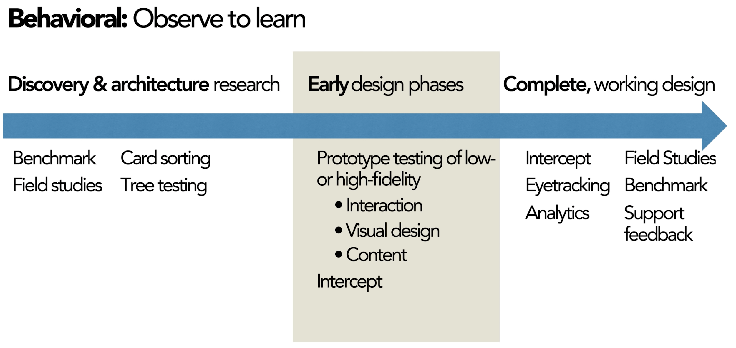

* + Tempting to ask user directly what they think during the prototyping phase → try and avoid this
  + Instead, direct the user to try and do something
* Ask users questions - self-reported by users → attitudinal study
  + Interested in what people have to say - whether they’ll like to dislike something
  + Self-reported methods can be used:
    - Interviews
    - Surveys
    - Focus groups

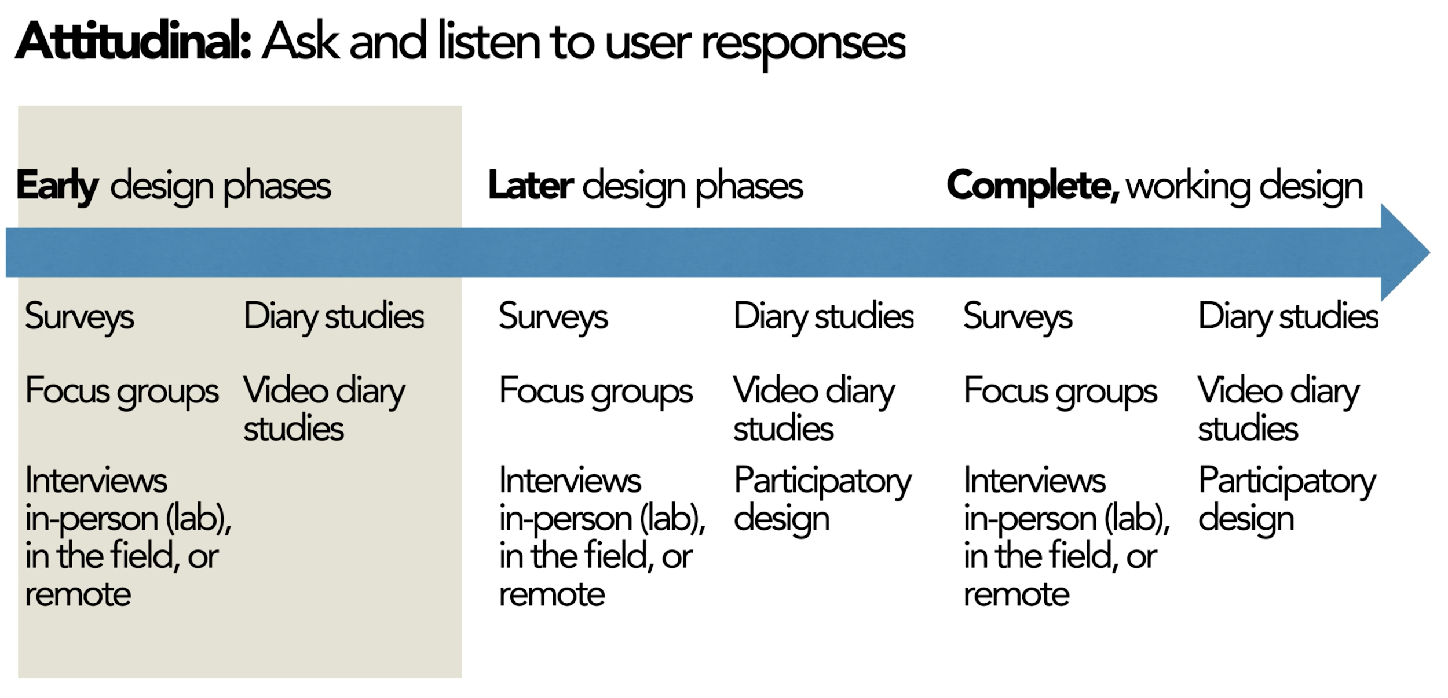

* Quantitative: metrics and numbers
  + Answers “How many” and “How much”
  + Goals include:
    - Determine priority or scale of the problem
    - Compare alternative design options
    - Benchmark user services
  + Compute expected cost savings from design changes
  + E.g.
    - Cart sorting
    - Tree testing
    - Eyetracking heatmaps
    - Quantitative usability tests
* Qualitative: stories, events, and examples
  + Answers “What” and “Why”
  + Goals include:
    - Discovery problems
    - Investigate why
    - Learn how to fix
  + Used in very early prototypes usability tests
  + E.g.
    - Field studies
    - Diary studies
* Controlled or contextual user environment

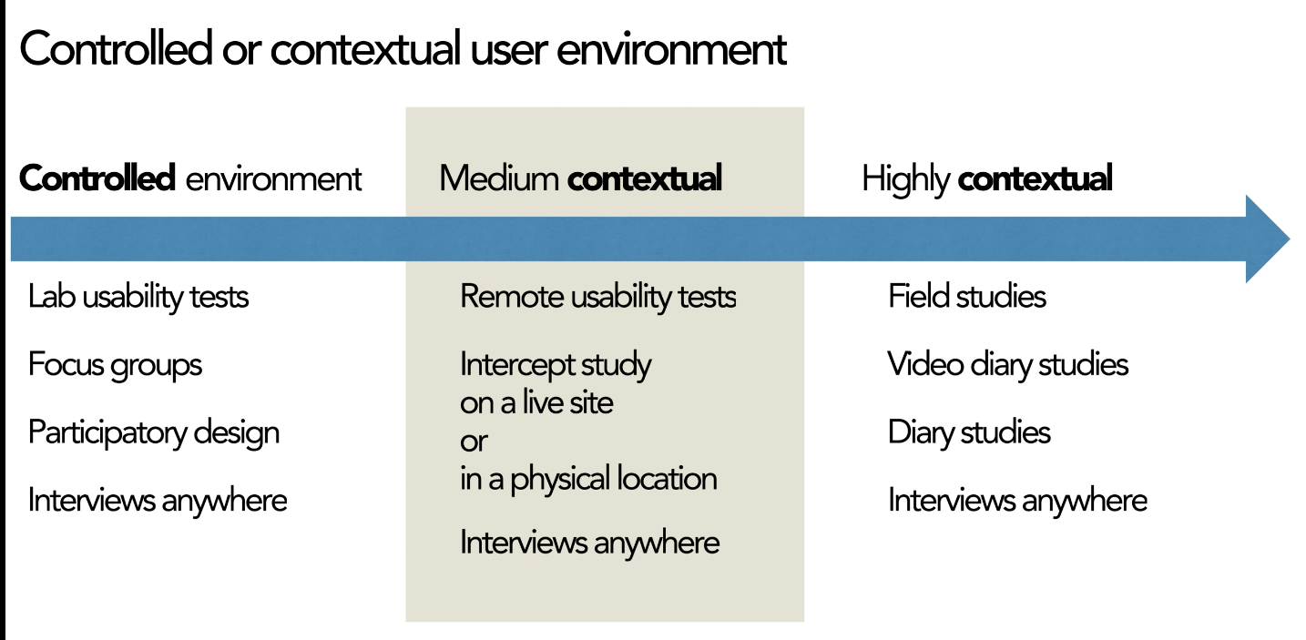

## How to avoid bias in card sorting

* Choose a sample of content for sorting.
* Remember the content and size of the samples impact the groupings the customers will make.
  + E.g. broccoli, apples, scones, and muffins would be split into two categories - produce and baked goods
  + E.g. broccoli, apples, scones, banana, carrots, and muffins would be split into two new categories - fruits and vegetables and baked goods
* The more items you include, the more likely people are to make a new standalone category.
* Ensure cards that proportionally represent your content - but keep in mind these are based on your preconceived notion of what a card sort is
* Pilot test your card sort
* Good idea to follow up card sort with tree test → ask users to use the categories you selected to find content on your site.

## How to Maximize User Research Insight (Jakob Nielsen keynote)

* Reliability: the probability of getting the same number if running the same test twice
* Validity: Do findings translate into the real world?
  + If we make a business decision with this result, is it going to make us more money?
* Studies in UX might be stale.
* Diversification in research:
  + Different demographics, behavioral → different personas
  + Study diversity → Test different designs, tasks, and methods
  + Use different testing methods.

## Contextual Inquiry: Leave Your Office to Find Design Ideas

* semi-structured interview method to obtain information about the context of use, where users are first asked a set of standard questions and then observed and questioned while they work in their own environments.
* Early stages - helps see things you won’t anticipate
* Helps shapings things like requirements, personas, user flows, architecture, and content strategies
* Provides insights for new features
* Find illogical processes

## How Can We Study Website Credibility? (Katie Sherwin)

* Observe users rather than ask them whether the site is credible
* Asking questions influencers their answers and/or behavior (while doing the tasks)
* Look for signs where they question information on the site.

## 4 Steps to Field Studies with Users

* In Situ: in the natural or original position or place
  + Gain real insights
  + See social situations to see how to fit products and services into users’ daily lives.

1. Screen for participants
2. Schedule participants - try and not tell them what you’re looking for (as this can influence their behavior)
3. Plan your setup
4. Conduct the visit

## User Testing with Sensitive Data

* Hide sensitive/mask data
* Provide company credit card instead of making them use their own
* Make clear the purpose of the session and the type of information that will be collected.
* Steps to use protect their privacy
* Follow through with the data retention policy.
* Take notes if a recording isn’t possible.
* Take screenshots and redact personal information.

## The 3 Types of User Interviews: Structured, Semi-Structured, and Unstructured

* Structured:
  + Carefully scripted questions
  + Lots of closed questions with predetermined options
  + Do not probe the user with questions.
  + Not used in the early stages of the project.
  + Used when interviewing a lot of people and want to compare responses
* Semi-Structured:
  + Few questions prepared
  + also known as open-ended guide
  + Generally open-ended questions
  + Will ask probing questions
  + Can change the ordering of questions as well - depending on insights user is generating
  + Looking for answers about specific areas
* Unstructured
  + No questions prepared
  + Instead have a list of topics to cover
  + Conducted when we know nothing about the domain
  + But hard to think of good non-leading questions on the spot

## 5 Qualitative Research Methods

* User interviews
  + One-one conversions
  + Learn first-hand stories
  + Structured, semi-structured, unstructured
  + In-person or over the phone
* Field Studies
  + Takes place in the user’s context
  + (A) Direct observation
    - Used to understand user vocabulary
    - Used to better understand what users do
    - Discover common workarounds
  + (B) Contextual inquiry
    - Semi-structured
    - Ask a standard set of questions, then observe the user and ask questions while the user performs processes
* Diary study
  + Longitudinal method
  + Collect:
    - Habitual Usage - primary tasks and routines
    - Change in attitude - brand perception and loyalty
* Focus groups
  + Users come together to understand issues and concerns

## Survey Response Biases in User Research

* Acquiescence Bias
  + A tendency to agree or say yes
* Social desirability bias
  + The tendency to overreport socially desirable behavior
  + And underreport socially undesirable behavior and characteristics.
* Recency bias
  + Respondents will give more weight to recent experiences.
* Surveys measure user perception and not objective performance.
* Response bias Is why we need a large sample size - cancel out random variations.

## Tree Testing to Evaluate Information Architecture Categories

* Give participants menu structures and give them tasks to find specific information.
* Can also test structure of a competitor
* Trying to find what % of users were able to find the content they were looking for

## Incentives for Participants in UX Research

* Monetary:
  + usually meant for research conducted on the weekdays
  + These users have taken time off their work to take up this interview
  + Considerations:
    - Job category
    - Study location
    - Session length
    - Task complexity
* But don’t overemphasize incentive when looking for people - will lead people to exaggerate their qualifications
* Non-monetary
  + Usually for internal employees

## Running a Remote Usability Test

* Send out day-of reminders:
  + Time
  + Equipment
  + App installed
  + How to join
  + Good wifi
  + Quiet place
* Bring in observers and participants.
* Introduce the session:
  + Welcome and thanks
  + Confirm the name pronunciation
  + Mention observers
  + Collect consent
  + Tell them you’re starting the recording.
  + Ask them to share their screen.
* Optional: Short interview
  + Ask some behavioral questions, e.g., what kind of apps do you use when shopping online.
  + Gives you context about the participant’s experiences and preferences
* Administer tasks
  + Participants should have a written copy.
* Reassure the participant
* Close the session
  + Final questions
  + Thank participant + give the gift
* Discuss and Reflect

## How to Do User Research Within Constraints

* Create a low fidelity artifact instead of high fidelity to avoid unnecessary silos and handoffs
* The time you save = can be spent on research.
* Get your team into research.
* Carve out time in existing meetings to discuss UX research rather than setting up new meetings

## Using usability-test participants multiple times (Kara Pernice)

* Can you use the same persons more than once in a usability study?
  + Usually no, since the person is already aware of the tasks he/she needs to undertake.
  + Post-interview questions and debrief gives them a better understanding of the study itself and no longer makes them a “user.”
  + But can make them design partners.
* How to find new users?
  + Use recruiting agencies
  + Social media
  + Build a database of people
  + Friends and family + ask them to ask their friends and families.

## 5-Second Usability Test

* Show web page to user and then ask them to recall what they’ll see.
* Used to gauge users first responses to a screen or design
* Don’t tell users that you’ll be asking them to recall what they’ll see before you start the test
* Not used for user preferences but only to draw out first impressions and gut reactions.

## Paper Prototyping 101

* Used to get feedback quickly
* Can test:
  + Information architecture
  + Content
  + Structure
  + Task flows
  + Interaction designs
* Should be a collection of screens - one screen per page
* Include a loading indicator
* Under construction page
* Show printed or written list of tasks.
* Use a blank paper to draw out improvements between tests.

## Top Tasks for UX Design: How and Why to Create Them

* Tasks a user should be able to do or else your design has failed.
* Helps maintains balance in research.
* Use as a guide for heuristic evaluation.
* Collect data from previous methods to create tasks
* Can use an open-ended survey to find some top tasks

## Intentional Silence as a Moderation Technique

* In periods of silence, participants often offer poignant information.
* Can break a participants train of thought if a facilitator rushes into the next question
* Use body language to provide space:
  + Maintain eye contact or focus
  + Don’t speak nor nod your head.
  + Wait patiently, relax, and wait for the other person to speak.
* Tricks:
  + Count silently to 7 before speaking
  + Take a sip of water

## Usability Testing with Minors

1. Determine age-appropriate incentives
2. Prepare a variety of tasks
   * make tasks engaging
   * Write more tasks than you think you need as kids tend to focus mainly on completing a task rather than completing it correctly
3. Don’t look or act too authoritative.
   * Remind them that they’re not being tested - no right or wrong answer
   * Respond since kids look for responses - encourages confidence

## Catching Cheaters and Outliers in Remote Unmoderated User Studies

* Cheaters = only interested in getting paid and may not even try to perform the tasks
* Outliers = whose behavior and performance is very different from the rest of your user population
* Qualitative:
  + Watch the recordings
* Quantitive
  + Spot-check the videos
  + Time on task:
    - Check the distribution for times that are too long or too short.
    - Mark this as outliers but don’t throw this data away
    - Investigate further. E.g. if task duration is too short and there are few successes, then this might be a “cheater”
  + Task successes per participant
  + Look at multiple platforms.

## Doing Field Studies Remotely

* Have users take photos of their environment beforehand
* Allow extra time for technical issues.
* Turn off your webcam during the observational part of the study.
* Ask them to think out loud - better to do this during remote (not recommended in-person)
* Observe for environmental cues.
* Keep sessions shorts and try follow-ups.