PRO Salesforce Connector

Table of Contents

About this Application 3

How to Use This Application 3

Installation 3

Getting Started 3

Meeting Sheet Generator 4

Red Issue Importer 5

Application Acknowledgments and Licenses 7

Version History 7

Version 0.5.0 7

# About this Application

This application was developed to aid in ongoing sales support activities managed through salesforce. This document serves to inform new/existing users on how to use the PRO Salesforce Connector and how to manage ongoing maintenance of the extension. Please note that this extension **ONLY** works on the **Salesforce Lightning Experience**. Future iterations may not have this requirement, but as of the current version this will only work there.

# How to Use This Application

## Installation

First ensure that you have google chrome browser (or a chromium style browser), the extension was build using the chrome API and will not work on Safari, Firefox, or Internet Explorer. To add the chrome extension to your browser please follow the link below:

[insert link]

[insert steps to follow on the chrome store]

## Getting Started

Usage of the extension will require access to the Salesforce REST API. Authorization is built directly into the Salesforce Connector extension. Once installed you will site the PROBOT Icon (see Figure 1). Click the icon to see the popup window with various usage functions.



Figure : Extension Icon

Once clicked the Pop-up Controller will appear (see Figure 2). Before the extension can be used the user must authorize them selves. Click the authorize button from Figure 2. On first usage salesforce will ask your permission to use the extension, as the extension has the right to query and set information in salesforce. Once you agree to the permissions, salesforce will ask you to login with your credentials and provide the extension with an API token.

On completion of this process the extension has the token to access the API. However, this token will expire over a period of time (could be a day could be a few hours) depending on the usage of the extension. If at any time the extension does not appear to be working, the token may have expired. In this case, simple click the “Authorize” button again. You may be prompted to login to salesforce again, however if your credentials are saved to chrome, that may not be required. You will see a new tab popup in the browser and disappear and Authorization will be complete.

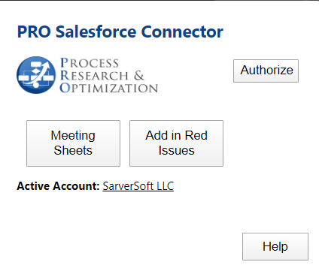

Figure : Pop-up Controller

## Meeting Sheet Generator

To generate a meeting sheet you must go to a “Meeting Set” activity on Salesforce Lightning. It is important to note, that the meeting **MUST** be linked the respective account so the API can automatically pull information from the Account the meeting is tied to. While the meeting sheet generator may run without linking (very unlikely), it would not be able to source all of the required information.

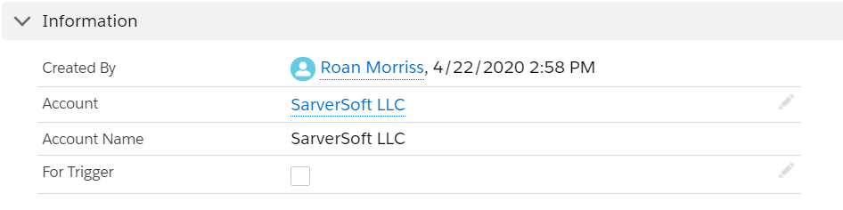

Figure : Linking Accounts

Once the “Meeting Set” activity is ready, click the “Meeting Sheets” button on the Pop-up Controller as seen in Figure 2. If the operation was successful you will be prompted with a popup window allowing you to specify what content you want to fill in the meeting sheet with from salesforce data. Select the appropriate parameters from the Meeting Sheets Options window (see Figure 4). Note that if there are additional participents/Prospects from the Account, their information can be added to the meeting sheet by selecting their names from the section box. Note that only contacts from the actual account are added here. It may take a few seconds for this box to populate once the Meeting Sheets Options window appears.

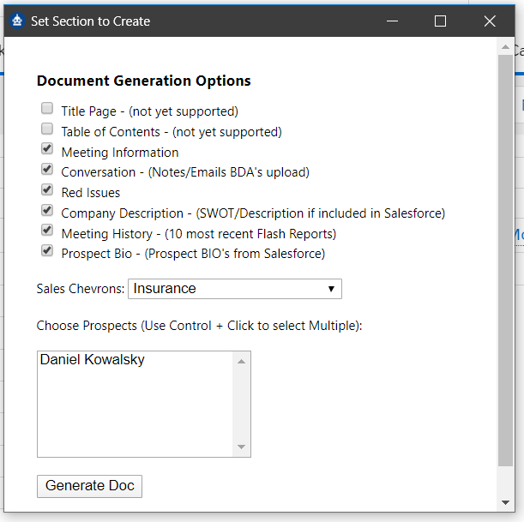

Figure : Meeting Sheets Options

Once the options from Figure 4 have been appropriately selected, click the “Generate Doc” button. A tab will appear with all of the context for the meeting sheets, as a webpage and a .Doc file will automatically download to your computer, and the meeting sheet process if complete minus some minor editing that may be required.

## Red Issue Importer

As part of generating meeting sheets, a BDA must compile a listing of articles about the company. The extension as the ability to automatically import an article directly to salesforce, in the news section of the account. To use the importer, you must first assign an account from salesforce. Go to an account in salesforce lightning and you will see the PROBOT icon at the top of the page (see Figure 5). The next to the badge there will be an Active/Inactive indicator. Click the badge to make the account active, and you will notice the text turn green. You know now the account is active. When browsing the web, to recall the active account simply click on the extension and in the Pop-up Controller window, next to **“Active Account:”** you will see the active account name.

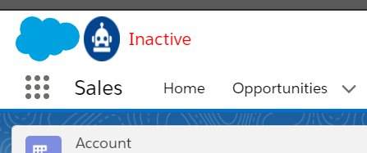

Figure : Active Account Badge

Once the correct account has been activated go to an article online. If the article or part of the article is suitable to add to salesforce simply click on the “Add Red Issue” button from the Pop-up Controller from Figure 2. This will open a new tab which allows the user to edit the context that is imported.

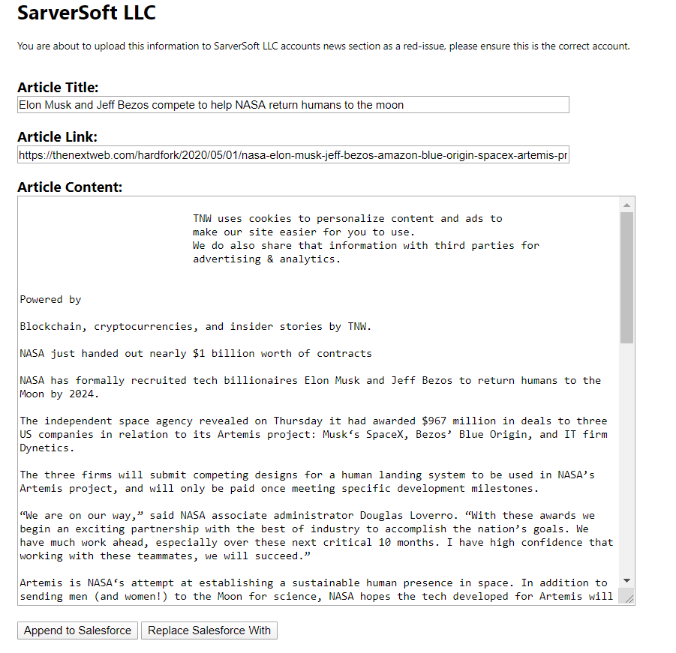

Figure : New Importer Options

Figure 6 shows that options that user can make to the information imported into salesforce. If the importer got the title incorrect or incomplete, please feel free to edit the text. If you want some of the Article content delete the parts you don’t want. If want to append the article to news already in salesforce, click the “Append to Salesforce” button. If the information is outdated in salesforce and you want to replace with newer and relevant information, click the “Replace Salesforce with” button. The tab will close and the action is complete. Refresh the account page in salesforce to see your newly uploaded article.

# Application Acknowledgments and Licenses

To build this application required the use of the JQuery which is avaiaible through the MIT license below:

Copyright JS Foundation and other contributors, https://js.foundation/

Permission is hereby granted, free of charge, to any person obtaining a copy of this software and associated documentation files (the "Software"), to deal in the Software without restriction, including without limitation the rights to use, copy, modify, merge, publish, distribute, sublicense, and/or sell copies of the Software, and to permit persons to whom the Software is furnished to do so, subject to

the following conditions:

The above copyright notice and this permission notice shall be included in all copies or substantial portions of the Software.

THE SOFTWARE IS PROVIDED "AS IS", WITHOUT WARRANTY OF ANY KIND, EXPRESS OR IMPLIED, INCLUDING BUT NOT LIMITED TO THE WARRANTIES OF MERCHANTABILITY, FITNESS FOR A PARTICULAR PURPOSE AND NONINFRINGEMENT. IN NO EVENT SHALL THE AUTHORS OR COPYRIGHT HOLDERS BE LIABLE FOR ANY CLAIM, DAMAGES OR OTHER LIABILITY, WHETHER IN AN ACTION OF CONTRACT, TORT OR OTHERWISE, ARISING FROM, OUT OF OR IN CONNECTION WITH THE SOFTWARE OR THE USE OR OTHER DEALINGS IN THE SOFTWARE.

In setting up the authentication process source code was used from the [ChromeAuth2](https://github.com/whoisjuan/ChromeAuth2) developed by whosisjuan originally forked from jjNford which is copyrighted under the Apache License:

Copyright-2017 2012: Original Author, JJ Ford and Contributor, Juan J Ramirez.

Licensed under the Apache License, Version 2.0 (the "License"); you may not use this file except in compliance with the License.

You may obtain a copy of the License at

http://www.apache.org/licenses/LICENSE-2.0

Unless required by applicable law or agreed to in writing, software distributed under the License is distributed on an "AS IS" BASIS, WITHOUT WARRANTIES OR CONDITIONS OF ANY KIND, either express or implied. See the License for the specific language governing permissions and limitations under the License.

# Version History

## Version 0.7.0

* Secondary Beta Test Release
  + Meeting Sheet formatting Clean up, Dropping one external library for document generation
  + Red Issue importer functional
  + Documentation update
  + Adding additional prospects to meeting sheets
  + Added options to meeting sheet generation
  + Fixed special characters not converting to MS word
  + Removed any company context from the source code

## Version 0.5.0

* Primary beta testing release
* Current functionalities
  + Authenticate rest API using following salesforce’s outline [insert link here]
  + Initial development of popup user interface includes “meeting sheets”, authorization, and help button
  + Meeting sheets developed using lightning force experience only, meeting sheets can only be generated on a “Client Activity” page and nowhere else including the listing of client activities page (individual activities only)