Project Report on

SMART STREET LIGHT

Submission to THE ROBOTICS CLUB - SNIST as a part of INDUCTION'22

TEAM NO – 12



THE ROBOTICS CLUB-SNIST

# SREENIDHI INSTITUTE OF SCIENCE AND TECHNOLOGY

## (AUTONOMOUS)

(Affiliated to JNTU University, Hyderabad)

Yamnampet, Ghatkesar, Hyderabad – 501301.

2022

**CERTIFICATE**

This is the project work titled ‘SMART STREET LIGHT’ by 'Eshwar’, ’P. Madhavi’, ’Satwik Reddy’, ’Varshith Reddy’, ’Ejjigiri Siri Chandana’, ’Veladanda Sai Shiva Sankeerth’. This is a record of the project work carried out by them during the year 2022 as part of INDUCTION’22 under the guidance and supervision of L Yashwanth Rao and Y.Shreya.

**Mr. S. V. REDDY**

**&**

**Mr. BHUVAN PRATHAP ARGHWAL**

**Technical head**

**Mr. Md. NIHAL ASJAD**

**The President of**

**THE ROBOTICS CLUB**

**Dr. A. PURUSHOTHAM**

**Faculty Advisor**

**Mechanical Department**

**DECLARATION**

The project work reported in the present thesis titled “SMART STREET LIGHT” is a record work done by Team “12” in THE ROBOTICS CLUB as a part of INDUCTION'22.

**No part of the thesis is copied from books/ journals/ Internet and wherever the portion is taken ,the same has been duly referred in the text. The report is based on the project work done entirely by TEAM “12” and not copied from any other source.**

**ACKNOWLEDGMENT**

This project report is the outcome of the efforts of many people who have driven our passion to explore into implementation of “SMART STRRET LIGHT”. We have received great guidance, encouragement and support from them and have learned a lot because of their willingness to share their knowledge and experience. Primarily, we would like to express our gratitude to our Joint Secretaries of Technical Affairs, ‘S V REDDY and ‘BHUVAN PRATHAP AGARWAL’. Their guidance has been of immense help in surmounting various hurdles along the path of our goal.

We thank all the members of Executive Body, Technical Advisory Board, Club's Incubation and Competence Committee of The Robotics Club for helping us with crucial parts of the project. We are deeply indebted to Mr. Md. NIHAL ASJAD - The President,

Mr. KARUMURI JAYANTH SIVA MADHAV - The Vice President, Mr. GELLI KUSAL VENKATA SAI SHRAVANTH - SAB Chairman and Ms. RUSHIKA REDDY - General Secretary of THE ROBOTICS CLUB respectively and also every other person who spared their valuable time without any hesitation whenever we wanted.

We also thank our faculty advisor Dr. A. PURUSHOTHAM, Professor, Mechanical Department, who encouraged us during this project by rendering his help when needed.

**Contents Page No**

|  |  |  |
| --- | --- | --- |
| **Chapter 1** | **Introduction** | **6-8** |
| 1.1 | Problem Statement |  |
| 1.2 | Introduction of the project |  |
| 1.3 | Literature Survey |  |
| 1.4 | Organization of project |  |

|  |  |  |
| --- | --- | --- |
| **Chapter 2** | **Architecture** | **9-12** |
| 2.1 | List of Figures |  |
| 2.2 | Components used |  |
| 2.3 | Hardware |  |
| 2.4 | Software |  |

|  |  |  |
| --- | --- | --- |
| **Chapter 3** | **Implementation and Working** | **13** |
| 3.1 | Block Diagram |  |
| 3.2 | Circuit Diagram |  |
| 3.3 | Working |  |
| 3.4 | Flowchart |  |

|  |  |  |
| --- | --- | --- |
| **Chapter 4** | **Experimental Results and Conclusions** | **14-18** |
| 4.1 | Results |  |
| 4.2 | Future Enhancements |  |
| 4.3 | Conclusions |  |

**Source Code 15-18**

**List of Expenses 19**

**ABSTRACT**

**THE ROBOTICS CLUB – SNIST**

**INDUCTION’22**

**TEAM NO - 12**

**The Problem:**

Now a days generally during day time and when there is no vehicle movement at night time, continues ON of street lights on the roads wastes a lot of energy. And the over speeding of the vehicles during night time is the major concern on the highways. As there is a chance of leading to accidents.

**The Teams Approach To The Problem:**

The Smart Street light provides a solution for energy saving which is achieved by sensing an approaching vehicle using the IR sensors and then switching ON a block of street lights ahead of the vehicle with high intensity. As the vehicle passes by, the trailing lights turn OFF automatically during nights. And also the LDR senses the light during daytime and remains the street lights OFF even through vehicle is detected. Thus we save a lot of energy. The smart street light also has addition feature like calculating the speed of the vehicle using IR sensors and displays speed on a LCD display. When the speed is detected more than the predefined speed then an alert is sent to a nearest check post or control room. And a camera module is placed at a streetlight and thus the police can see the vehicle which is over speeding using live streaming.

**Block Diagram:**

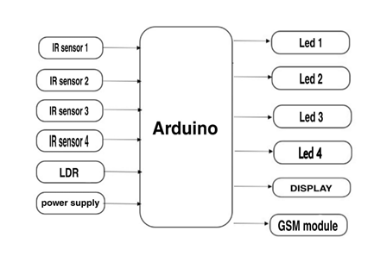

*FIG 1: Block Diagram of Smart Street Light*

**Title of the Project:** THE SMART STREET LIGHT

**What inspired you to select the problem?**

In present generation usage of power is maximum and lots is power is being wasted. Street lights on highways require lots of energy and most of the power is wasted when there is no vehicle detection or movement. And not only power many accidents are occurring due to harsh driving and over speeding. So, to save power for our future generations and to reduce the chances of occurring accidents we came up with an idea of Smart Street light.

**What do you feel is the most innovative part of the problem?**

The most innovative part of our project is IR sensors detect vehicle movement and thus, Next Street light ON when IR sensor of previous street light detect a vehicle. We are using LCD display to show the speed of a vehicle which is been calculated with the help of IR sensors used. If any vehicle crosses its maximum speed it automatically sends an alert to local check post.

**SMART STREET LIGHT**

**Abstract: Now a days, wastage of power is increasing gradually. Near highways during day time or when there is no vehicle movement at night due to continuous glow of light power wastage is maximum. And over speeding of vehicles leads to accidents. By considering all the consequences we came up with an idea of Smart Street Light.**

**Introduction:**

Smart Street light is an automated system which automates the street. The main aim of Smart Street light is to reduce the power consumption when there are no vehicle movements on the road. The Smart Street light will glow when there are vehicles on the road otherwise the lights will remain off. This work shows automatic control of streetlights as a result of which power is saved to an extent. The Smart Street light provides a solution for energy saving which is achieved by sensing an approaching vehicle using the IR sensors and then switching ON a block of street lights ahead of the vehicle. As the vehicle passes by, the trailing lights turn OFF automatically. Thus, we save a lot of energy. So, when there are no vehicles on the highway, then all the lights will remain OFF.

**i)PROBLEM STATEMENT:**

Now a days generally during day time and when there is no vehicle movement at night time, the continuous ON of street lights on the roads wastes a lot of energy. And the over speeding of the vehicles during night time is the major concern on the highways. As there is a chance of leading to accidents.

**ii)LITERATURE SURVEY:**

We all discussed about the problem statement and put out own ideas and changes to bring this small-scale project which can be made fast. We saw multiple videos and had many discussions about Smart Street Light and what the important information and sensible information which will be lost and also be important to store.

**II) Architecture:**

**Components required:**

**Hardware:**

**1.Arduino Mega 2560**

The Arduino Mega 2560 is a microcontroller board based on the ATmega2560. It has 54 digital input/output pins (of which 15 can be used as PWM outputs), 16 analog inputs, 4 UARTs (hardware serial ports), a 16 MHz crystal oscillator, a USB connection, a power jack, an ICSP header, and a reset button.

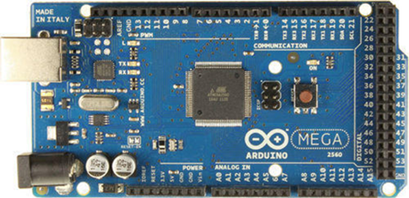

*FIG 2: Image of Arduino Mega 2560*

**2.GSM 900A**

It is a wireless module. SIM 900A deliver voice, SMS, data, fax in a small form factor with low power consumption. It uses 900-1800MHz frequency band and allows user to send/receive mobile calls and SMS.

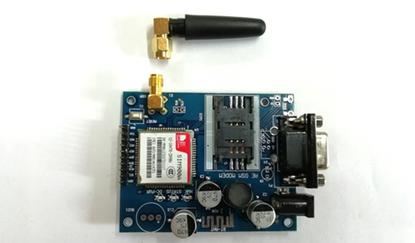

*FIG 3: Image of GSM 900A*

**3.LED**

A Light Emitting Diode (LED) is a semiconductor device, which can emit light when an electric current passes through it. To do this, holes from p-type semiconductors recombine with electrons from n-type semiconductors to produce light.

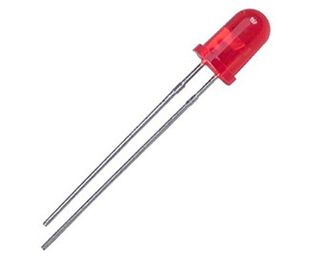

*FIG 4: LED*

**4.IR Sensors**

Infrared detectors (also called infrared sensors or pyro electric detectors) are optoelectronic components and represent the core element of gas analyzers, flame sensors, devices of spectral analysis, as well as non-contact temperature measurement. IR sensors detect the heat radiation (infrared radiation) that changes over time and space due to the movement of people.

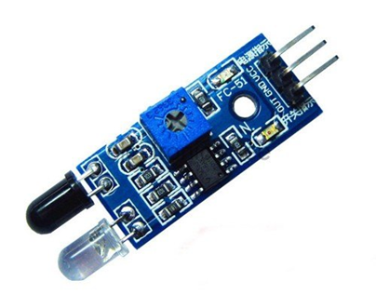

*FIG 5: IR Sensor*

**5.Lithium-ion batteries**

Lithium-ion battery or Li-ion battery is a type of rechargeable battery in which lithium ions move from the negative electrode through an electrolyte to the positive electrode during discharge, and back when charging.

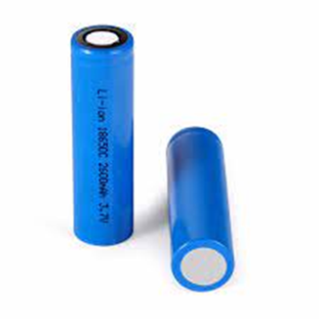

*FIG 6: Li-ion Batteries*

**6.LCD Display**

A liquid-crystal display (LCD) is a flat-panel display or other electronically modulated optical device that uses the light-modulating properties of liquid crystals combined with polarizers. Liquid crystals do not emit light directly, instead using a backlight or reflector to produce images in color or monochrome.

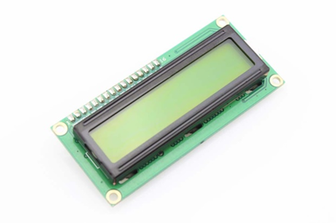

*FIG 7: LCD Display*

**7.ESP 32 Camera Module**

The ESP32-CAM is a small size, low power consumption camera module based on ESP32. It comes with an OV2640 camera and provides onboard TF card slot.

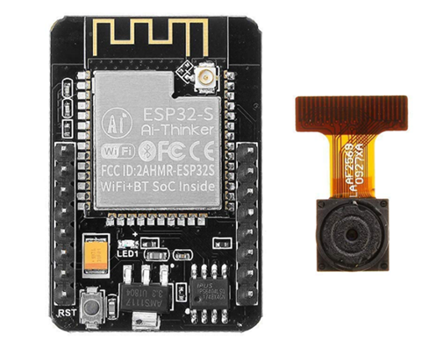

*FIG 8: ESP 32 Camera Module*

**8.Jumper Wires**

These are used to connect the components to pins of Arduino board with the help of connecting pins.

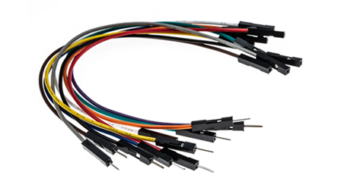

*FIG 9: Image of Jumper Wires*

**9.LDR**

An LDR is a component that has a (variable) resistance that changes with the light intensity that falls upon it. During sunlight LDR exhibits high resistance and it acts as insulator. While during night time it exhibits low resistance hence, it acts as conductor.

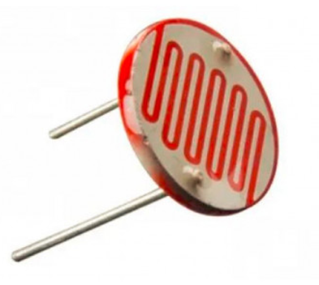

*Fig 10: LDR*

**10.Resistor:** A resistor is a passive two-terminal electrical component that implements electrical resistance as a circuit element. In electronic circuits, resistors are used to reduce current flow, adjust signal levels, to divide voltages, bias active elements, and terminate transmission lines, among other uses. High-power resistors that can dissipate many watts of electrical power as heat may be used as part of motor controls, in power distribution systems, or as test loads for generators. Fixed resistors have resistances that only change slightly with temperature, time or operating voltage

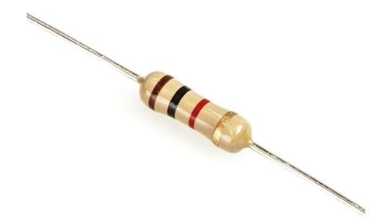

*Fig 11: Resistor*

**11.Bread Board:** A breadboard, solderless breadboard, protoboard, or terminal array board is a construction base used to build semi-permanent prototypes of electronic circuits. Unlike stripboard (Veroboard), breadboards do not require soldering or destruction to tracks and are hence reusable. For this reason, breadboards are also popular with students and in technological education.A variety of electronic systems may be prototyped by using breadboards, from small analog and digital circuits to complete central processing units (CPUs).Compared to more permanent circuit connection methods, modern breadboards have high parasitic capacitance, relatively high resistance, and less reliable connections, which are subject to jostle and physical degradation. Signaling is limited to about 10 MHz, and not everything works properly even well below that frequency.

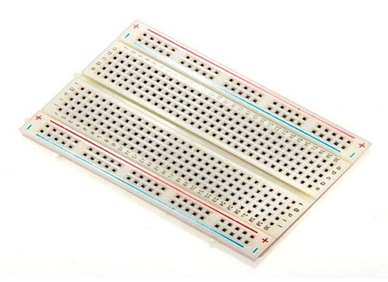

*Fig 12: Bread Board*

**Software:**

**1.ARDUINO IDE**

The Arduino Integrated Development Environment - or Arduino Software (IDE) - contains a text editor for writing code, a message area, a text console, a toolbar with buttons for common functions and a series of menus. It connects to the Arduino hardware to upload programs and communicate with them.

**2.FRITZING**

Fritzing is an open-source initiative to develop amateur or hobby CAD software for the design of electronics hardware, to support designers and artists ready to move from experimenting with a prototype to building a more permanent circuit.

**3.FUSION 360**

Fusion 360 is a cloud-based CAD/CAM tool for collaborative product development. Fusion 360 enables exploration and iteration on product ideas and collaboration within distributed product development team. Fusion 360 combines organic shapes modelling, mechanical design and manufacturing in one comprehensive package.

**IMPLEMENTAION AND WORKING**

**I)BLOCK DIAGRAM**

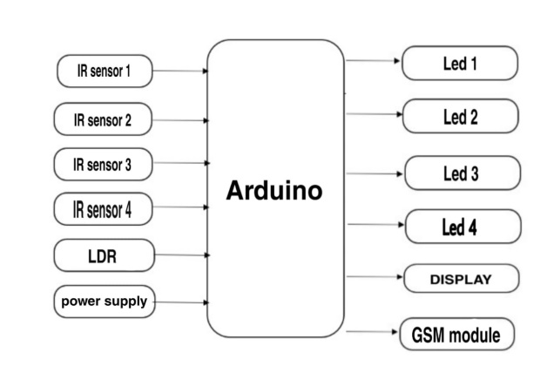

*FIG 11: Block Diagram*

**II)WORKING**

In this project we are using IR sensors, LDR, GSM 900A, LCD Display, Arduino.

During sunlight LDR exhibits high resistance and it acts as insulator. While during night time it exhibits low resistance hence, it acts as conductor. The IR sensor which is placed near first street lights detects when a vehicle comes in the range of IR sensor. When a vehicle is detected, automatically next street light turns ON. When a vehicle is detected at IR sensor 1, it also calculates the speed of the vehicle using distance between two sensors and time taken to cross those two sensors. If a vehicle extends minimum speed limit through GSM 900A an alert is sent to nearby check post.

**III)SIMULATION**

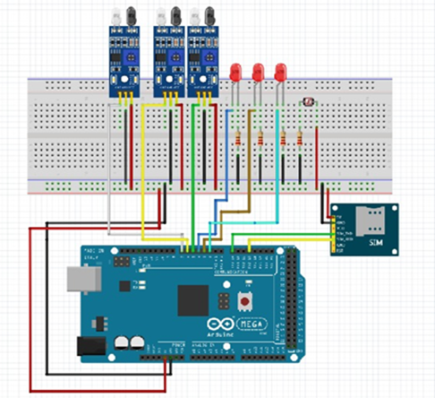

*FIG 14: Circuit Diagram*

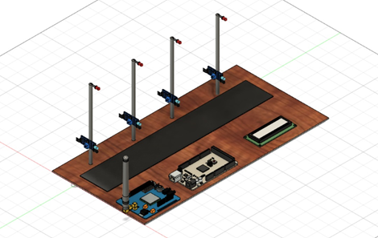

*FIG 15: CAD Design*

**IV. EXPERIMENTAL RESULTS:**

**RESULT**

When a vehicle is detected automatically next street light turns ON and thus it can save lots of power from being wasted. If any vehicle crosses minimum speed it gets displayed on LCD screen and an alert message is sent to local or nearby check post.

**FUTURE ENHANCEMENT**

The smart street light can be further extended by adding ESP 32 Camera Module which shows the vehicle which crosses minimum speed limit. Directly imposing fines by capturing number plate through ESP 32 Camera Module

**CONCLUSION**

Now a days we can see lots of power is been wasted. To save power from being wasted we came up with the idea of Smart Street Light. This also prevents unnecessary wastage of electricity, caused due to manual switching of streetlights when it’s not required. This provides efficient and automatic switching ON OFF street lights using IR sensors. It also sends an alert to local check whenever a vehicle is detected traveling with high speed. Thus it saves power for our future generations and helps in reducing the chances of occurring accidents.

**SOURCE CODE**

int led = 11;

int led1 = 10;

int led2 = 9;

int led3 = 6;

int led4 = 5;

int ldr = A0;

int x1, x2, x3, x4,x5;

void setup()

{

Serial.begin (115200);

pinMode (led,OUTPUT);

pinMode (led1,OUTPUT);

pinMode (led2,OUTPUT);

pinMode (led3,OUTPUT);

pinMode (led4,OUTPUT);

pinMode (ldr,INPUT);

}

void loop()

{

int ldrStatus = analogRead (ldr);

if (ldrStatus <=300)

{

if (analogRead(A1)<500) // IR 1 CODE

{

x1=0;

x2=1;

digitalWrite(led,HIGH);

digitalWrite(led1,HIGH);

delay(100);// micro second

}

else

{

if(x1==0){

digitalWrite(led,HIGH);

analogWrite(led,255/5);

delay(50);

}

if(x2==1){

digitalWrite(led1,HIGH);

analogWrite(led1,255/5);

delay(50);

}

}

if (analogRead(A2)<500) // IR 2 CODE

{

x2=0;

x3=1;

digitalWrite(led1,HIGH);

digitalWrite(led2,HIGH);

delay(100);// micro second

}

else

{

if(x2==0)

{

digitalWrite(led1,HIGH);

analogWrite(led1,255/5);

delay(50);

}

if(x3==1)

{

digitalWrite(led2,HIGH);

analogWrite(led2,255/5);

delay(50);

}

}

if (analogRead(A3)<500) // IR 3 CODE

{

x3=0;

x4=1;

digitalWrite(led2,HIGH);

digitalWrite(led3,HIGH);

delay(100);// micro second

}

else

{

if(x3==0)

{

digitalWrite(led2,HIGH);

analogWrite(led2,255/5);

delay(50);

}

if(x4==1)

{

digitalWrite(led3,HIGH);

analogWrite(led3,255/5);

delay(50);

}

}

if (analogRead(A4)<500) // IR 4 CODE

{

x4=0;

x5=1;

digitalWrite(led3,HIGH);

digitalWrite(led4,HIGH);

delay(100);// micro second

}

else

{

if(x4==0){

digitalWrite(led3,HIGH);

analogWrite(led3,255/5);

delay(50);

}

if(x5==1){

digitalWrite(led4,HIGH);

analogWrite(led4,255/5);

delay(50);

}

}

if (analogRead(A5)<500) // IR 5 CODE

{

x5=0;

digitalWrite(led4,HIGH);

delay(100);// micro second

}

else

{

if(x5==0){

digitalWrite(led4,HIGH);

analogWrite(led4,255/5);

delay(50);

}

}

}

else

{

digitalWrite(led, LOW);

digitalWrite(led1, LOW);

digitalWrite(led2, LOW);

digitalWrite(led3, LOW);

digitalWrite(led4, LOW);

}}

|  |  |  |
| --- | --- | --- |
| **Sl No.** | **Components** | **Cost** |
| 01. | Arduino mega 2560 | 1610 |
| 02. | GSM 900A | 875 |
| 03. | LED | 6 |
| 04. | LCD Display | 290 |
| 05. | Resistors | 20 |
| 06. | LDR | 15 |
| 07 | I2C | 80 |
| 08. | IR SENSORS | 210 |
| 09. | Jumper Wires | 115 |
| 10. | Li-ion Batteries | 150 |
| 11. | Bread Board | 65 |
|  | **Total** | **3436** |

|  |  |
| --- | --- |
| MEMBERS | SCORE:  MECH: ELE: PROG: |
|  | |  |  |  | | --- | --- | --- | |  |  |  | |
|  |
|  |
|  |
|  |
|  |
|  |

|  |
| --- |
| REMARKS: |