INSTALACIÓN DE ODOO

1.Hacemos un sudo apt update y sudo apt install git python3-pip build-essential wget python3-dev python3-venv python3-wheel libfreetype6-dev libxml2-dev libzip-dev libldap2-dev libsasl2-dev python3-setuptools node-less libjpeg-dev zlib1g-dev libpq-dev libxslt1-dev libldap2-dev libtiff5-dev libjpeg8-dev libopenjp2-7-dev liblcms2-dev libwebp-dev libharfbuzz-dev libfribidi-dev libxcb1-dev libpq-dev.
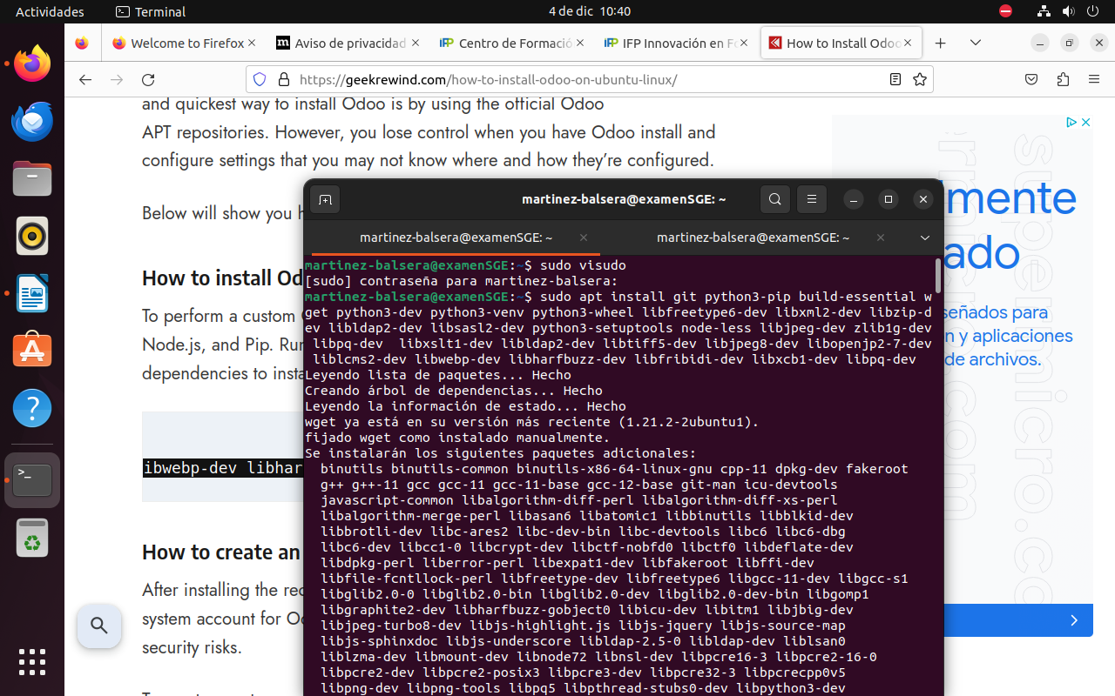
2.sudo useradd -m -d /opt/odoo -U -r -s /bin/bash odoo

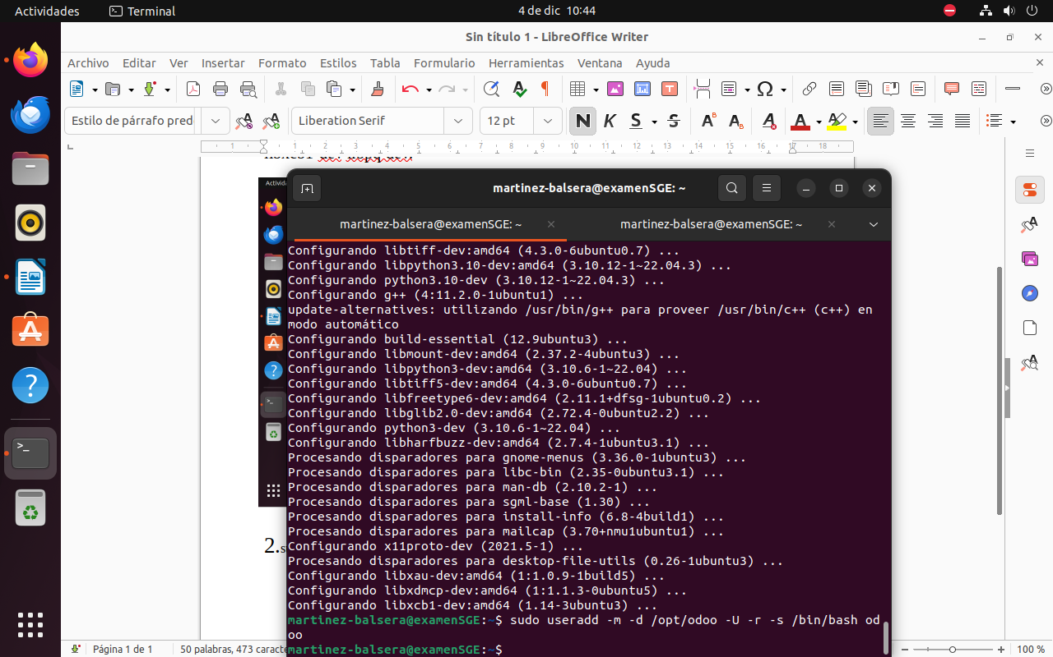

3.sudo apt install postgresql

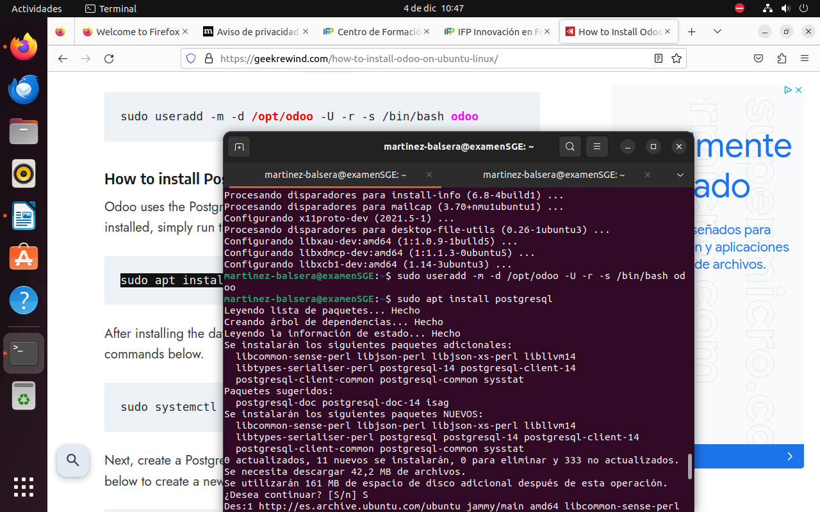

4.sudo systemctl enable --now postgresql.service

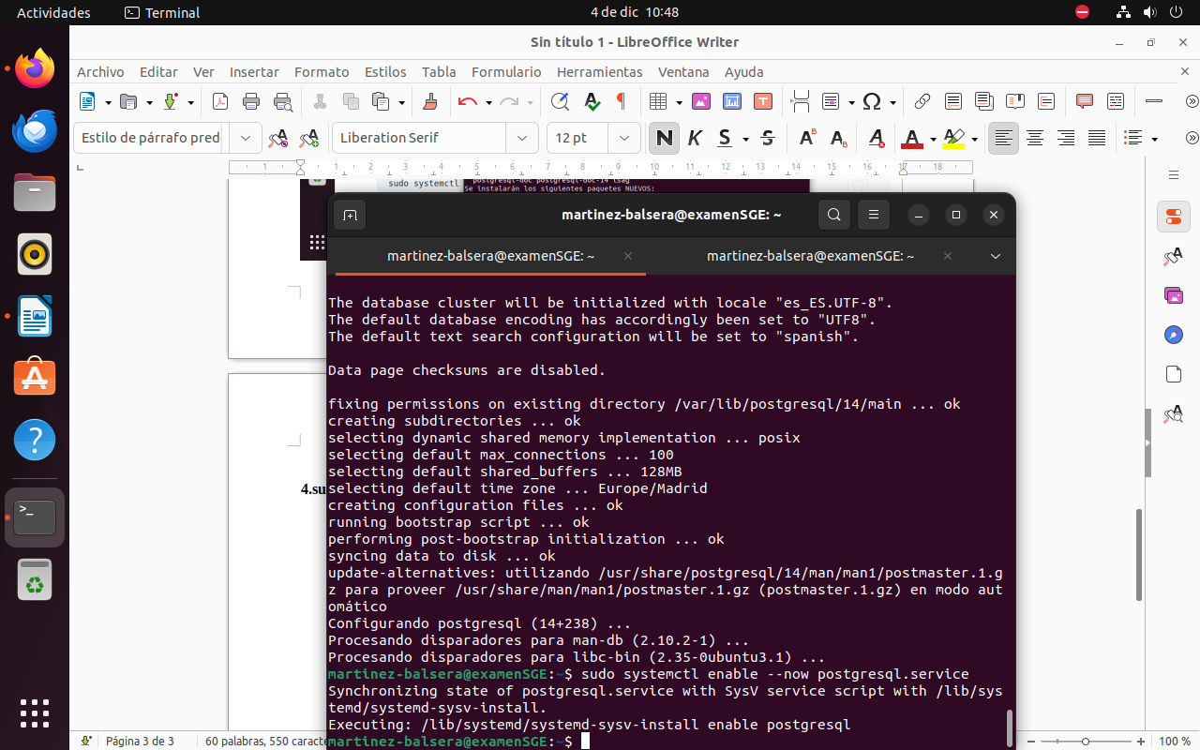
5.sudo su - postgres -c "createuser -s odoodbuser"

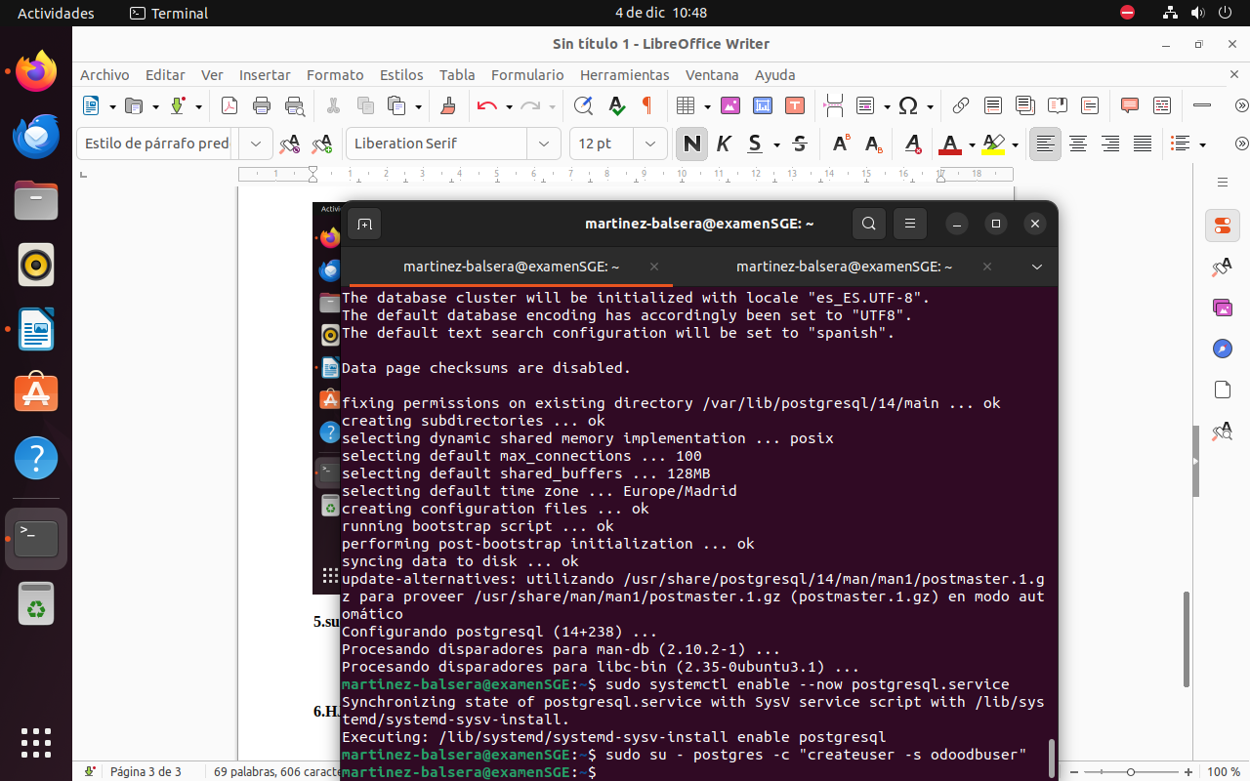

6.sudo apt update && sudo install wget

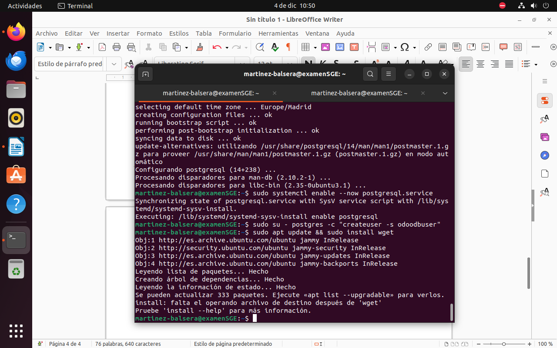

7.wget https://github.com/wkhtmltopdf/packaging/releases/download/0.12.6.1-2/wkhtmltox_0.12.6.1-2.jammy_amd64.deb
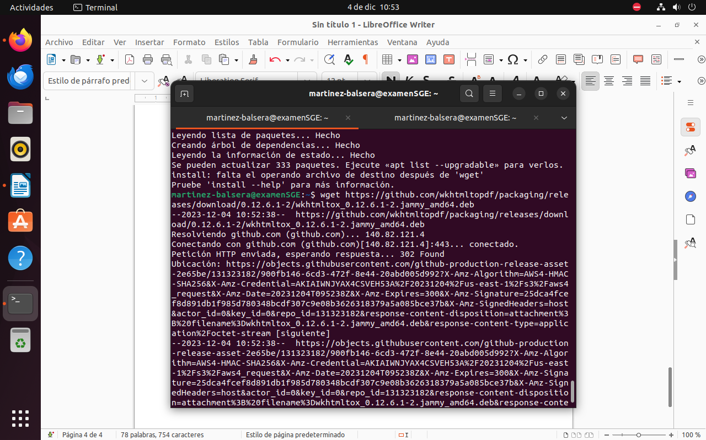

8.sudo apt install -f ./wkhtmltox_0.12.6.1-2.jammy_amd64.deb

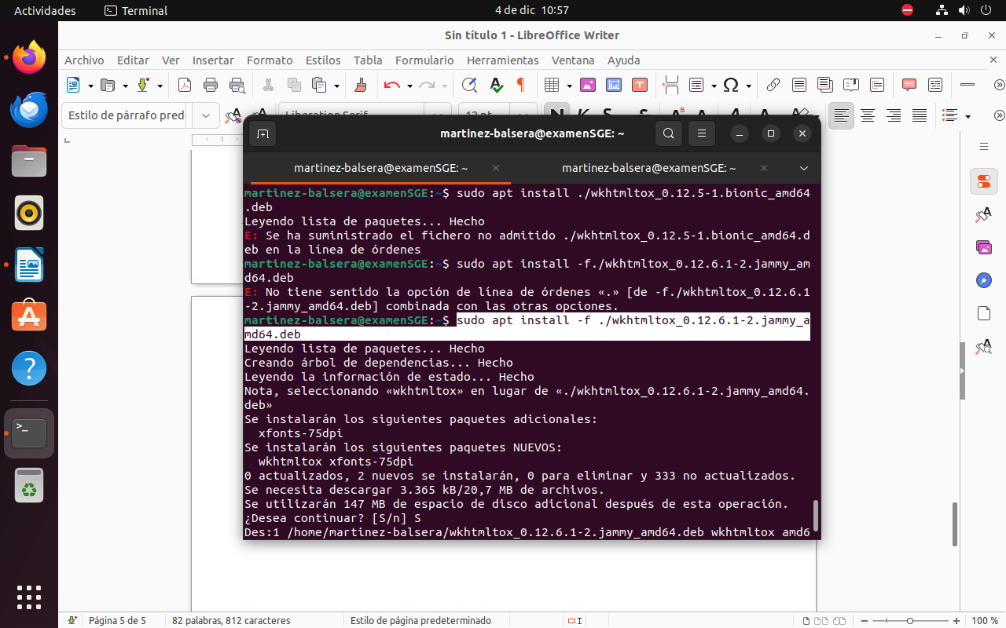
9.sudo su – odoo
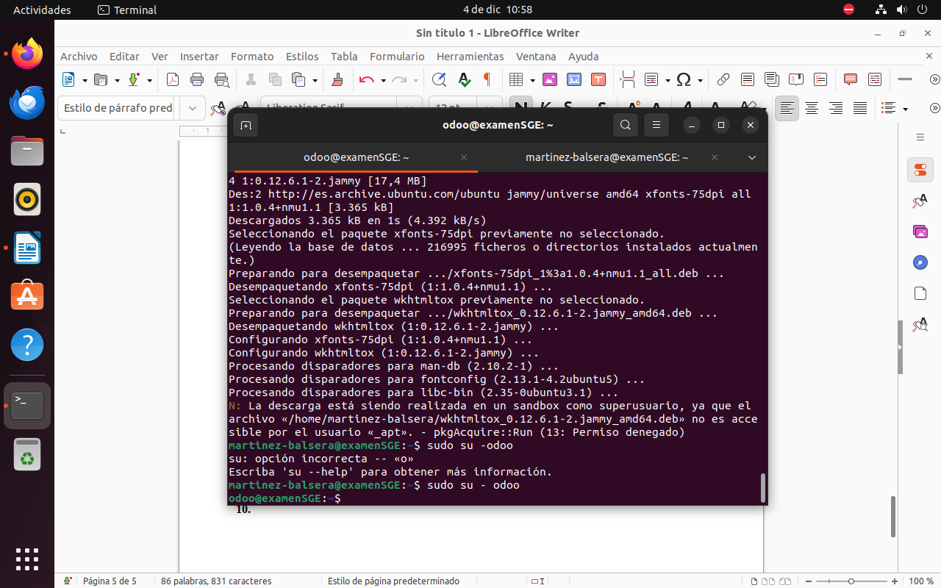

10.git clone https://www.github.com/odoo/odoo --depth 1 --branch 15.0 /opt/odoo/odoo
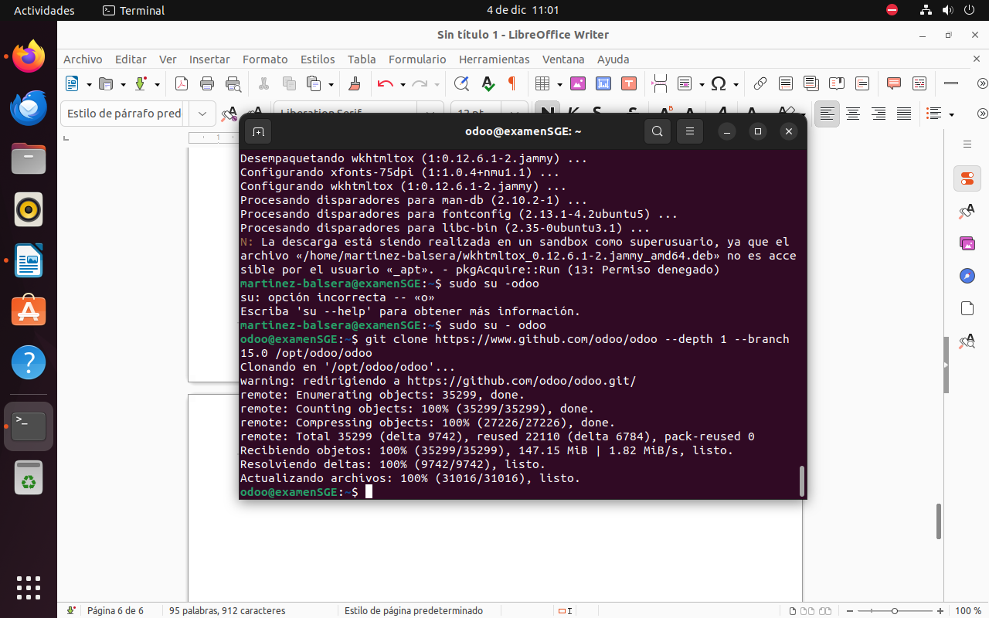
11.cd /opt/odoo
python3 -m venv odoo-venv
source odoo-venv/bin/activate
pip3 install wheel
pip install python-ldap
pip3 install -r odoo/requirements.txt
deactivate

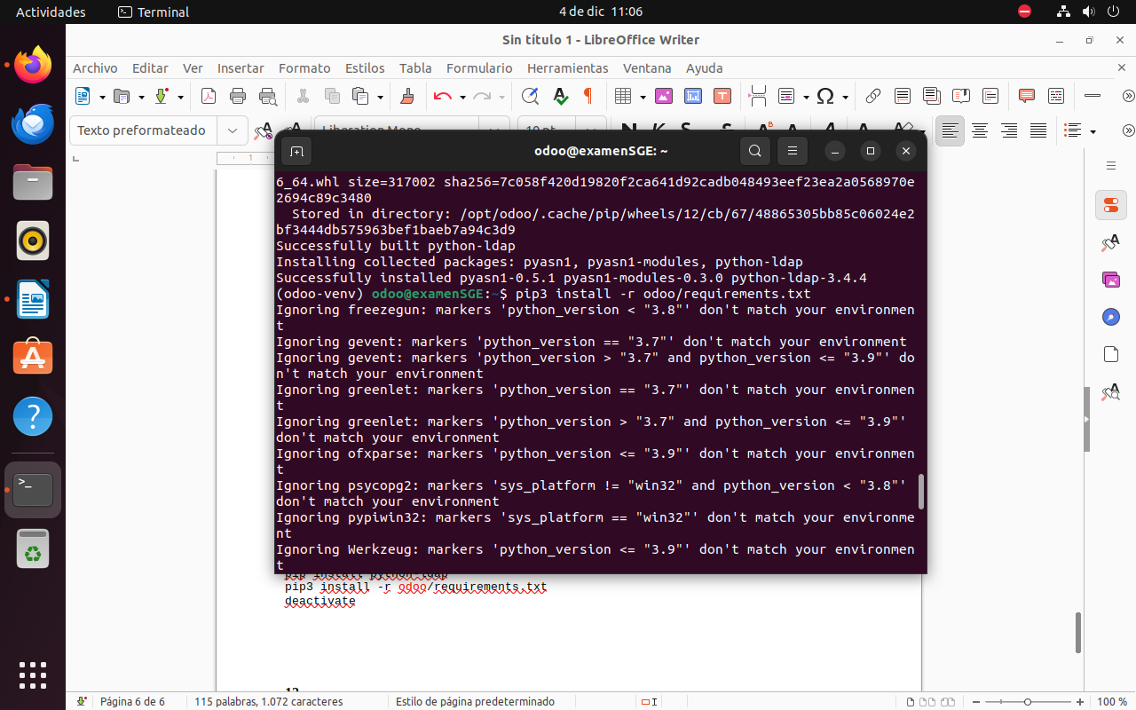
12.mkdir /opt/odoo/odoo-custom-addons
exit
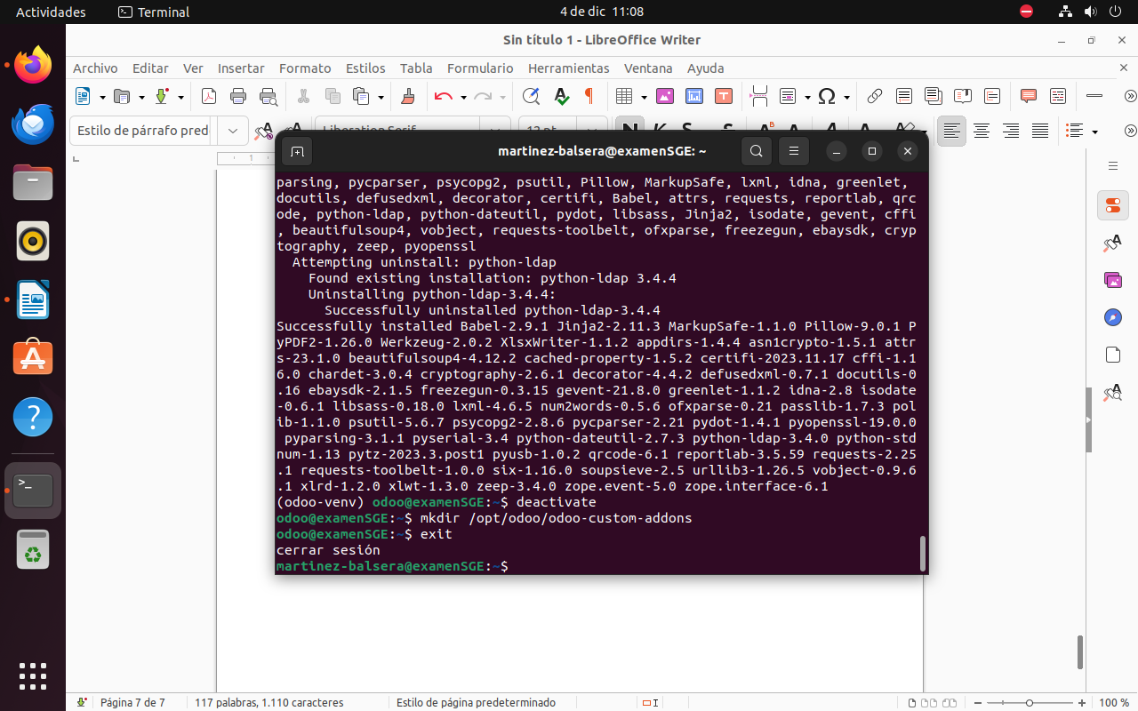

13.sudo nano /etc/odoo.conf
Y pegar dentro

[options]
; This is the password that allows database operations:
admin_passwd = type_new_password_here
db_host = False
db_port = False
db_user = odoodbuser
db_password = False
addons_path = /opt/odoo/odoo/addons,/opt/odoo/odoo-custom-addons

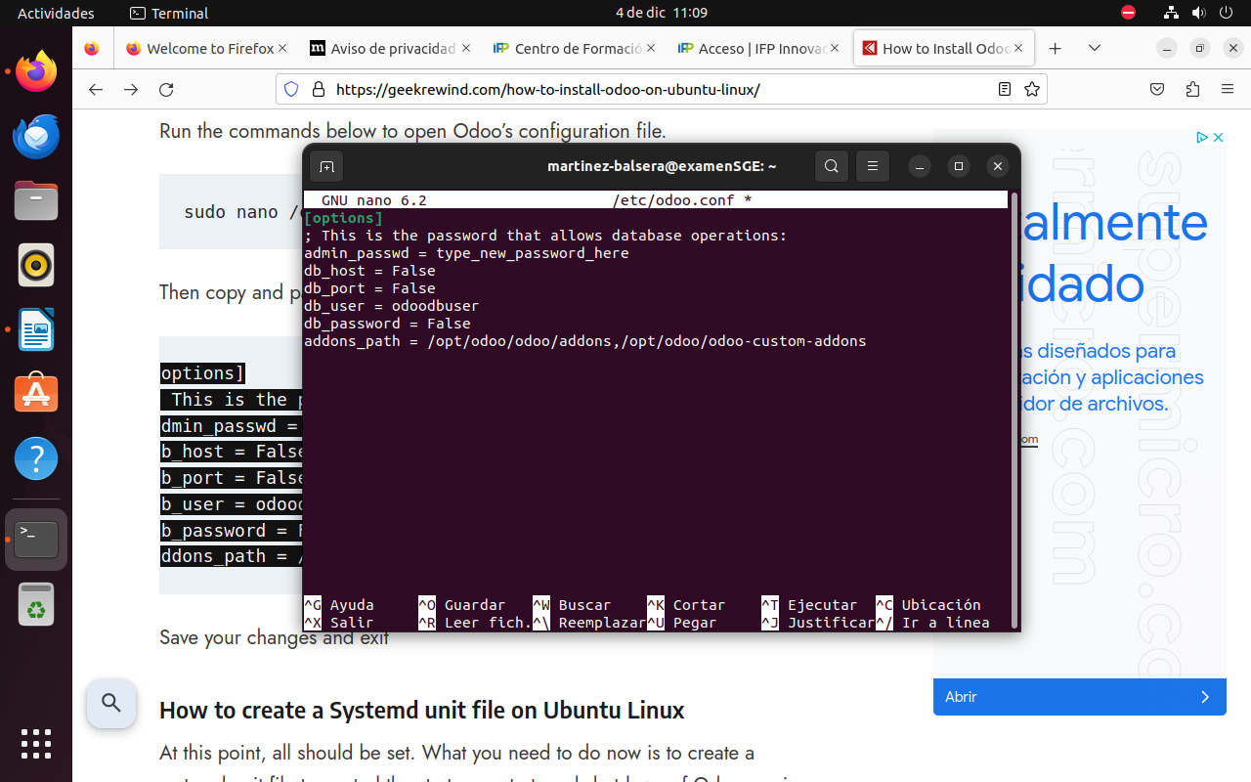

14.sudo nano /etc/systemd/system/odoo.service

[Unit]
Description=Odoo
Requires=postgresql.service
After=network.target postgresql.service

[Service]
Type=simple
SyslogIdentifier=odoo
PermissionsStartOnly=true
User=odoo
Group=odoo
ExecStart=/opt/odoo/odoo-venv/bin/python3 /opt/odoo/odoo/odoo-bin -c /etc/odoo.conf
StandardOutput=journal+console

[Install]
WantedBy=multi-user.target
sudo systemctl daemon-reload
sudo systemctl enable --now odoo

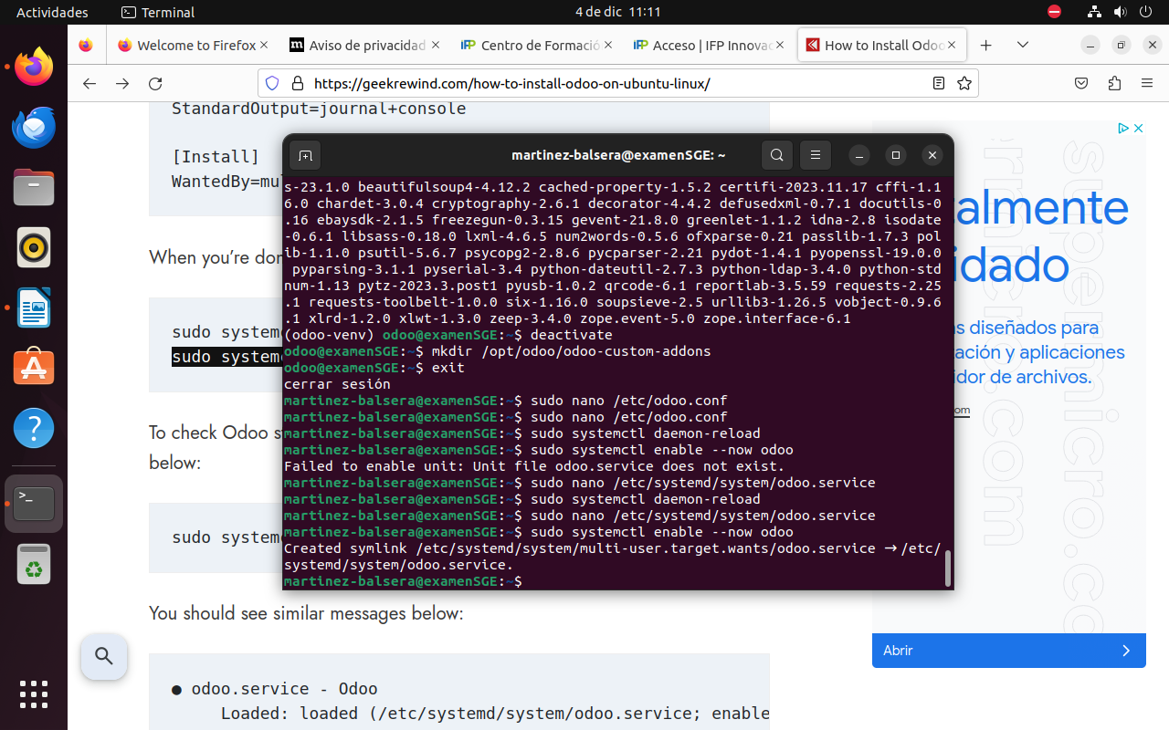

15.sudo systemctl status odoo

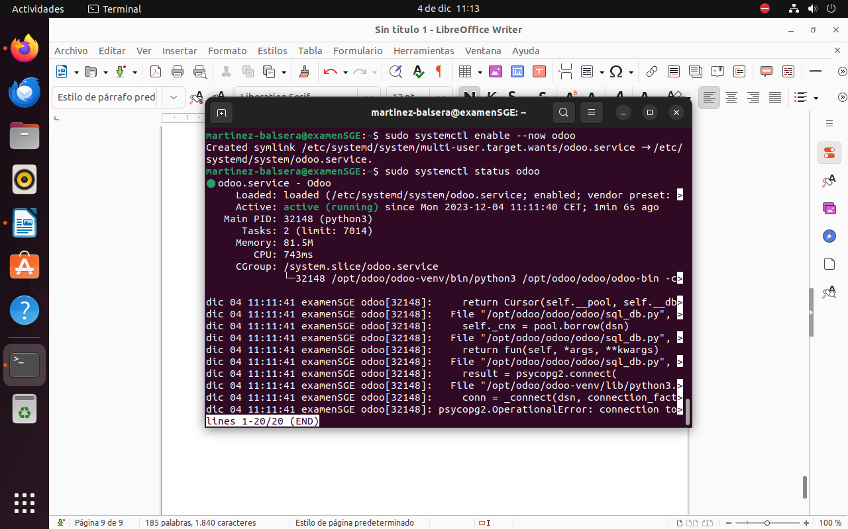
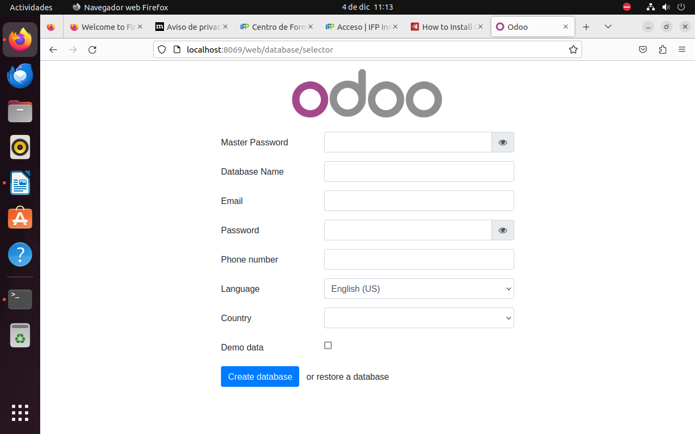
16.https://github.com/TheRockex/examen-odoo-alejandro-martinez

