GITHUB

1.GIT CLONE
2.GIT COMMIT –AMEND
3.GIT BRANCH GT-README
4.LOS NANOS DEL README
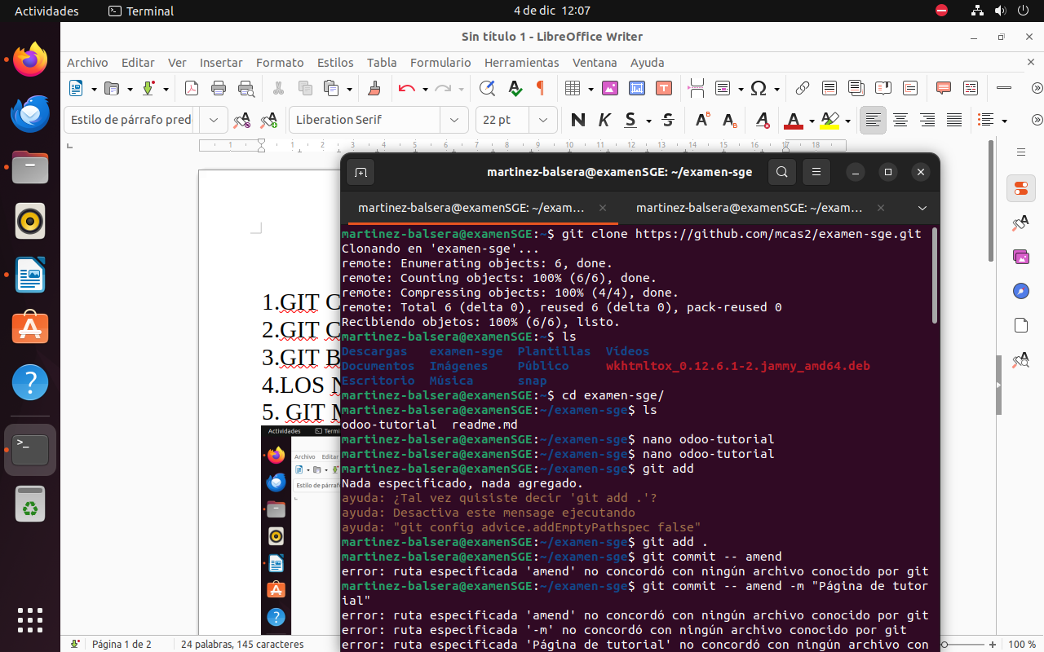
5. GIT MERGE GT-README
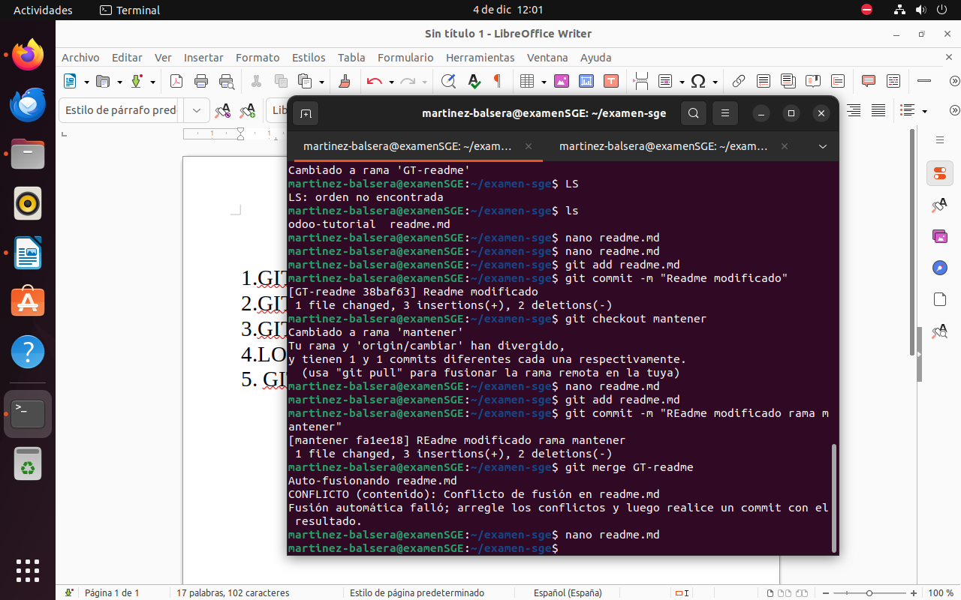
6.commit -m “Version final”
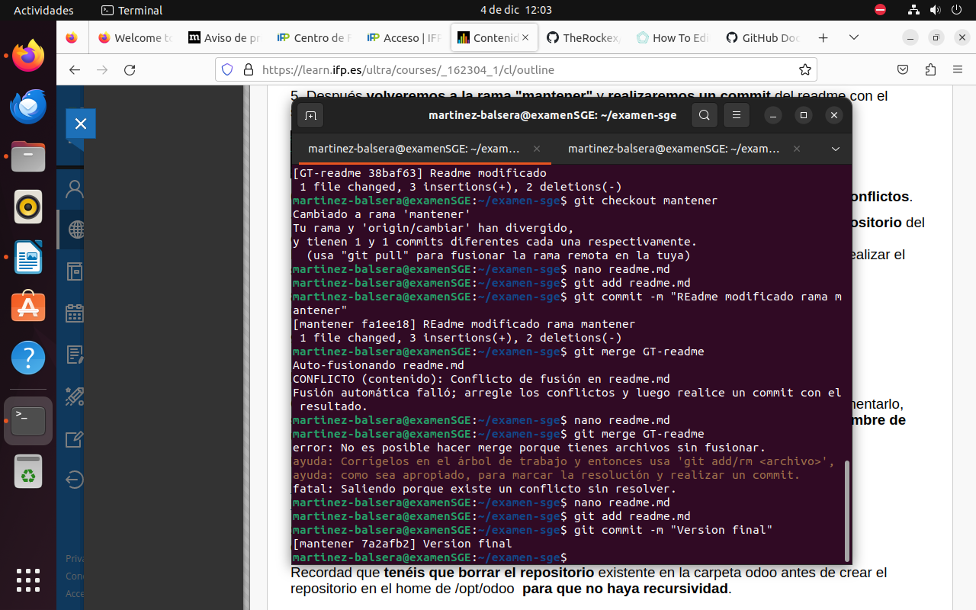
7.subirlo al git
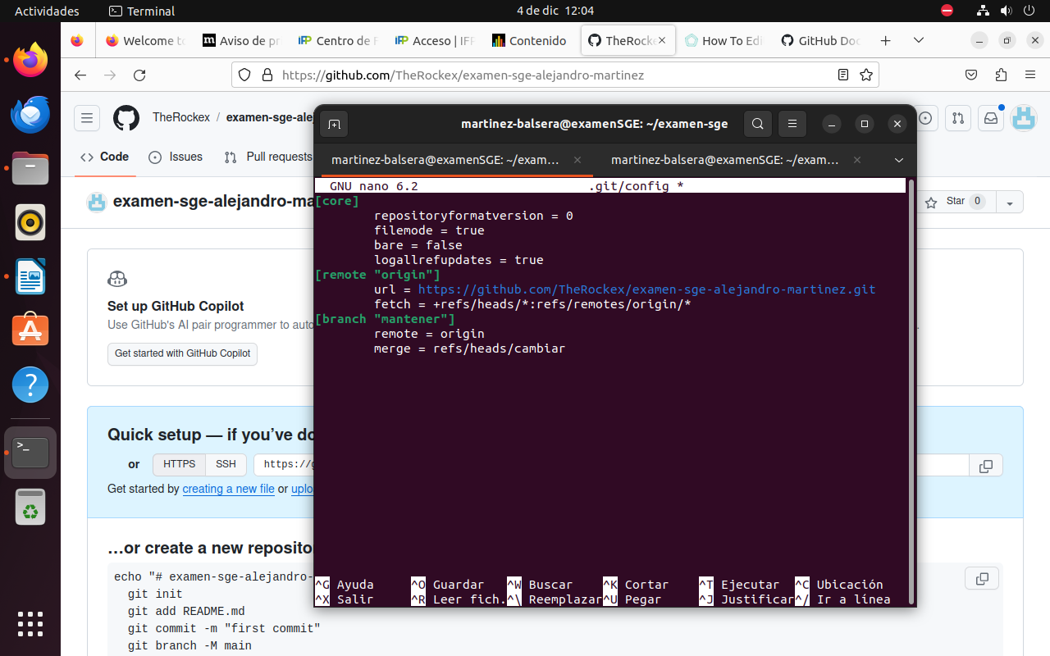
https://github.com/TheRockex/examen-sge-alejandro-martinez.git

