# THE PROJECT BUDGET

|  |  |
| --- | --- |
| Juan Manuel Vargas Rabbit | JM |
| José Luis Corona Huerta | JL |
| Joanna Elizabeth Guerrero Campos | JE |
| Rogelio Almanza Herrejón | RA |

|  |  |  |  |  |
| --- | --- | --- | --- | --- |
| STAGE | ACTIVITY | RESPONSIBLE | HOURS | WAGES |
| PROJECT PLANNING | Project Charter | RA | 1 | $ 124.68 |
| Meeting minutes | JE | 7 | $ 872.76 |
| Lifecycle | JE | 1 | $ 124.68 |
| Proyect Plan | JL / JM | 5 | $ 328 / $ 328 |
| ANALYSIS | Requirements Management | JE | 2 | $ 112.50 |
| Define data collection techniques | JE | 1 | $ 65.62 |
| Identify system processes | JE | 2 | $ 131.24 |
| Identify functional requirements | JE | 2 | $ 131.24 |
| Identify non-functional requirements | JE | 2 | $ 131.24 |
| Describe the requirements | JE | 2 | $ 131.24 |
| Evaluate requirements | JM | 2 | $ 225.00 |
| Prioritizing requirements | JM | 2 | $ 225.00 |
| Assign to the development of software requirements. | RA | 2 | $ 225.00 |
| Manage changes in requirements | JM | 1 | $ 112.50 |
| DESIGN | Use cases | RA | 2 | $ 249.68 |
| Sequence Diagrams | RA | 2 | $ 249.36 |
| Class diagrams | RA | 2 | $ 249.36 |
| ER diagram | RA | 2 | $ 249.36 |
| relational diagram | RA | 2 | $ 249.36 |
| Maquetación | RA | 6 | $ 748.08 |
| Navigation map | RA | 2 | $ 249.36 |
| Booklets | RA | 6 | $ 748.08 |
| Product image creation and editing | JE | 4 | 264484 |
| DEVELOPMENT | Encode database | JM | 2 | $ 131.24 |
| Index module | JM | 2 | $ 131.24 |
| Module philosophy | JM | 2 | $ 131.24 |
| Module products | JM | 3 | $ 196.68 |
| FAQ module | RA | 3 | $ 196.86 |
| module comments | RA | 2 | $ 131.24 |
| cenos module | RA | 2 | $ 131.24 |
| module register | RA. | 2 | $ 131.24 |
| User module | JM | 3 | $ 196.68 |
| TESTS | Unit tests | JL | 2 | $ 175.00 |
| Testing module | JL | 2 | $ 175.00 |
| System Tests | JL | 2 | $ 175.00 |
| Quality Testing | JL | 2 | $ 175.00 |
| IMPLEMENTATION | Selecting hosting | JL | 1 | $ 65.62 |
| Riding the application | JM | 3 | $ 337.50 |
| System Tests | JL | 4 | $ 262.48 |
| END OF PROJECT | Letter of Acceptance | RA | 1 | $ 112.50 |
| Training | RA | 4 | $ 450 |
| Acata project closure | RA | 1 | $ 112.50 |
| Performance evaluation | RA | 3 | $ 337.50 |
| Release resources | RA | 1 | $ 112.50 |
| Learned lessons | RA | 1 | $ 112.50 |
| Delivery of documentation and presentation | RA | 1 | $ 112.50 |
| Final report | RA | 1 | $ 112.50 |
|  | | **Total:** | | $ 8072.64 |

|  |  |  |
| --- | --- | --- |
| materials | cost | Total |
| Flights | Person $ 8 | $ 6720 |
| Stationery | Sheet packs $ 60  8 $ 5 pen  Print $ .50  Other $ 60 | $ 170 |
| Light | Monthly $ 75 | $ 300 |
| Water | Monthly $ 50 | $ 200 |
| USB memory | 4 memories 16g $ 170 c / u | $ 680 |
| Internet | Monthly $ 349 | $ 1396 |
| Mobile calling | $ 200 per person per month | $ 3200 |
|  |  | $ 12,666 |
| Total | | 23396.46 |
|  | |

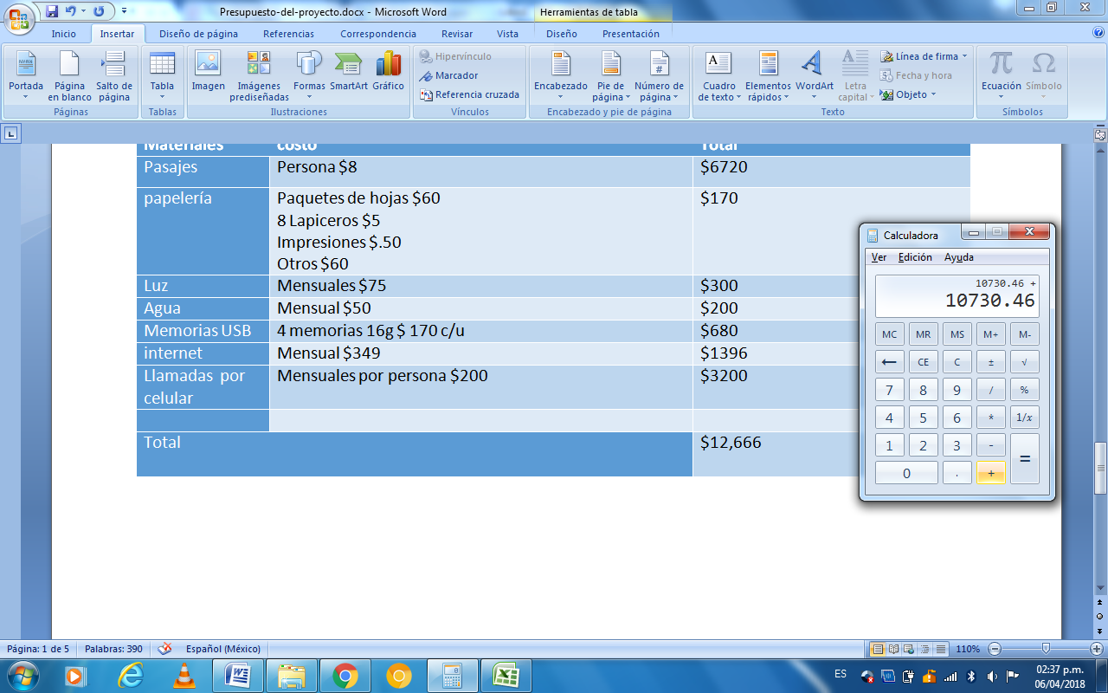

Reference information: https://sg.com.mx/buzz/reporte-salarios-y-mejores-empresas-2017