Myuart_reg.v test

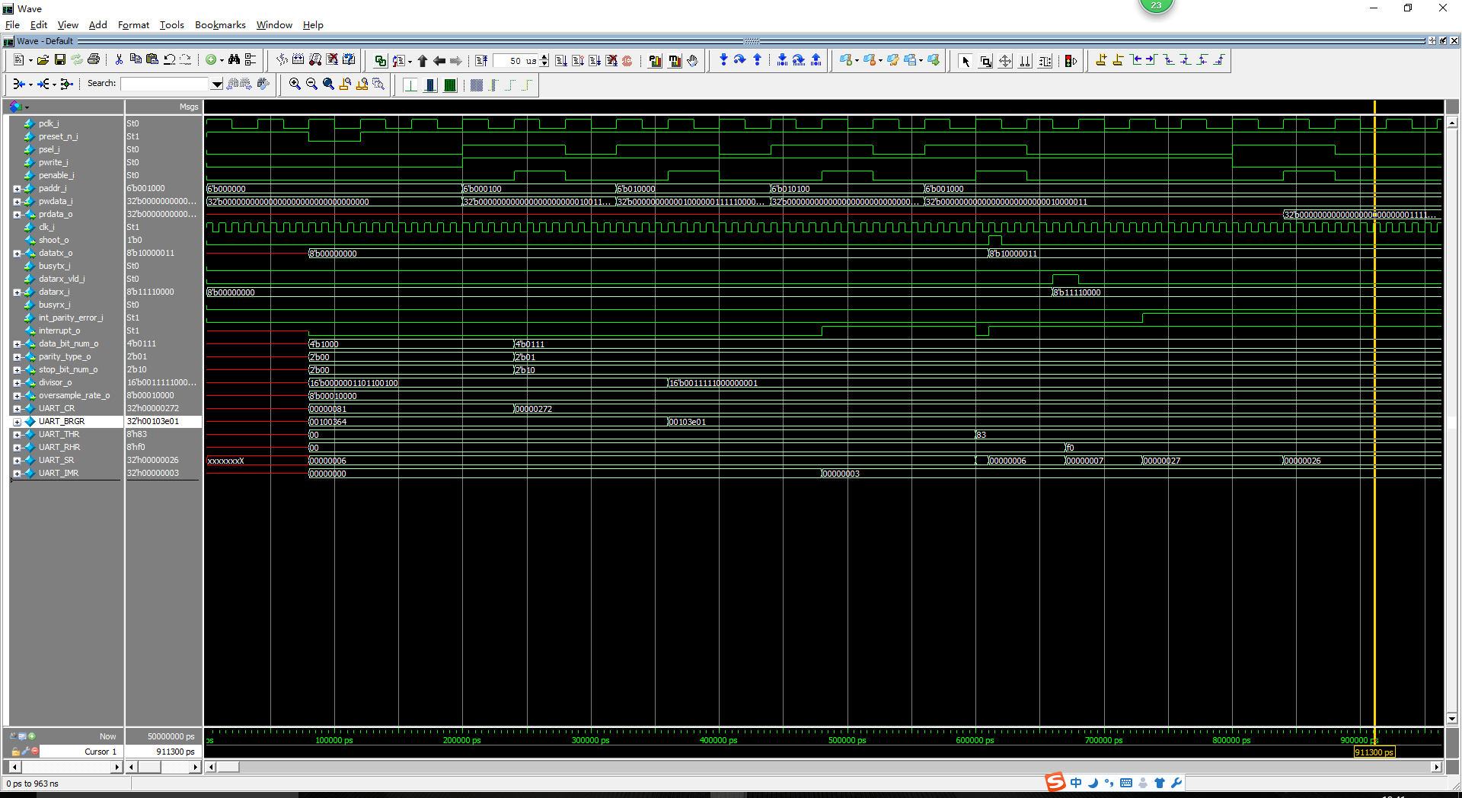

Myuart.v test

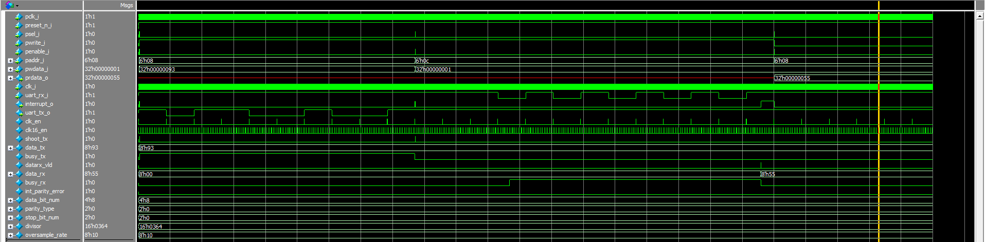

Reset -> APB write IMR -> APB write THR -> APB write SR (W1C) -> uart rx input -> APB read RHR