------------------------------------------------------------TABLES----------------------------------------------------------------

create table orders (o_id int primary key, cust_id int, o_date date, status varchar(50), p_id int, quantity int, total_price numeric );

create table customer (cust_id int primary key,cust_name varchar(50),cust_city varchar(50), email varchar(50),ph_no numeric,gender varchar(10));

create table catagory (cat_id int primary key,cat_name varchar(10));

create table product (p_id int primary key ,cat_id int ,p_name varchar(50), price numeric, size varchar(10), color varchar(20),brand varchar(50), material varchar(30),stock_quantity int, rating numeric(2,1));

**-----------------------------------------------------INSERT QUERY-------------**------------------------------------------------

insert into customer values(1,'Rohit Sharma','Ahmedabad','Rohit45@gmail',9855552533,'Male'),

(2,'Riya Shah','Mumbai','Riya22@gmail',9876543210,'Female'),

(3,'Virat Kohli','Surat','Virat18@gamil',9362581470,'Male'),

(4,'Shreyas Iyer','Pune','Shreyas19@gamil',9352581470,'Male'),

(5,'Axar Patel','Surat','Axar66@gamil',9392588470,'Male'),

(6,'Jiya Patel','Vapi','Jiya26@gmail',9876223210,'Female'),

(7'Shreya Sharma','Baroda','Riya22@gmail',9321654870,'Female'),

(8,'Kartik Aaryan','Ahmedabad','Kartik555@gamil',9214581470,'Male'),

(9,'Tara Sutaria','Surat','Tara45@gamil',9352551470,'Female'),

(10,'Shefali Verma','Baroda','Shefali75@gamil',9352542870,'Female'),

(11,'Hritik Roshan','Vapi','Hritik585@gamil',9224581000,'Male'),

(12,'Sara Tendulkar','Mumbai','Sara75@gamil',9352444470,'Female'),

(13,'Shubman Gill','Mumbai','Gill77@gamil',9224581100,'Male'),

(14,'Daya Gada','Surat','Daya664@gamil',9355874470,'Female'),

(15,'Kriti Sanon','Pune','Kriti554@gamil',7894561230,'Female');

insert into product values(1,1,'Shirt',500,'S','Black','H&M','Cotton',5,4.6),

(2,1,'Shirt',500,'L','Black','H&M','Cotton',8,4.6),

(3,1,'Shirt',600,'S','Red','H&M','Cotton',4,4.6),

(4,1,'Shirt',600,'L','Red','H&M','Cotton',9,4.6),

(5,2,'Top',700,'S','Pink','Zara','Polyester',5,4.8),

(6,2,'Top',700,'L','Pink','Zara','Polyester',8,4.8),

(7,1,'Jeans',900,'S','Blue','Max','Jeans',12,3.9),

(8,1,'Jeans',900,'L','Blue','Max','Jeans',14,3.9),

(9,2,'Jeans',850,'S','Black','Ketch','Jeans',8,4.2),

(10,2,'Jeans',850,'L','Black','Ketch','Jeans',11,4.2),

(11,1,'T-shirt',450,'S','White','Zudio','Rayon',3,3.9),

(12,1,'T-shirt',450,'L','White','Zudio','Rayon',7,3.9),

(13,2,'T-shirt',650,'S','Peach','Gap','Polyester',5,4.2),

(14,2,'T-shirt',650,'L','Peach','Gap','Polyester',9,4.2),

(15,1,'Kurta',1000,'S','Orange','Anouk','Cotton',9,4.3),

(16,1,'Kurta',1000,'L','Orange','Anouk','Cotton',4,4.3),

(17,1,'Kurta',500,'S','Blue','Fubar','Cotton',15,4.5),

(18,1,'Kurta',500,'L','Blue','Fubar','Cotton',12,4.5),

(19,2,'Saree',800,'S','Magenta','Kalini','Silk',13,4.4),

(20,2,'Saree',800,'L','Magenta','Kalini','Silk',14,4.4),

(21,2,'Saree',1500,'S','Black','Taavi','Arganza',19,4.8),

(22,2,'Saree',1500,'L','Black','Taavi','Arganza',17,4.8),

(23,2,'Co-ord',950,'S','Wine','Griva','Lyara',13,3.3),

(24,2,'Co-ord',950,'L','Wine','Griva','Lyara',13,3.3),

(25,1,'Co-ord',1100,'S','Green','Bani','Rayon',4,2.3),

(26,1,'Co-ord',1100,'L','Green','Bani','Rayon',4,2.3),

(27,1,'Jacket',750,'S','Blue','Levis','Denim',7,4.7),

(28,1,'Jacket',750,'L','Blue','Levis','Denim',5,4.7),

(29,2,'Jacket',980,'S','Brown','Diwaah','Polyester',2,4.0),

(30,2,'Jacket',980,'L','Brown','Diwaah','Polyester',8,4.0);

insert into catagory values(1,'Male'),(2,'Female');

insert into orders values(1,1,'10-03-2023','Placed',7,1,900),

(2,3,'2023-10-01','Placed',25,2,2200),

(3,14,'2023-09-25','Placed',19,1,800),

(4,8,'2023-09-20','Placed',27,1,750),

(5,4,'2023-08-06','Delivered',1,2,1000),

(6,8,'2023-07-22','Delivered',12,1,450),

(7,10,'2023-06-21','Delivered',23,1,950),

(8,2,'2023-05-05','Delivered',5,2,1400);

---------------------------------------FUNCTIONS & PROCEDURES---------------------------------------------------------

create or replace procedure quantity_lessthan (q int) as

$$

declare

a_product product.p_name%type;

a_quantity int;

a_id int;

a1 cursor for select p_id,p_name,stock_quantity from product where stock_quantity<=q;

begin

raise notice 'id name quantity';

open a1;

loop

fetch a1 into a_id,a_product,a_quantity;

exit when not found;

raise notice '% , % , %',a_id,a_product,a_quantity;

end loop;

close a1;

end;

$$

language plpgsql;

call quantity_lessthan(3);

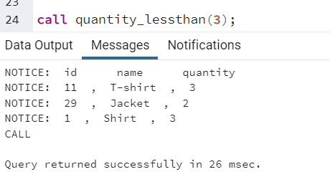

create or replace procedure buy_ (a_cid int,a_pid int,q int,a_oid int) as

$$

declare

c1_pid int;

a_stock int;

a_price numeric;

begin

select stock_quantity,price into a_stock,a_price from product where p_id=a_pid;

if a_stock>q then

insert into orders values (a_oid,a_cid, current_date, 'placed',a_pid,q,a_price*q);

update product set stock_quantity=stock_quantity-q where p_id=a_pid;

raise notice 'order succesfully placed ';

else

raise notice 'insufficient stock !!';

end if;

end;

$$

language plpgsql;

call buy_(3,8,2,12);

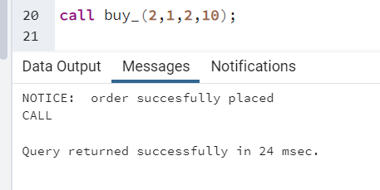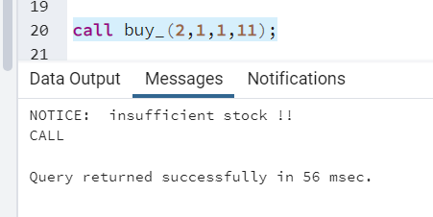

create or replace procedure search_by_type_range(p1 varchar(50), st numeric, z numeric) as

$$

declare

res product%rowtype;

c1_id product.p_id%type;

c1_name product.p_name%type;

c1_price product.price%type;

c1_size product.size%type;

c1_color product.color%type;

c1_brand product.color%type;

c1_material product.material%type;

c1_quantity product.stock_quantity%type;

c1_rating product.rating%type;

c1 cursor for select p_id ,p_name, price, size, color,brand, material, stock_quantity, rating from product where p_name=p1 and price between st and z;

begin

open c1;

loop

fetch c1 into c1_id ,c1_name ,c1_price ,c1_size ,c1_color ,c1_brand ,c1_material ,c1_quantity ,c1_rating;

exit when not found;

raise notice ' % , % , % , % , % , % , % , % , % ',c1_id ,c1_name ,c1_price ,c1_size ,c1_color ,c1_brand ,c1_material ,c1_quantity ,c1_rating;

end loop;

close c1;

end;

$$

language plpgsql;

call search_by_type_range('Co-ord',950,1000)

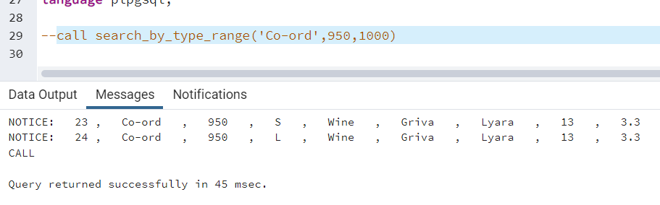

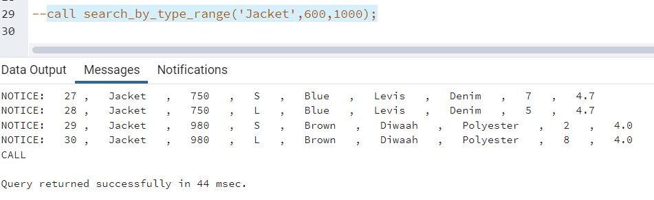

CREATE OR REPLACE PROCEDURE calculate_final_bill(id INT) AS

$$

DECLARE

amt NUMERIC;

final_amt NUMERIC;

gst_rate NUMERIC := 0.18; -- 18% GST rate

c1_row orders%ROWTYPE;

c1 CURSOR FOR SELECT * FROM orders WHERE cust_id = id and status='placed';

BEGIN

RAISE NOTICE 'Customer ID: %', id;

RAISE NOTICE ' O_ID Order Date Status Product ID Quantity Price';

OPEN c1;

LOOP

FETCH c1 INTO c1_row;

EXIT WHEN NOT FOUND;

RAISE NOTICE ' % % % % % %', c1_row.o_id, c1_row.o_date, c1_row.status, c1_row.p_id, c1_row.quantity, c1_row.total_price;

END LOOP;

close c1;

SELECT SUM(total_price) INTO amt FROM orders WHERE cust_id = id and status='placed';

final_amt = amt + (amt * gst_rate);

RAISE NOTICE 'GST charge: 18%%';

RAISE NOTICE 'Payable amount: %', final_amt;

END;

$$

LANGUAGE plpgsql;

call calculate_final_bill(2);

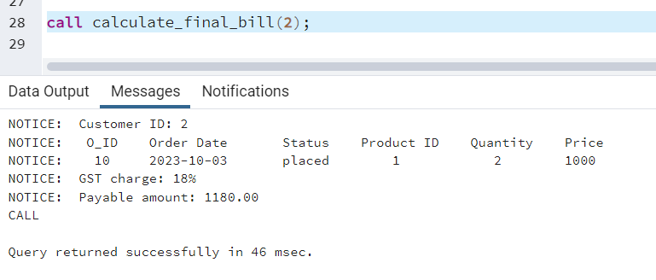

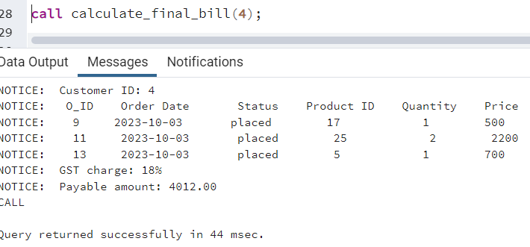

create or replace function change_price (a_name varchar(50),inc int) returns varchar as

$$

declare

a int;

p1_name product.p_name%type;

p1_price product.price%type;

p1 cursor for select p_name,price from product;

begin

open p1;

loop

fetch p1 into p1_name,p1_price;

exit when not found;

if p1_name=a_name then

update product set price=price+inc where p_name=a_name;

return 'price updated !!';

end if;

end loop;

close p1;

get diagnostics a=row_count;

if a=0 then

return 'no product available';

end if;

end;

$$

language plpgsql;

select change_price('Shirt',100);

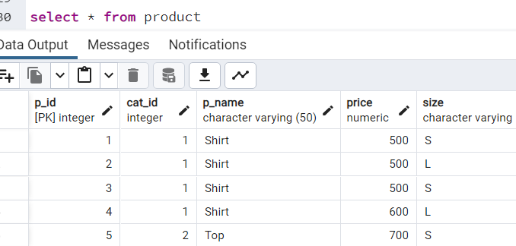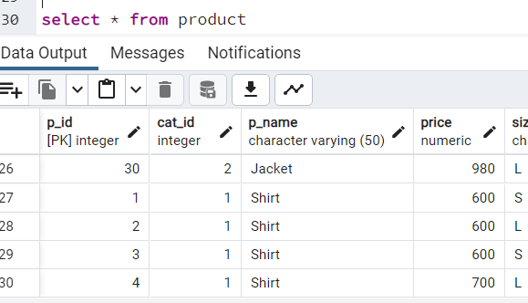

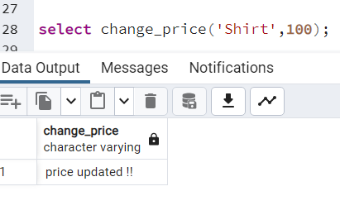

----------------------------------------------------SQL QUERIES----------------------------------------------------------------

select * from orders where cust_id=5;

select * from product where p_name='kurta' and size='s';

select * from product inner join catagory on product.cat_id=catagory.cat_id where cat_name='Female' and p_name='Top';

select cust_id, sum(total_price) from orders group by cust_id order by sum(total_price) desc limit 1;

select * from orders where status='delivered';

select p_id, p_name from product where stock_quantity between 1 and 5;

____________________________________________________________________________________________________________________________________________________________________