EE-2160 CAD Lab Project : Rain Detector
Mini Report II :Testing the Circuit on Breadboard

Project Name: Rain detector using NE555.
Name: Chayan Deb.
Roll No.: 121801012.

Project Description: Rain Alarm Project is a simple but very useful project that detects Rain (Rain Water) and automatically triggers an alarm or buzzer. With the help of saving this rain water through rain water harvesting, we can increase the levels of underground water by using underwater recharge technique. In this project, a simple Rain Alarm Circuit has been designed, which, upon detecting rain, will activate a buzzer. Based on the buzzer, we can take necessary actions.

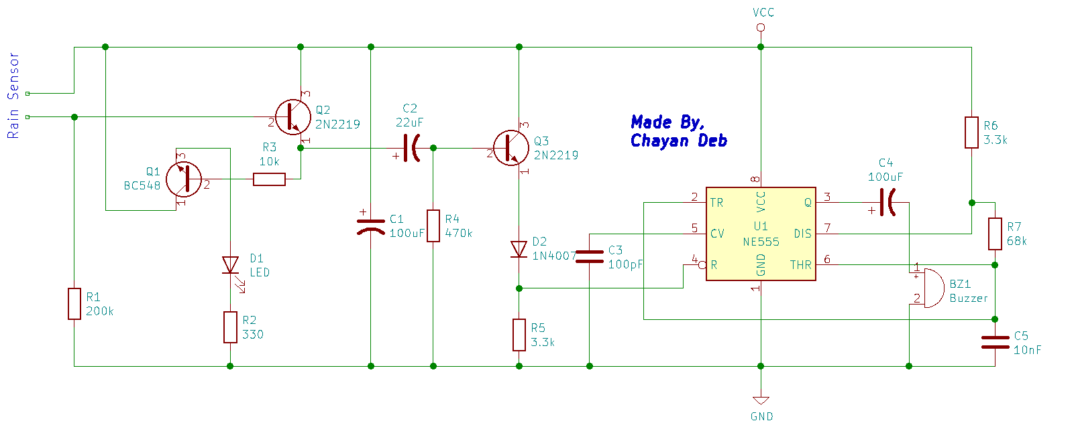
Project Schematic: The project schematic is attached below for reference :
Figure 1 : Circuit Diagram of Rain Detector

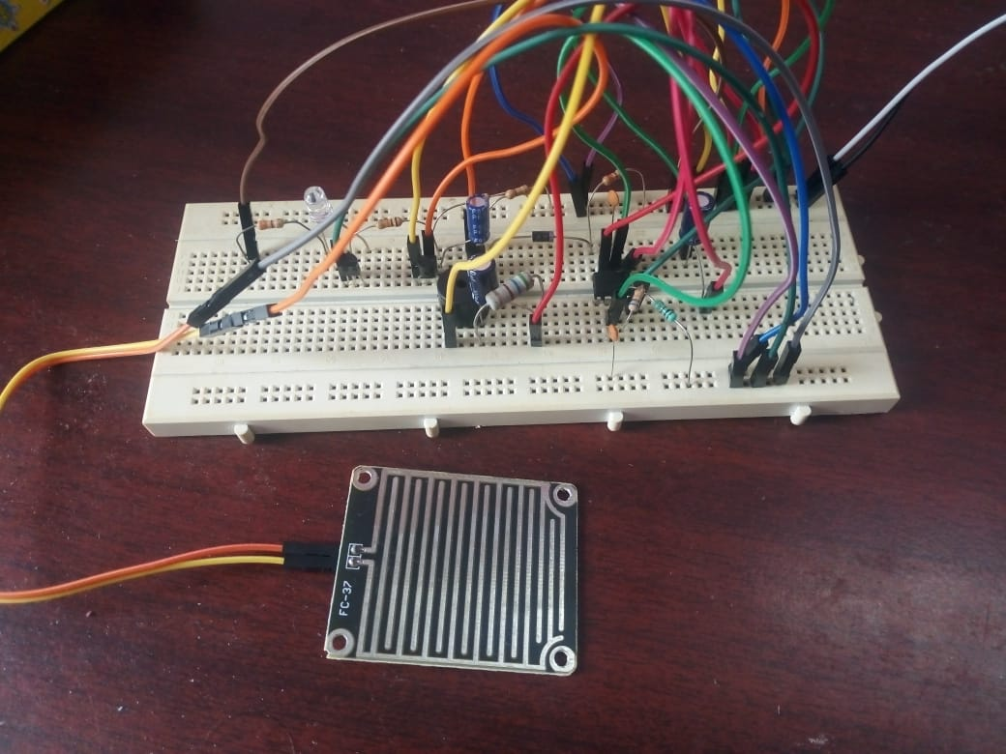
Testing on Breadboard: The breadboard circuit’s photo is attached below :

Testing Observations: The breadboard circuit was working by amplifying the signal generated by the current flow due to the moisture on the sensor plate and it was reflected on the buzzer as a high voltage signal.
But, when the sensor plate did not have moisture the buzzer did not ring, showing that the voltage across the buzzer to be low.

Testing Results: The breadboard circuit was successfully tested and was found to be working properly.

