Project Report on
“AI-Driven Centralized Recruitment and Job Matching Platform”

Submitted by

Name | PRN
Sachin Ware | 22210489
Tarun Patil | 22210177
Harshvardhan Waghmare | 22210098
Suraj Honmane | 22210591

Under the Guidance of
Dr. Suruchi Dedgaonkar



DEPARTMENT OF INFORMATION TECHNOLOGY
BRACT's, Vishwakarma Institute of Information Technology
[MAR-2026]
Affiliated to


SAVITRIBAI PHULE PUNE UNIVERSITY

DEPARTMENT OF
INFORMATION TECHNOLOGY

This is to certify that,
Certificate

Name | PRN
Sachin Ware | 22210489
Tarun Patil | 22210177
Harshvardhan Waghmare | 22210098
Suraj Honmane | 22211037

have successfully completed this project report entitled “AI-Driven Centralized Recruitment and Job Matching Platform”, under my guidance in partial fulfillment of the requirements for the degree of Bachelor of Technology in Department of INFORMATION TECHNOLOGY of Vishwakarma Institute of Information Technology, Savitribai Phule Pune University, Pune during the academic year 2024-25.

Date: - 30/3/2026 Place: - Pune

Dr. Suruchi Dedgaonkar Dr. P.R. Futane
Guide Head of Department

CONTENTS
- Abstract 4
- Introduction 5
  - Overview 5
  - Need of System 5
  - Objective 6
- Literature Review and Research Gap 7
  - Literature review 7
  - Research Gap 11
- Scope 12
- Hardware/Software Requirements Specification 13
  - Hardware Specifications 13
  - Software Requirement Specification 13
- Proposed Methodology 14
- Graphical User Interface 20
- Conclusion & Future Scope 29
- References 30

ABSTRACT

The rapid expansion of online recruitment has introduced significant challenges, including the manual burden of screening thousands of resumes and the prevalence of poorly structured job descriptions. These inefficiencies often lead to recruiters receiving irrelevant applications, while job seekers struggle to identify roles that genuinely align with their professional expertise. To address these systemic issues, this project proposes the kGamify Job Portal, an AI-Driven Centralized Recruitment and Job Matching Platform designed to streamline the hiring workflow through intelligent automation.

The platform is developed as a robust web-based system utilizing a modern full-stack architecture comprising React.js for the frontend, Node.js and Express.js for the backend, and MongoDB for scalable data management. Central to its functionality is the integration of advanced Artificial Intelligence techniques, specifically semantic text embeddings and similarity scoring. These tools allow the system to go beyond simple keyword matching, enabling a deeper contextual analysis of candidate resumes against specific job requirements to provide accurate, ranked shortlists.

In addition to candidate matching, the platform features specialized AI modules for job description validation and user assistance. The validation module assists recruiters in creating clear, structured, and high-quality job postings to attract the right talent, while an integrated AI chatbot provides real-time support to answer user queries and navigate platform features. These components work in tandem to create a centralized environment that manages everything from company registration and job posting to application tracking and automated notifications.

The expected outcome of the kGamify platform is a significant reduction in the time and manual effort required for the recruitment cycle. By improving the accuracy of candidate shortlisting and enhancing the quality of job communications, the system provides a more productive experience for recruiters and a more targeted job-seeking process for candidates. Ultimately, this project demonstrates the potential of AI to transform traditional recruitment into a more efficient, data-driven, and user-centric digital ecosystem.

INTRODUCTION

OVERVIEW
The AI-Driven Centralized Recruitment and Job Matching Platform, also known as the kGamify Job Portal, is a modern web-based solution designed to address the inefficiencies of traditional recruitment, such as time-consuming manual resume screening and poorly structured job descriptions. Built using a full-stack architecture of React.js, Node.js, Express.js, and MongoDB, the platform centralizes the hiring workflow by allowing companies to post jobs, manage applications, and utilize semantic text embeddings to rank candidates based on similarity scoring. Beyond simple job matching, the system integrates specialized AI modules for Job Description Verification to improve posting quality and a RAG-based chatbot to provide real-time user assistance. By automating these critical tasks, the platform aims to significantly reduce the hiring cycle's duration, enhance recruiter productivity, and provide a more targeted experience for job seekers in the digital era.

NEED OF SYSTEM
The following points outline the critical gaps in traditional recruitment that necessitate the development of the kGamify platform:
- Manual Screening Inefficiency: Traditional systems rely on manual resume review, which consumes significant time and effort for recruiters.
- Poor Job Posting Quality: Many platforms suffer from poorly written or incomplete job descriptions, leading to a high volume of irrelevant applications.
- Keyword-Based Limitations: Existing systems often lack intelligent filtering, failing to understand contextual meaning beyond simple keyword matching.
- Candidate Mismatch: Job seekers frequently struggle to identify opportunities that truly align with their specific skill sets and experience levels.
- Workflow Fragmentation: There is a lack of centralized automation for managing job postings, candidate ranking, and recruiter communication.
- Communication Gaps: Inefficient communication and a lack of real-time assistance for users often slow down the hiring process.

OBJECTIVE
The primary objective of this project is to design and develop an intelligent recruitment platform that enhances the hiring process through artificial intelligence and automation. The specific objectives include:
- Centralized Management: Develop a unified platform for efficiently managing job postings and candidate applications.
- AI-Powered Analysis: Implement AI-based resume analysis and intelligent candidate-job matching to ensure high-quality recruitment.
- Content Validation: Improve the quality and clarity of job descriptions using AI-driven validation modules.
- User-Centric Design: Provide an intuitive and easy-to-use interface tailored for both recruiters and job seekers.
- Automated Shortlisting: Implement mechanisms for automated candidate ranking to streamline the shortlisting process.
- Real-time Assistance: Provide a RAG-based chatbot to guide users and answer queries instantly.
- Enhanced Communication: Enable efficient notifications and communication channels between recruiters and candidates.
- Administrative Control: Create a comprehensive dashboard for administrators to monitor and manage platform operations.

LITERATURE REVIEW AND RESEARCH GAP

LITERATURE REVIEW
- 'AI-Powered Resume Screening and Job Matching System' was authored by S. Malhotra and R. Sharma, who developed an intelligent recruitment framework using Natural Language Processing (NLP) to extract key skills and experiences from resumes. They successfully demonstrated how semantic analysis and machine learning algorithms provide more accurate candidate-job matching compared to traditional keyword filters, while also offering personalized career guidance through skill-gap identification. However, the research primarily focuses on technical skill extraction and lacks a deeper evaluation of qualitative candidate experience or soft skills. Overall, the paper highlights how AI can reduce hiring costs and time, though it notes that continuous updates to skill databases are necessary to maintain system relevance.
- 'AI Powered Resume Parser for Enhanced Recruitment Process' by P. Verma and A. Gupta presents an automated parsing system designed to handle diverse resume formats and layouts using advanced NLP techniques. The authors successfully implemented a ranking mechanism that prioritizes candidates based on recruiter-defined requirements, effectively reducing the manual workload and potential human error in early-stage screening. Despite these advancements, the study lacks a robust solution for processing highly graphic or non-standard infographic resumes, which can lead to data extraction inconsistencies. This research provides a solid foundation for automated data organization while identifying that the quality of NLP training data remains a critical factor for accuracy.
- 'AI-Based Resume Ranking System Using Semantic Similarity and Skill-Based Scoring' was conducted by D. Patel and M. Shah, who introduced a dual-scoring model that combines contextual understanding with technical merit. By utilizing sentence embeddings and cosine similarity, they proved that their system could identify qualified candidates even when resumes used non-standard terminology, significantly outperforming legacy keyword-matching tools. However, the paper lacks an exploration of how ambiguous language or incomplete resume sections might negatively impact the final compatibility score. The study concludes that while semantic matching increases objectivity, it requires large datasets and periodic retraining to adapt to evolving industry job roles.

- 'AI-Based Resume Screening and Ranking System' by K. Singh, R. Kumar, and S. Tiwari focuses on an ethical framework that balances recruitment efficiency with fairness-aware AI development. They successfully utilized supervised learning models like Random Forest and BERT to achieve high accuracy in candidate identification while implementing fairness metrics to mitigate demographic bias. Yet, the research lacks a detailed strategy for evaluating cultural fit or interpersonal traits, which are often vital for long-term hiring success. Their work underscores the potential of AI to revolutionize hiring pipelines, concluding that transparency in AI decision-making is essential for gaining recruiter trust.

- 'AI-Powered Resume Screening and Role-Fit Analysis System' was authored by A. Mehta and S. Patel, who integrated Large Language Models (LLMs) with a Flask-based web environment to classify candidates into specific roles such as frontend or backend developers. They successfully demonstrated that their system could process hundreds of resumes in minutes with high accuracy, providing recruiters with an automated, unbiased ranking list. However, the study lacks a long-term analysis of how the system handles candidates with complex, multi-domain career paths that do not fit into rigid role categories. Ultimately, the paper establishes a clear link between LLM-driven analysis and improved hiring speed, while suggesting that further research is needed to refine soft-skill interpretation.

- 'AI-Powered Automated Resume Screening and Job Matching System Using NLP and Machine Learning' by N. Jain and P. Agarwal proposes an end-to-end framework featuring a real-time interactive dashboard for recruiters. They successfully used Sentence-BERT (S-BERT) to transform unstructured text into vector formats for precise similarity calculations, helping to shorten the overall recruitment cycle. While the system excels at structured data extraction, it lacks a mechanism for verifying the authenticity of the information provided in resumes. The study concludes that while automated filtering minimizes cognitive burden, human oversight remains necessary to validate the AI’s final shortlisting decisions.

- 'Smart Application Tracking System Utilizing Generative AI for Efficient Resume Matching' was authored by R. Gupta, S. Verma, and A. Mishra, who developed an AI-ATS that provides personalized feedback to candidates for resume improvement. They demonstrated how transformer-based embeddings can significantly improve matching accuracy over traditional ATS tools by understanding semantic meaning and synonyms. However, the paper lacks a detailed framework for ensuring data privacy and security when handling sensitive candidate information in a cloud environment. Their findings suggest that generative AI can bridge the gap between candidate self-presentation and recruiter expectations, though it requires high computational resources to scale effectively.

- 'AI-Driven Semantic Similarity-Based Job Matching Framework' by Y. Zhang, L. Chen, and H. Wang focuses on a framework that prioritizes semantic vector representations over traditional keyword logic. They successfully proved that measuring the "distance" between candidate profiles and job requirements in a vector space identifies high-quality matches that keyword searches would typically miss. Yet, the research lacks a strategy for handling domain-specific jargon in highly niche industries, which can sometimes lead to semantic "noise" and false positives. Overall, the paper highlights the superiority of semantic frameworks in job matching while noting that high-quality training data is the primary barrier to mass adoption.

- 'Learning Effective Representations for Person-Job Fit by Feature Fusion' by J. Zhang, X. Li, and Y. Huang proposes a deep learning model that combines explicit resume text with implicit historical recruitment data. They successfully utilized feature fusion techniques to predict candidate-job compatibility more reliably than single-feature systems, achieving higher accuracy in real-world scenarios. However, the paper lacks a solution for the high computational complexity and latency associated with deep learning models, making real-time deployment challenging for smaller organizations. The study proves that multi-source data integration is the future of recruitment AI, while identifying that large volumes of labeled data are required for model training.

- 'ResumeAtlas: Resume Classification Using Large Language Models' was authored by S. Kumar, R. Patel, and T. Singh, who curated a massive dataset to revisit traditional resume classification methods. They successfully demonstrated that using models like BERT and Gemma significantly improves accuracy over standard machine learning, achieving over 90% top-1 accuracy in role categorization. Despite these results, the research lacks an exploration of how standardized templates affect classification, as non-standard layouts still pose significant hurdles for text extraction. Their work emphasizes the critical importance of dataset quality, concluding that advanced model architectures are necessary for robust recruitment systems.

- 'Augmented Fine-Tuned LLMs for Recruitment Automation' by M. Anderson, L. Brown, and J. Davis introduces a novel methodology using fine-tuned, domain-specific language models like Phi-4 for recruitment tasks. They successfully implemented a hybrid dataset of real and synthetic resumes to train models that understand the nuances of hiring requirements with exceptional precision. However, the study lacks a detailed security audit regarding AI-generated content and the potential for "hallucinations" in candidate evaluation. Ultimately, the paper establishes that fine-tuning generic LLMs specifically for HR tasks is the most effective path toward full recruitment automation, provided that ethical safeguards are maintained.

The literature reflects a significant transition from traditional keyword-based recruitment to intelligent, automated systems that leverage Natural Language Processing (NLP), Machine Learning, and Large Language Models (LLMs) to enhance the efficiency of candidate-job matching. Research demonstrates that techniques such as semantic text embeddings, TF-IDF vectorization, and cosine similarity allow systems to understand the contextual meaning of resumes, significantly reducing manual screening time and improving shortlisting accuracy. While many studies successfully implement automated resume parsing and skill-based ranking to prioritize high-quality applicants, recurring limitations include a struggle with non-standard resume formats, a lack of deep evaluation for soft skills and personality traits, and the high computational resources required for advanced models. Ultimately, these papers suggest that while AI-driven platforms like kGamify can transform recruitment into a more productive, data-driven process, human oversight remains necessary to address potential biases and validate qualitative factors in candidate evaluation.

RESEARCH GAP
Based on the analysis of existing literature and the limitations of current systems, the following research gaps have been identified:
- Contextual Understanding Over Keywords: Many existing systems rely primarily on keyword-based matching, which often fails to capture the deeper contextual meaning of a candidate's experience or misses qualified individuals who use different terminology for similar skills.
- Structural Quality of Job Descriptions: There is a significant lack of automated tools to assist recruiters in creating clear and well-structured job descriptions, leading to an influx of irrelevant applications due to vague requirements.
- Real-Time Interactive Support: Traditional recruitment portals often lack integrated, intelligent assistants (like RAG-based chatbots) to provide immediate answers to user queries regarding platform navigation or application status.
- Parsing Non-Standard Formats: Current resume parsing technologies frequently struggle with resumes that use complex layouts, non-standard fonts, or infographic elements, resulting in data loss during extraction.
- Holistic Candidate Evaluation: Most AI models focus strictly on technical qualifications and struggle to evaluate qualitative factors such as soft skills, personality traits, or cultural fit through automated text analysis alone.
- Communication Automation: There is a gap in seamless, automated communication flows that keep candidates and recruiters updated in real-time through multiple channels like Email or WhatsApp during the screening process.
- Resource Intensity vs. Accessibility: Many high-performing deep learning models require extensive computational resources and labeled datasets, making them difficult to deploy for small-to-medium-scale recruitment operations.

SCOPE

The scope of the AI-Driven Centralized Recruitment and Job Matching Platform (kGamify Job Portal) encompasses the design and implementation of an end-to-end digital ecosystem that bridges the gap between hiring organizations and job seekers through automation and artificial intelligence.

  - Functional Scope :-
- Centralized Job Hub: A web environment for companies to register, post vacancies, and manage candidate applications in one place.
- AI Matching & Ranking: Utilizes semantic text analysis to parse resumes and automatically rank candidates based on their suitability for specific job roles.
- Content Validation: An AI module that reviews job descriptions to ensure clarity and professional structure.
- Interactive Support: A RAG-based chatbot provides immediate assistance and answers user queries regarding the platform.

  - Technical Scope :
- MERN Stack Development: Implementation using React.js for the interface, Node.js/Express.js for the backend, and MongoDB for data storage.
- AI & API Integration: Integration of LLMs (Gemini/Llama) for NLP tasks and Razorpay for secure subscription payments.
- Automated Notifications: Email systems to alert users about application updates and account activity.

1.3 Administrative Scope
- Operational Monitoring: A dashboard for administrators to oversee platform activity, manage users, and revoke access when necessary.

HARDWARE/SOFTWARE REQUIREMENTS SPECIFICATION

HARDWARE SPECIFICATIONS
The development and deployment of the kGamify Job Portal require a standard technical setup to manage the MERN stack and AI integrations efficiently. The hardware must include a multi-core processor such as an Intel Core i5 (10th Gen) or AMD Ryzen 5 to handle simultaneous processes for the React frontend and Node.js backend. A minimum of 8 GB RAM (16 GB recommended) is necessary to ensure smooth performance while running the development server and local MongoDB instances. Additionally, a 256 GB SSD is required for rapid data access, alongside a high-speed internet connection to facilitate real-time API calls to the Gemini AI service and the Razorpay payment gateway.

SOFTWARE REQUIREMENTS SPECIFICATIONS (SRS)
The Software Requirements Specification (SRS) for the kGamify Job Portal defines a robust full-stack environment tailored for AI-driven recruitment and secure data management. The frontend is built using React.js to provide a responsive, interactive user interface for candidates and recruiters, while the backend utilizes Node.js and Express.js to handle server-side logic and API communication. Data persistence is managed through MongoDB, which stores user profiles, job postings, resumes, and complex application metadata. Additionally, the system integrates the Razorpay API for secure subscription payments and Gemini/Llama LLMs for advanced natural language processing tasks.
To ensure efficient operation and security, the system implements specific non-functional requirements and administrative controls. It utilizes JSON Web Tokens (JWT) for secure user authentication and session management, protecting sensitive candidate and company information. The AI integration requires stable API connectivity to perform semantic analysis, resume parsing, and RAG-based chatbot responses. For operational oversight, an administrative dashboard is developed to monitor platform activity, manage user access, and oversee the job matching ecosystem, ensuring the integrity and scalability of the recruitment workflow.

PROPOSED METHODOLOGY
The development of the kGamify Job Portal follows a modern full-stack web development methodology, integrating Agile practices to ensure iterative improvements and high-quality AI features. The methodology is structured around the following core components:
1.1 Architecture Design
The system utilizes a Client-Server Architecture built on the MERN stack. The frontend is developed using React.js to create a responsive and interactive user interface for various stakeholders. The backend, powered by Node.js and Express.js, manages the application logic, secure authentication through JWT, and seamless API communication. Data persistence is handled by MongoDB, which provides a flexible schema for storing user profiles, complex job descriptions, and resume metadata.
1.2 AI and NLP Implementation
A critical phase of the methodology involves the integration of Artificial Intelligence for core recruitment tasks.
- Semantic Analysis: The system employs NLP techniques to convert resumes and job descriptions into semantic text embeddings.
- Candidate Matching: A similarity scoring mechanism (such as Cosine Similarity) is used to compare these vectors and rank candidates based on their suitability rather than simple keywords.
- RAG Integration: For the platform chatbot, a Retrieval-Augmented Generation (RAG) architecture is used, where user queries are vectorized, matched against relevant context in a vector database, and processed by LLMs (Gemini/Llama) to generate accurate responses.

1.3 System Workflow and Integration
The methodology follows a structured workflow as depicted in the system diagrams:
- Registration and Verification: Companies undergo a registration process followed by an administrative review before gaining access to the platform.
- Job Posting Cycle: Recruiters fill job descriptions which are then validated by the AI service for quality and clarity before being stored in the database.
- Payment Processing: A secure subscription model is implemented using the Razorpay API, ensuring that premium features are activated only upon successful payment verification through webhooks.
- Application and Tracking: Candidates search for jobs and apply, with their data being stored and analyzed to provide recruiters with a ranked view of the applicant pool.

1.4 Testing and Validation
To ensure reliability, the methodology includes rigorous testing phases covering functional, performance, and usability aspects. Every module—ranging from the AI matching algorithm to the payment gateway—is subjected to test cases to validate that the implementation matches the initial design and meets the performance expectations of the recruitment process

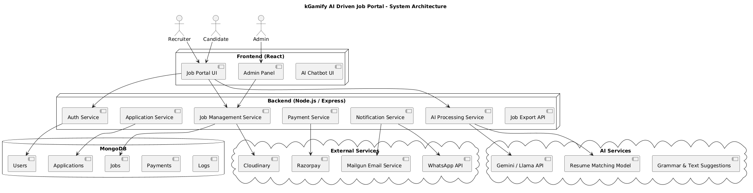
Fig. 1 – System Architecture

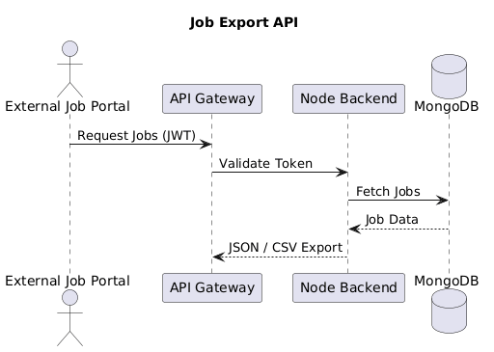
Fig. 2 – Job Export API Architecture

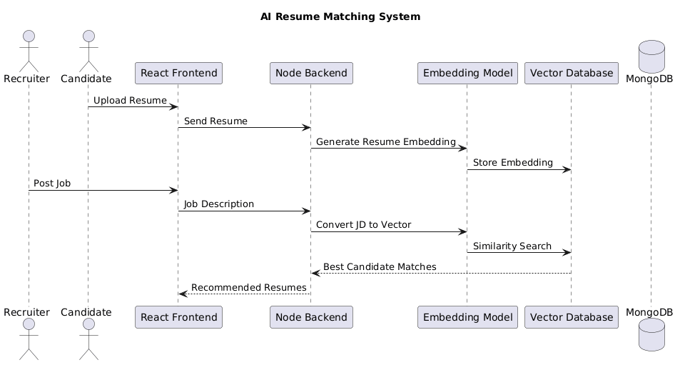

Fig. 3 - AI Resume Recommendation Architecture

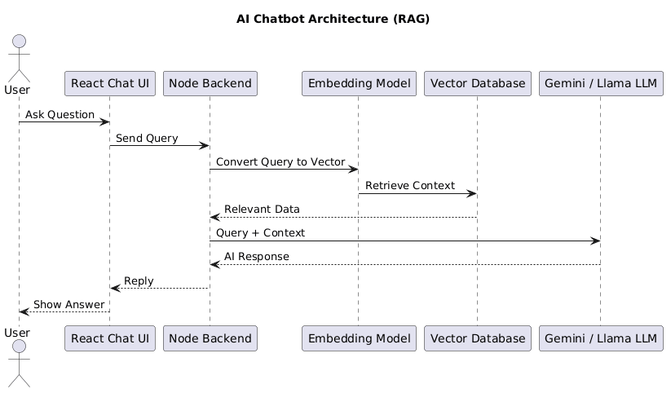

Fig. 4 - AI Chatbot Architecture (RAG Based)

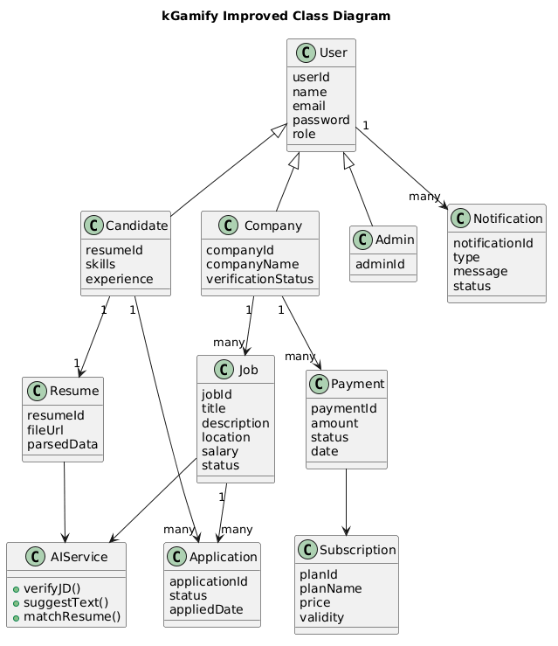

Fig. 5- Class Diagram

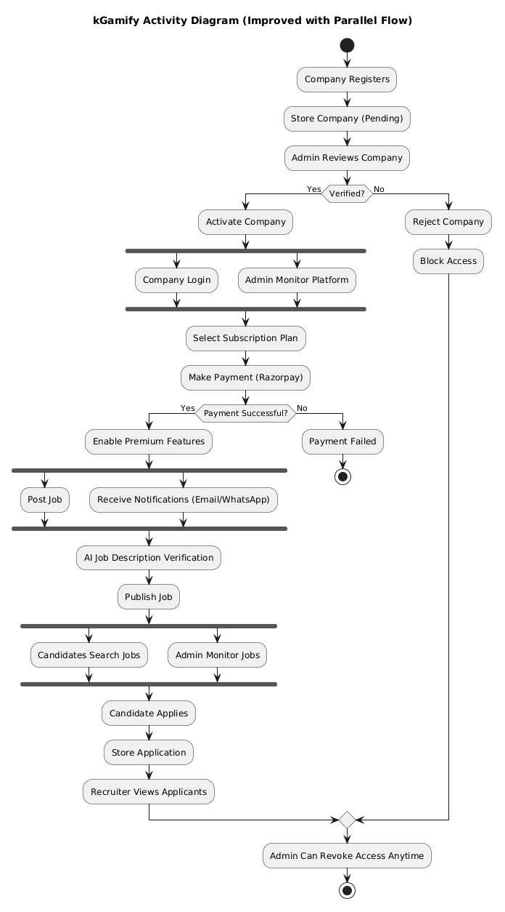

Fig. 6 – Activity Diagram

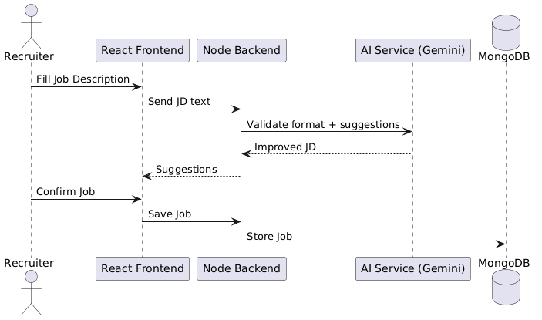

Fig. 7 - Sequence Diagram (AI Job Posting)

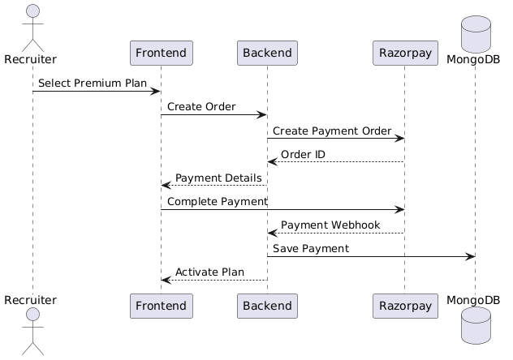

Fig. 8 - Sequence Diagram (RazorPay Payment)

GRAPHICAL USER INTERFACE
T The user interface of the kGamify Job Portal is designed to be professional and intuitive, featuring a clean, dashboard-style layout that simplifies the recruitment and job-seeking experience. The homepage provides a streamlined gateway for both recruiters and candidates, while the sidebar ensures seamless navigation between job postings, application tracking, and profile management. Interactive job cards display key information such as role titles, company names, and real-time application status, accompanied by an AI-generated suitability rank for recruiters. The integrated secure authentication system offers a protected login environment for all user roles, ensuring data privacy. User-friendly input forms for job descriptions—enhanced by AI validation—and high-contrast call-to-action buttons allow recruiters to post openings and candidates to upload resumes with ease.

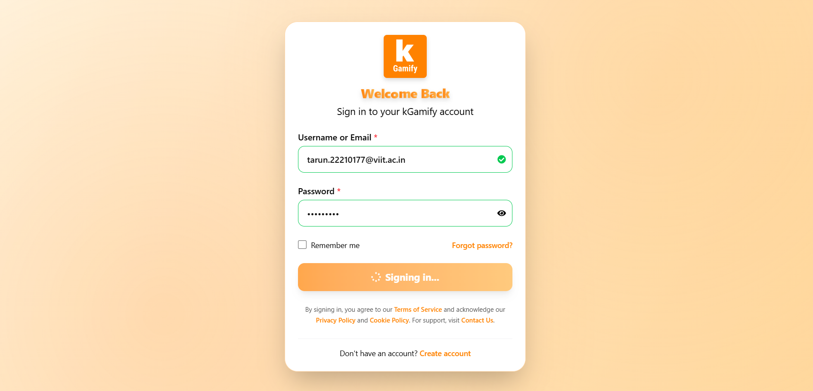
Fig.1 – Login / Signup Page
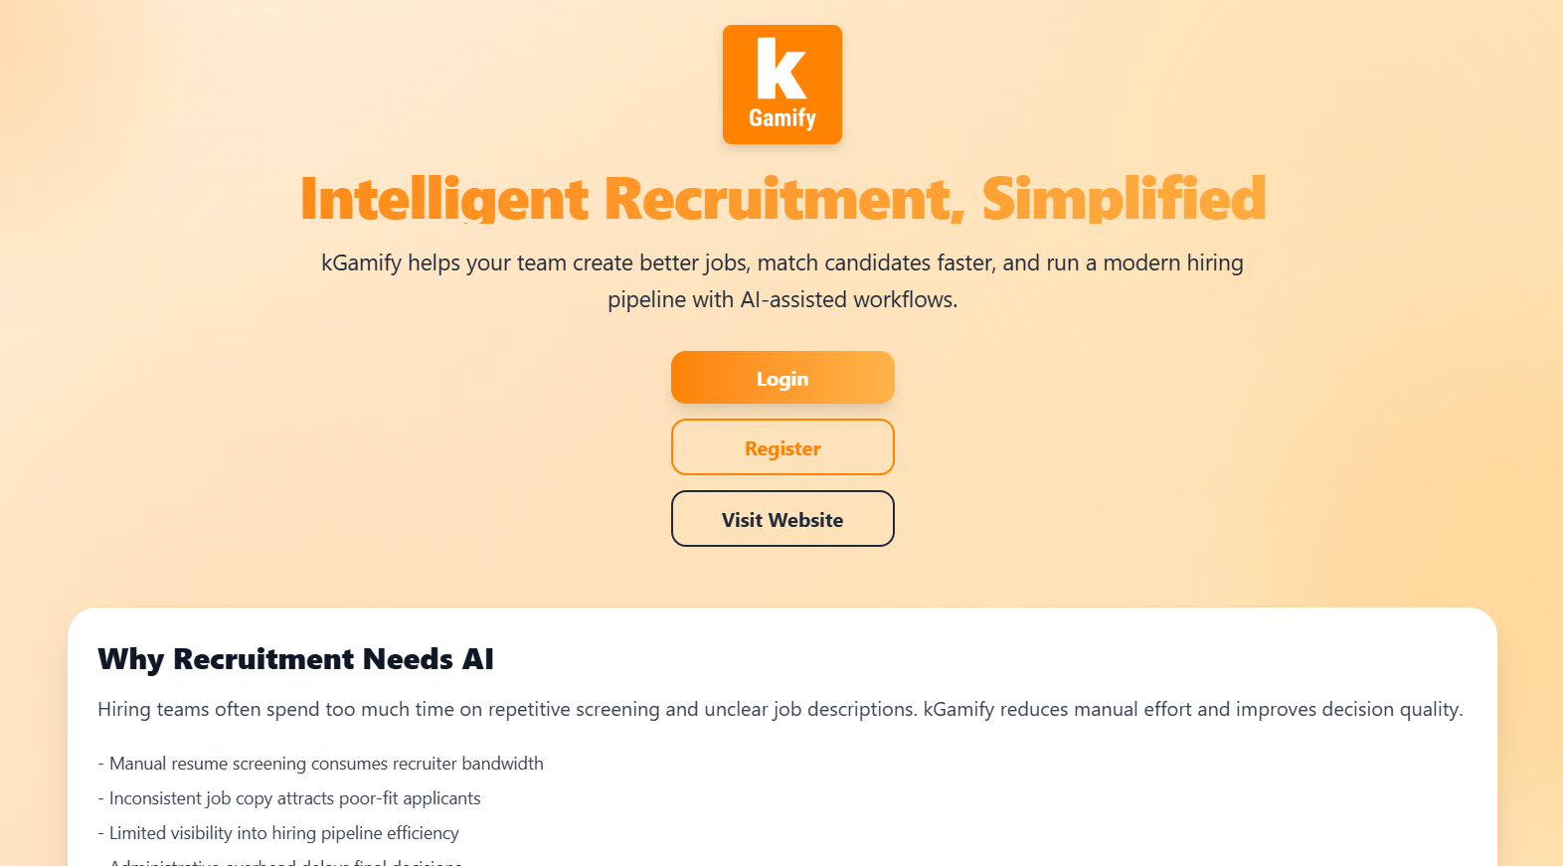
Fig. 2.1 – Homepage of Kgamify

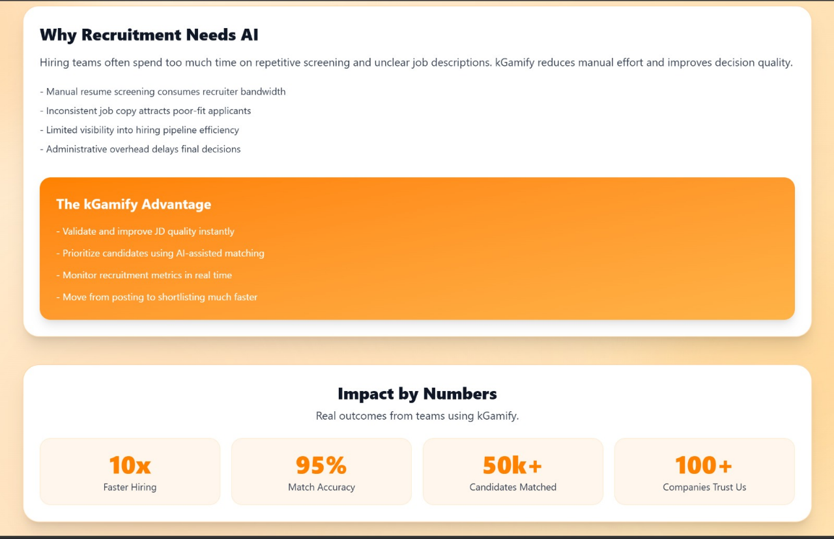
Fig. 2.2 – Homepage of Kgamify

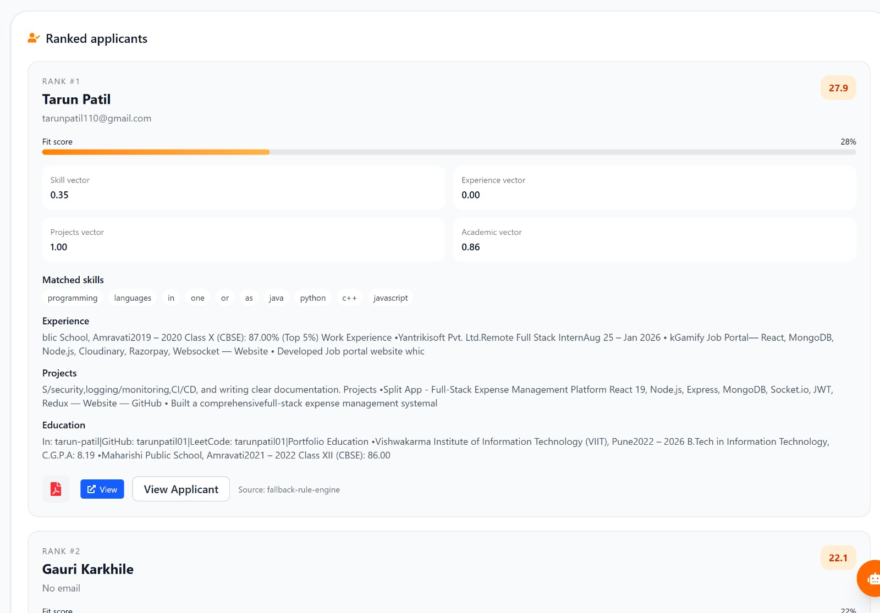
Fig. 3 – Analysis of Applicant

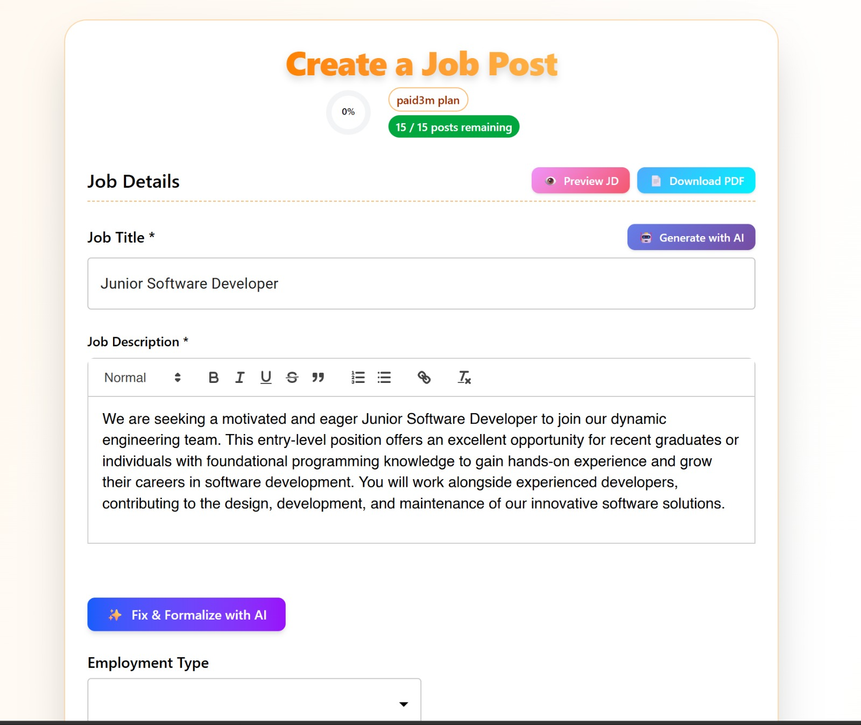
Fig. 4 – JD creation with AI
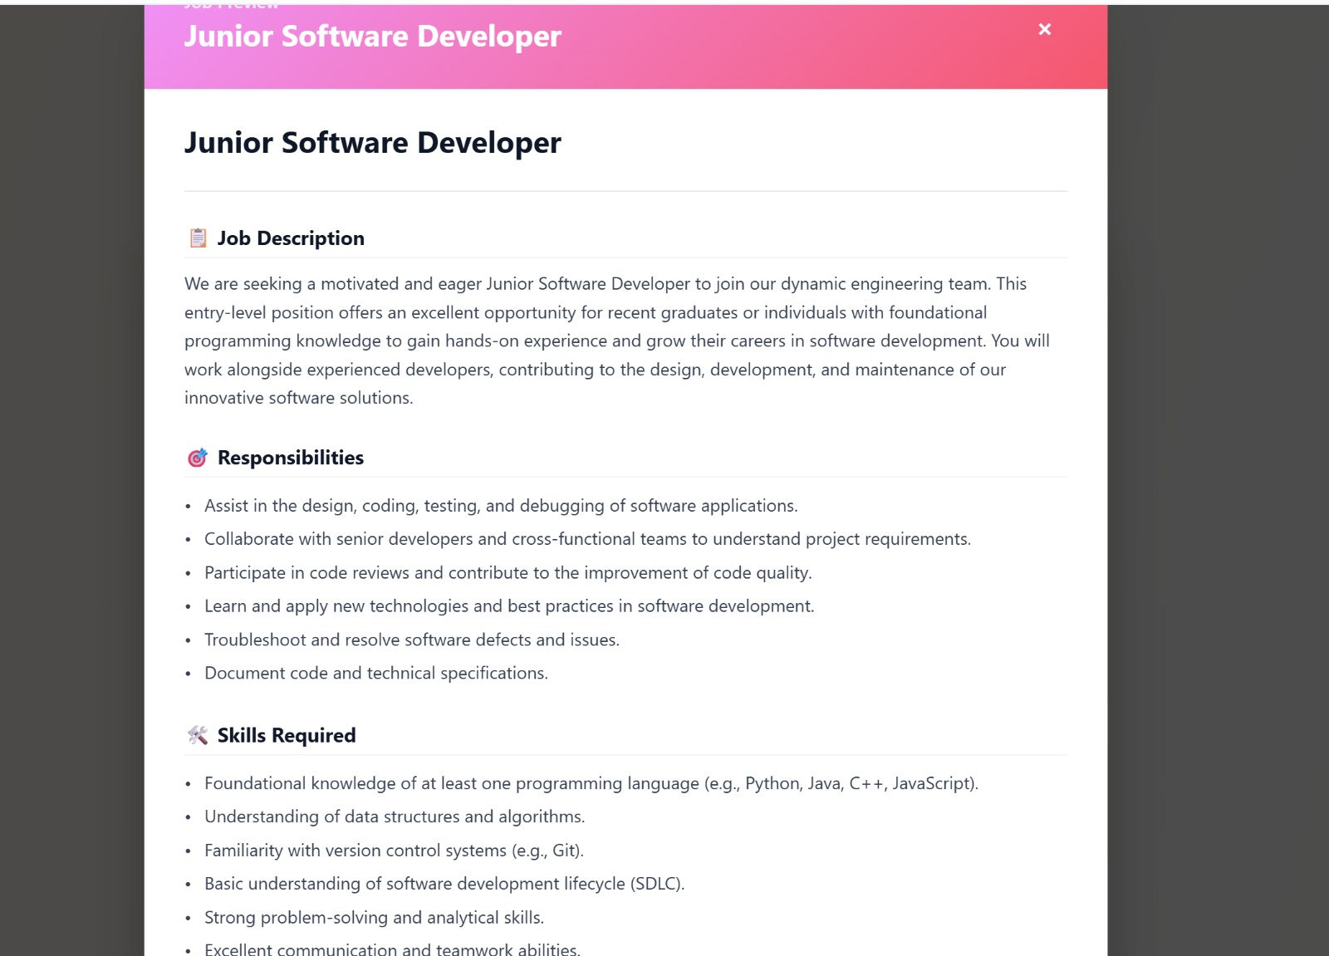
Fig. 5 – JD Preview

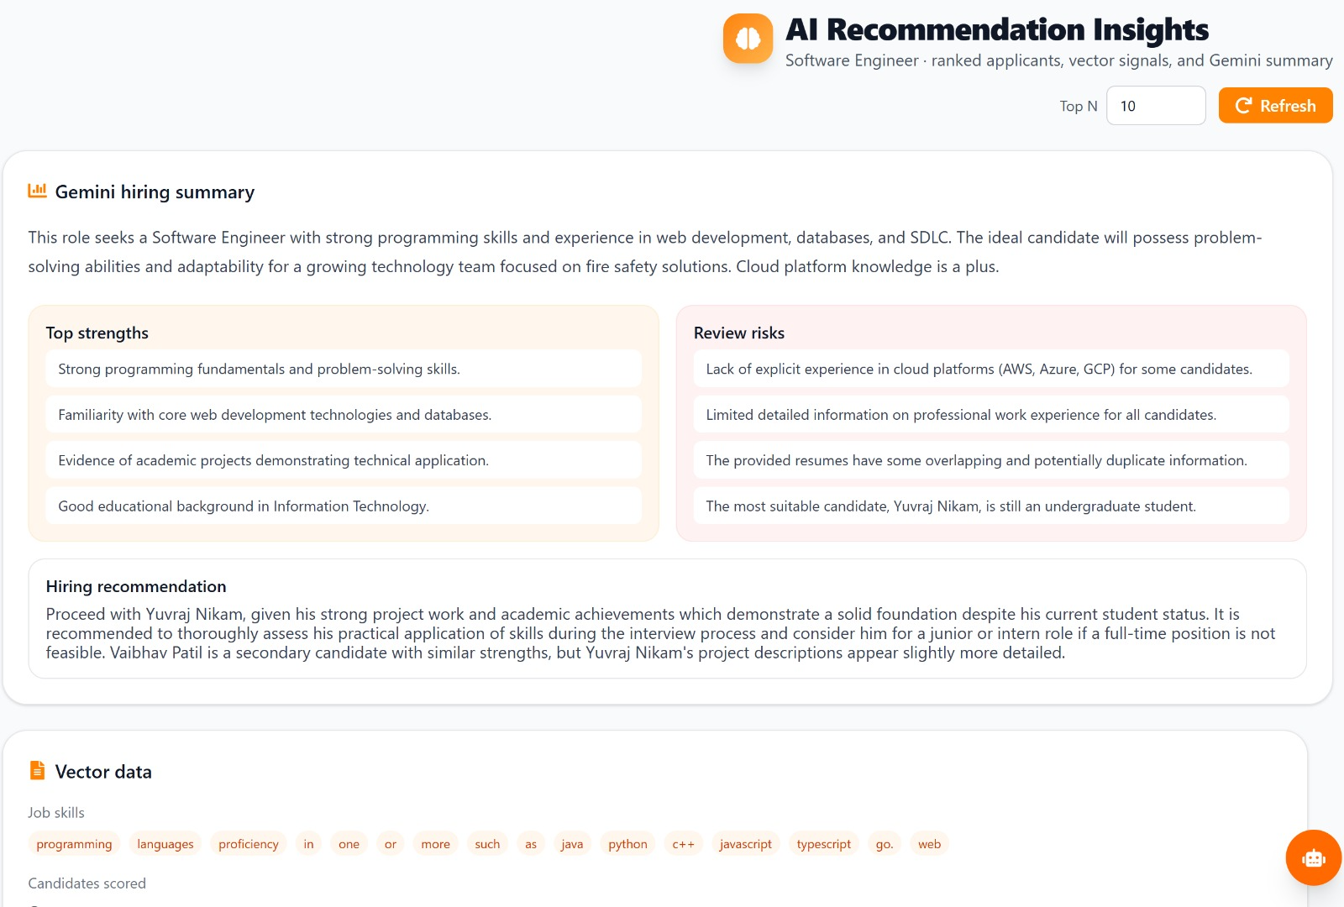
Fig. 6 – AI recommendation Insight

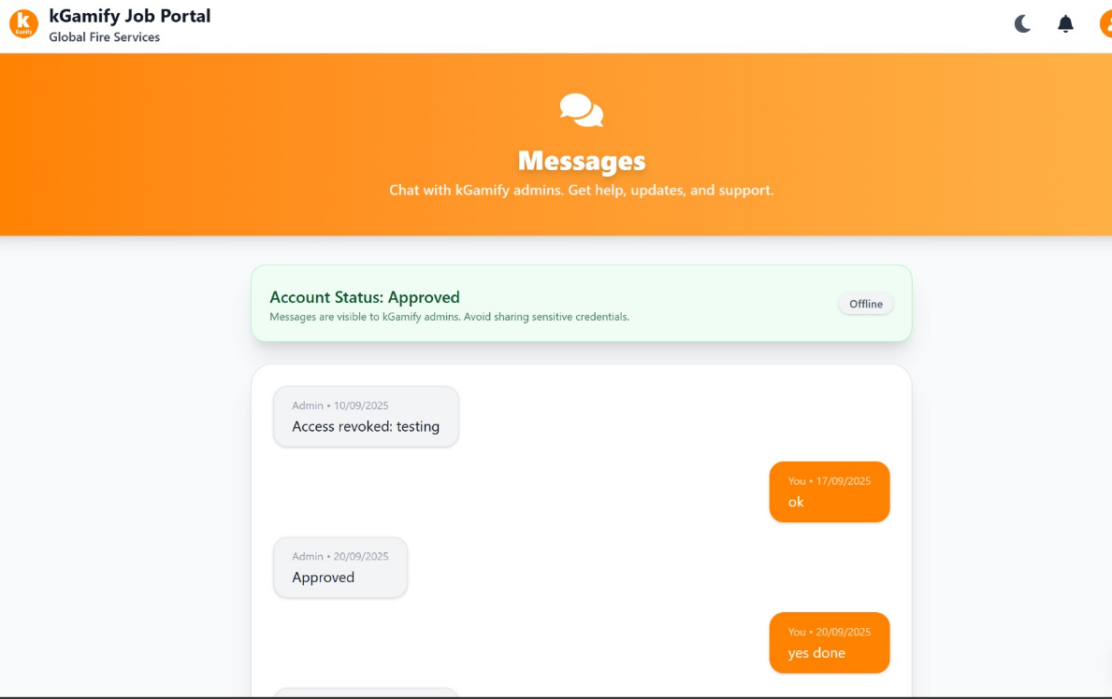
Fig. 7 – Real Time Messages

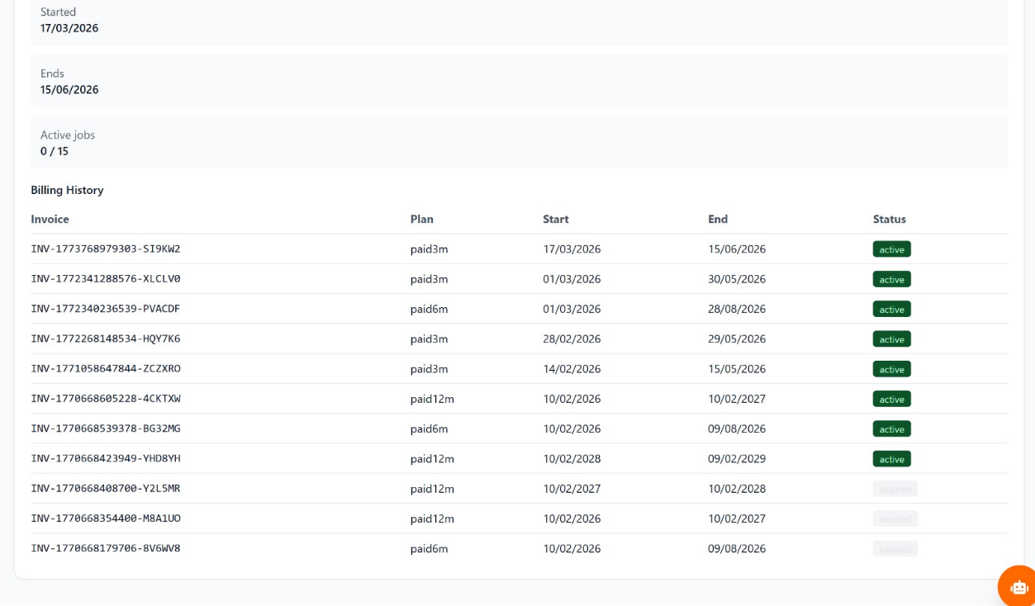
Fig. 8 - Billing history
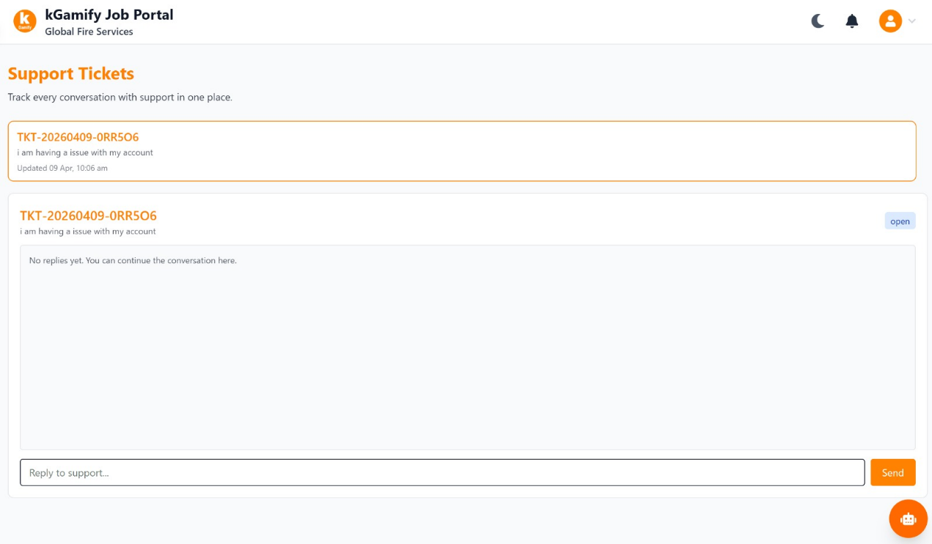
Fig. 9 – Support Tickets

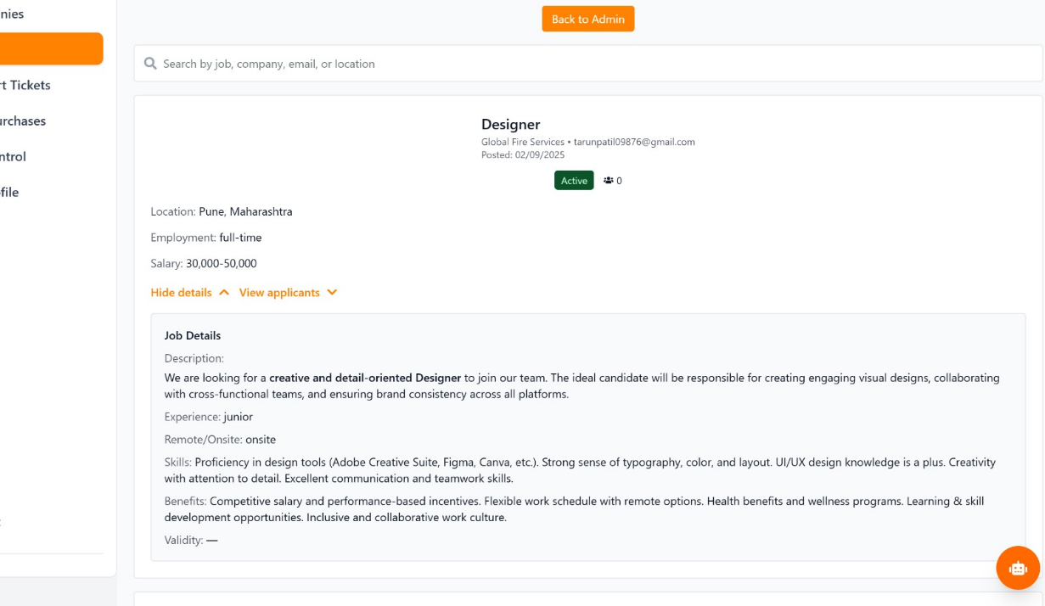
Fig. 10 – Job Management

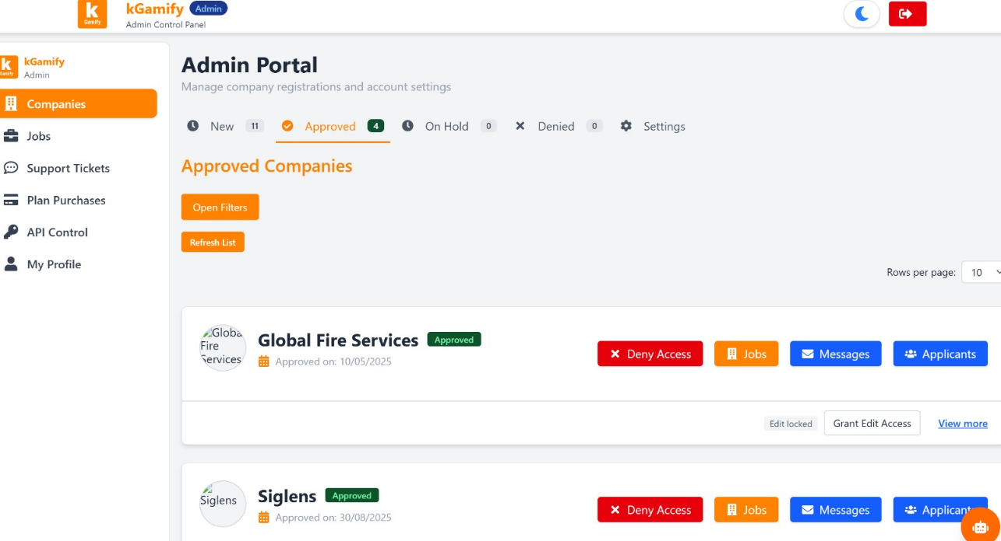
Fig. 11 – Admin Page Job Portal

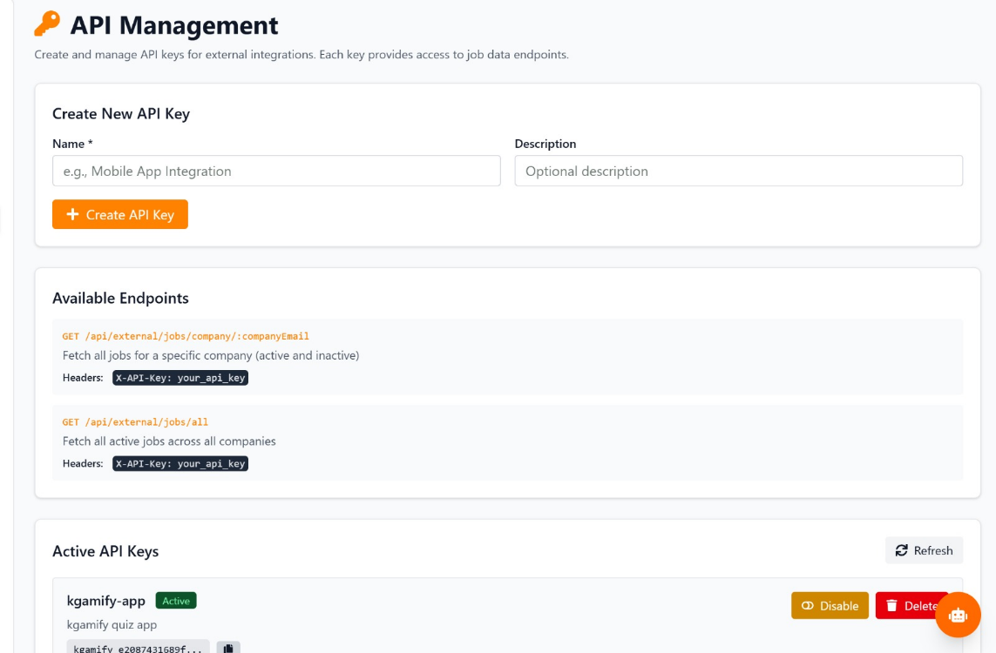
Fig. 12 – API Export Management

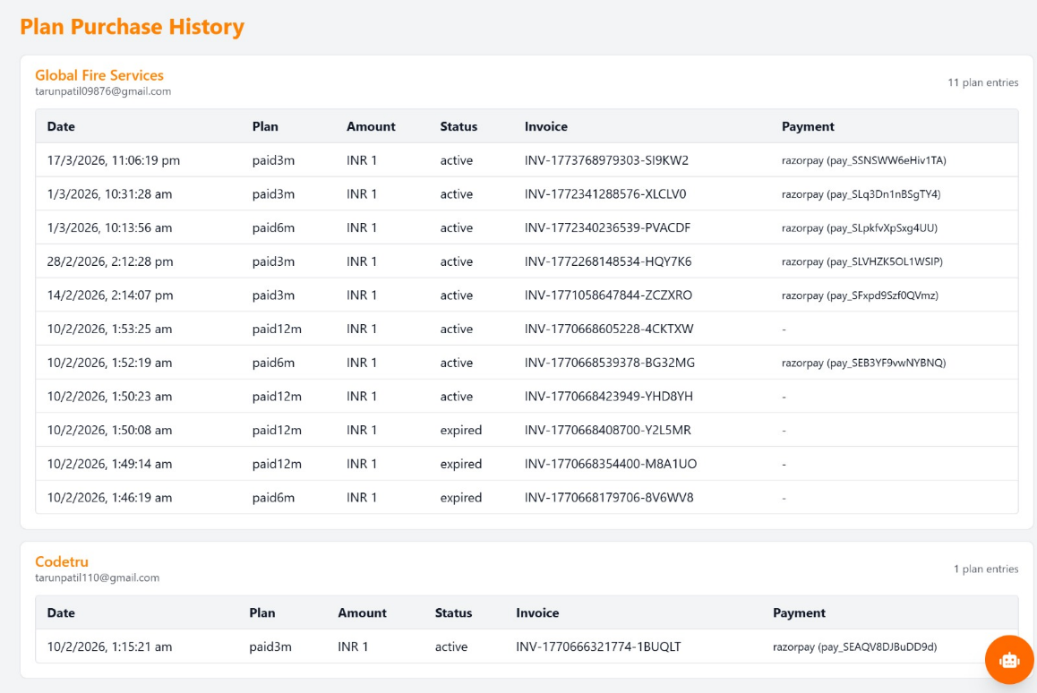
Fig. 13 – Plan purchase history

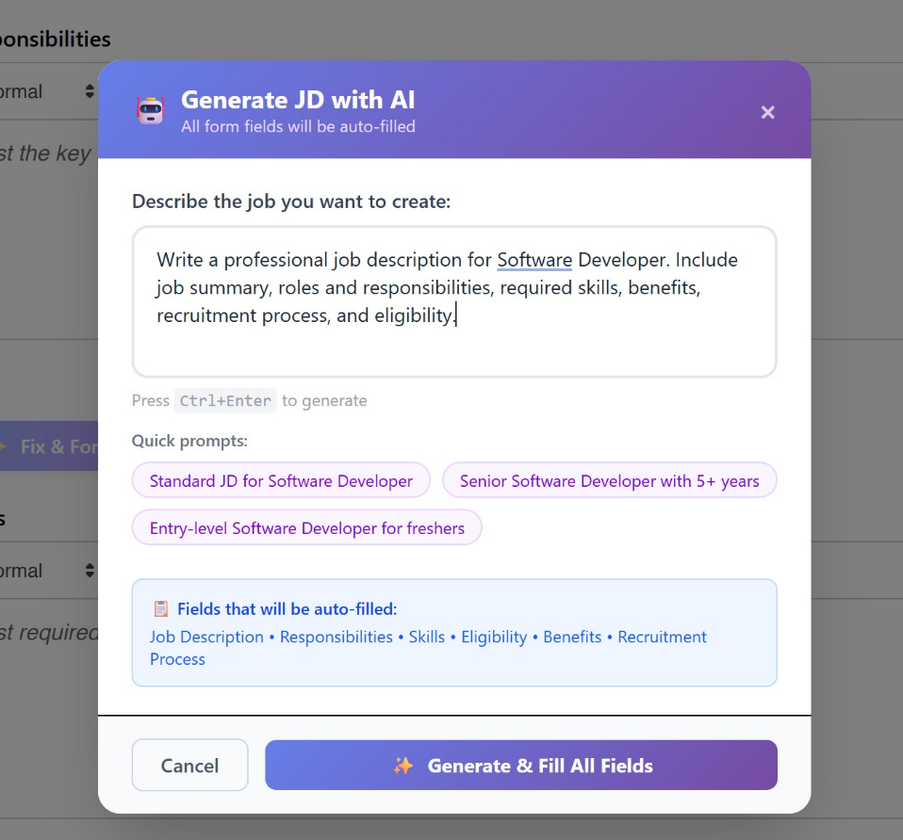
Fig. 14 – AI assistance for filling Job
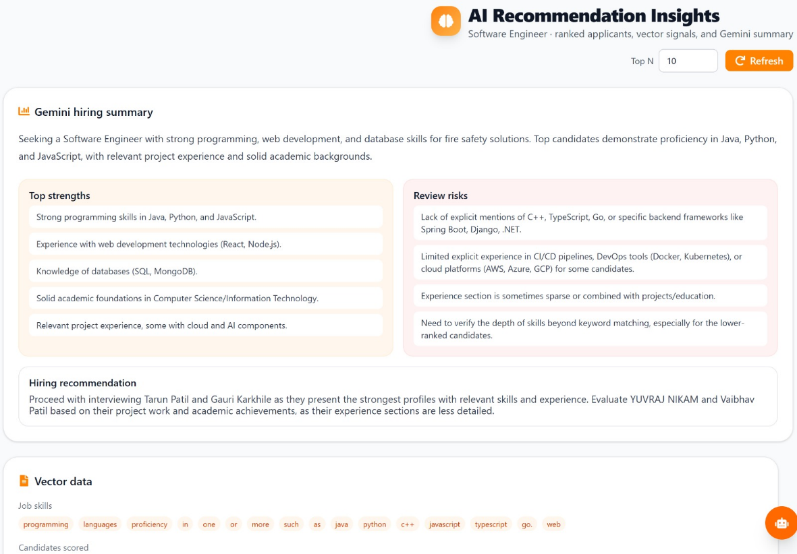
Fig. 15 – AI Resume Summarizer


Fig. 16 – Invoice / Mail sent to user

CONCLUSION AND FUTURE SCOPE

The kGamify Job Portal successfully demonstrates the integration of Artificial Intelligence into a centralized recruitment platform to address the inefficiencies of traditional hiring processes. By utilizing a full-stack architecture of React.js, Node.js, and MongoDB, the system provides a robust environment for managing the end-to-end recruitment lifecycle, from company verification to candidate shortlisting. The implementation of semantic text embeddings and similarity scoring allows for a more nuanced and accurate matching of resumes to job descriptions compared to legacy keyword-based systems. Ultimately, the platform achieves its goal of reducing manual screening effort, enhancing the quality of job postings through AI validation, and improving overall recruitment productivity for both hiring organizations and job seekers.
Looking ahead, the future scope of the platform includes several advanced enhancements to further automate and refine the recruitment experience. Integration of AI-driven video interviewing and automated sentiment analysis could provide deeper insights into a candidate's communication skills and personality traits. To improve data integrity, blockchain technology could be implemented for the immutable verification of academic credentials and professional certifications. Additionally, the system could be expanded to include predictive analytics for long-term employee retention and the integration of a mobile application to provide seamless, on-the-go access for candidates. These advancements would transform the platform into a comprehensive, AI-first human resource management ecosystem capable of meeting the evolving needs of the global job market.

REFERENCES

- S. Malhotra and R. Sharma, "AI-Powered Resume Screening and Job Matching System," International Journal of Scientific Computing, vol. 12, no. 3, pp. 45-52, 2025.
- P. Verma and A. Gupta, "AI Powered Resume Parser for Enhanced Recruitment Process," International Journal of Advanced Computing and Technology, vol. 9, no. 2, pp. 101-108, 2025.
- D. Patel and M. Shah, "AI-Based Resume Ranking System Using Semantic Similarity and Skill-Based Scoring," Journal of Software Research and Technology, vol. 7, no. 1, pp. 22-30, 2025.
- K. Singh, R. Kumar, and S. Tiwari, "AI-Based Resume Screening and Ranking System," International Journal of Scientific Computing and Innovation, vol. 11, no. 4, pp. 88-95, 2025.
- A. Mehta and S. Patel, "AI-Powered Resume Screening and Role-Fit Analysis System," International Journal for Research in Applied Science and Engineering Technology, vol. 13, no. 5, pp. 1340-1346, 2025.
- N. Jain and P. Agarwal, "AI-Powered Automated Resume Screening and Job Matching System Using NLP and Machine Learning," International Journal of Research in Engineering and Science Management, vol. 8, no. 2, pp. 59-66, 2025.
- R. Gupta, S. Verma, and A. Mishra, "Smart Application Tracking System Utilizing Generative AI for Efficient Resume Matching," International Journal of Innovative Science and Research Technology, vol. 10, no. 1, pp. 122-129, 2025.
- Y. Zhang, L. Chen, and H. Wang, "AI-Driven Semantic Similarity-Based Job Matching Framework," Information Sciences, vol. 670, pp. 120-134, 2026.
- J. Zhang, X. Li, and Y. Huang, "Learning Effective Representations for Person-Job Fit by Feature Fusion," arXiv preprint arXiv:2006.07017, Jun. 2020.
- S. Kumar, R. Patel, and T. Singh, "ResumeAtlas: Resume Classification Using Large Language Models," arXiv preprint arXiv:2406.18125, Jun. 2024.
- M. Anderson, L. Brown, and J. Davis, "Augmented Fine-Tuned LLMs for Recruitment Automation," arXiv preprint arXiv:2509.06196, Sep. 2025.

