Project Report on
“AI-Driven Centralized Recruitment and Job Matching Platform”

Submitted by

Name | PRN
Tarun Patil  Sachin Ware | 22210177  22210489
Harshvardhan Waghmare | 22210098
Suraj Honmane | 22211037

Under the Guidance of
Dr. Suruchi Dedgaonkar



DEPARTMENT OF INFORMATION TECHNOLOGY
BRACT's, Vishwakarma Institute of Information Technology
[MA-2026]
Affiliated to


SAVITRIBAI PHULE PUNE UNIVERSITY

DEPARTMENT OF
INFORMATION TECHNOLOGY

Certificate
This is to certify that, successful completion of this project report entitled “AI-Driven Centralized Recruitment and Job Matching Platform”, under my guidance in partial fulfillment of the requirements for the degree of Bachelor of Technology in Department of INFORMATION TECHNOLOGY of Vishwakarma Institute of Information Technology, Savitribai Phule Pune University, Pune during the academic year 2025-26.

Date :- 4/5/2026
Place :- Pune

Dr. Suruchi Dedgaonkar Dr. Pravin R. Futane
Guide Head of Department

Examiners :-
1. . . . . . . . . . . . . . . 2. . . . . . . . . . . . . .

CONTENTS
Abstract 8
- Introduction 10
  - Overview 10
  - Need of System 11
  - Objective 12
- Literature Review & Research Gap 14
  - Literature Review 14
  - Research Gap 18
- Requirements Specification 21
  - Hardware Specifications 21
  - Software Requirement Specification 21
    - Core Architecture and Technologies 21
    - Security and Authentication 22
    - Non-Functional Requirements 23
    - Scope 23
- Proposed Methodology 26
  - Architecture Design 27
  - AI and NLP Implementation 27
  - System Workflow and Integration 28
  - Testing and Validation 28
- Graphical User Interface 36
- Version Control & Source code management 45
- Conclusion & Future Scope 46
- Outcome 49
- References 50

LIST OF FIGURES

Fig. No. | Figure Name | Page No.
Fig. 1 | System Architecture | 26
Fig. 2 | Job Export API Architecture | 30
Fig. 3 | AI Resume Recommendation Architecture | 30
Fig. 4 | AI Chatbot Architecture - RAG Based | 31
Fig. 5 | Class Diagram | 32
Fig. 6 | Activity Diagram | 33
Fig. 7 | Sequence Diagram - AI Job Posting | 34
Fig. 8 | Sequence Diagram - RazorPay Payment | 35
Fig. 9.1 | Login / Signup Page | 36
Fig. 9.2 | Homepage of Kgamify - 1 | 37
Fig. 9.3 | Homepage of Kgamify - 2 | 37
Fig. 10 | Analysis of Applicant | 38
Fig. 11 | JD creation with AI | 38
Fig. 12 | JD Preview | 39
Fig. 13 | AI recommendation Insight | 39
Fig. 14 | Real Time Messages | 40
Fig. 15 | Billing history | 40
Fig. 16 | Support Tickets | 41
Fig. 17 | Job Management | 41
Fig. 18 | Admin Page Job Portal | 42
Fig. 19 | API Export Management | 42
Fig. 20 | Plan purchase history | 43
Fig. 21 | AI assistance for filling Job | 43
Fig. 22 | AI Resume Summarizer | 44
Fig. 23 | Invoice / Mail sent to user | 44
Fig. 24 | Github Repository | 45
Fig. 25 | Task management | 45

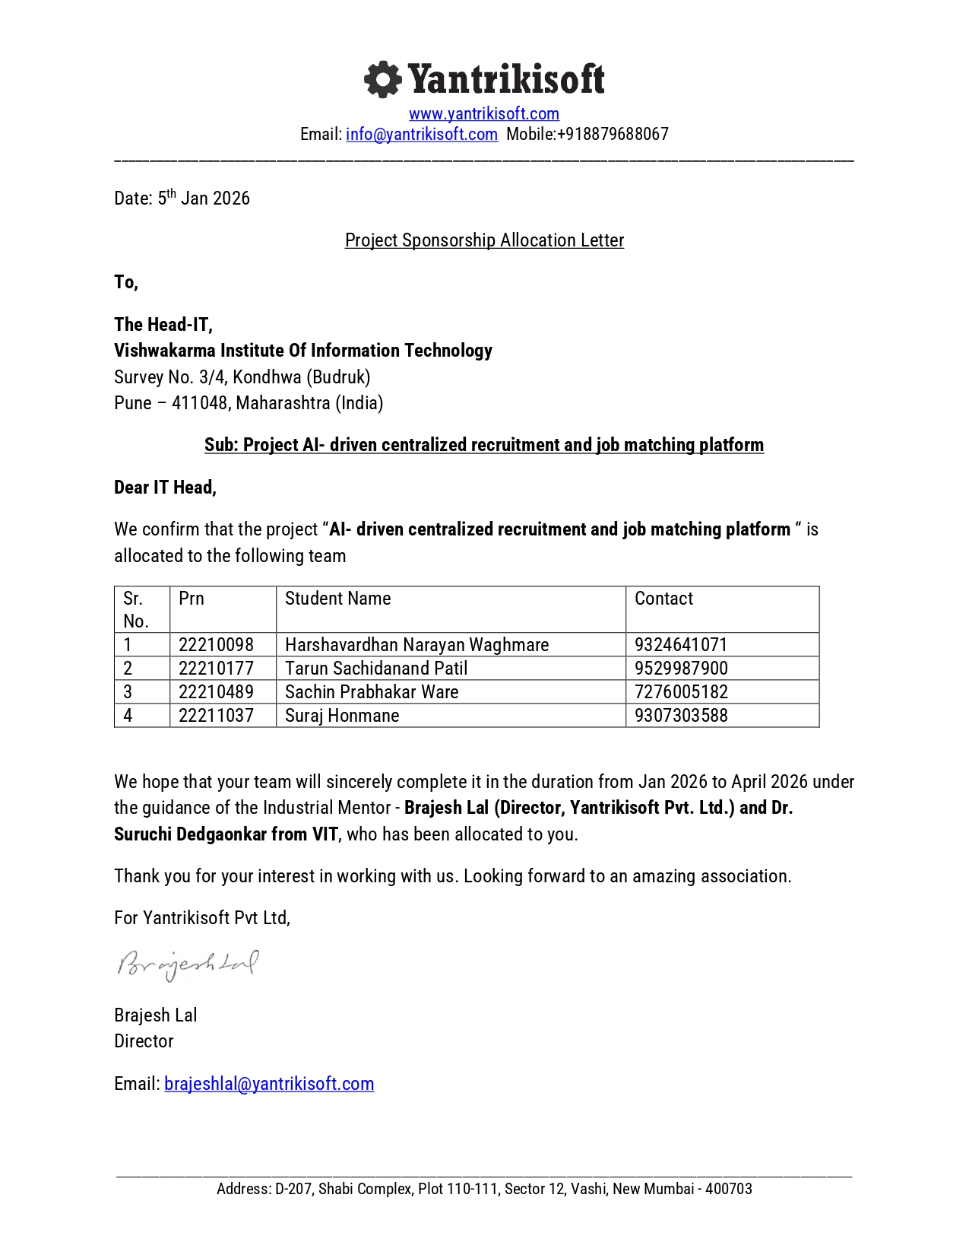

ACKNOWLEDGEMENT

We take this opportunity to thank Head of the Department Prof. Pravin Futane and our project guide Dr. S. G. Dedgaonkar for their valuable guidance and providing all the necessary facilities, which were indispensable in the completion of this project report. We are also thankful to all the staff members of the Department of Information Technology, VIIT, Pune for their valuable time, support, comments, suggestions and persuasion. We would also like to thank Dr. Suruchi Dedgaonkar, Prof. Pravin Futane, Mr. Brajesh Lal, kGamify & the institute for providing the required infrastructure, internet and library facility.

Tarun Patil – 22210177
Sachin Ware – 22210489
Harshvardhan Waghmare – 22210098
Suraj Honmane - 22211037

ABSTRACT

Because of the rapid growth in recruiting on the Internet, there have been instances of challenges encountered, including the amount of labor required for manually filtering numerous resumes and poorly crafted job descriptions by many companies. This has led to individuals applying for jobs which do not match their qualifications, as well as HR personnel receiving candidates not suitable for the offered position. As a response, the proposed project is the creation of the kGamify task Portal, which will be an integrated AI platform.

This software is designed to become an efficient internet-based system employing a cutting-edge full-stack approach. The front-end can be created utilizing React. js, the back-end can be created utilizing Node. js and express. js, and MongoDB can be employed for storing information in a scalable manner. At the core of this platform's capabilities is the deployment of cutting-edge artificial intelligence technology, namely semantic text embedding and similarity scoring. This will allow for the software to go beyond basic keyword matching and offer an insight into the meaning of resumes in relation to job requirements.

Along with candidate matching, this platform also consists of specific AI elements which will be useful to validate the description of tasks as well as help customers. With the help of validation feature, the recruiter is assisted to create appropriate process descriptions for making sure that only the best candidates become members of their teams, while via the AI chatbot, customers are provided assistance every time they require it on the platform. In all, these specific elements work in harmony with each other in order to form one integrated platform managing processes like employer registration, job postings and more.

What is expected to happen through the implementation of kGamify recruitment is that there would be an enormous reduction in time and efforts used during a certain stage of the entire recruitment process. The advancements in precision that would occur at a certain stage of the shortlisting process and in communication between the job seeker and the employer would lead to an even more efficient experience for the employer and a much more focused search for the right type of process for the job seeker.

INTRODUCTION

. OVERVIEW
The Centralized Recruitment and Job Matching Platform powered by AI, marketed under the name of kGamify process portal, is an extensive online solution that seeks to revolutionize the classic approach to recruitment by automating the whole recruitment process. As we live in the times when recruiters are constantly pestered by the "resume overload" problem and where job-seekers struggle with vague process listings, the kGamify process portal becomes an efficient centralization tool that helps to fill the gap between skill sets and possibilities. By combining the power of AI and a full-stack approach, kGamify makes recruitment precise and data-driven.
The platform is engineered the use of the MERN stack (React.js, Node.js, explicit.js, and MongoDB), ensuring a scalable and responsive surroundings for all stakeholders. It helps a secure and obvious surroundings wherein groups can undergo administrative verification, manage activity postings, and tune applications in actual-time.

Key Components of the Device :-
- Lifecycle Management: Centralized Lifecycle management allows three different users, namely applicants, Recruiters, and directors, to use the tool to control the complete lifecycle of job applications right from the creation of profiles till monitoring their activities.
- Semantic task matching: Going past simple keyword searching, the platform uses semantic text embedding techniques along with scoring to comprehend the meaning behind the resume and job postings to produce a ranking list of the best-suited applicants for recruiters.

- Content Validation using AI: In order to ensure a professional and effective recruitment process, the tool also comes equipped with a module that checks and validates activity descriptions for their clarity and professionalism before publication.
- Consumer Shrewdness Assistance: An AI chatbot based on RAG technology is used to offer immediate assistance that is contextual and helps consumers navigate the platform and answer questions regarding their fame as recruiters.

- Financial Relaxation Integration: A paid version of the platform is used by integrating the Razorpay API, enabling organizations to access advanced recruitment functionalities using a relaxed and reliable payment system.

. NEED OF SYSTEM
There are various crucial problems within the current recruitment arena that cannot be effectively addressed by traditional methods. KGamify has been designed to overcome such issues via automated approaches. The following are some of the constraints that have led to the development of this solution:
- Manual Screening Inefficiency: Traditional methods of hiring are highly dependent on resume screening guides, which take a lot of time and effort for the recruiter and often lead to mistakes and exhaustion.
- Poor Process of Job Description Writing: The poor writing of job descriptions leads to many irrelevant resumes being submitted and wasted resources.
- Obstacles Dependent on key-word Search: Common filtering techniques lack proper semantic wisdom and thus cannot select candidates qualified for positions using different terminologies to describe similar qualifications.

- Candidate Mismatch: Job searchers find it difficult to sift through numerous job postings to find those suited to their skill set, causing dissatisfaction among users and wasting opportunities.
- Workflow Fragmentation: There's a awesome lack of centralized automation for dealing with the whole hiring lifecycle, such as task posting control, candidate ranking, and recruiter-to-candidate conversation.
- Communication and Assistance Gaps: Inefficient communique channels and the absence of real-time technical or procedural help for users frequently stall the recruitment timeline.
- Lack of First-class Manipulate: with out automatic validation for activity descriptions or candidate data, the general fine of the recruitment database stays low and tough to manage successfully.
By way of addressing those wishes, the kGamify system pursuits to convert recruitment right into a greater green, records-pushed, and person-centric system.

. OBJECTIVE
The first and foremost objective of this project is to design and expand upon the kGamify Recruitment Platform, which improves the recruitment process through the use of artificial intelligence and workflow automation. The specific objectives that will help achieve this purpose are as follows:
- Centralized control: Expand on a cohesive and Internet-based platform for organizations to efficiently publish job opportunities and handle candidate applications within a centralized environment.
- AI-Driven Resume Analysis: Implement more advanced AI techniques such as semantic text embedding and similarity scores to overcome limitations of keyword-based resume analysis.

- Intelligent Candidate Matching: Use ranking similarities to match skills of candidates with the job requirements to get recruitment outcomes right away.
- Content Validation: Enhance readability and formatting of job posts by incorporating an AI-powered content validation module, which enables the creation of clear job postings.
- Consumer-centric Interface: Develop a sleek, efficient, and easy-to-navigate interface using React.js which caters specifically to the needs of recruiters as well as the activity seekers.
- Automated Shortlisting and Rating: Utilize methods for ranking candidates based on the appropriateness of their suitability to undertake the tasks in hand, thus reducing the effort involved in shortlisting.
- Real-time RAG-powered support: Incorporate an intelligent chatbot powered by the Retrieval-Augmented Generation technology to provide instant, context-aware assistance.
- More effective communication system: allow green communication by means of computerized electronic mail notice systems which can alert users in case of any update in the method, packages or account actions.
- Easy payment integration: allow premium plan via safe API integration with Razorpay that allows businesses to entry superior platform capabilities.
- Total administration: establish an administrative dashboard that allows supervision of machine activity, administration of platform buyers, and management of the recruiting environment.

LITERATURE REVIEW AND RESEARCH GAP

. LITERATURE REVIEW
- ‘AI-Powered Resume Screening and Job Matching System’ were developed by S. Malhotra and R. Sharma, who proposed a novel intelligent recruitment model utilizing Natural Language Processing (NLP) to identify important skills and qualifications from resumes. The study successfully demonstrated the effectiveness of using semantic analysis and machine learning models for better candidate-job fit prediction and customization of career advice based on talent gaps. However, this study primarily focuses on identifying technical skills rather than conducting an in-depth assessment of soft skills or candidate experience. Overall, the article emphasizes the role of AI in reducing recruitment costs and improving speed; however, the need for regular updates to the skill database is crucial to ensure the relevancy of the system.

- ‘AI Powered Resume Parser for Enhanced Recruitment Process’ by means of P. Verma and A. Gupta describes the development of a self sufficient parser which has been built for the function of handling various resume codecs and formats using advanced NLP techniques. The researchers have been able to integrate a rating device that ranks candidates according to requirements specified through the recruiters, hence minimizing the amount of laborious effort put in throughout the preliminary stage. Even even as those developments are notable, the research fails to supply a proper strategy for coping with resumes with high portions of photographs or infographics, causing discrepancies in data extraction.

- The research ‘AI-Based Resume Ranking System Using Semantic Similarity and Skill-Based Scoring’, done through D. Patel and M. Shah, presented a dual-scorer approach wherein both context awareness and technical advantages were taken into account. Through sentence embedding and cosine similarity methods, they successfully demonstrated how the system could detect competent applicants despite using jargons on the resume;

thus, performing significantly better than conventional keyword-based approaches. However, this research does not address how ambiguity and incomplete sections in the resume would impact the overall compatibility rating. The observation is that even as the application of semantic matching can improve objectivity, it needs massive information sets and continual retraining to progress into evolving roles inside enterprise processes.

- ‘AI-Based Resume Screening and Ranking System’ by K. Singh, R. Kumar, and S. Tiwari focuses on the ethics of ensuring a trade-off between recruitment effectiveness and the development of AI with awareness of fairness. The authors were able to effectively utilize supervised learning algorithms such as Random Forest and BERT to attain high accuracy in identifying candidates while using fairness metrics to address demographic biases. However, the study does not have a comprehensive approach in assessing cultural fit and interpersonal skills, which are important factors in hiring success over time. The researchers highlight the power of AI in transforming the recruitment process and emphasize the importance of transparency in AI decision-making.

- ‘AI-Powered Resume Screening and Role-Fit Analysis System’ becomes developed through A. Mehta and S. Patel in the context of merging Big Language models (LLMs) with Flask-based internet architecture for candidate classification into particular jobs including front-end and back-end developers. Their model was effectively validated by demonstrating that the machine can automatically evaluate thousands of CVs within minutes with high precision, thereby giving recruiters an unbiased ranking list. However, there is no investigation of the machine's effectiveness for long-term application in evaluating applicants with complex career histories across multiple fields that do not correspond to fixed job positions. In conclusion, this study clearly illustrates a connection between using LLM for analysis and faster recruitment, while noting a need for additional research in interpreting soft skills.

- ‘AI-Powered Automated Resume Screening and Job Matching System Using NLP and Machine Learning’ through N. Jain and P. Agarwal suggests an adoption to adoption model with an interactive dashboard for recruiters. The duo has successfully incorporated Sentence-BERT (S-BERT) in order to encode unstructured data into vector formats for similarity computations, contributing to reducing the total duration of the recruitment process. However, the tool may be efficient in extracting structured data but falls short on validating the accuracy of such data entered in the resume. The study recommends that although automation reduces cognitive overload, human intervention is essential to confirm the decision-making by AI.

- ‘Smart Application Tracking System Utilizing Generative AI for Efficient Resume Matching’ was authored by using R. Gupta, S. Verma, and A. Mishra, who proposed an AI-ATS that furnished customized responses to the applicants for developing their resumes. The authors showed that transformer embeddings could enhance the precision of matching resumes through realizing semantic meanings and synonyms. However, this paper does not give a comprehensive approach for safeguarding statistics privateness and protection while manipulating sensitive applicant data on the cloud. Their research findings indicate that generative AI may help fill the space among candidate self-representation and recruiter anticipation, despite its heavy reliance on computing assets.

- ‘AI-Driven Semantic Similarity-Based Job Matching Framework’ through the use of Y. Zhang, L. Chen, and H. Wang, it becomes clear that the framework in question focuses on the utilization of semantic vectors rather than the use of key-word based systems. It was effectively shown that using the measurement of distance between profiles and task criteria within a vector space can reveal matches which otherwise might be overlooked by a key-word search. However, there is a lack of any mechanism to deal with highly specialized domain-specific terminology in certain fields, which may result in semantic "noise" and false positives. Generally speaking, the paper emphasizes the advantages of semantic systems when dealing with task matching problems, although education statistics remain the primary obstacle.

- ‘Learning Effective Representations for Person-Job Fit by Feature Fusion’ through the use of Zhang et al. (J. Zhang, X. Li, and Y. Huang) a deep learning approach is proposed that combines explicit resumes with implicit recruitment data. Through the use of function fusion methods, they achieved superior performance in determining the suitability of candidates to processes when compared to approaches based on single features. Nevertheless, there is no solution given to the problem associated with the high computation costs of deep learning techniques and hence their latency makes them hard to implement for small companies. The research clearly shows that multi-sourced data is the future of recruitment artificial intelligence; nevertheless, plenty of categorized data is necessary.

- ‘ResumeAtlas: Resume Classification Using Large Language Models’ The approach is based on S. Kumar, R. Patel, and T. Singh, who have compiled a large-scale dataset in order to reconsider traditional methods for resume categories classification. It has been properly noted that the use of BERT and Gemma models considerably boosts the accuracy compared to contemporary machine learning approaches, providing a classification accuracy above 90% top-1 in roles classification tasks. Although the study provides excellent results, it does not consider the impact of standardized templates on classification accuracy due to the significant difficulties in text parsing of non-standard templates.

- ‘Augmented Fine-Tuned LLMs for Recruitment Automation’ by M. Anderson, L. Brown, and J. Davis presents a unique approach to utilizing well-tuned, specialized language models such as Phi-four in the task of recruiting. Their use of a combination of real and artificial CVs to train their models to understand the intricacies of hiring specifications with extraordinary accuracy proved to be very effective. Nevertheless, this research fails to present a comprehensive analysis of security measures regarding the potential of "hallucination" in evaluating candidates. Ultimately, this article proves that fine-tuning general-purpose LLMs specifically for HR tasks remains the only viable route to recruitment automation.

This literature clearly shows a change in approach from traditional methods of recruitment based on keywords to intelligent and automatic systems that use natural language processing (NLP), machine learning techniques, and large language models (LLM) for improving efficiency and matching candidates to jobs.

It is proven by research that methods like semantic text embedding, vectorization using TF-IDF, and cosine similarity allow intelligent algorithms to understand the meaning in context of resumes, thus saving a lot of time spent manually screening resumes. Although many research appropriately implement automatic parsing of CVs along with talent-based ratings for prioritizing candidates, common challenges include dealing with inconsistent formats of CVs, lack of depth when analyzing soft skills and personality patterns, and high computing resources for advanced models.

Ultimately, what is suggested in these papers is that while systems such as kGamify, powered by AI, might transform the process of recruiting people into an objective and data-driven one, human intervention remains essential to deal with biases in capabilities and qualitative aspects.

2.2 . RESEARCH GAP
Based on an important review of the existing literature, coupled with the challenges that exist within the recruitment process, various research gaps have been established. Despite the strengths shown by AI within the 11 papers evaluated, there are recurrent weaknesses in recruitment systems that kGamify Task Portal aims to address.

Identified Gaps in Existing Literature :-
- Contextual proficiency over relevant phrases: The present-day infrastructure, which incorporates many talked about via the usage of Malhotra and Sharma, primarily depends upon the keyword-based technique, which is not able to recognize contextual significance.

This leads to the omission of expert applicants who use unknown vocabulary to describe their competencies.
- Failure to address difficult formats: Verma and Gupta research indicate that even sophisticated NLP parsers are incapable of coping with strange resume codecs or infographic components, leading to excessive facts loss during extraction.
- Computational hurdles: Methods that rely on deep learning or large language models, as analyzed by Kumar et al. and Anderson et al., often necessitate high computational power as well as large amounts of labelled data, thereby being out of reach for smaller recruitment campaigns.
- Absence of structural activities description aid: Although the literature available now is greatly concentrated on the candidate’s aspect (resumes), it greatly ignores the war being fought by the recruiter in developing the well-known “beside the point” packages, which are structurally developed jobs descriptions.
- Absence of real-time interactive aids: the traditional portals fail to have intelligent assistants that can provide immediate solutions to individual user queries regarding the portal or software usage.
- Restrictive evaluation of qualitative attributes: The most advanced AI of today relies solely on technical competence and competition to measure qualitative attributes like soft skills or "role fit" through automation.
- Fragmentation of communication channels: There is a huge gap in automated multi-channel communication (emails/WhatsApp) to keep both recruiters and candidates updated throughout the screening process.

Improvements Implemented in the kGamify Project :-
kGamify Job Portal resolves such issues by moving from mere theoretical work to an actual and incorporated solution:
- Semantic Similarity vs Keyword Matching: We have employed semantic textual embeddings that let the system recognize the relation between unique keywords (for example, “MERN Stack” vs “Full Stack Developer”), enabling us to rank appropriate candidates even without matching keywords.
- AI-based Job Description Validation: Unlike traditional platforms, kGamify Job Portal offers an AI component that analyzes the description and recommends improvements before posting it, thus guaranteeing high readability and quality candidates.
- RAG-based totally wise Chatbot: we have included a Retrieval-Augmented generation (RAG) chatbot that ultra-modern the platform's own facts to offer context-conscious, real-time assist to users, filling the communique gap found in most portals.
- Centralized computerized Workflow: we've got bridged the distance among fragmented equipment via creating a unified environment that manages the entirety from Admin Verification and Razorpay subscription bills to computerized ranking and multi-channel notifications.
- Performance for Small-Scale Operations: via leveraging API-primarily based LLM services (like Gemini), we offer AI competencies with out the need for the heavy nearby computational sources generally required by deep latest fashions.

REQUIREMENTS SPECIFICATION

.HARDWARE SPECIFICATIONS
To deploy the kGamify task Portal effectively, it needs a vast array of technical infrastructure that will enable the manipulation of the MERN stack and integration of AI tools successfully. The system should have a multicore processor with Intel Core i5 (10th Gen) or AMD Ryzen 5 in order to cater to both front-end (React) and back-end (Node.js). At least 8 GB RAM (16GB recommended) is mandatory to guarantee efficient processing when running the application on the development server and MongoDB instances locally. Moreover, 256GB SSD storage space is required to allow quick data access, together with a high-speed internet connection to support real-time API calls to Gemini AI service and Razorpay payment gateway.

3.2. SOFTWARE REQUIREMENTS SPECIFICATIONS (SRS)
The Software Needs Specification (SRS) of the kGamify Job Portal provides an entire technical specification that is designed to create a robust, full-stack environment specifically tailored to AI-based recruitment and highly reliable statistic management. The current document provides a list of functional and non-functional needs that need to be fulfilled to provide a seamless experience.

3.2.1. Core Architecture and Technologies :-
The device is based on the current architecture of distribution aimed at scalability and overperformance:
- Front End Layer: Highly sophisticated, the front end provides users with an interactive user interface tailored for all process job seekers and employers across devices.

- Back End Layer: Implemented with the use of Node.js and specific.js, the back end performs the business logic and deals with complicated communication between AI services and the user interface.
- Information Layer: The choice of MongoDB is justified as the main database because of its flexible and file-based schema, which allows storing diverse information types, such as candidate resumes, sophisticated metadata of tasks, and application data.
- Artificial Intelligence (AI): The platform uses either the Gemini or Llama large language models (LLM) to perform advanced natural language processing, such as semantic parsing of resumes and context-based task matching.
- External Services: Integration of the Razorpay API ensures hassle-free and PCI-compliant subscription payments for corporate clients.

3.2.2. Security and Authentication :-
In order to ensure that confidential personal and organizational information is protected, the system employs known security measures used within enterprise systems:
- Session Control: This portal uses JSON Web Tokens (JWT) in order to manage session control across a stateless back end.
- Position-based access management (RBAC): Perfect permissions are put in place to ensure that clients can only have access to information that pertains to their position.
- Token validation: The Job Export API has been developed with a token validation feature for protection against any unauthorized access to information outside sources.

3.2.3. Non-Functional Requirements :-
In addition, the SRS also provides performance and operability requirements that guarantee platform reliability:
- Scaling capability of gadget: The architecture of MERN stack makes the system capable of handling increasing numbers of simultaneous users and processing resumes at scale without any latency.
- Reliability of AI services: High availability of API connectivity is requested to ensure that any responses from RAG-based chatbots as well as AI process Description validations occur in real time.
- Integrity of Information: Comprehensive control procedures are implemented through the dashboard in order to ensure platform monitoring, business enterprise registration verification, as well as quality of the entire job-matching environment.

3.2.4. Scope :-
The coverage of AI-powered Centralized Recruitment and Job Matching Platform (kGamify Task Portal) covers the designing, enhancing, and implementation of a full digital ecosystem. The venture addresses the vital link that exists between the hiring companies and the job applicants by eliminating traditional and manual procedures and using automation and artificial intelligence instead.

Functional Scope :-
The operational challenges of the device guarantee a fully-fledged recruitment process cycle:

- Hub for centralized activities and skill sets: Multi-user web-based portal that allows companies to log in and get administered evaluations of their needs in order to administer all of their job openings and candidate profiles through a single portal.
- Semantic AI Matching & rating: semantic AI analysis of resumes using Natural Language Processing (NLP) in order to match them against the job description. This ensures that matching is done based on expertise rather than keyword matching.
- Validation Of Sensible Content: This is an AI-driven feature that will analyze the descriptions created by the users in advance and ensure that they are compliant with all professional standards before posting.
- RAG-Driven Interactive Guide: A chatbot that utilizes RAG-based functionality and provides real-time contextual support to the customers in understanding the status of their software and platform.
- For subscription and premium packages, access to: Monetization layer that handles special tiers of access for recruiters, allowing premium recruiting capabilities on a successful transaction basis.

Technical Scope :-
The technological realization of the solution is carried out throughout the whole software product lifecycle using contemporary technologies:
- Complete Stack MERN Enhancement: Using React.js for a live front-end application, Node.js and explicit.js for backend scalable solutions and MongoDB to enhance overall performance through record-based statistical analysis.

- Advanced AI & API Integration: The use of advanced large language models (LLM’s) such as Gemini or Llama for natural language processing (NLP) tasks and Razorpay API for easy money transfers.
- Friendly authentication & authorization: The implementation of JSON internet Tokens (JWT) used in role-based access control to ensure that delicate recruiter and candidate information is protected.
- Multiple-channel notifications: A service on the backend responsible for sending emails and possibly WhatsApp messages regarding application updates, payment confirmation, and user activities.

Administrative Scope :-
The administration level offers control and governance for the entire system:
- Operational Monitoring Dashboard: This is an above-the-cloud interface that machine administrators use to monitor platform wellness, music general job postings, and assess consumer growth.
- Entity Verification and Control: Either manual or semi-automatic procedures that ensure no fake posts are made, enabling the revocation of individual access at any point in time.
- Operational Monitoring: A dashboard for administrators to oversee platform activity, manage users, and revoke access when necessary.

PROPOSED METHODOLOGY
The conception and realization of the kGamify task portal are based on a contemporary full-stack network development paradigm. This approach is fully consistent with the principles of the Agile methodology, ensuring constant integration, continuous improvement, and seamless implementation of intricate AI-driven features. By leveraging this flexible approach, the development process will be able to rapidly adjust to changing recruiting needs without compromising software quality. The approach has been strategically formulated based on several "middle-tier" components and key architectural blocks designed specifically to address longstanding technological problems related to automated recruiting and large data management.
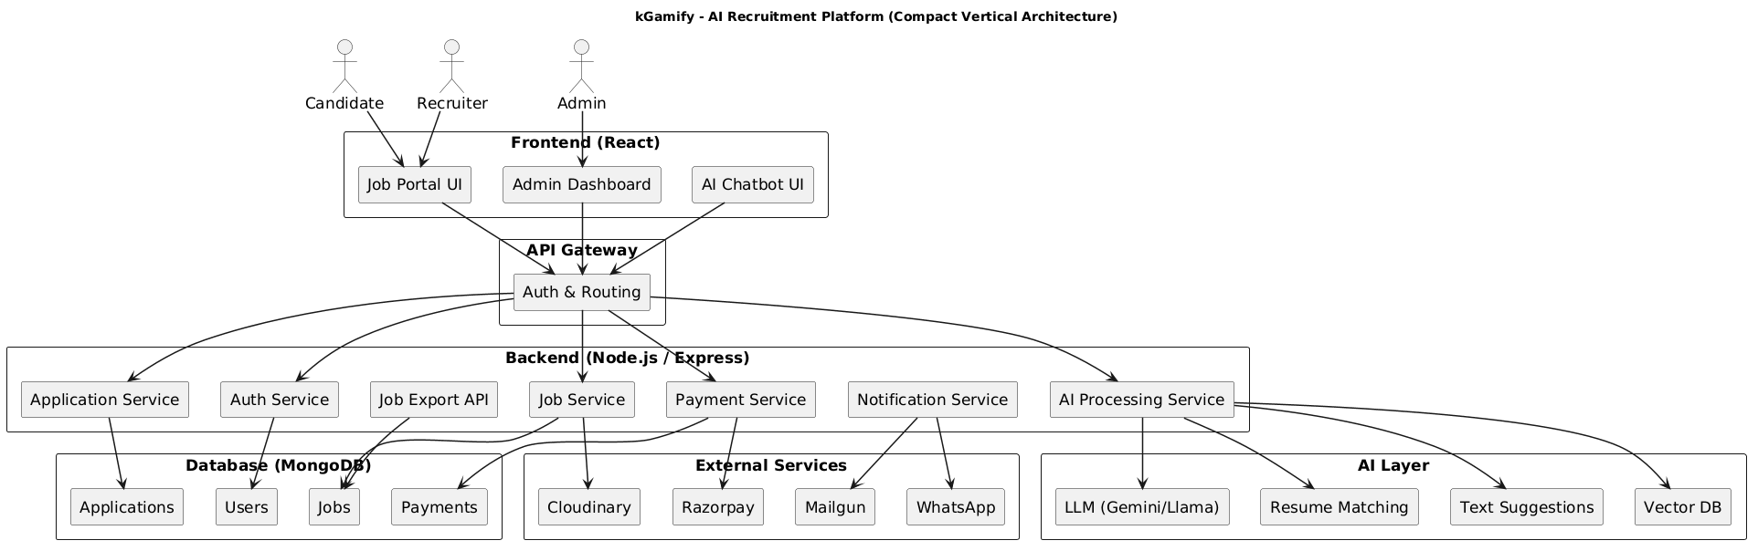

Fig. 1 – System Architecture

(This diagram illustrates the multi-tier architecture of kGamify, an AI-driven recruitment platform that connects candidates, recruiters, and admins through a React-based frontend. User requests are funneled through an API Gateway for authentication and routing before reaching specialized Node.js/Express backend services, such as payment and application management. Data is stored across several MongoDB collections and integrated with external providers like Razorpay for payments and Cloudinary for media. Finally, a dedicated AI Layer leverages Large Language Models (LLMs) and vector databases to power advanced features like resume matching and text suggestions).

4.1. Architecture Design
The system incorporates a robust client-server model based on the MERN stack to provide scalable and responsive service:
- Front-end: Responsible for the implementation of React.js, thereby developing an interactive user interface that makes the complicated recruitment processes simple to use by both candidates and recruiters.
- Back-end: Implemented using Node.js and express.js, which handle business logic, comfortable user authentication using JWT, and smooth communication through API Gateway.
- Statistics endurance: Managed using MongoDB, providing a flexible database architecture that is needed for storing individual information, jobs description, and resume hierarchy.

4.2. AI and NLP Implementation
An essential part of this methodology includes the use of artificial Intelligence in automating center recruiting activities which were done manually before:
- Semantic Analysis: Superior natural Language Processing (NLP) capabilities are employed by this system to turn unstructured resumes and job descriptions into semantic vector representations.
- Candidate Matching and Ranking: Instead of merely matching keywords, a scoring method based on similarity is employed, such as Cosine Similarity, to compare vectors and enable the gadget to rank candidates based on their contextual fit for a role.

- RAG Architecture: The chatbot on the platform employs a Retrieval Augmented Generative (RAG) system architecture. User requests are transformed into vectors and compared against the context stored in a vector database and then processed by large language models (LLMs) such as Gemini/Llama.

4.3. System Workflow and Integration
The procedure involves a multi-degree process as follows:
- Registration and verification: The group needs to follow a registration process together with methods of an administrative test to confirm their authenticity before being granted access to the platform.
- Smart Process of Posting: Task descriptions will be sent to the recruiters, and these need to be verified using artificial intelligence. The task will then be posted into the database.
- Payment & Top Category Admission: Subscription plan is used in a safe manner using the Razorpay API. The premium services can be activated only after the confirmation of payment. Revenue flow into accessing flow is ensured using webhooks.
- Utility Lifecycle: The candidates undergo the search & follow cycle, where their application form is directly stored and analyzed for recruitment teams to view the list of candidates rankedly.

4.4.Testing and Validation
In order to ensure the reliability and performance of the system for long-term use, there is a strict testing phase included within the process:

- Functional Testing: Ensuring each module, from user registration to job packages, works according to the Software Requirements Specification (SRS).
- Validation of AI Model: Testing the precision of the matching algorithm and relevance of the chatbot's responses with actual-world resumes and job data.
- Security and Performance: Performing audit of the JWT-based authentication common sense and guaranteeing that the charge gateway manages transaction failure in an effective way.
- Outcome Analysis: Using data gained from the investigation to make decisions about the development of algorithms, which meet the high-performance requirements of a professional recruitment portal.

The kGamify portal has been designed using the Agile-driven full-stack approach where MERN stack technology is utilized in creating a scalable and responsive recruitment ecosystem. With the help of React.js in the frontend, Node.js in the backend, and MongoDB for dynamic data storage, the platform consolidates all phases of the recruitment process with ease, aided by JWT for authentication and Razorpay for payment handling. The key highlight of the portal is the incorporation of AI and NLP where text embeddings and similarity score techniques are used to offer a context-aware ranking process, while the RAG chatbot enables real-time interaction. This dependable process, validated via exhaustive testing for efficiency and security, ensures a high-class recruitment system.

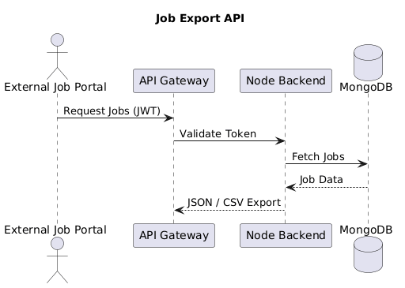

Fig. 2 – Job Export API Architecture
(This diagram illustrates the multi-tier architecture of kGamify, an AI-driven recruitment platform that connects candidates, recruiters, and admins through a React-based frontend. User requests are funneled through an API Gateway for authentication and routing before reaching specialized Node.js/Express backend services, such as payment and application management. Data is stored across several MongoDB collections and integrated with external providers like Razorpay for payments and Cloudinary for media. Finally, a dedicated AI Layer leverages Large Language Models (LLMs) and vector databases to power advanced features like resume matching and text suggestions).

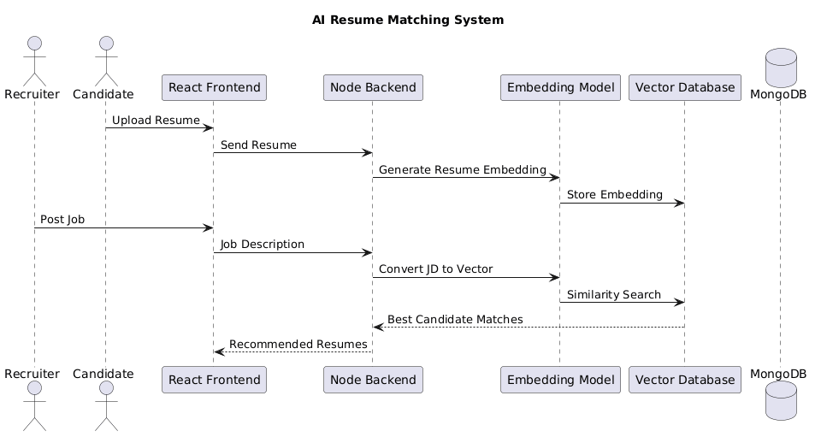

Fig. 3 - AI Resume Recommendation Architecture
(The AI Resume Matching System begins with candidates uploading resumes through the React frontend, which the Node backend then sends to an embedding model to generate numerical vectors. These resume embeddings are stored in a Vector Database to enable high-speed semantic retrieval rather than simple keyword matching. When a recruiter posts a job description, the system converts that text into a vector and performs a similarity search against the stored resumes. Finally, the best candidate matches are identified and returned to the frontend as recommended resumes for the recruiter to review).

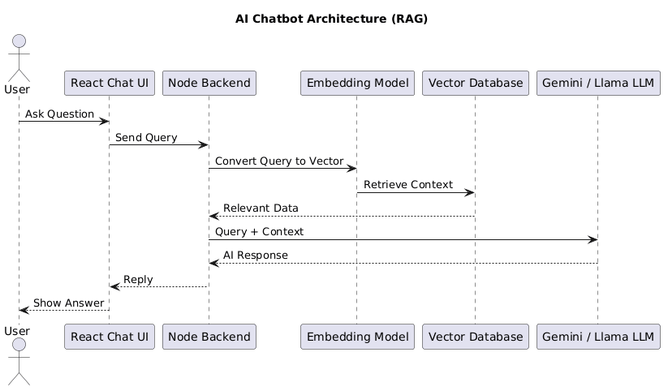

Fig. 4 - AI Chatbot Architecture - RAG Based
(This diagram depicts a Retrieval-Augmented Generation (RAG) architecture where a user query from the React UI is converted into a vector by an embedding model. The system uses this vector to perform a similarity search in a Vector Database, retrieving relevant data to provide specific context for the user's question. This context is then bundled with the original query and sent to a Large Language Model (LLM), such as Gemini or Llama, to generate a grounded and accurate response.
Finally, the generated answer is passed back through the Node backend and displayed to the user via the chat interface).

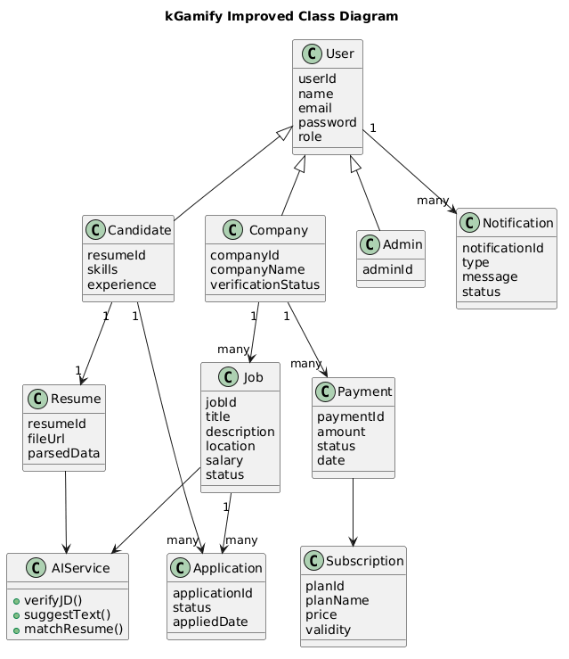

Fig. 5- Class Diagram
(The kGamify Class Diagram uses inheritance to define specific user roles, with Candidate, Company, and Admin extending a base User class that handles shared attributes like login credentials. Candidates are linked to their professional resumes and job applications, while Companies manage multiple job postings and track subscription-based payments. Relationships across the system ensure that a single Job can receive many Applications, which are then processed by an AIService to perform tasks like resume matching and text suggestions. Finally, a notification system is integrated at the base level to provide real-time status updates to all user types across the platform).

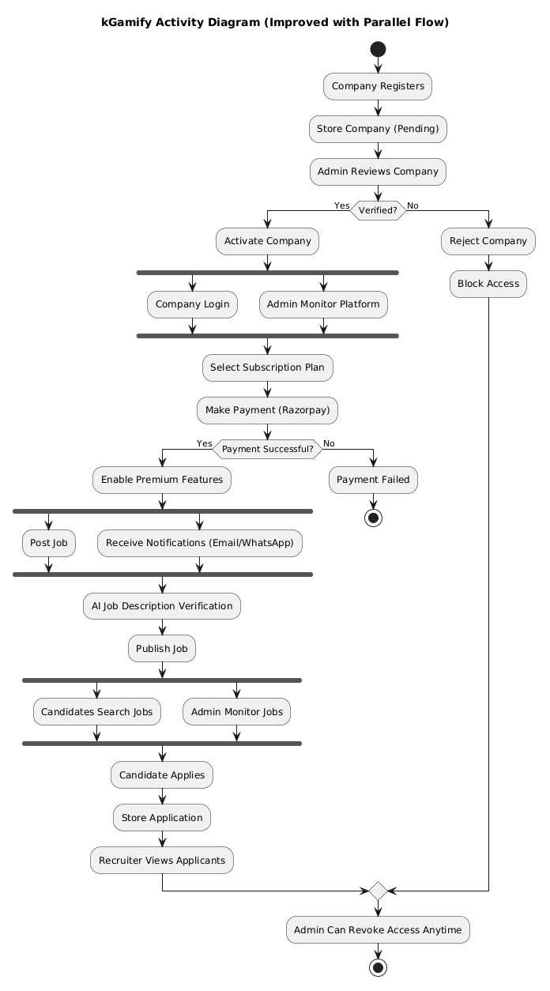

Fig. 6 – Activity Diagram

(The kGamify Activity Diagram outlines a company's journey from initial registration and admin verification to active participation on the platform. Following a successful Razorpay payment, companies unlock premium features and proceed through parallel workflows to post jobs while simultaneously receiving multi-channel notifications. The process incorporates an automated AI step for job description verification before listings are published for candidate discovery and application. Throughout the entire lifecycle, administrators maintain oversight with the ability to monitor activities and revoke access at any point to ensure platform integrity).

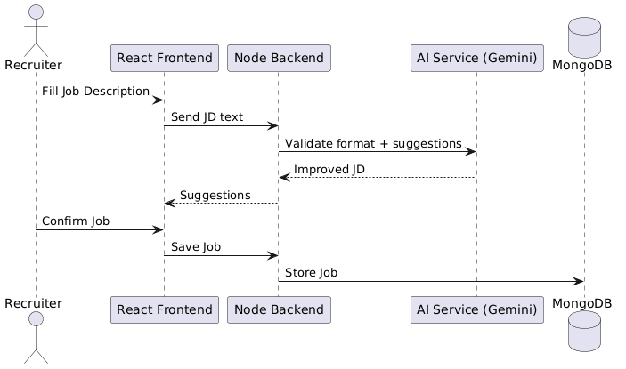

Fig. 7 – Sequence Diagram - AI Job Posting
(The AI Job Description Verification flow starts with a recruiter filling out job details in the React frontend, which are then passed to the Node backend. The backend leverages an AI Service (Gemini) to validate the formatting and provide intelligent suggestions to enhance the quality of the job post. These improvements and suggestions are sent back to the recruiter for review and confirmation through the user interface. Once the recruiter confirms the final version, the backend stores the finalized job data into the MongoDB database for publication).

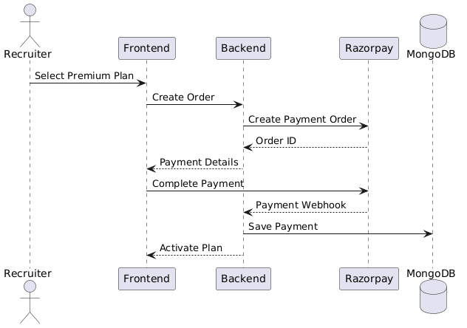

Fig. 8 - Sequence Diagram - RazorPay Payment
(This sequence diagram illustrates the Razorpay integration workflow, beginning when a recruiter selects a premium subscription plan via the frontend. The backend creates a payment order through the Razorpay API, which returns a unique Order ID that is then used by the recruiter to complete the transaction securely. Upon successful completion, Razorpay sends a payment webhook to the backend, ensuring a reliable and asynchronous confirmation of the transaction. Finally, the backend saves the payment record to MongoDB and triggers the frontend to activate the premium plan for the recruiter’s account).

GRAPHICAL USER INTERFACE

The kGamify activity Portal interface is professional and easy-to-use, providing an uncluttered dashboard-style interface which makes recruiting and task searching experience very simple. The homepage acts as an entry point for both recruiters and job seekers, whereas the side bar allows for easy navigation between different tasks, applications, and profiles.
Process Cards provide important documents such as role titles, companies, and real-time application popularity. These are supplemented by an AI-based compatibility rating. This is supported by the provision of a simple authentication system that ensures a secure log-in interface for all users. Easy-to-fill input forms for job postings that include AI-powered validation, along with high-quality call-to-action buttons enable recruiters to post vacancies while applicants can submit their resumes with ease.

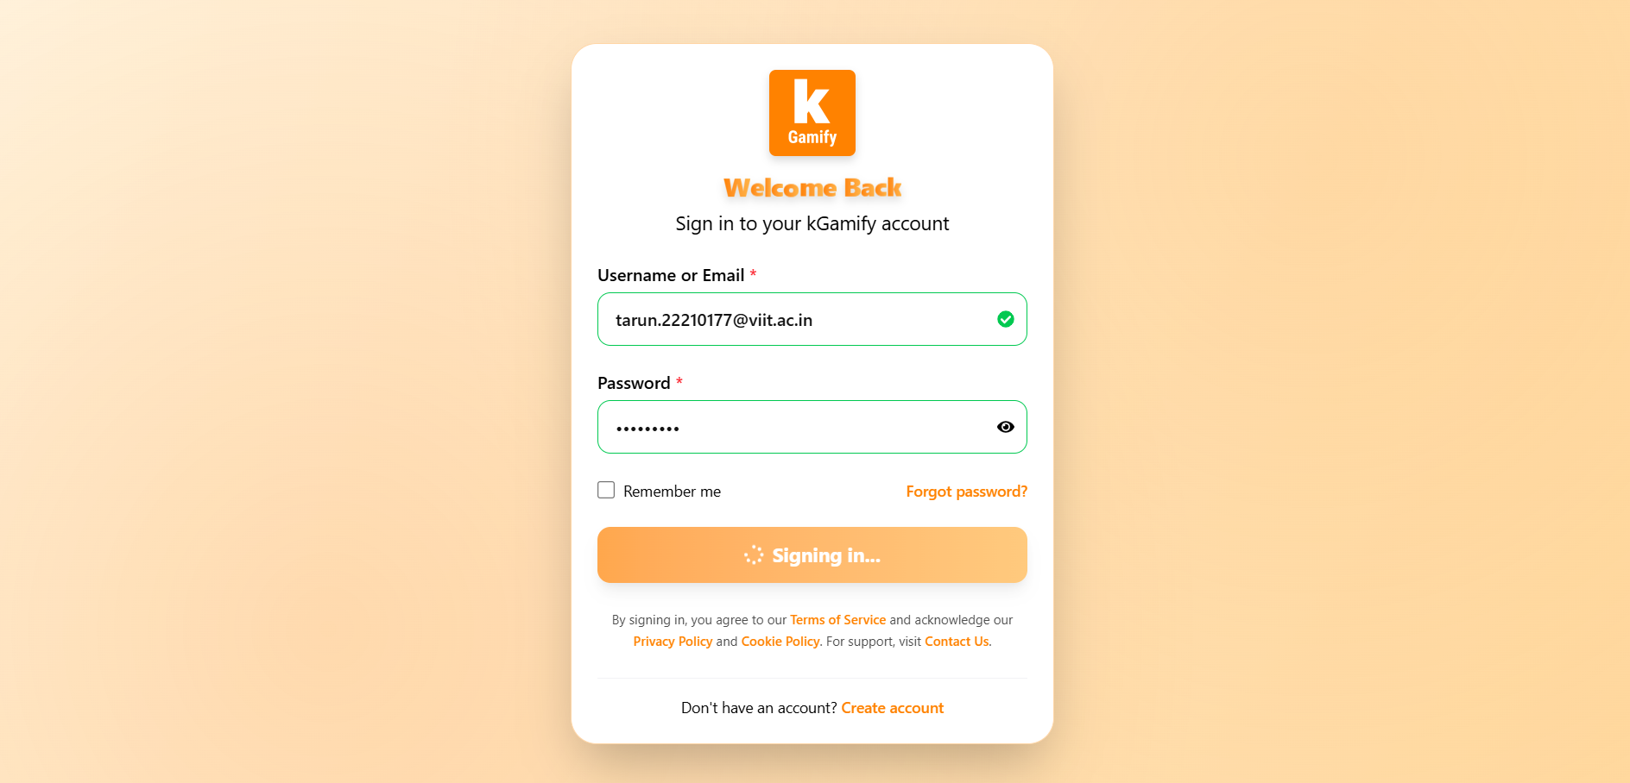
Fig. 9.1 – Login / Signup Page
(User authentication interface allowing users to securely register and log into the platform).
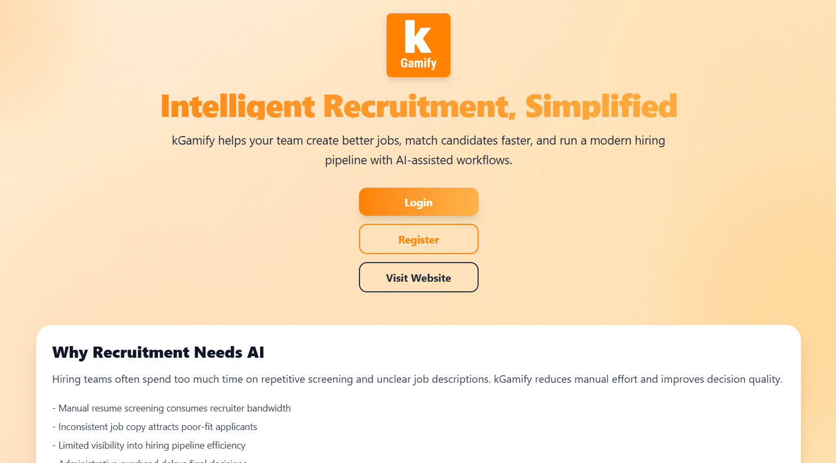

Fig. 9.2 – Homepage of Kgamify
(Landing page showcasing platform features, job listings, and navigation options for users).

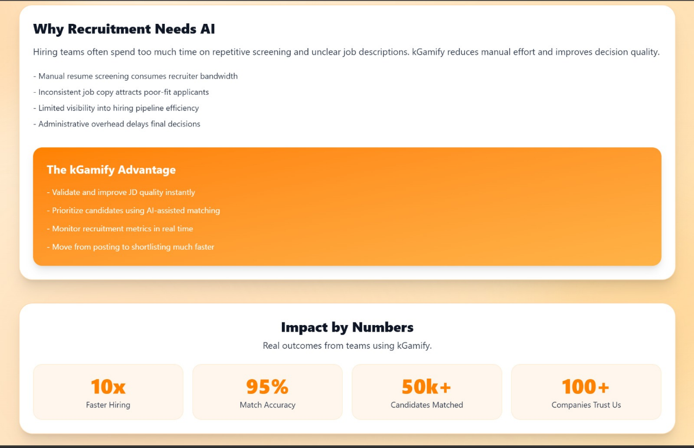
Fig. 9.3 – Homepage of Kgamify
(Interactive dashboard view providing quick access to job postings, applications, and key platform functionalities).

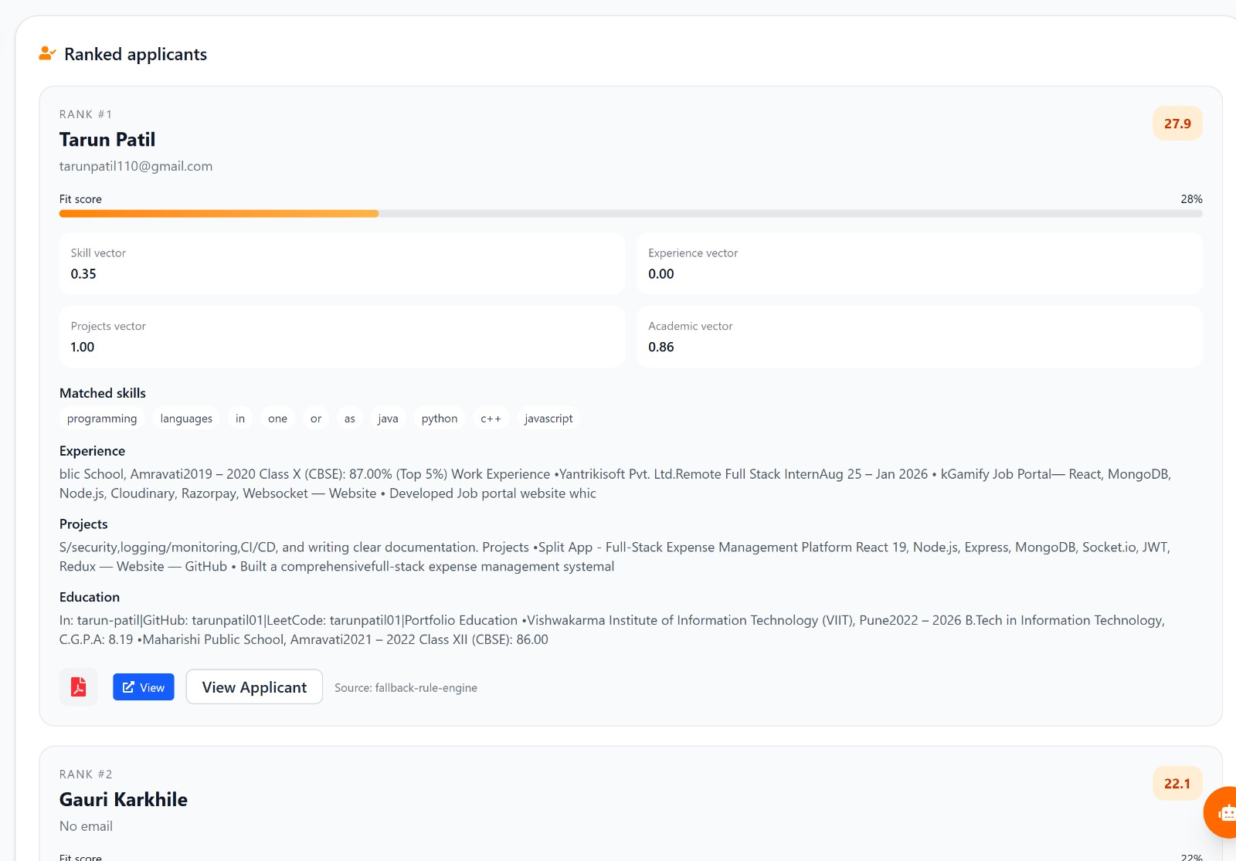

Fig. 10 – Analysis of Applicant
(Interface displaying AI-driven insights and evaluation metrics for candidate applications).

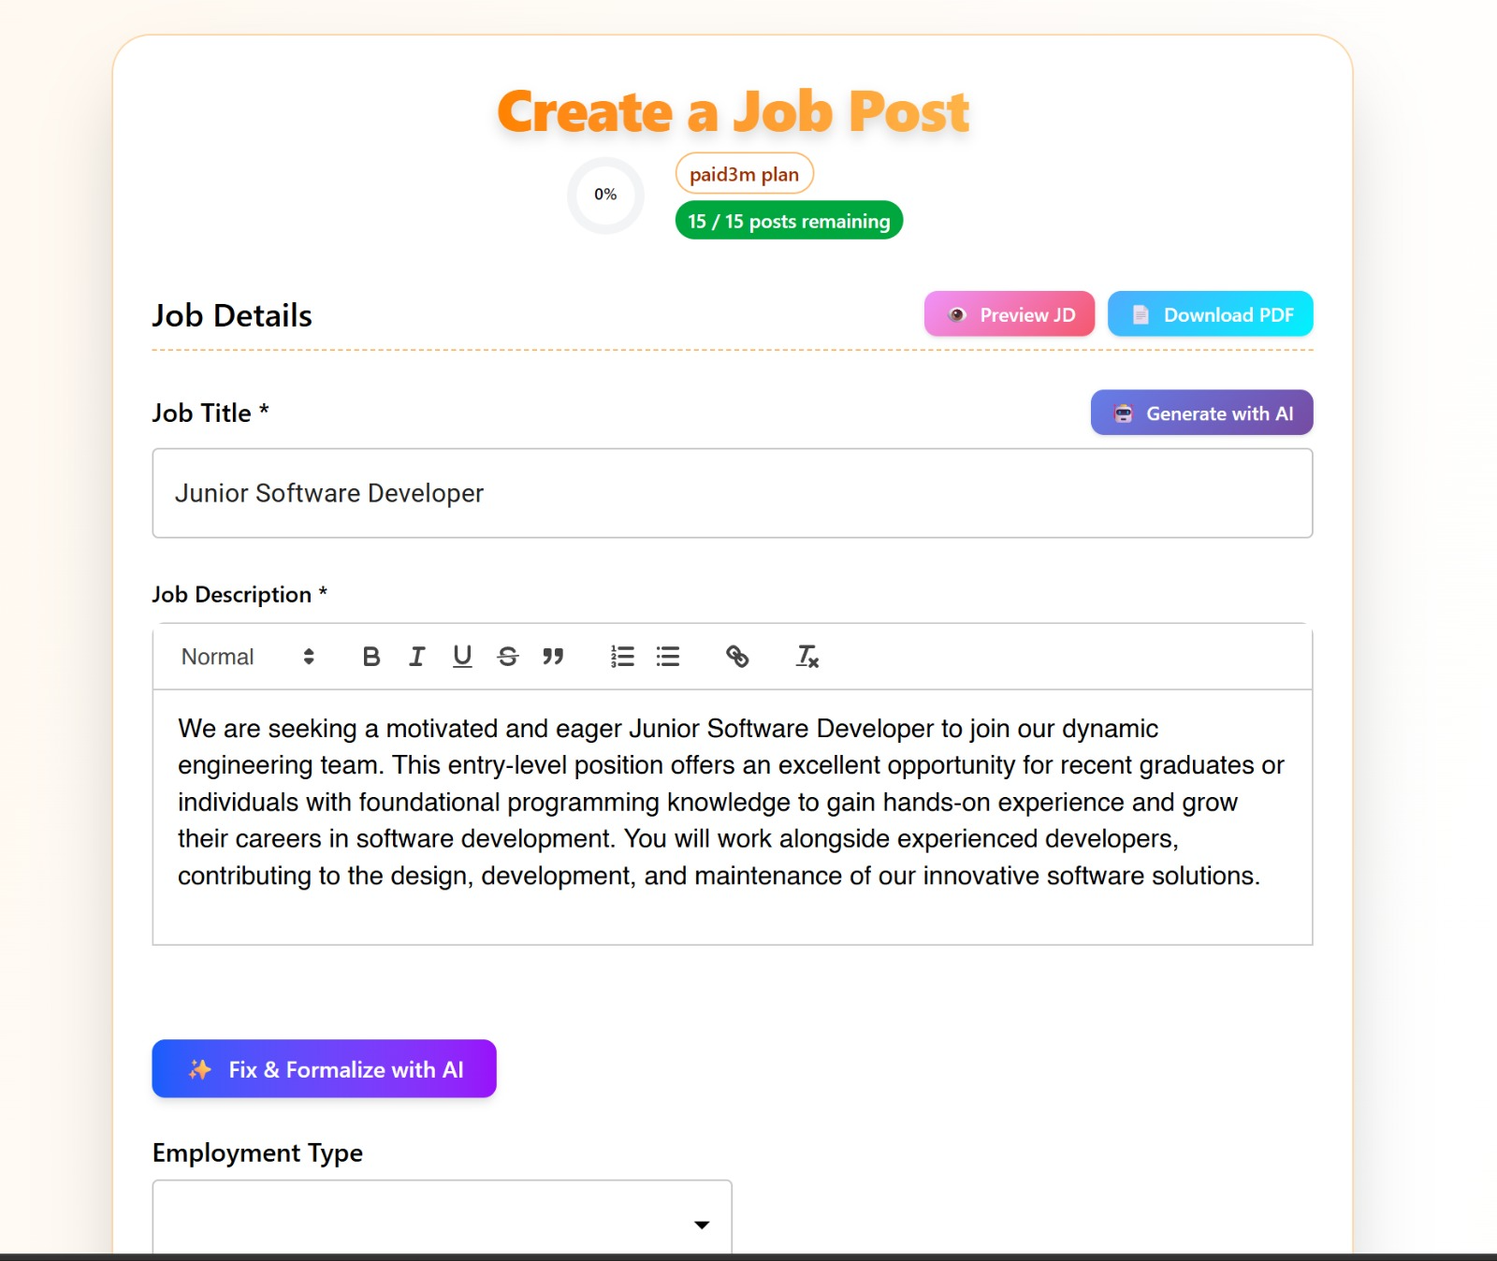
Fig. 11 – JD creation with AI
(Form interface where recruiters create job descriptions with real-time AI assistance).
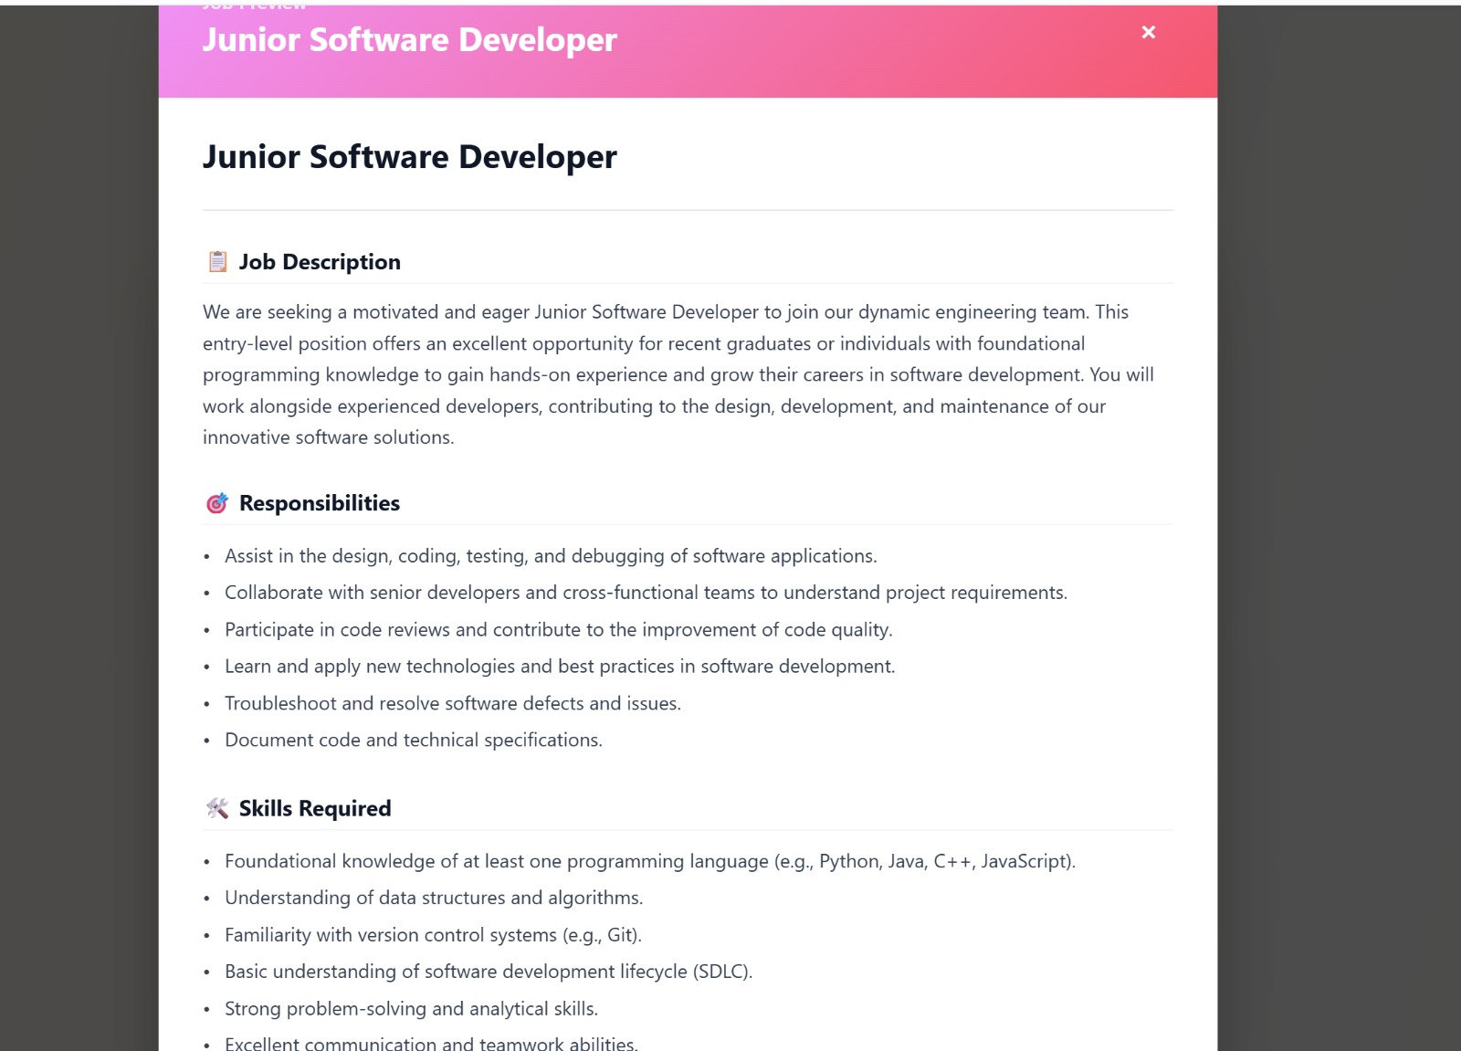

Fig. 12 – JD Preview
(Preview screen allowing users to review and finalize job descriptions before publishing).

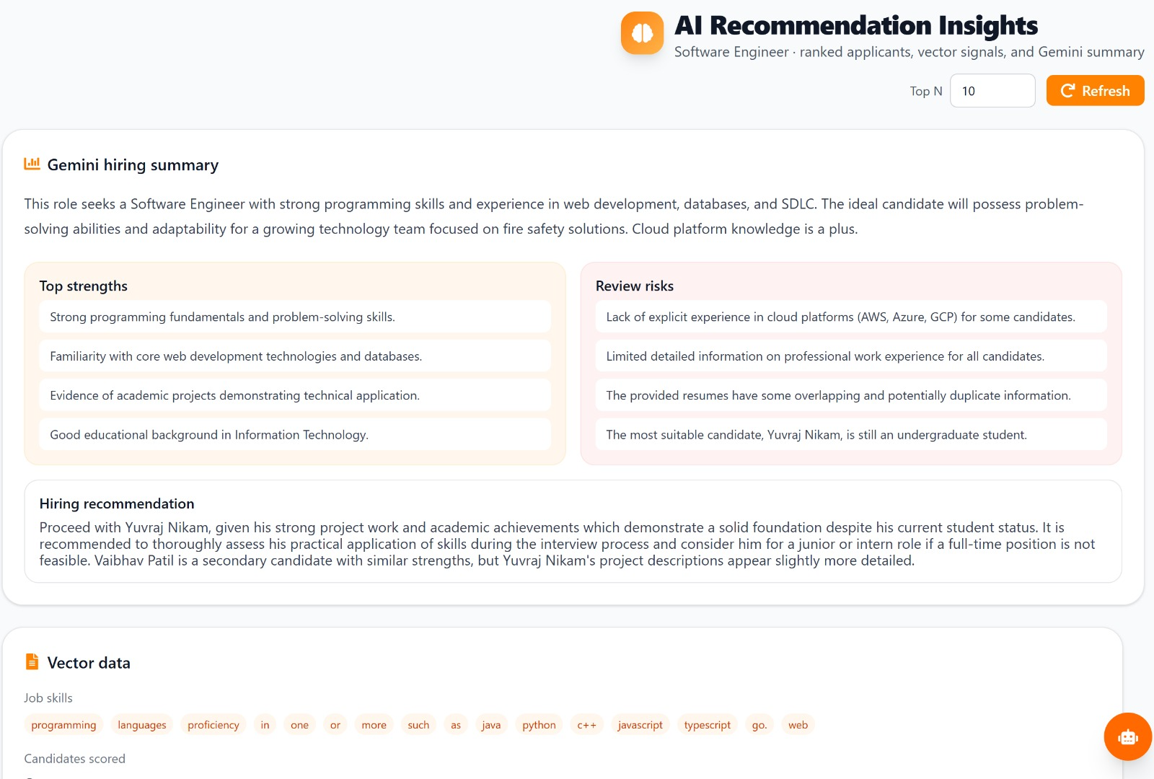

Fig. 13 – AI recommendation Insight
(Dashboard presenting AI-based recommendations for candidate-job matching).

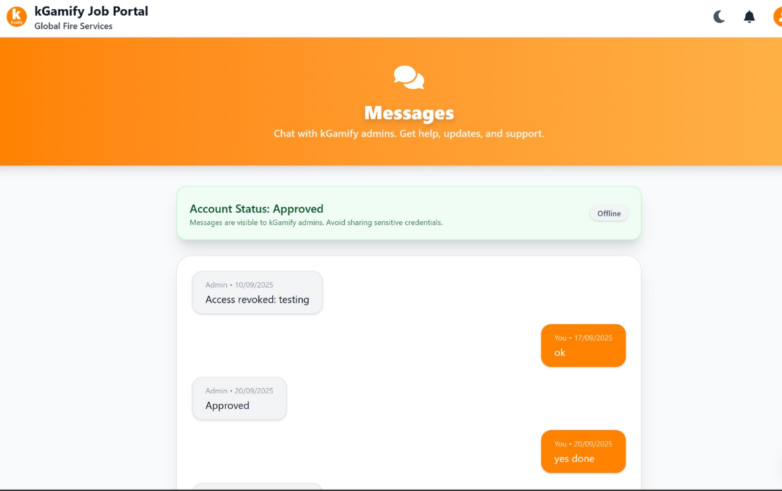

Fig. 14 – Real Time Messages
(Messaging interface enabling instant communication between recruiters and applicants).

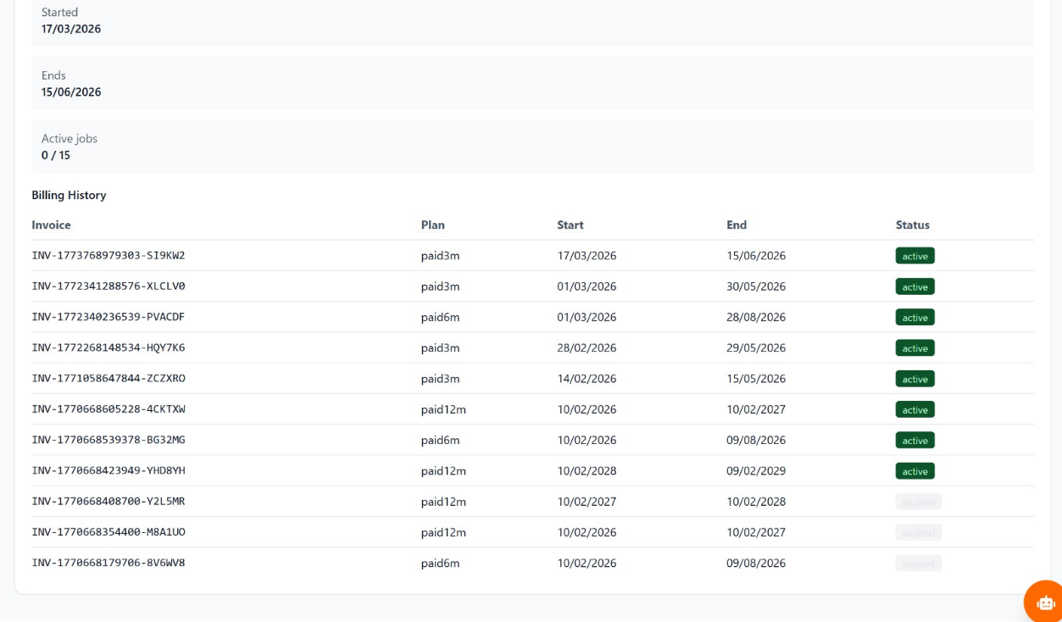

Fig. 15 - Billing history
(Section displaying past transactions, invoices, and subscription payment details).
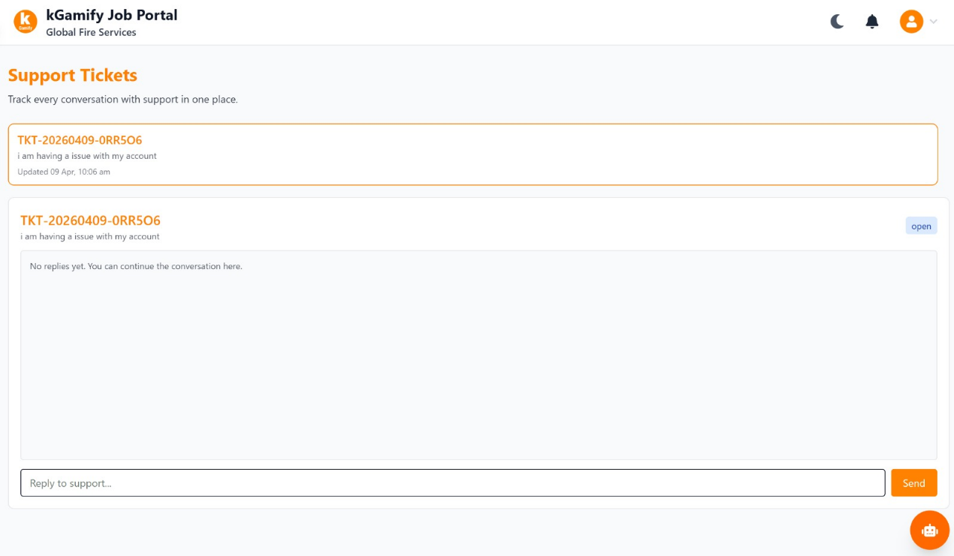

Fig. 16 – Support Tickets
(Interface for raising, tracking, and managing user support queries).

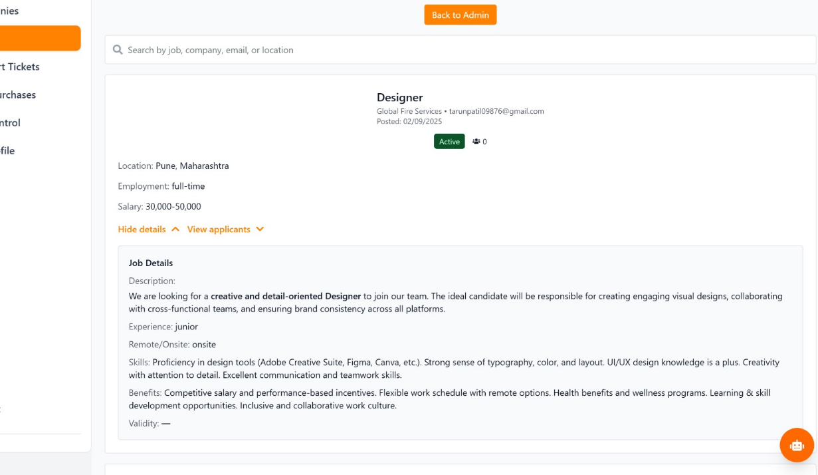

Fig. 17 – Job Management
(Dashboard for creating, editing, and monitoring job postings and applications).
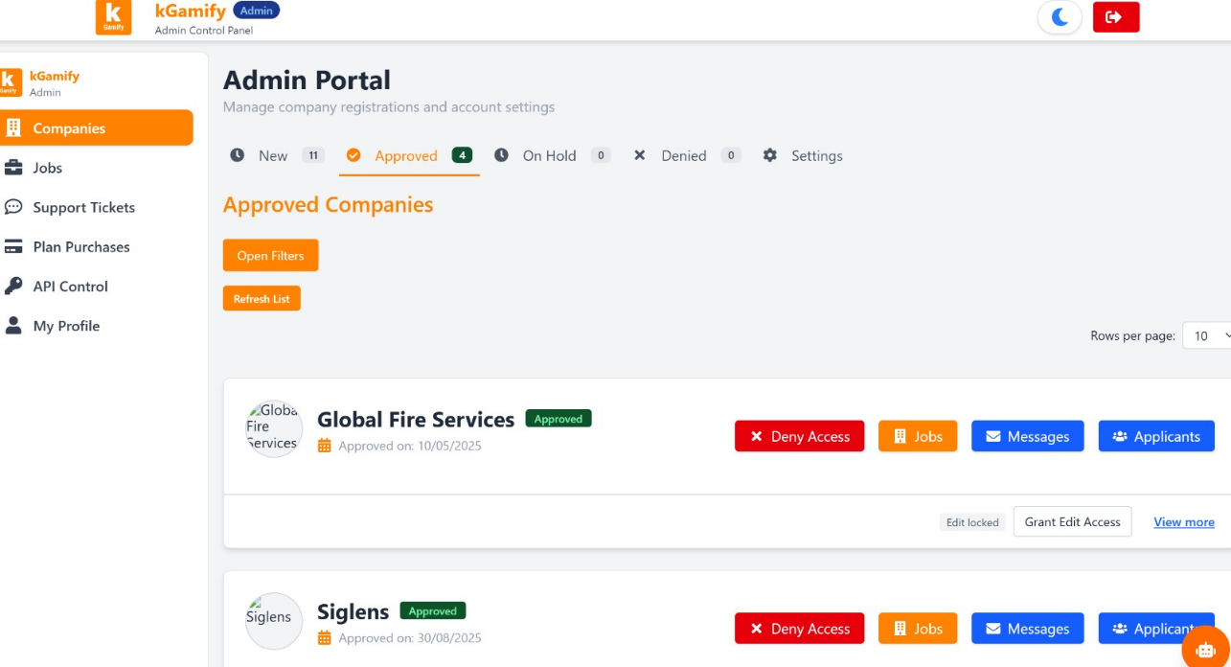

Fig. 18 – Admin Page Job Portal
(Administrative panel for managing users, jobs, and overall platform operations).

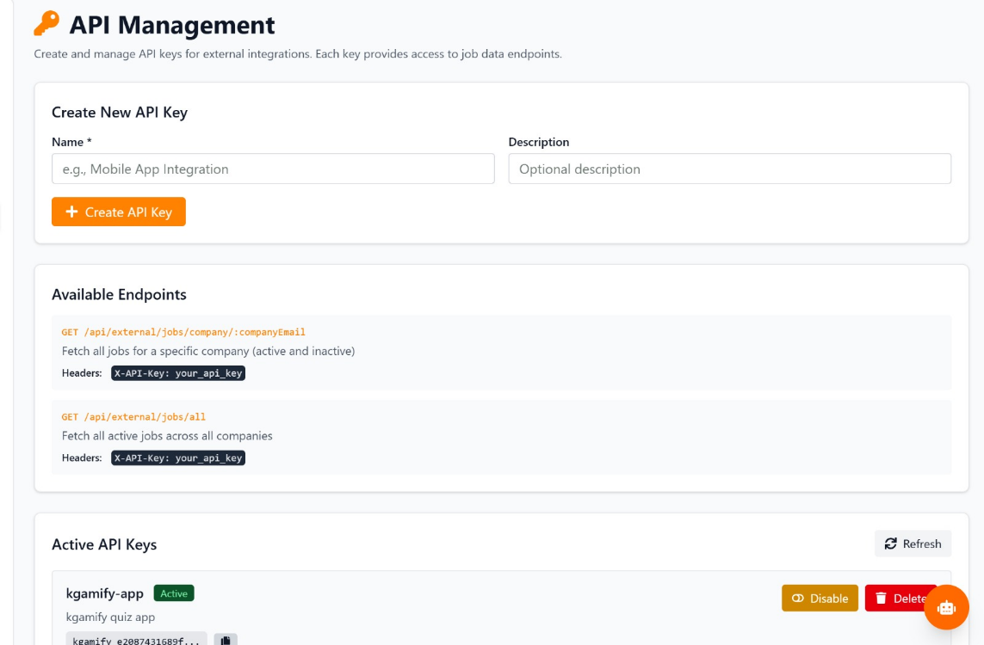

Fig. 19 – API Export Management
(Interface for managing job export APIs, including access control and data export options).

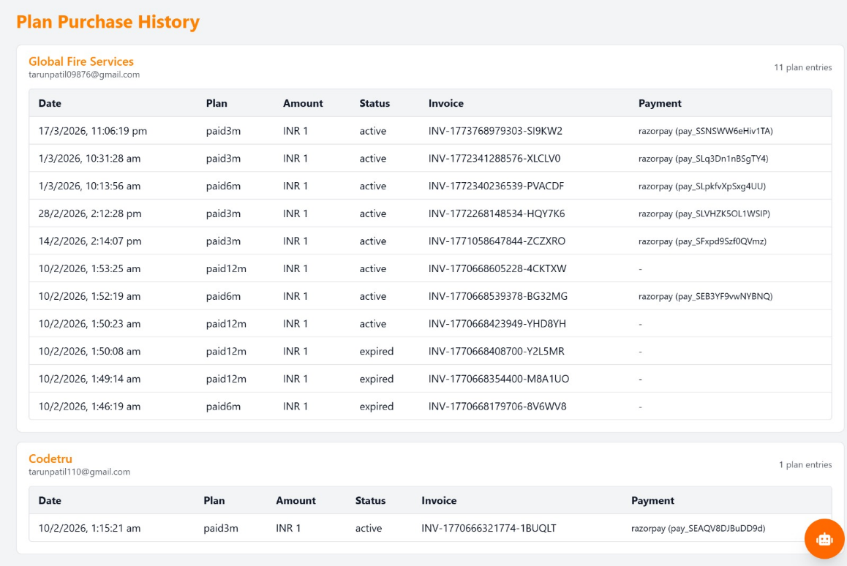
Fig. 20 – Plan purchase history
(Section showing records of subscription plans purchased by users).

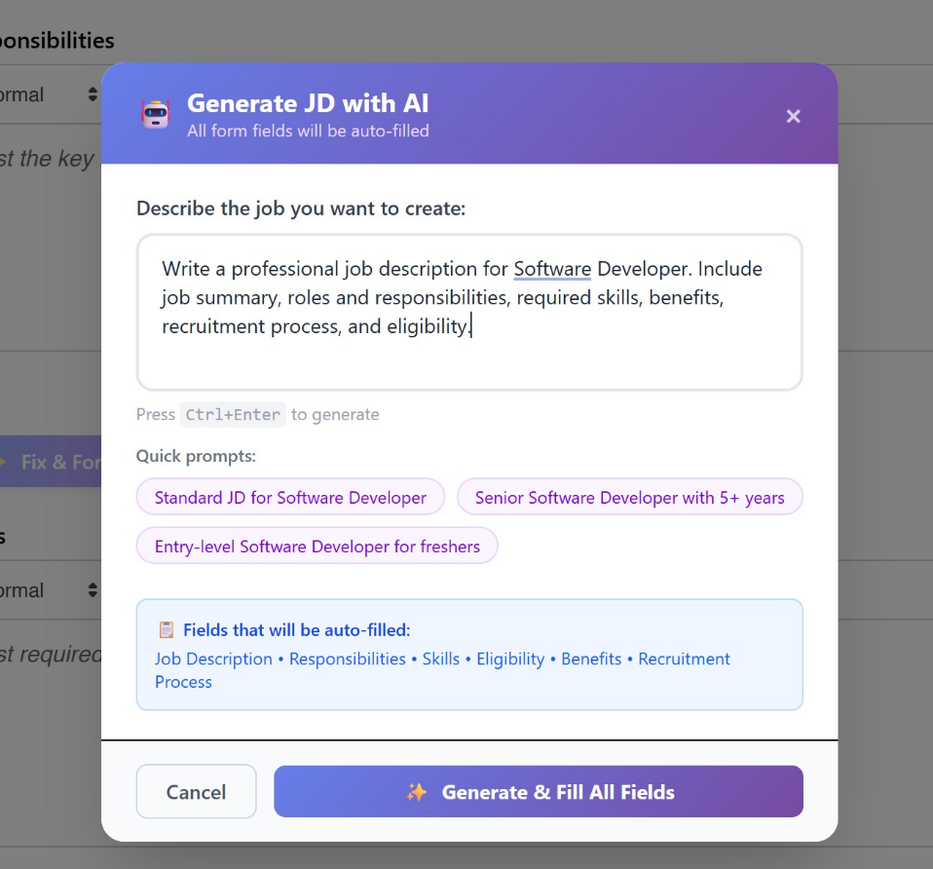

Fig. 21 – AI assistance for filling Job
(Real-time AI support interface that helps users improve job form inputs with suggestions).
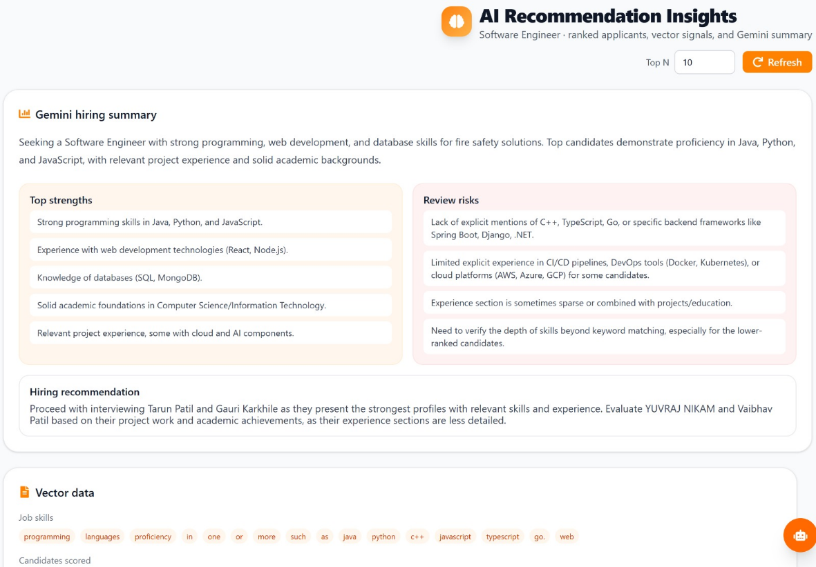

Fig. 22 – AI Resume Summarizer
(Tool that generates concise summaries of candidate resumes using AI).



Fig. 23 – Invoice / Mail sent to user
(Automated notification system displaying invoices and email confirmations sent to users).

- VERSION CONTROL & SOURCE CODE MANAGEMENT

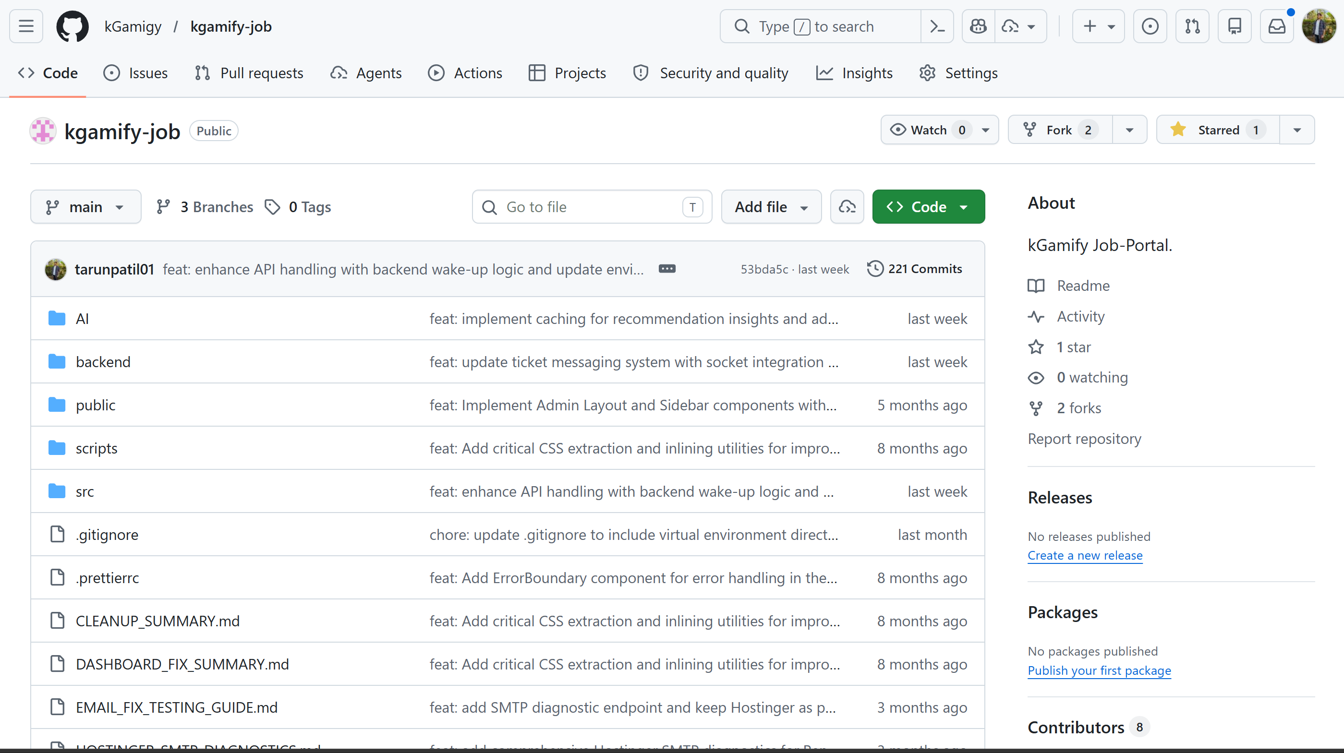

Fig.24 - Github Repository
(Link :- https://github.com/kGamigy/kgamify-job )

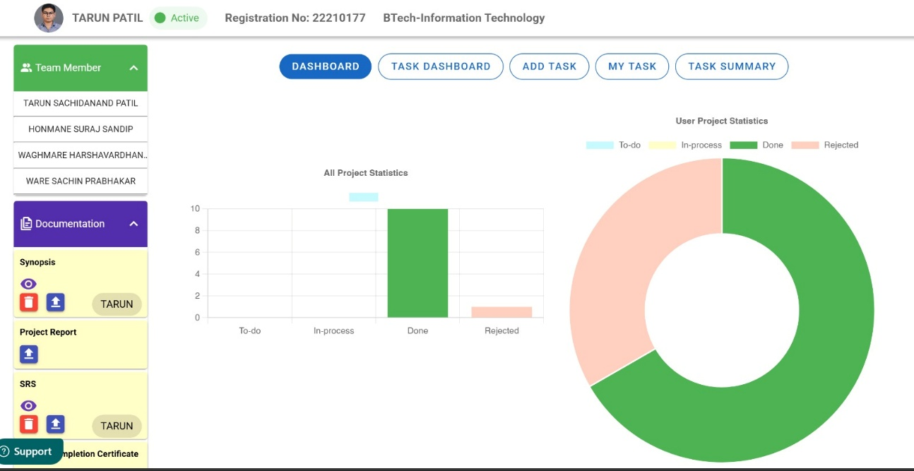

Fig.25 -Task management

CONCLUSION & FUTURE SCOPE

Conclusion :-
The kGamify assignment Portal is a great instance that illustrates how impactful it can be to include synthetic Intelligence within an organization’s central recruiting process to address the inherent inefficiencies in conventional recruiting practices. With the utilization of an up-to-date full stack technology structure like React.js, Node.js, explicit.js, and MongoDB, the assignment presents a robust, scalable, and fast platform that can deal with all the phases of recruiting, from onboarding corporations to advanced candidate shortlisting.
One of the critical accomplishments of this project is the successful passing beyond legacy, key-word-based filtering. The introduction of semantic text embedding and similarity scoring ensures that the gadget can perform an in-depth contextual evaluation of the candidate CVs against complicated process descriptions, ensuring that the recruiters get of suitable candidates that keyword search alone would have overlooked. Additionally, the application incorporates crucial management mechanisms through the use of AI-powered process description validation gadget, which will help the recruiters design job posts effectively and reduce the number of irrelevant applications from the source.
The addition of an AI chatbot that is built on a RAG system helps the platform's value proposition by offering real-time and context-aware assistance to the users, thus creating a connection between the users that is often missing on many other websites. Moreover, the use of a comfortable subscription model via Razorpay demonstrates that the platform is not only technologically robust but also commercially viable.
Concise, the kGamify mission Portal accomplishes its secondary goals of reducing guide screening, improving the quality of recruiting communications, and substantially increasing productivity on behalf of recruiting organizations and applicants. This project serves as an all-encompassing roadmap for the future of digital recruiting, demonstrating that data analytics and an AI-first strategy are critical to meeting the requirements of today’s rapidly evolving global business world.

Future Scope :-
KGamify Job Portal uses a modulated design framework that permits easy scaling and the incorporation of latest technology. even though the current portal is firmly based at the use of AI-powered matching and centralized management, the future roadmap incorporates quite a few significant upgrades to create an absolutely full-fledged AI-led human resources ecosystem.
The subsequent are the key aspects of our platform's future development that include the improvement of:
- AI-driven Video Interviewing & Behavioral Analysis: Future versions will aim at incorporating video interviewing algorithms which make use of AI for emotion analysis as well as sentiment analysis. This will ensure that the machine analyzes the behavioral attributes of the candidates' responses through their body language, tone of voice, etc., thus giving a complete overview beyond just technical skills.
- Credential Verification Based on Blockchain Technology: In order to delay resume fraud and improve data accuracy, the use of Blockchain technology could be employed in the immutability of certification and educational degree verification. Through storing the hashes of credentials in a decentralized ledger, the platform can deliver "instant verification" to recruiters.
- Analytical Skills Analytics: By taking into account historical data about hiring and the performance of candidates, the software should include Predictive Modeling to determine employee retention and organizational fit over a long period. This will help organizations make data-driven hiring decisions to minimize costs related to turnover.
- Mobile App Environment: Developing separate mobile apps for Android and iOS platforms will ensure a smooth transition into an app-only environment for job seekers. Features like push notifications about candidate-job matches and “one-touch” apps would significantly increase engagement.

- API Development Expansion: With its advanced API framework, it can be scaled out to become a full-fledged Developer Hub, enabling 1/3-celebration HR tools and agency websites to share job information in real time, making kGamify an integral part of a multi-structure recruitment spine.
- Integration of VR/AR Career Fairs: As the professional world shifts toward the metaverse, it must become home to virtual career fairs, where individuals can engage with recruiters in a 3-dimensional world, while gamifying the job searching experience based on the ‘kGamify’ brand identity.
This way, the platform would be able to stay ahead of the pack in the competitive world of HR tech services.

- OUTCOME

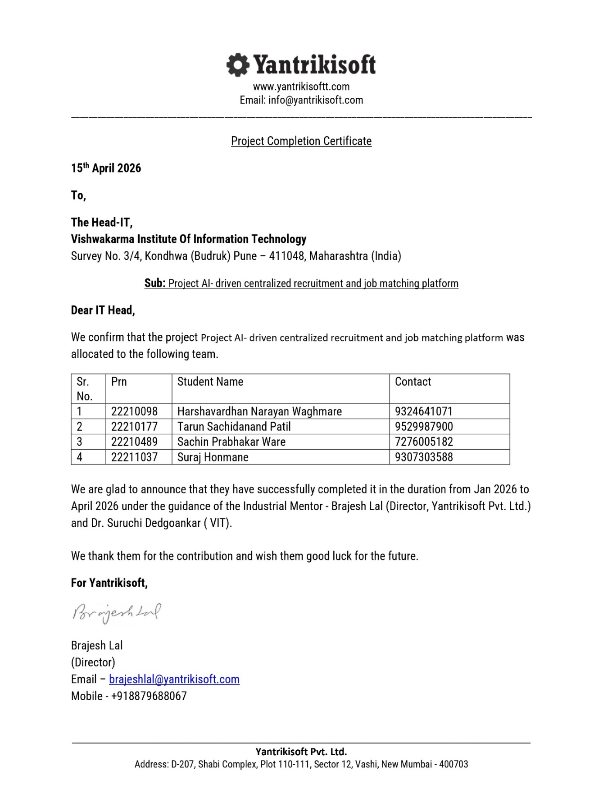

- REFERENCES

- S. Malhotra and R. Sharma, ‘AI-Powered Resume Screening and Job Matching System’, International Journal of Scientific Computing, vol. 12, no. 3, pp. 45-52, 2025.
- P. Verma and A. Gupta, ‘AI Powered Resume Parser for Enhanced Recruitment Process’, International Journal of Advanced Computing and Technology, vol. 9, no. 2, pp. 101-108, 2025.
- D. Patel and M. Shah, ‘AI-Based Resume Ranking System Using Semantic Similarity and Skill-Based Scoring’, Journal of Software Research and Technology, vol. 7, no. 1, pp. 22-30, 2025.
- K. Singh, R. Kumar, and S. Tiwari, ‘AI-Based Resume Screening and Ranking System’, International Journal of Scientific Computing and Innovation, vol. 11, no. 4, pp. 88-95, 2025.
- A. Mehta and S. Patel, ‘AI-Powered Resume Screening and Role-Fit Analysis System’, International Journal for Research in Applied Science and Engineering Technology, vol. 13, no. 5, pp. 1340-1346, 2025.
- N. Jain and P. Agarwal, ‘AI-Powered Automated Resume Screening and Job Matching System Using NLP and Machine Learning’, International Journal of Research in Engineering and Science Management, vol. 8, no. 2, pp. 59-66, 2025.
- R. Gupta, S. Verma, and A. Mishra, ‘Smart Application Tracking System Utilizing Generative AI for Efficient Resume Matching’, International Journal of Innovative Science and Research Technology, vol. 10, no. 1, pp. 122-129, 2025.
- Y. Zhang, L. Chen, and H. Wang, ‘AI-Driven Semantic Similarity-Based Job Matching Framework’, Information Sciences, vol. 670, pp. 120-134, 2026.
- J. Zhang, X. Li, and Y. Huang, ‘Learning Effective Representations for Person-Job Fit by Feature Fusion’, arXiv preprint arXiv:2006.07017, Jun. 2020.
- S. Kumar, R. Patel, and T. Singh, ‘ResumeAtlas: Resume Classification Using Large Language Models’, arXiv preprint arXiv:2406.18125, Jun. 2024.
- M. Anderson, L. Brown, and J. Davis, ‘Augmented Fine-Tuned LLMs for Recruitment Automation’, arXiv preprint arXiv:2509.06196, Sep. 2025.

