Project Report on
“AI-Driven Centralized Recruitment and Job Matching Platform”

Submitted by

Name | PRN
Sachin Ware | 22210489
Tarun Patil | 22210177
Harshvardhan Waghmare | 22210098
Suraj Honmane | 22211037

Under the Guidance of

Dr. Suruchi Dedgaonkar
DEPARTMENT OF INFORMATION TECHNOLOGY
BRACT's, Vishwakarma Institute of Information Technology
[MAR-2026]
Affiliated to


SAVITRIBAI PHULE PUNE UNIVERSITY

Project Report
For
AI-Driven Centralized Recruitment and Job Matching Platform

Table of Contents
1. Introduction
1.1 Purpose
1.2 Document Conventions
1.3 Intended Audience and Reading Suggestions
1.4 Product Scope
1.5 References
2. Overall Description
2.1 Product Perspective
2.2 Product Functions
2.3 User Classes and Characteristics
2.4 Operating Environment
2.5 Design and Implementation Constraints
2.6 User Documentation
2.7 Assumptions and Dependencies
3. External Interface Requirements
3.1 User Interfaces
3.2 Hardware Interfaces
3.3 Software Interfaces
3.4 Communications Interfaces
4. System Features
4.1 Feature Description
4.2 Priority Levels
5. Other Nonfunctional Requirements
5.1 Accuracy Tests
5.2 Stress Testing
5.3 Security Audits
6. Other Requirements
6.1 Glossary
6.2 Graphical User Interface
6.3 Diagrams
6.3.1 Architecture Diagram
6.3.1 Class Diagram
6.3.1 Activity Diagram
6.3.1 Sequence Diagram
7. References

- Introduction :
  - Purpose :
The purpose of this project is to develop an AI-Driven Centralized Recruitment and Job Matching Platform (kGamify Job Portal) that simplifies and improves the recruitment process for both recruiters and job seekers. The system provides a single platform where companies can post job opportunities and candidates can search and apply for relevant jobs.
The platform integrates Artificial Intelligence techniques to automate important recruitment tasks such as job description validation, resume analysis, and candidate-job matching. By using AI-based matching and ranking methods, the system helps recruiters quickly identify suitable candidates and reduces the time spent on manual resume screening.
The project also aims to improve the quality of job postings, assist users through an AI chatbot, and provide a scalable recruitment solution that enhances hiring efficiency, accuracy, and user experience.

  - Document Conventions :
This document follows a structured format to clearly describe the requirements of the AI-Driven Centralized Recruitment and Job Matching Platform. Headings and subheadings are organized using numbered sections to make the document easy to read and navigate.
Technical terms related to the system such as AI, API, database, and authentication are written in clear and consistent terminology throughout the document. Functional requirements describe the features and operations of the system, while non-functional requirements define system performance, security, and reliability expectations.
Where necessary, key system components, modules, and technologies are referred to using standard naming conventions to maintain clarity and consistency in the documentation.

  - Intended Audience and Reading Suggestions :
This document is intended for various stakeholders involved in the development and use of the AI-Driven Centralized Recruitment and Job Matching Platform. The primary audience includes project developers, system designers, testers, project supervisors, and administrators who need a clear understanding of the system requirements and functionalities.
Recruiters and companies using the platform can refer to relevant sections to understand how job posting, application management, and candidate evaluation features work. Developers and system architects should review the sections related to system features, interfaces, and constraints to guide the design and implementation of the platform. Testers can use the requirements defined in this document to design appropriate test cases and verify system functionality.
Readers are encouraged to start with the Introduction section to understand the project overview, followed by the Overall Description and System Features sections for detailed information about system operations and functionalities.

  - Product Scope
The AI-Driven Centralized Recruitment and Job Matching Platform (kGamify Job Portal) is a web-based system designed to streamline and automate the recruitment process. The platform allows companies to post job openings, manage candidate applications, and evaluate applicants through a centralized system. Job seekers can search for available jobs, upload resumes, and apply for positions that match their qualifications.
The system integrates Artificial Intelligence to enhance recruitment efficiency. AI techniques are used to validate job descriptions, analyze resumes, and match candidates with job requirements using similarity-based ranking. The platform also includes features such as an AI chatbot for user assistance, email notifications, subscription-based recruiter services, and an admin dashboard for platform management.
The overall scope of the product is to improve hiring efficiency, reduce manual effort in resume screening, and provide a scalable recruitment solution for companies and candidates.

  - References :
The development of this project is based on various technical resources and documentation related to modern web technologies and artificial intelligence systems. References include the official documentation of React.js for frontend development, Node.js and Express.js for backend server implementation, and MongoDB for database management. Authentication mechanisms were designed using the JWT (JSON Web Token) framework. For payment processing and subscription management, the Razorpay API documentation was referred to, while Mailgun API documentation was used for implementing email notification services. In addition, research papers, technical blogs, and online resources related to AI-based recruitment systems, resume analysis, and job matching techniques were also consulted to design and implement the intelligent features of the platform.

2. Overall Description
2.1 Product Perspective
The AI-Driven Centralized Recruitment and Job Matching Platform (kGamify Job Portal) is a web-based recruitment system designed to function as an independent platform that connects recruiters and job seekers. The system acts as a centralized environment where companies can create job postings, manage candidate applications, and evaluate potential employees, while candidates can search for jobs and apply through a single interface.
The platform integrates multiple modules such as job management, resume submission, AI-based resume matching, job description validation, chatbot assistance, and subscription management. These modules work together to automate and improve different stages of the recruitment process. The system also interacts with external services such as payment gateways for subscription plans and email services for notifications.
Overall, the platform is designed as a scalable and modular system that can be extended in the future with additional features such as advanced analytics, mobile applications, and AI-based candidate evaluation tools.

2.2 Product Functions
The major functions of the AI-Driven Centralized Recruitment and Job Matching Platform (kGamify Job Portal) include:
- User registration and login for recruiters, candidates, and administrators
- Company profile creation and management
- Job posting and job listing management by recruiters
- Job search and job application submission by candidates
- Resume upload and storage for candidate profiles
- AI-based resume analysis and candidate-job matching
- Automatic ranking and shortlisting of candidates based on job requirements
- AI-based job description validation to improve job posting quality
- AI chatbot assistance for answering user queries and providing platform guidance
- Email notification system for job applications, subscriptions, and updates
- Subscription and payment system for recruiter plans
- Job exporting API for third-party integrations
- Admin dashboard for managing users, jobs, and platform activities

2.3 User Classes and Characteristics
The system has three main classes of users, each with different roles and characteristics:
- Recruiters / Companies
- Organizations or HR representatives who use the platform to post job openings.
- They can create company profiles, manage job postings, and review candidate applications.
- Recruiters may subscribe to premium plans to access advanced recruitment features.
ii. Job Seekers / Candidates
- Individuals looking for job opportunities through the platform.
- They can create profiles, upload resumes, search for jobs, and apply to relevant job postings.
- Candidates may have different levels of experience, education, and technical knowledge.
iii. Administrators
- Platform managers responsible for maintaining and monitoring the system.
- They manage users, approve or review job postings, monitor platform activities, and generate reports.
- Administrators require a higher level of system access and technical understanding to manage the platform effectively.

2.4 Operating Environment
The AI-Driven Centralized Recruitment and Job Matching Platform (kGamify Job Portal) operates in a web-based environment that can be accessed through modern web browsers. The system is designed to run on standard computing devices such as desktop computers, laptops, tablets, and smartphones with internet connectivity.
The frontend of the platform is developed using React.js and is compatible with popular browsers such as Google Chrome, Mozilla Firefox, Microsoft Edge, and Safari. The backend services are implemented using Node.js and Express.js, while MongoDB is used for database management. The system is deployed on cloud-based hosting services and integrates external services such as payment gateways and email notification APIs.
Overall, the platform requires a stable internet connection, a web browser, and a server environment capable of running Node.js applications and database services.

2.5 Design and Implementation Constraints
The development of the AI-Driven Centralized Recruitment and Job Matching Platform (kGamify Job Portal) is subject to several design and implementation constraints. The system must be developed using web technologies such as React.js for the frontend, Node.js and Express.js for the backend, and MongoDB for database management. Integration with external services such as payment gateways and email notification APIs must follow the guidelines and limitations defined by those service providers.
The platform must also operate within the constraints of internet-based systems, including network availability, server performance, and data security requirements. AI features such as resume matching and job description validation depend on external AI models and APIs, which may have usage limits or response time constraints.
Additionally, the system must ensure secure handling of user data, authentication processes, and payment transactions while maintaining performance and scalability for multiple users accessing the platform simultaneously.

2.6 User Documentation
The system will provide basic user documentation to help users understand and operate the platform effectively. This documentation may include user guides, help sections, and FAQs that explain how to use the major features of the system.
Recruiters will be guided on how to create company profiles, post job openings, manage applications, and use AI-assisted tools. Candidates will receive instructions on creating profiles, uploading resumes, searching for jobs, and submitting applications. Administrators will have documentation describing how to manage users, monitor job postings, and maintain platform operations.
In addition, the platform may include on-screen guidance, tooltips, and chatbot assistance to help users navigate the system and resolve common queries.

2.7 Assumptions and Dependencies
The development and operation of the AI-Driven Centralized Recruitment and Job Matching Platform depend on several assumptions and external dependencies. It is assumed that users will have access to a stable internet connection and modern web browsers to use the platform. Recruiters and candidates are expected to provide accurate information such as job details and resumes for the system to perform effective matching.
The system also depends on external services and technologies, including cloud hosting services for deployment, payment gateway services for subscription processing, and email service providers for sending notifications. AI-based features rely on external AI models and APIs for resume analysis, job description validation, and chatbot responses.
In addition, the platform assumes that the integrated databases and third-party services will remain available and function correctly to support the system’s overall performance and reliability.

3. External Interface Requirements
External Interface Requirements describe how the system interacts with users, hardware devices, external software systems, and communication networks. These interfaces define how data is exchanged between the platform and external components to ensure smooth system operation.
3.1 User Interfaces
The system provides a web-based user interface that allows users to interact with the platform easily. The interface is designed to be simple, responsive, and user-friendly so that recruiters, candidates, and administrators can perform their tasks efficiently.
- Recruiter Interface: Allows companies to create profiles, post jobs, manage applications, and view candidate details.
- Candidate Interface: Allows users to create accounts, upload resumes, search for jobs, and apply for job postings.
- Admin Interface: Provides administrative controls to manage users, monitor job postings, and view system activities.
- The interface supports responsive design so it can work on desktops, laptops, tablets, and smartphones.

3.2 Hardware Interfaces
The system does not require any specialized hardware components and operates on standard computing devices. Users can access the platform using devices such as desktop computers, laptops, tablets, or smartphones. The system interacts with basic hardware components including input devices such as keyboards and mice for user interaction and display screens for presenting the user interface.
The server-side components run on cloud-based infrastructure that supports Node.js applications and database services. Network hardware such as routers and internet connectivity is required for communication between users and the platform.

3.3 Software Interfaces
The system interacts with several software components and external services to perform its operations. The frontend interface is developed using React.js, which communicates with backend services through REST APIs built using Node.js and Express.js. The platform uses MongoDB as the primary database for storing user information, job postings, resumes, and application data.
The system also integrates with external APIs and services such as AI model APIs for resume analysis and job matching, payment gateway APIs for subscription processing, and email service APIs for sending notifications. These software interfaces allow the platform to exchange data and perform automated functions efficiently.

3.4 Communications Interfaces
The system communicates through standard internet communication protocols to enable interaction between users, servers, and external services. The platform uses HTTP/HTTPS protocols for secure data transfer between the frontend interface and backend server.
Communication between the client and server is handled through RESTful APIs, which allow the frontend application to send and receive data such as user information, job postings, and application details. The system also communicates with external services such as payment gateways, email notification services, and AI APIs through secure API requests over the internet.
These communication interfaces ensure reliable data exchange, system security, and smooth operation of the platform.

4. System Features
System features describe the main functionalities provided by the AI-Driven Centralized Recruitment and Job Matching Platform. These features define the important services the system offers to users such as job posting, job searching, resume upload, AI-based candidate matching, chatbot assistance, and platform administration.

4.1 Feature Description
The system includes several features that support the recruitment process for recruiters, candidates, and administrators.
- User Registration and Login: Users can create accounts and securely log in to access the platform.
- Company Profile Management: Recruiters can create and manage company profiles.
- Job Posting System: Recruiters can post job openings with details such as job role, skills, experience, and location.
- Job Search and Application: Candidates can search available jobs and apply directly through the platform.
- Resume Upload: Candidates can upload resumes for job applications.
- AI-Based Resume Matching: The system analyzes resumes and matches candidates with job requirements.
- AI Job Description Validation: The system checks job descriptions for completeness and clarity.
- AI Chatbot Assistance: Users can interact with a chatbot to receive help and answer queries.
- Admin Dashboard: Administrators can monitor users, job postings, and system activities.

4.2 Priority Levels
The system features are categorized based on their priority to ensure proper development and implementation of the platform.
- High Priority:
Core features that are essential for the system to function properly, such as user registration and login, job posting, job search, resume upload, job application submission, and AI-based resume matching.
- Medium Priority:
Important features that improve system functionality and user experience, such as AI job description validation, email notifications, and admin dashboard management.
- Low Priority:
Additional features that enhance the platform but are not critical for basic operation, such as AI chatbot assistance, advanced analytics, and future feature integrations.

5. Other Nonfunctional Requirements
Nonfunctional requirements define the quality attributes and performance standards of the system. These requirements ensure that the AI-Driven Centralized Recruitment and Job Matching Platform operates reliably, securely, and efficiently under different conditions.

5.1 Accuracy Tests
Accuracy tests are performed to ensure that the system provides correct and reliable results. The AI-based resume matching system must accurately analyze resumes and compare them with job descriptions to generate relevant candidate rankings.
The system should also verify that job descriptions, user inputs, and application data are processed correctly without errors. Testing will be conducted to ensure that search results, job applications, and system responses produce accurate outputs based on the given inputs.

5.2 Stress Testing
Stress testing is performed to evaluate how the system performs under heavy workloads and high user traffic. The platform should be able to handle multiple users accessing the system simultaneously without significant performance degradation.
During stress testing, the system will be tested with a large number of job postings, resume uploads, and job applications to ensure that the server, database, and APIs can manage high volumes of requests. This helps identify performance bottlenecks and ensures that the system remains stable and responsive even during peak usage.

5.3. Security Audits
Security audits are conducted to ensure that the system protects user data and prevents unauthorized access. The platform must implement secure authentication mechanisms such as password encryption and token-based authentication to protect user accounts.
Regular security checks will be performed to identify vulnerabilities such as unauthorized data access, injection attacks, and improper data handling. The system will also ensure secure communication using HTTPS protocols and protect sensitive information such as personal details, resumes, and payment data.

6. Other Requirements
6.1 Glossary
- AI (Artificial Intelligence): Technology that enables computers to perform tasks such as data analysis, decision-making, and pattern recognition.
- API (Application Programming Interface): A set of rules that allows different software systems to communicate and exchange data.
- Resume Matching: The process of comparing candidate resumes with job descriptions to find the most suitable candidates.
- Job Portal: An online platform where recruiters post job opportunities and candidates apply for jobs.
- Recruiter: A company or HR representative responsible for posting jobs and selecting candidates.
- Candidate: A job seeker who applies for job opportunities through the platform.
- Database: A system used to store and manage structured information such as user profiles, job postings, and applications.
- Authentication: The process of verifying the identity of a user before allowing access to the system.
- Admin: A user with special privileges who manages and monitors the overall platform operations.
6.2 Graphical User Interface
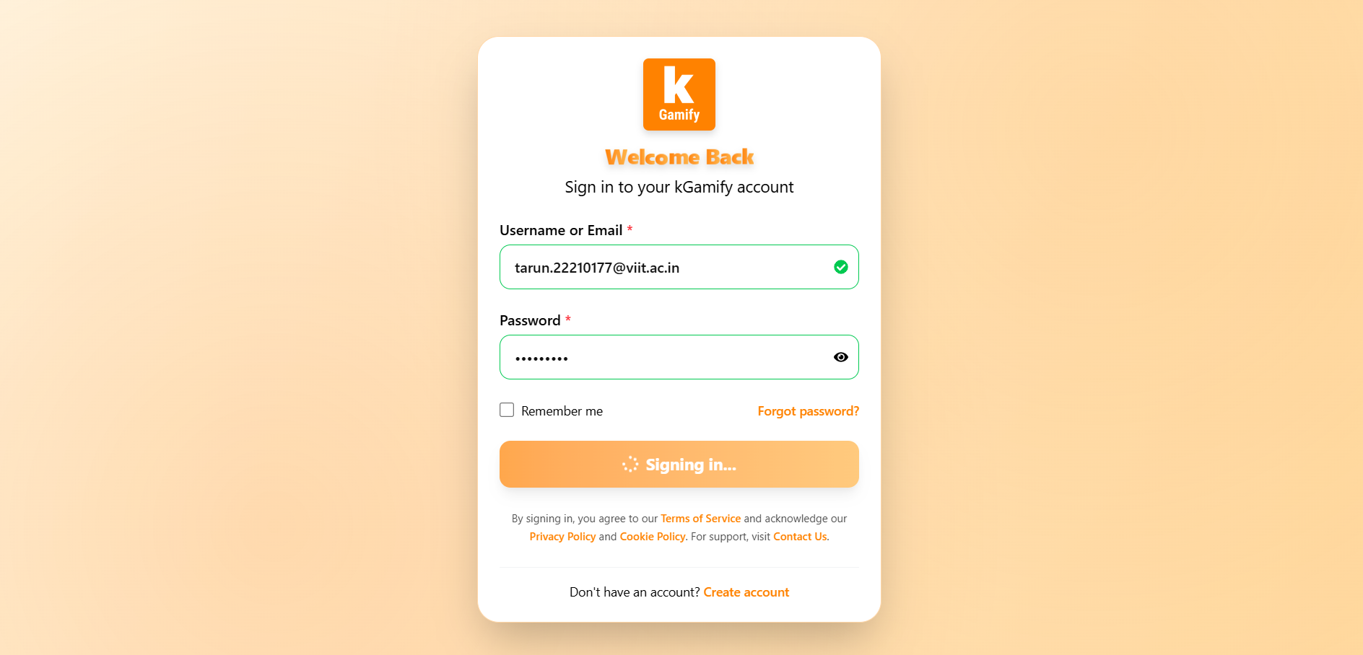
Fig.1 – Login / Signup Page
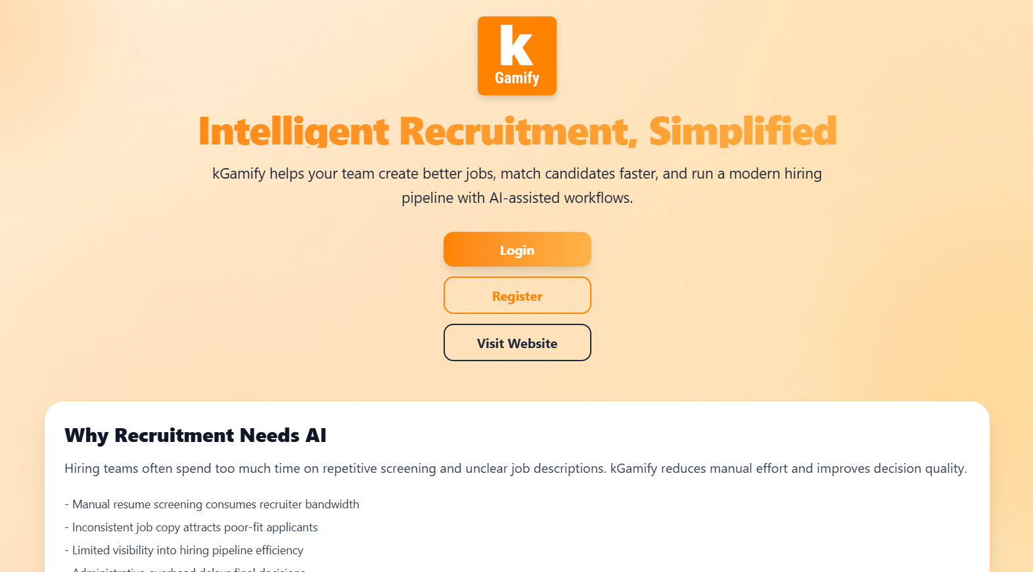
Fig. 2.1 – Homepage of Kgamify
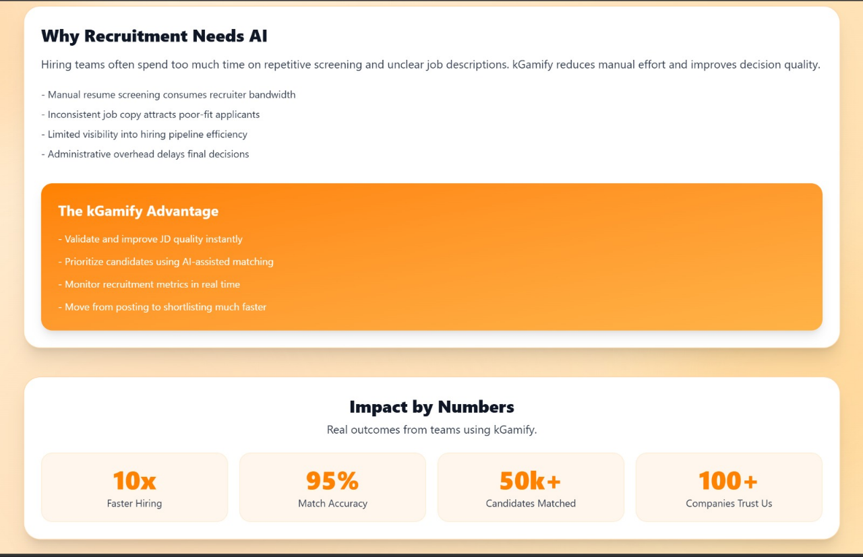
Fig. 2.2 – Homepage of Kgamify

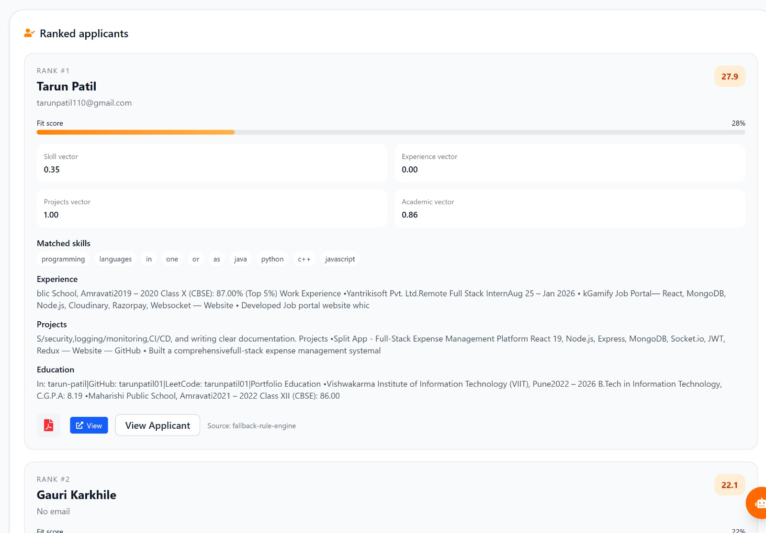
Fig. 3 – Analysis of Applicant
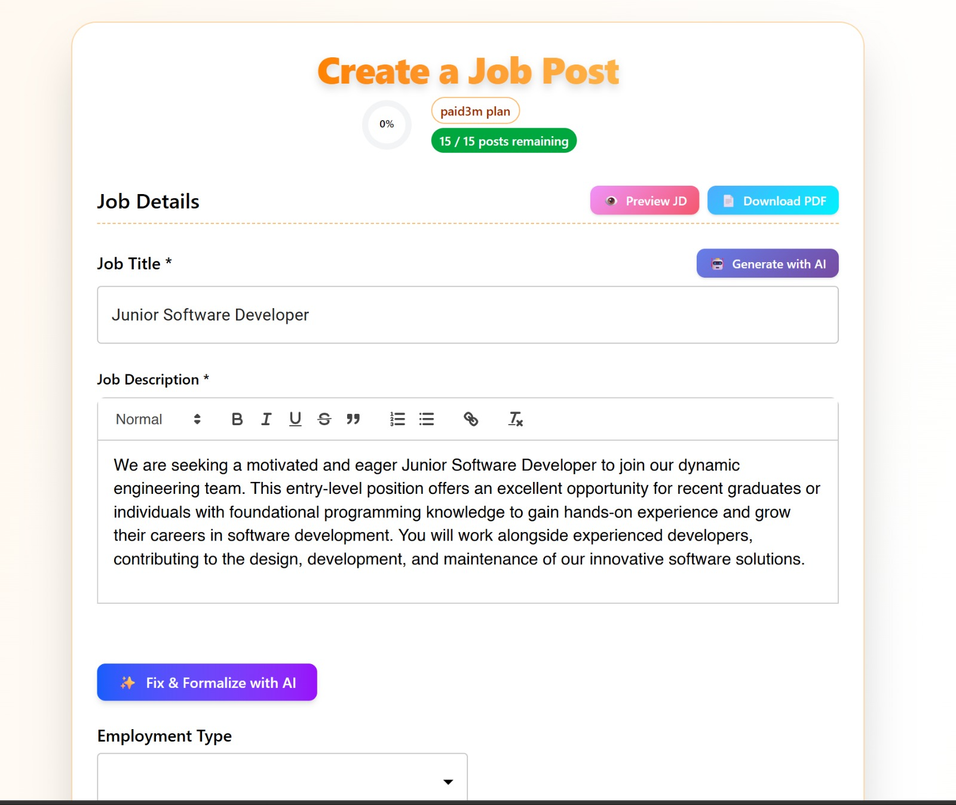
Fig. 4 – JD creation with AI
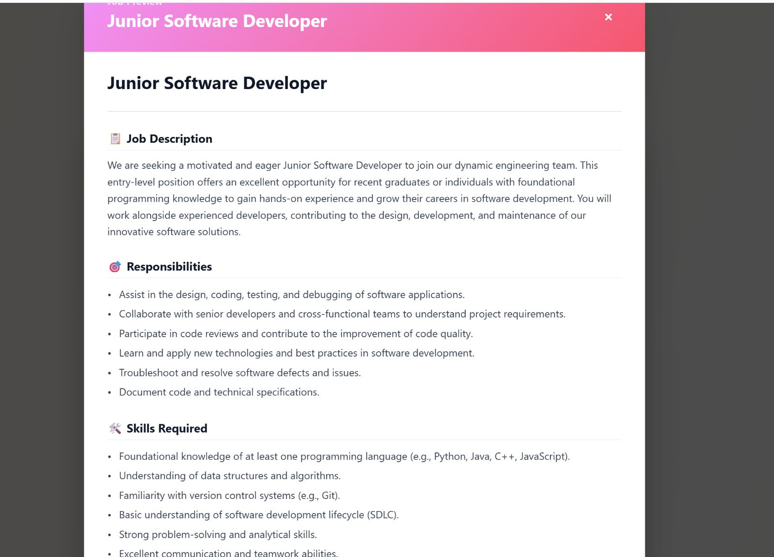
Fig. 5 – JD Preview
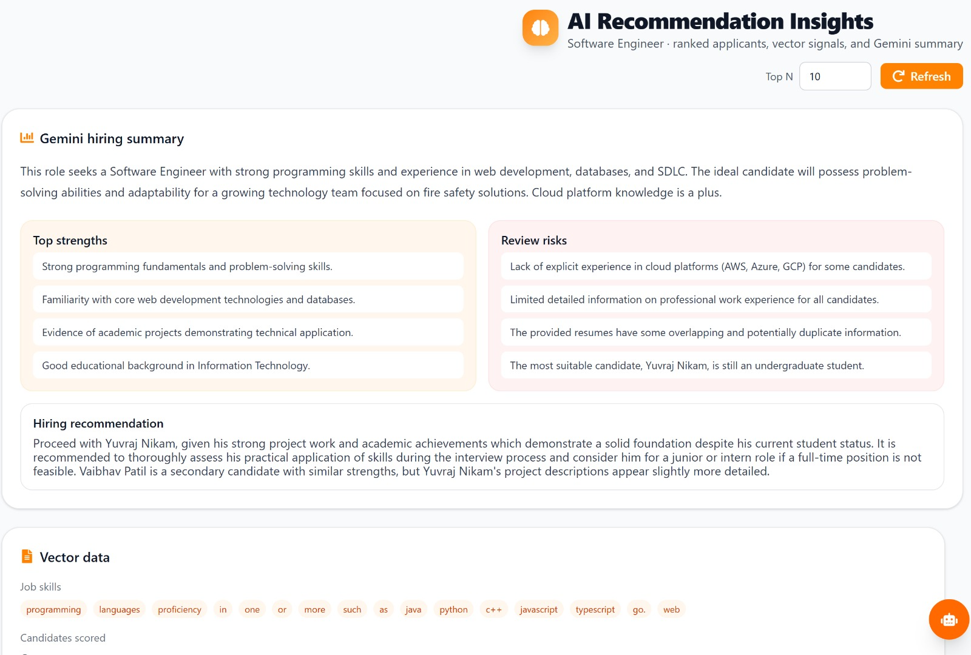
Fig. 6 – AI recommendation Insight

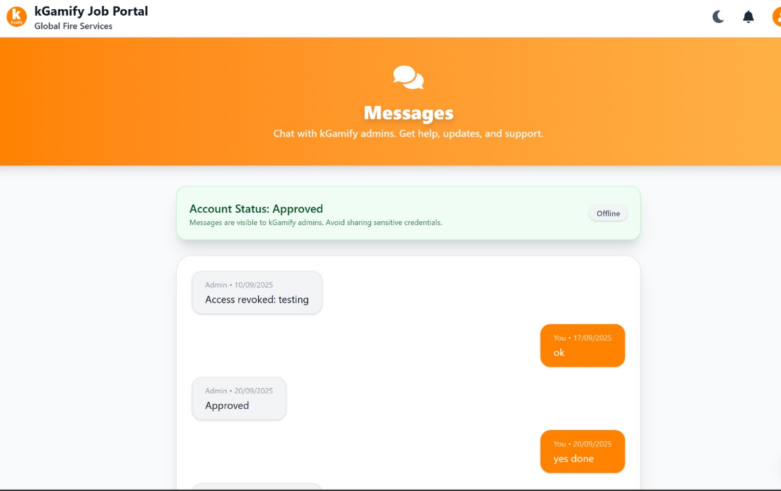
Fig. 7 – Real Time Messages
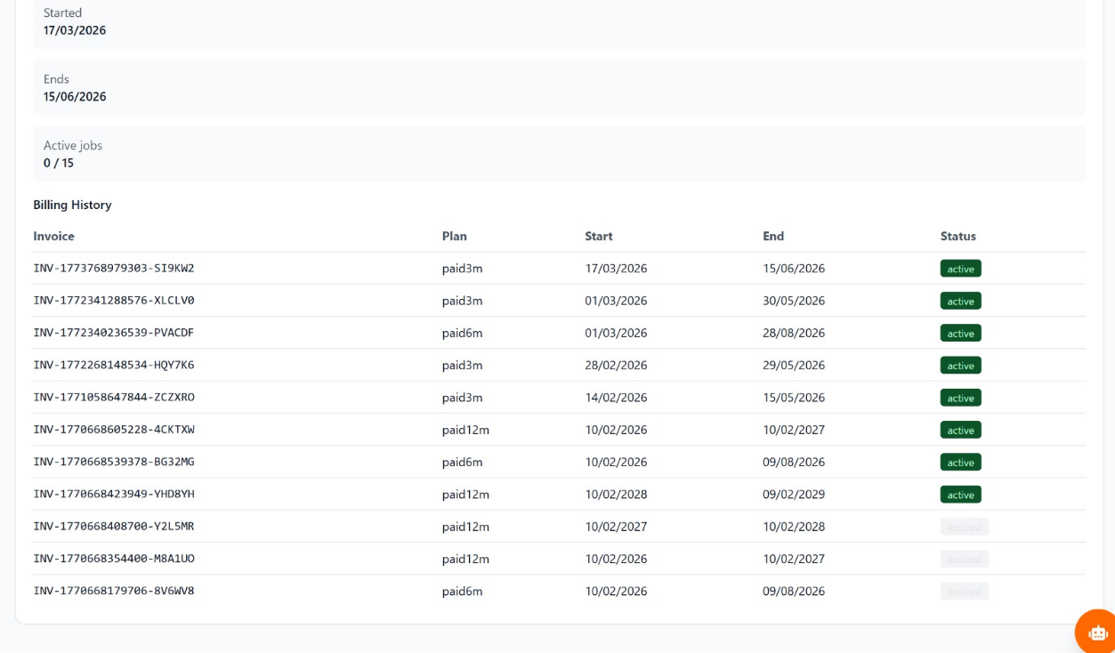
Fig. 8 - Billing history
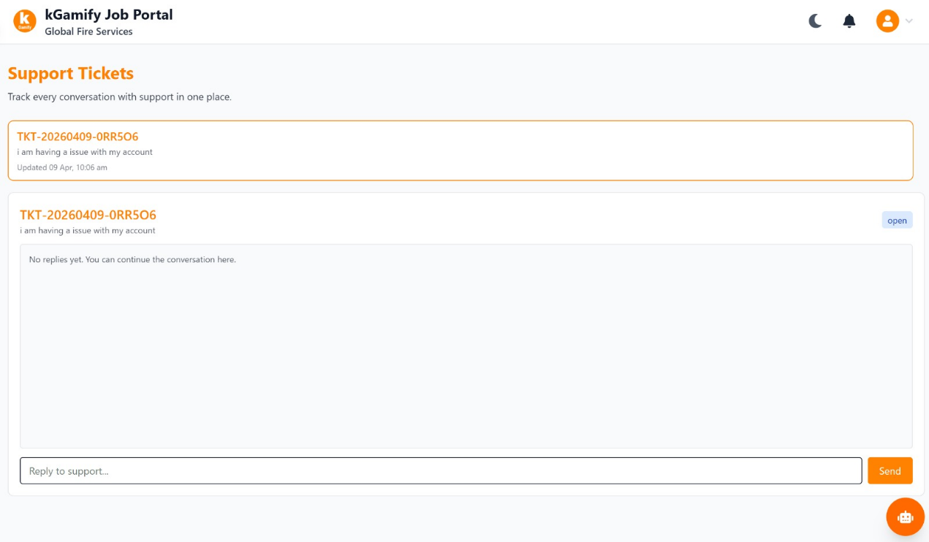
Fig. 9 – Support Tickets
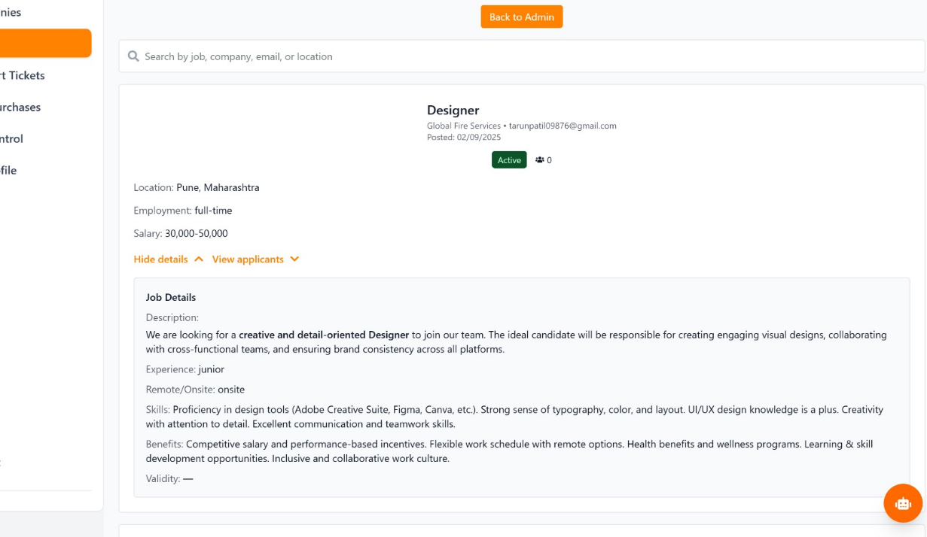
Fig. 10 – Job Management

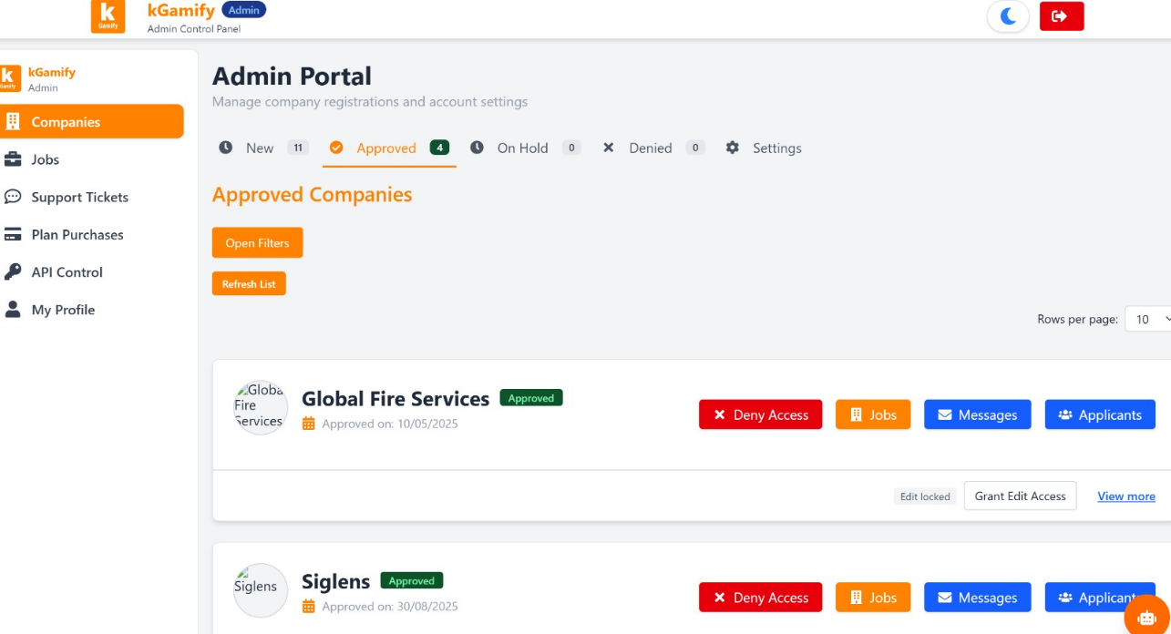
Fig. 11 – Admin Page Job Portal

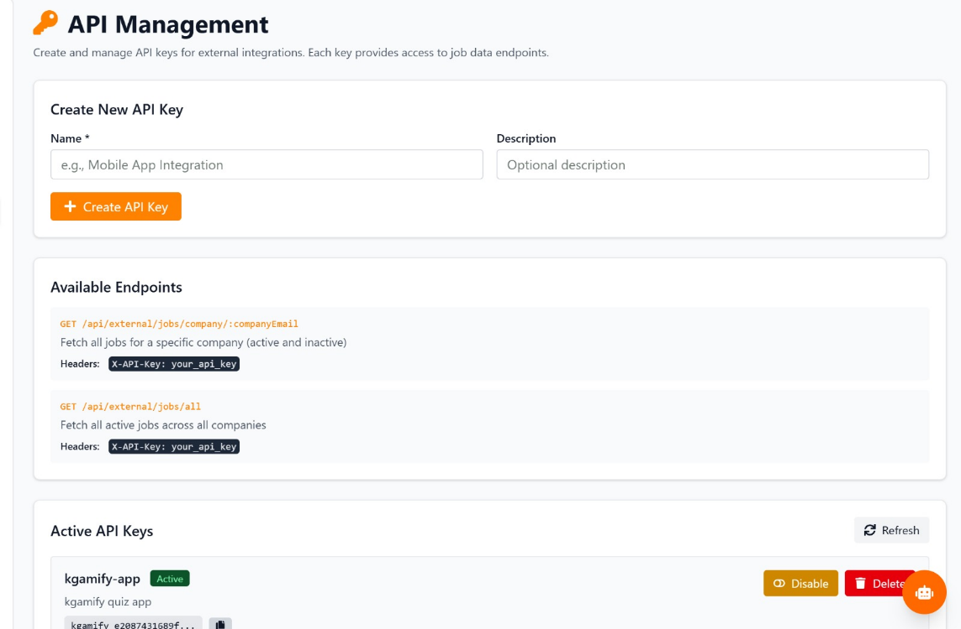
Fig. 12 – API Export Management

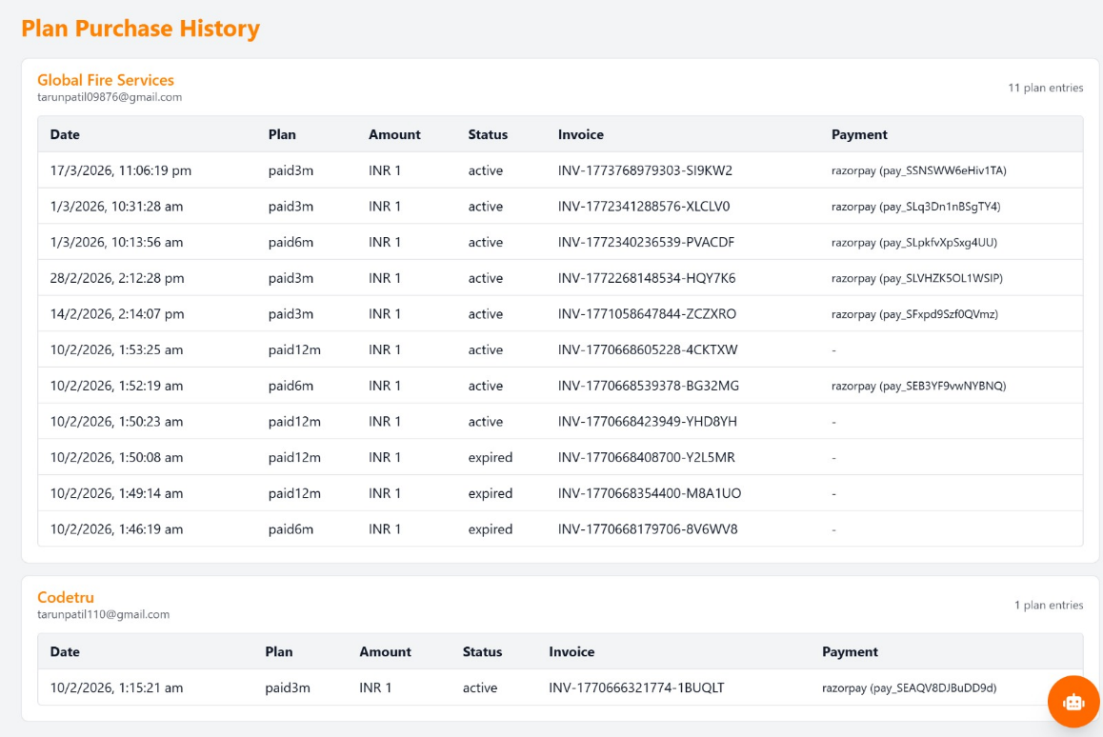
Fig. 13 – Plan purchase history

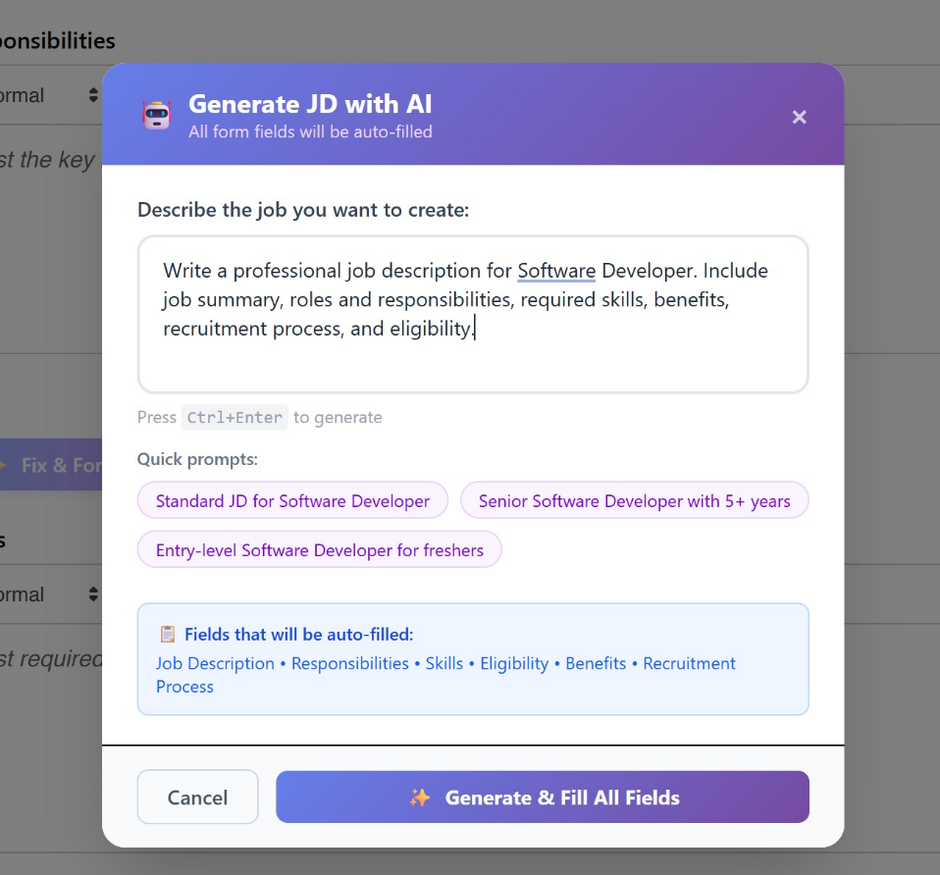
Fig. 14 – AI assistance for filling Job
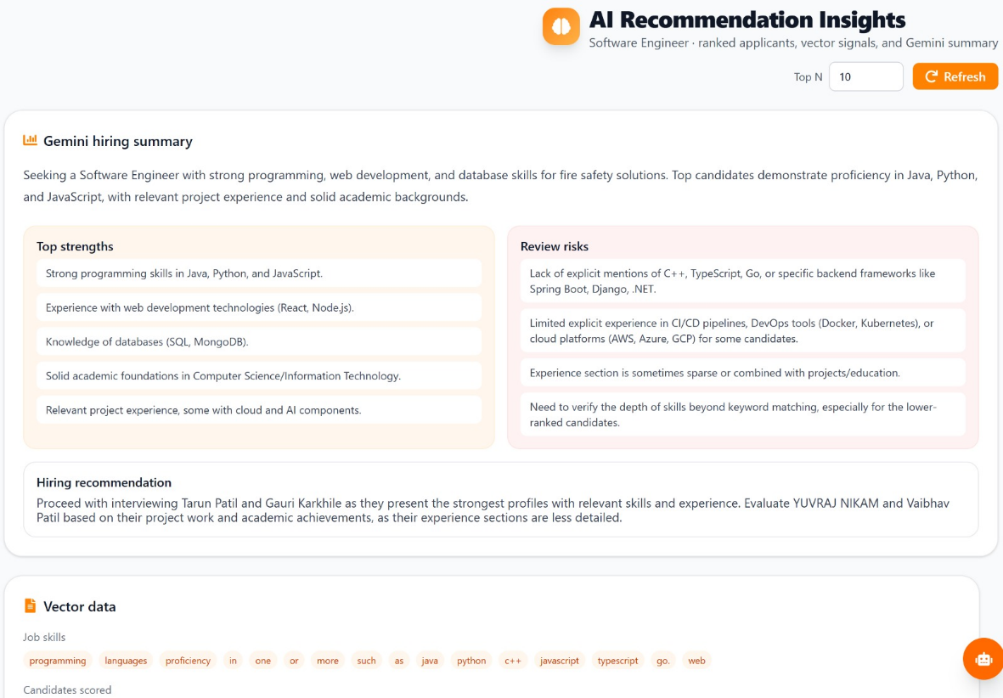
Fig. 15 – AI Resume Summarizer

Fig. 16 – Invoice / Mail sent to user

6.3 Diagrams
6.3.1 Architecture Diagram
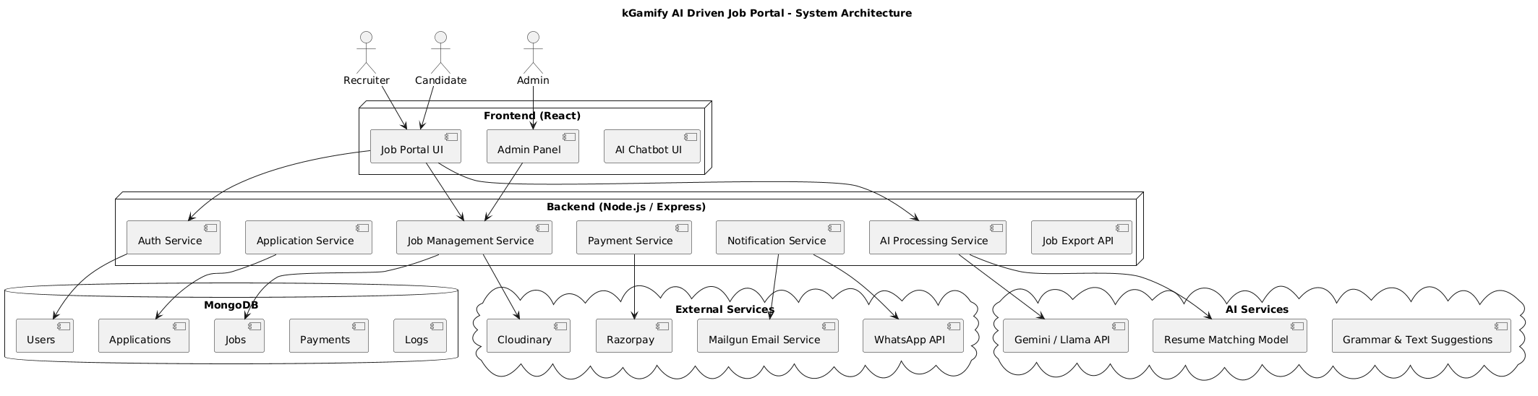
Fig. 1 – System Architecture
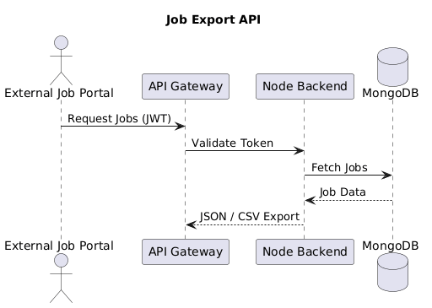
Fig. 2 – Job Export API Architecture

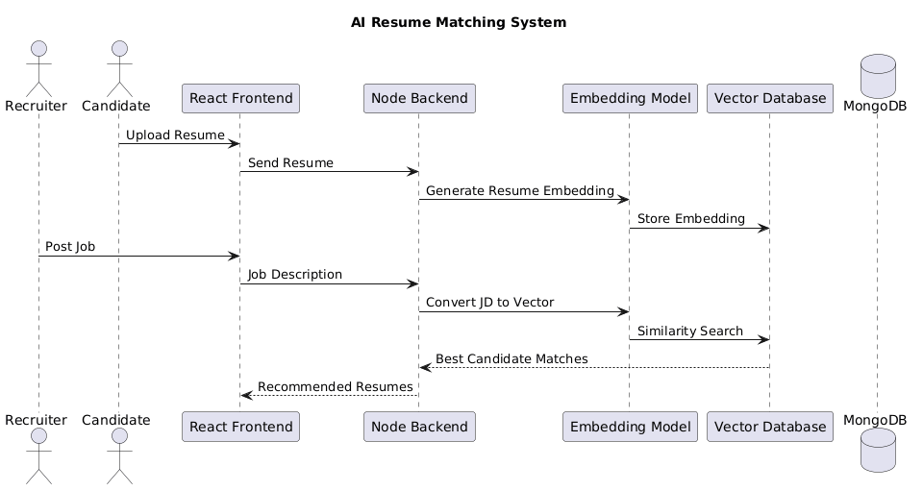
Fig. 3 - AI Resume Recommendation Architecture
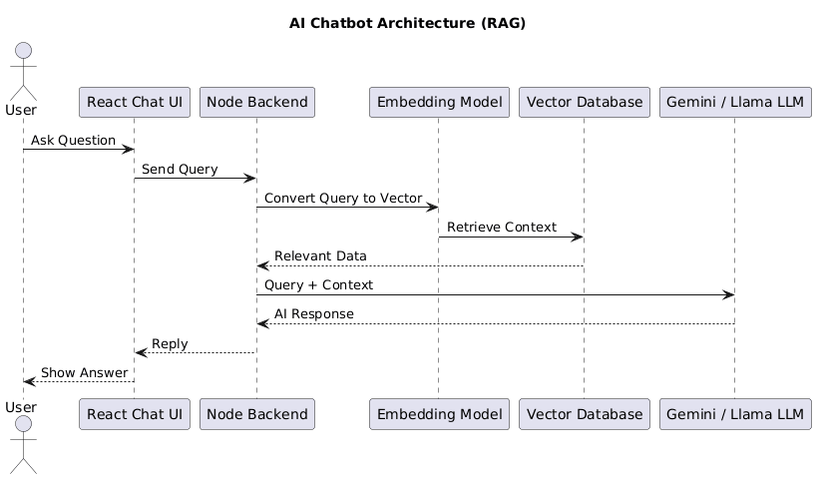
Fig. 4 - AI Chatbot Architecture (RAG Based)

6.3.2 Class Diagram
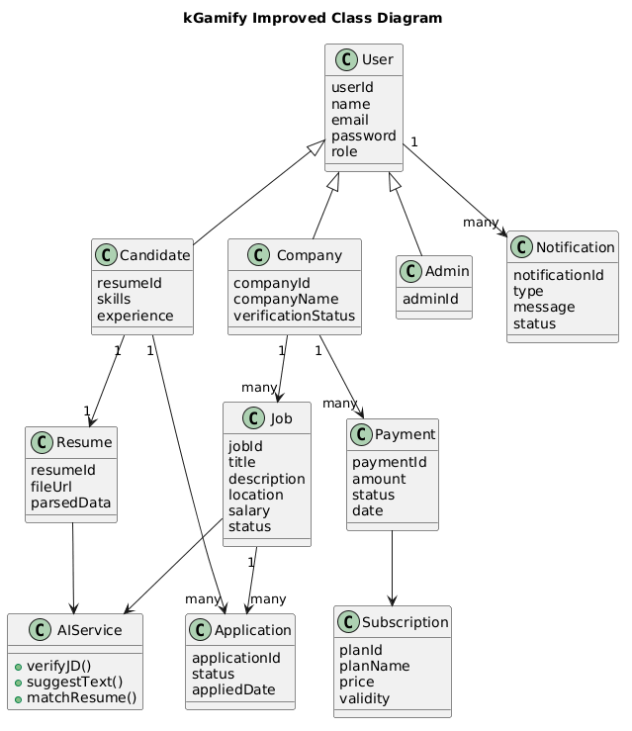
Fig. 5- Class Diagram

6.3.3 Activity Diagram
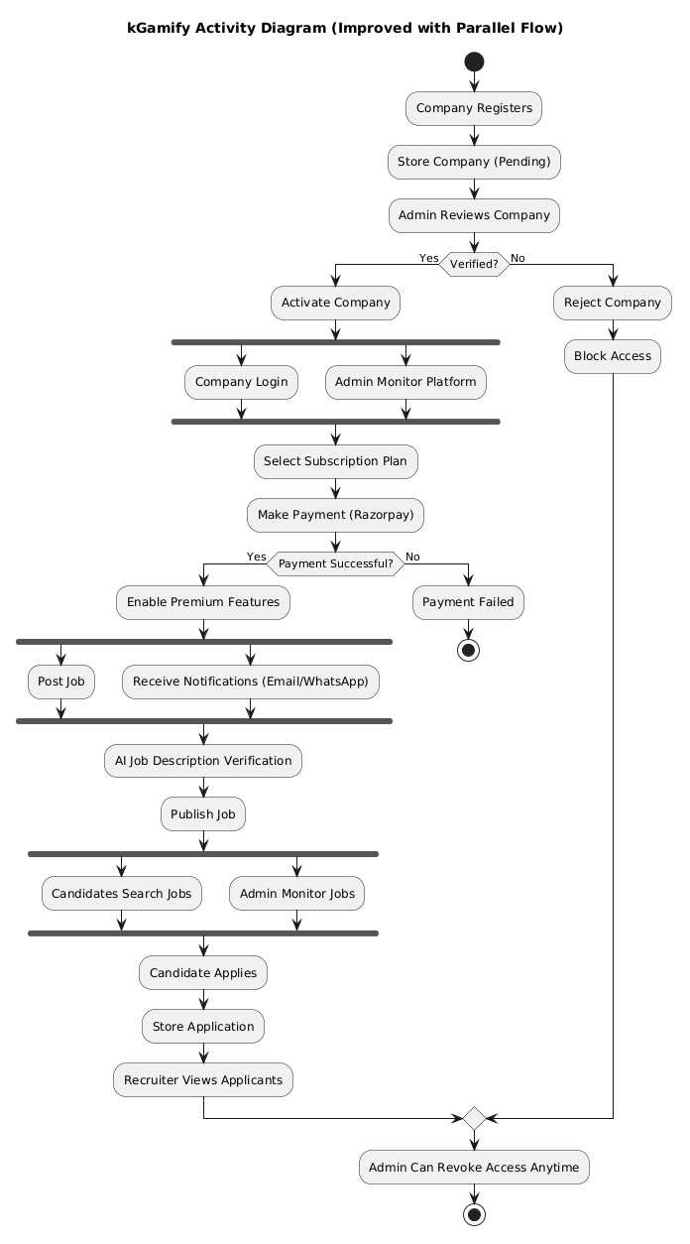
Fig. 6 – Activity Diagram

6.3.4 Sequence Diagram
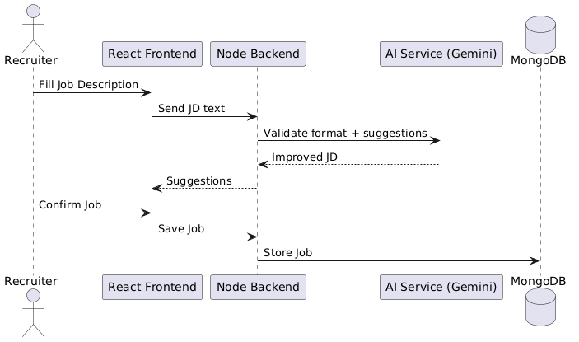
Fig. 7 - Sequence Diagram (AI Job Posting)

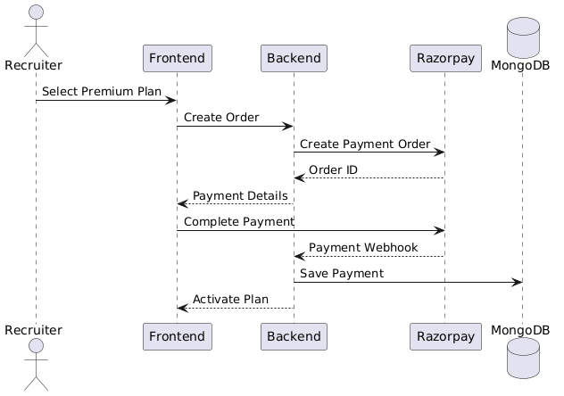
Fig. 8 - Sequence Diagram (RazorPay Payment)

7. References :
[1] S. Malhotra and R. Sharma, "AI-Powered Resume Screening and Job Matching System," International Journal of Scientific Computing, vol. 12, no. 3, pp. 45-52, 2025.
[2] P. Verma and A. Gupta, "AI Powered Resume Parser for Enhanced Recruitment Process," International Journal of Advanced Computing and Technology, vol. 9, no. 2, pp. 101-108, 2025.
[3] D. Patel and M. Shah, "AI-Based Resume Ranking System Using Semantic Similarity and Skill-Based Scoring," Journal of Software Research and Technology, vol. 7, no. 1, pp. 22-30, 2025.
[4] K. Singh, R. Kumar, and S. Tiwari, "AI-Based Resume Screening and Ranking System," International Journal of Scientific Computing and Innovation, vol. 11, no. 4, pp. 88-95, 2025.
[5] A. Mehta and S. Patel, "AI-Powered Resume Screening and Role-Fit Analysis System," International Journal for Research in Applied Science and Engineering Technology, vol. 13, no. 5, pp. 1340-1346, 2025.
[6] N. Jain and P. Agarwal, "AI-Powered Automated Resume Screening and Job Matching System Using NLP and Machine Learning," International Journal of Research in Engineering and Science Management, vol. 8, no. 2, pp. 59-66, 2025.
[7] R. Gupta, S. Verma, and A. Mishra, "Smart Application Tracking System Utilizing Generative AI for Efficient Resume Matching," International Journal of Innovative Science and Research Technology, vol. 10, no. 1, pp. 122-129, 2025.
[8] Y. Zhang, L. Chen, and H. Wang, "AI-Driven Semantic Similarity-Based Job Matching Framework," Information Sciences, vol. 670, pp. 120-134, 2026.
[9] J. Zhang, X. Li, and Y. Huang, "Learning Effective Representations for Person-Job Fit by Feature Fusion," arXiv preprint arXiv:2006.07017, Jun. 2020.
[10] S. Kumar, R. Patel, and T. Singh, "ResumeAtlas: Resume Classification Using Large Language Models," arXiv preprint arXiv:2406.18125, Jun. 2024.
[11] M. Anderson, L. Brown, and J. Davis, "Augmented Fine-Tuned LLMs for Recruitment Automation," arXiv preprint arXiv:2509.06196, Sep. 2025.

SOFTWARE REQUIREMENTS SPECIFICATION (SRS) DOCUMENT

