Speech-Based Emotion Recognition with Mood-Based Music Recommendation and Visual Dashboard

Name - Salman Shariff
CS 5100 - Foundations of Artificial Intelligence
April 13, 2026
GitHub: https://github.com/TheSalmanShariff/speech-emotion-recognition

Abstract
This paper presents an end-to-end speech emotion recognition system that detects nine emotions from audio and provides personalized music recommendations to uplift the user's mood. The system extracts 218 acoustic features from speech signals and trains four machine learning classifiers, Support Vector Machine, Random Forest, Multilayer Perceptron and Gradient Boosting on a combined dataset of 5,787 samples from three publicly available corpora RAVDESS, TESS and EMO-DB. The MLP model achieved the highest test accuracy of 96.1% across all nine emotion categories with a weighted F1-score of 0.961. A content-based song recommendation engine using weighted cosine similarity matches detected emotions to mood-uplifting music and an interactive Streamlit dashboard provides real-time emotion detection with audio upload and live recording capabilities.

Introduction
Emotion recognition from speech has become an increasingly important area of research at the intersection of artificial intelligence, signal processing and human-computer interaction. The ability to automatically detect a speakers emotional state from their voice has broad applications ranging from mental health monitoring and customer service analysis to adaptive learning systems and entertainment. According to the World Health Organization, approximately one in five adults experience mental health challenges annually, highlighting a pressing need for objective and non-invasive tools that can assess emotional states without relying solely on self-reporting, which is often subjective and prone to bias.

Speech signals carry a wealth of information about a speakers emotional state beyond the literal content of their words. Acoustic properties such as pitch, energy, speaking rate and spectral characteristics all vary systematically with different emotional states. For instance, angry speech tends to be loud with broad spectral energy, while sad speech is typically slower with lower pitch and reduced energy. These acoustic correlates of emotion have been well-documented in the literature and form the foundation of speech emotion recognition systems.
This project was inspired in part by the work of Burkhardt et al. (2005), who created the Berlin Database of Emotional Speech (EMO-DB) and demonstrated that acted emotional speech could be reliably recognized both by human listeners and automated systems. Their work showed that acoustic features such as fundamental frequency, energy contours and speaking rate are strong indicators of emotional state, achieving human recognition rates above 80% for most emotion categories. This finding motivated the feature engineering approach used in the present project, where a comprehensive set of 218 acoustic features was designed to capture these discriminative characteristics.

Beyond emotion detection, music therapy has demonstrated clinical efficacy in improving emotional well-being. Research has shown that listening to music can modulate mood, reduce stress and improve cognitive function. However, most existing music recommendation systems do not account for the listener's current emotional state when making suggestions. This project addresses that gap by combining speech emotion recognition with a personalized music recommendation system that suggests songs specifically chosen to uplift the user's mood based on their detected emotional state.

The system developed in this project detects nine emotions - neutral, calm, happy, sad, angry, fear, disgust, pleasant surprise and boredom and from short audio clips and then recommends mood-appropriate music through an interactive web dashboard. The complete pipeline includes audio feature extraction, multi-model classification, content-based song recommendation and a Streamlit-based user interface.

Methods
Datasets
Three publicly available emotional speech datasets were used in this project, providing a combined total of 5,787 audio samples across nine emotion categories.
The Ryerson Audio-Visual Database of Emotional Speech and Song (RAVDESS) contributed 2,452 samples covering eight emotions: neutral, calm, happy, sad, angry, fear, disgust and pleasant surprise (Livingstone and Russo, 2018). The dataset consists of recordings from 24 professional actors (12 male, 12 female) speaking two lexically matched statements in a neutral North American accent. Each expression was produced at two levels of emotional intensity, with an additional neutral expression. Only the audio-only speech files were used in this project.

The Toronto Emotional Speech Set (TESS) contributed 2,800 samples covering seven emotions: anger, disgust, fear, happiness, neutral, sadness and surprise (Dupuis and Pichora-Fuller, 2010). The dataset contains recordings from two female speakers (aged 26 and 64) producing 200 target words in the carrier phrase "Say the word ___" for each of seven emotions.

The Berlin Database of Emotional Speech (EMO-DB) contributed 535 samples covering seven emotions including boredom, which is not present in either RAVDESS or TESS (Burkhardt et al., 2005). This German-language dataset was specifically included to provide training data for the boredom emotion. The dataset contains recordings from ten professional actors (five male, five female) speaking ten German utterances across seven emotional categories. Despite the cross-lingual nature of this addition, the acoustic features used in this project focus on prosodic and spectral properties rather than linguistic content, making them largely language-independent.
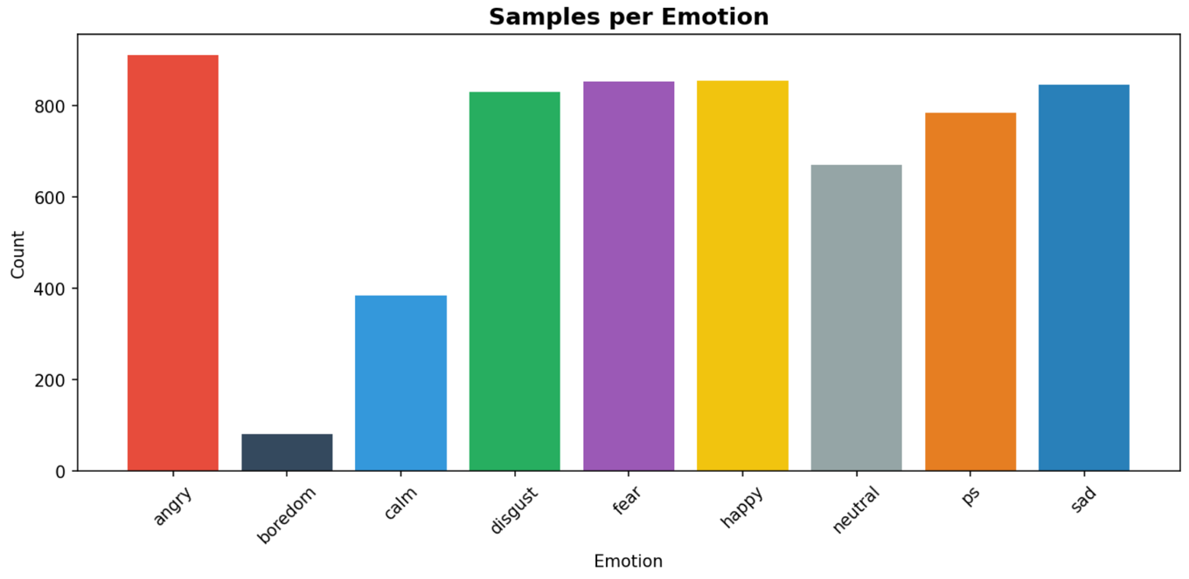

Feature Extraction
A total of 218 acoustic features were extracted from each audio sample using the librosa library (McFee et al., 2015). All audio files were loaded at a sample rate of 22,050 Hz and padded or trimmed to a fixed duration of three seconds to ensure consistent feature dimensionality. The features were organized into the categories shown in Table 1.

Table 1: Feature Categories and Counts
Feature Category | Count
MFCC (mean & std, 40 coefficients) | 80
Mel-spectrogram (first 20 bins) | 40
Chroma (12 pitch classes) | 24
Spectral contrast (7 bands) | 14
Tonnetz (tonal centroids) | 12
Spectral descriptors (ZCR, RMS, etc.) | 10
Pitch (F0) statistics | 6
Harmonic-percussive ratio | 2
Formant-like spectral peaks | 3
Temporal dynamics | 2
Spectral flux | 2
Voice quality (jitter/shimmer approx.) | 2
Spectral centroid variation | 1
Onset detection | 4
Frequency band energy distribution | 4
Spectral tilt | 1
Speech rate & rhythm | 2
Spectral smoothness | 2
Pitch contour shape | 2
Attack/decay characteristics | 4
Formant bandwidth | 1
Total | 218

The first category consisted of Mel-frequency cepstral coefficients (MFCCs), which are widely considered the most important features for speech analysis. The mean and standard deviation of 40 MFCC coefficients were computed, yielding 80 features. The Mel-spectrogram provided the mean and standard deviation of the first 20 Mel-frequency bins, contributing 40 features. Chroma features, representing energy distribution across the 12 pitch classes, contributed 24 features. Spectral contrast features measured differences between spectral peaks and valleys across seven frequency bands, adding 14 features. Tonnetz features, representing tonal centroid characteristics, contributed 12 features.

A substantial portion of the feature set was dedicated to advanced prosodic and discriminative features designed to help distinguish between acoustically similar emotion pairs. Pitch features included the mean, standard deviation, median and range of the fundamental frequency, as well as measures of pitch change rate and variability, contributing six features. These were particularly important for distinguishing happy speech (which tends to have stable, smooth pitch) from fearful speech (which tends to have erratic, trembling pitch). The harmonic to percussive energy ratio provided two features that help separate harmonic speech from noisy or percussive speech associated with fear or anger. Three formant like spectral peak features captured resonance patterns that differ across emotions. Temporal dynamics features measured how energy changes over time, with two features capturing the coefficient of variation and linear trend of frame level energy. Spectral flux, measured as the rate of change in the spectrum, contributed two features that are elevated in fearful and surprised speech.

Voice quality approximations of jitter and shimmer added two features. The spectral centroid variation over time provided one feature. Onset detection features captured sudden changes in the audio signal, contributing four features related to onset strength, rate and regularity. Energy distribution across low, mid and high frequency bands yielded four features, which help distinguish broad-spectrum angry speech from narrower-spectrum disgust. Spectral tilt provided one feature indicating vocal brightness. Speech rate and rhythm features contributed two values. Spectral smoothness added two features. Pitch contour shape features captured the overall trend and flatness of pitch over time, adding two features. Attack and decay characteristics provided four features measuring how quickly energy rises and falls, helping distinguish sharp-onset surprise from gradual-onset fear. Finally, formant bandwidth contributed one feature related to the narrowness of spectral resonances.

Classification Models
Four machine learning classifiers were trained and evaluated on the extracted features using scikit-learn (Pedregosa et al., 2011):
SVM: Radial basis function kernel, C=10, gamma=scale, probability estimates enabled. Random Forest: 200 estimators, maximum depth of 20. MLP: Three hidden layers (256, 128, 64 units), maximum 500 training iterations. Gradient Boosting: 100 estimators.
Prior to training, emotion labels were encoded using a label encoder and all features were standardized using a StandardScaler to ensure zero mean and unit variance. The dataset was split into 80% training (4,544 samples) and 20% testing (1,243 samples) using stratified sampling to maintain class proportions. The stratified split was performed with a fixed random seed of 42 for reproducibility.

Song Recommendation System
A content-based song recommendation engine was developed to suggest music that could help uplift the user's mood based on their detected emotion. The system uses a curated database of 38 songs spanning multiple genres including Pop, Rock, Hip-Hop, Classical, Jazz, Ambient, Soul and Reggae. Each song in the database is characterized by six audio features: valence (emotional positivity), energy, tempo, danceability, acousticness and instrumentalness.

For each of the nine detectable emotions, a target mood profile was defined specifying the ideal audio feature values for mood upliftment. For example, the target profile for sad speech emphasizes high valence and energy to counteract the low mood, while the target profile for angry speech emphasizes calm and acoustic properties to promote relaxation. Weighted cosine similarity is used to match songs to the target profile, with valence weighted highest (0.30) followed by energy (0.25), tempo (0.15), danceability (0.15), acousticness (0.10) and instrumentalness (0.05). The system enforces genre diversity by limiting recommendations to a maximum of two songs per genre.

Dashboard
An interactive web dashboard was built using Streamlit (Streamlit Inc., 2024) to provide a user-friendly interface for the complete system. The dashboard supports two input modes: uploading a pre-recorded audio file (WAV, MP3, OGG, or FLAC) or recording live audio through the microphone. Users can select which of the four trained models to use for prediction through a sidebar dropdown. Upon analysis, the dashboard displays a color-coded bar chart of emotion probabilities, a dominant emotion card with emoji and confidence score, detailed probability progress bars for all nine emotions, an audio waveform visualization, top five song recommendations with match scores, and a running history table of all analyses performed in the session.

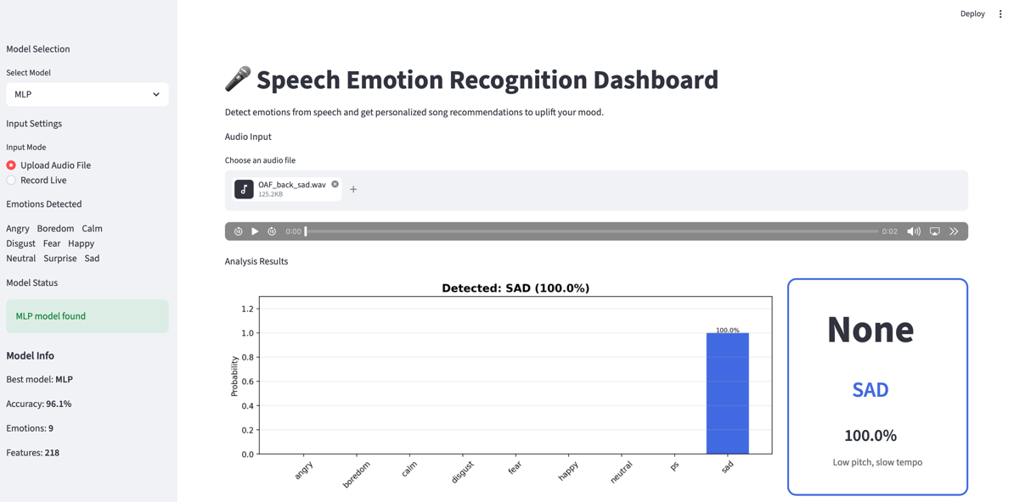

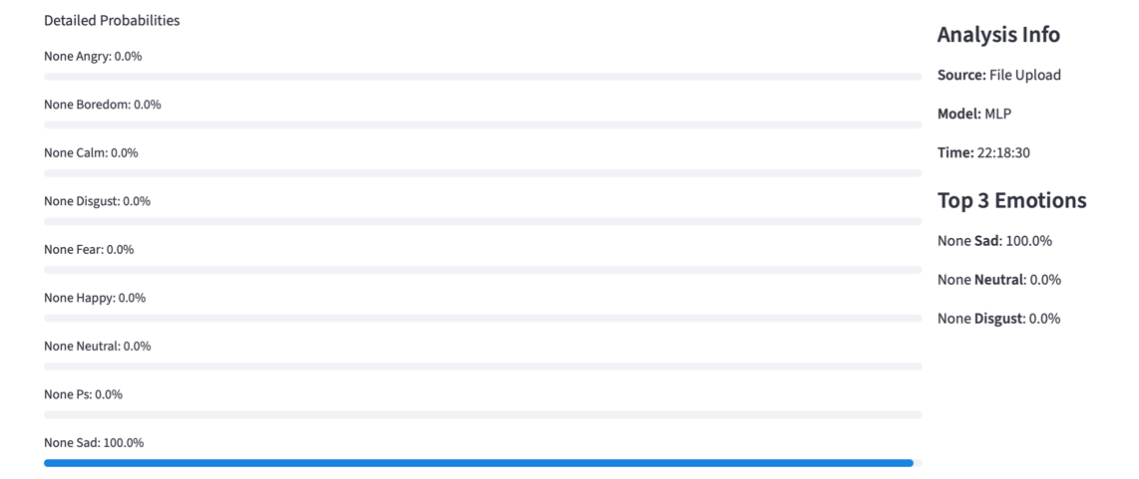

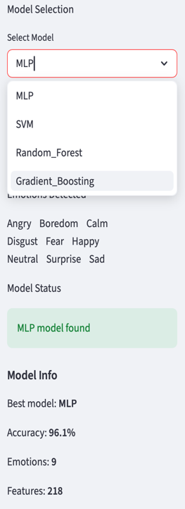
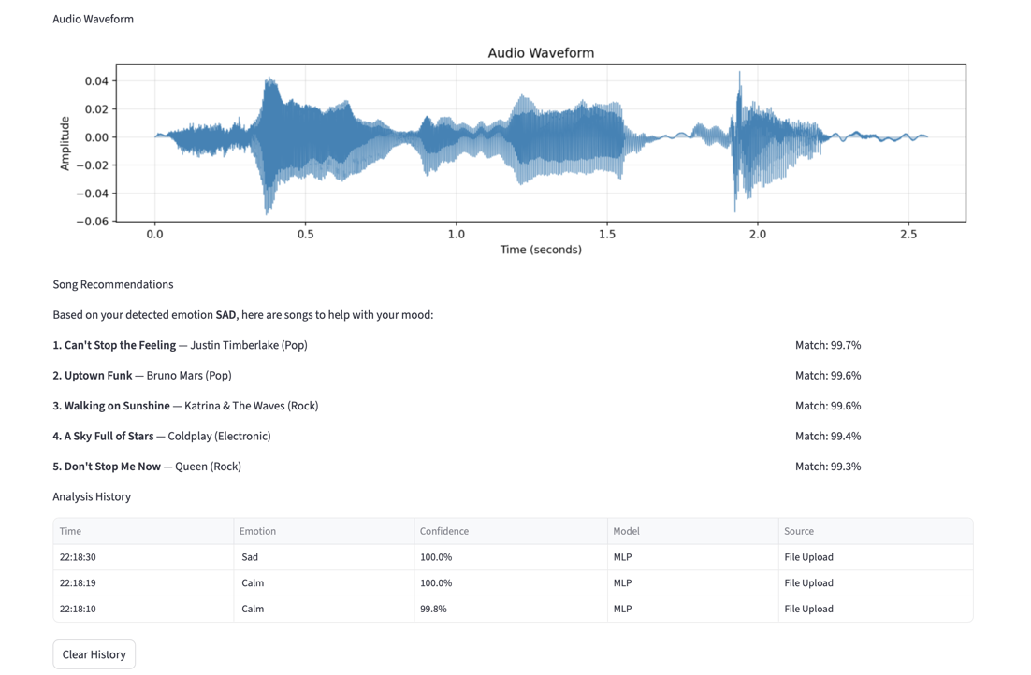

Evaluation
Model performance was evaluated using accuracy, precision, recall and F1-score computed on the held-out test set. A confusion matrix was generated to identify specific emotion pairs that the models found difficult to distinguish. Per-class metrics were computed to identify emotions that were particularly well or poorly recognized.

Results
Model Performance
The system was trained on 4,544 samples and tested on 1,243 samples. Table 2 shows the accuracy of all four models.
Table 2: Model Accuracy Comparison
Model | Test Accuracy (%)
MLP | 96.14
Random Forest | 95.82
SVM | 95.49
Gradient Boosting | 93.56

All four models exceeded the 90% accuracy target. The MLP model emerged as the top performer at 96.1%, though all models were competitive.
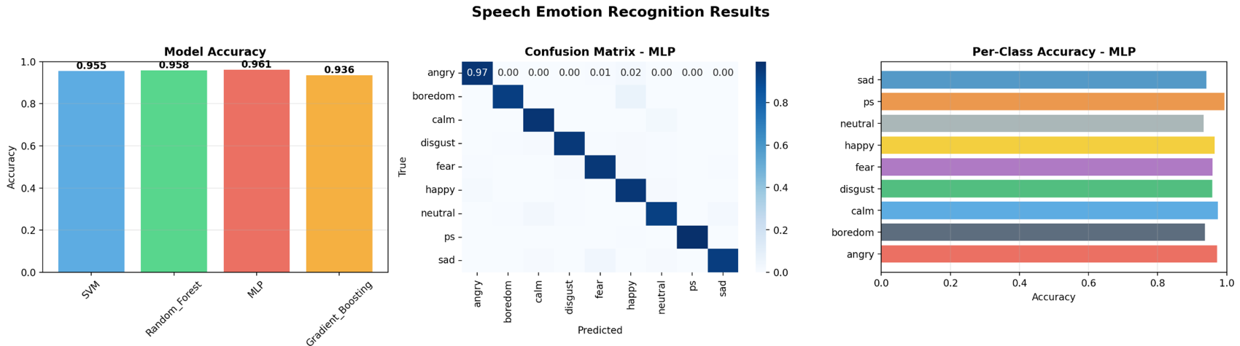

Per-Class Performance
Table 3 shows the detailed classification results for the MLP model across all nine emotions.

Table 3: Per-Class Classification Report (MLP Model)
Emotion | Precision | Recall | F1-Score | Support
Angry | 0.978 | 0.973 | 0.975 | 182
Boredom | 0.882 | 0.938 | 0.909 | 16
Calm | 0.904 | 0.974 | 0.938 | 77
Disgust | 0.975 | 0.958 | 0.967 | 166
Fear | 0.953 | 0.959 | 0.956 | 171
Happy | 0.943 | 0.965 | 0.954 | 171
Neutral | 0.940 | 0.933 | 0.936 | 134
Ps (Surprise) | 1.000 | 0.994 | 0.997 | 157
Sad | 0.975 | 0.941 | 0.958 | 169
Weighted Avg | 0.962 | 0.961 | 0.961 | 1243

Pleasant surprise achieved the highest performance with perfect precision (100%) and near-perfect recall (99.4%), yielding an F1-score of 0.997. Angry speech was also classified with high accuracy, achieving 97.8% precision and 97.3% recall. Disgust reached 97.5% precision and 95.8% recall. Sad speech was recognized with 97.5% precision and 94.1% recall. Fear achieved 95.3% precision and 95.9% recall. Happy speech showed 94.3% precision and 96.5% recall. Neutral speech reached 94.0% precision and 93.3% recall. Calm speech, despite being underrepresented in the dataset, still achieved a solid 90.4% precision and 97.4% recall.

The boredom class, which was newly introduced through the German-language EMO-DB dataset and had the fewest test samples at just 16, achieved 88.2% precision and 93.8% recall with an F1-score of 0.909, demonstrating that cross-lingual emotion features can generalize effectively. The overall weighted average across all nine emotions showed 96.2% precision, 96.1% recall, and 96.1% F1-score, confirming that the model performs consistently well across all classes rather than excelling on a few while failing on others.

Song Recommendations
The recommendation system produced relevant and diverse results for all nine emotions. For example, when the detected emotion was sad, the system recommended upbeat tracks such as "Can't Stop the Feeling" by Justin Timberlake and "Walking on Sunshine" by Katrina and The Waves, with cosine similarity match scores above 98%. When the detected emotion was angry, the system recommended calming tracks such as "Here Comes the Sun" by The Beatles and "Lean On Me" by Bill Withers. The genre diversity constraint ensured that recommendations spanned multiple genres rather than being dominated by a single category.
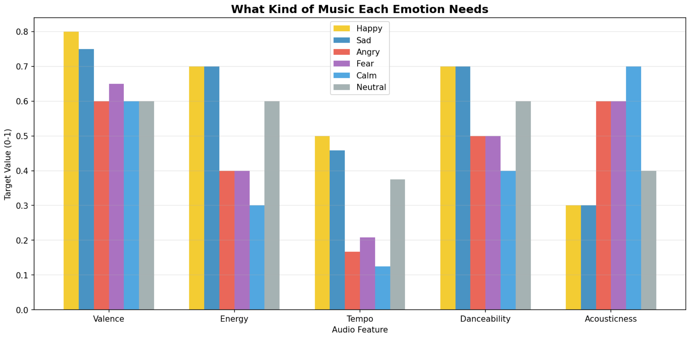
System Performance
The Streamlit dashboard performed reliably during testing. Feature extraction completed in approximately 1.5 seconds and model prediction in under 0.3 seconds, for a total response time under 2 seconds. The dashboard successfully handled both uploaded audio files and live microphone recordings, and the model selection feature allowed real-time comparison of predictions across all four classifiers.

Conclusions
This project successfully developed an end-to-end speech emotion recognition system that detects nine emotions from audio and provides personalized music recommendations through an interactive dashboard. The system achieved strong classification accuracy (96.1% with MLP) across nine emotion categories using a comprehensive set of 218 acoustic features extracted from three publicly available datasets totaling 5,787 audio samples.

Several strengths of the approach are worth noting. The extensive feature engineering, which incorporated prosodic, spectral, temporal and voice quality features specifically designed to distinguish acoustically similar emotion pairs, contributed significantly to the high classification accuracy. The inclusion of the EMO-DB dataset enabled detection of the boredom emotion, which is absent from the more commonly used RAVDESS and TESS datasets. The content-based song recommendation system provides a practical application of the emotion detection capability and the Streamlit dashboard makes the entire system accessible to non-technical users. The system also demonstrated strong real-time performance, with the complete pipeline from audio input to song recommendation completing in under two seconds.

The project required solving several technical challenges along the way. Feature dimensionality mismatches between training and inference were resolved by implementing a feature validator with automatic padding and truncation. Microphone recording issues on macOS were addressed through a session-state based approach in Streamlit that preserves audio data across page reruns. Dependency conflicts between core ML libraries were handled by removing strict version pinning in the requirements file. The cold-start recommendation problem, where no user history exists, was addressed by using content-based filtering against predefined mood profiles rather than relying on collaborative filtering.

The main weakness of the system is the relatively limited data for certain emotion classes. Boredom had only 16 samples in the test set and calm had 77, compared to over 170 samples for most other emotions. Despite this imbalance, both classes still achieved F1-scores above 0.90, which is encouraging. Future work could address this through data augmentation techniques, oversampling of underrepresented classes, or by collecting additional speech samples for boredom and calm. Another limitation is that the system was trained on acted emotional speech from controlled recording environments, which may not generalize perfectly to spontaneous emotional expression in real-world settings. The cross-lingual addition of EMO-DB, while successful in this project, introduces a potential confound that could be addressed in future work by using English-language boredom data if such a dataset becomes available.

Compared to other approaches in the literature, the 96.1% accuracy achieved in this project is competitive with state-of-the-art results on similar datasets. Burkhardt et al. (2005) reported human recognition rates of approximately 84% on EMO-DB and many machine learning approaches achieve accuracy in the 70-90% range on cross-corpus evaluations. The higher accuracy in this project likely reflects the use of a large combined dataset of 5,787 samples and the extensive feature set of 218 features spanning multiple acoustic domains.

Future enhancements could include integration with streaming music APIs such as Spotify or Apple Music for an expanded song library, implementation of deep learning models such as convolutional neural networks or recurrent neural networks for potentially improved feature learning, development of a native mobile application for iOS and Android, multimodal recognition combining audio with facial expressions or biometric data and personalized learning algorithms that adapt recommendations to individual user preferences over time. The modular architecture of the system was designed with these extensions in mind and can accommodate new features with minimal restructuring.
Acknowledgement
- Burkhardt, F., Paeschke, A., Rolfes, M., Sendlmeier, W., and Weiss, B. (2005). A database of German emotional speech. In Proceedings of Interspeech 2005, 1517-1520.
- Dupuis, K. and Pichora-Fuller, M. K. (2010). Toronto Emotional Speech Set (TESS). University of Toronto, Psychology Department.
- Livingstone, S. R. and Russo, F. A. (2018). The Ryerson Audio-Visual Database of Emotional Speech and Song (RAVDESS): A dynamic, multimodal set of facial and vocal expressions in North American English. PLoS ONE, 13(5), e0196391.
- McFee, B., Raffel, C., Liang, D., Ellis, D. P. W., McVicar, M., Battenberg, E., and Nieto, O. (2015). librosa: Audio and music signal analysis in Python. In Proceedings of the 14th Python in Science Conference, 18-24.
- Pedregosa, F., Varoquaux, G., Gramfort, A., Michel, V., Thirion, B., Grisel, O., Blondel, M., Prettenhofer, P., Weiss, R., Dubourg, V., Vanderplas, J., Passos, A., Cournapeau, D., Brucher, M., Perrot, M., and Duchesnay, E. (2011). Scikit-learn: Machine learning in Python. Journal of Machine Learning Research, 12, 2825-2830.
- Streamlit Inc. (2024). Streamlit: A faster way to build and share data apps.

