|  |  |  |  |  |
| --- | --- | --- | --- | --- |
| **School of Electronics Engineering (SENSE)** | | | | |
| **J COMPONENT – REPORT** | | | | |
| **COURSE CODE / TITLE** | BECE204L – MICROPROCESSORS & MICROCONTROLLERS | | | |
| **PROGRAM / YEAR/ SEM** | B.Tech II Year/ FALL 2023-2024 | | | |
| **LAST DATE FOR REPORT SUBMISSION** | 23.11.2023, 3PM | | | |
| **DATE OF SUBMISSION** | 22-11-2023 | | | |
| **TEAM MEMBERS**  **DETAILS** | **REGISTER NO.** | | **NAME** | |
| 22BAI1052 | | VIGNESHVAR.T | |
| 22BRS1057 | | SANJAY H | |
| 22BRS1150 | | SUBBAHEMANTH RAJU | |
| 22BRS1138 | | RANJIT KUMAR K | |
| 22BRS1069 | | LAKSHMAN SHRINATH S | |
| **PROJECT TITLE** | **BLUETOOTH CONTROLLED OBSTACLE AVOIDING ROBOT** | | | |
| **COURSE HANDLER’S NAME** | **Dr.S.Muthulakshmi** | **REMARKS** | |  |
| **COURSE HANDLER’S SIGN** |  |

**OBJECTIVE:**

To Design and develop an innovative obstacle-avoiding Bluetooth-controlled robot with the aim of providing an intelligent and user-friendly solution for navigating through diverse environments. This project seeks to integrate ultrasonic sensor technology, control algorithms, and seamless Bluetooth communication to enable real-time remote control and obstacle detection. The ultimate goal is to create a versatile and reliable robot that can navigate autonomously, avoiding obstacles with precision while offering a customizable and intuitive user interface through Bluetooth connectivity.

**BLOCK DIAGRAM:**

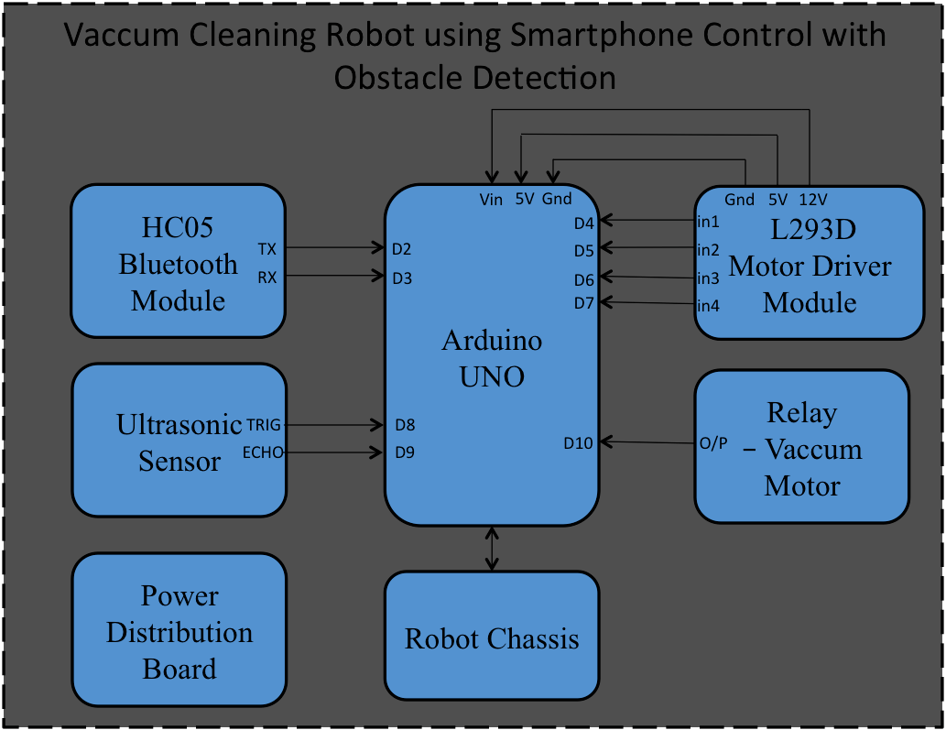

**COMPONENTS/ SOFTWARE REQUIRED:**

|  |  |
| --- | --- |
| **COMPONENT** | **QUANTITY** |
| ARDUINO UNO | 1 |
| HC-05 BLUETOOTH MODULE | 1 |
| POWER DISTRIBUTION BOARD | 1 |
| ULTRASONIC SENSOR | 1 |
| L293-D MOTOR DRIVER UNIT | 1 |
| ROBOT CHASSIS | 1 |
| 5-V RELAY | 1 |
| DC MOTOR FOR VACCUM | 1 |
| PLASTIC BOTTLE | 1 |
| ARDUINO IDE | - |
| JUMPER WIRES |  |
|  |  |

**PROJECT DESCRIPTION:**

The Bluetooth-controlled obstacle-avoiding robot, built with Arduino, a motor driver, ultrasonic sensor, and Bluetooth module, merges cutting-edge technology into an interactive and functional project. This robot is designed to autonomously navigate, detect obstacles using ultrasonic sensors, and steer clear of them. The Arduino acts as the brain, receiving sensor data and controlling the motors via a motor driver. Simultaneously, a Bluetooth module establishes a wireless connection, enabling remote control from a smartphone or tablet. This project not only offers an immersive experience in robotics and electronics but also showcases the seamless integration of these components, providing a tangible example of technology's practical applications in automation and control systems.

**CONCEPT LEARNED:**

1. **Arduino Programming:**
   * *Concept:* Understanding how to write and upload code to Arduino Uno microcontroller.
   * *Learning Outcome:* Acquiring the ability to program the robot's behavior, integrating sensor inputs, motor controls, and Bluetooth communication.
2. **HC-05 Bluetooth Module:**
   * *Concept:* Learning to communicate wirelessly with the robot using Bluetooth technology.
   * *Learning Outcome:* Gaining proficiency in configuring and utilizing the HC-05 module for establishing a reliable Bluetooth connection between the robot and a remote device.
3. **L293-D Motor Driver Unit:**
   * *Concept:* Grasping the principles of motor control and driver units for efficient movement.
   * *Learning Outcome:* Mastering the use of the L293-D motor driver unit to control the speed and direction of the robot's motors, enabling precise and responsive movement.
4. **Obstacle Avoidance Algorithm:**
   * *Concept:* Developing an algorithm to detect and navigate around obstacles.
   * *Learning Outcome:* Understanding the logic and implementation of an obstacle avoidance algorithm, ensuring the robot can autonomously sense and respond to its environment.
5. **Sensor Integration (e.g., Ultrasonic Sensors):**
   * *Concept:* Integrating sensors to gather data about the robot's surroundings. And how the trigger and echo sensor work together to generate the necessary data to process upon for further calculation on distance.
   * *Learning Outcome:* Implementing the connection and usage of ultrasonic sensors to detect obstacles, enabling the robot to make informed decisions about its movement.
6. **Bluetooth Communication Protocol:**
   * *Concept:* Understanding the protocol for communication between Arduino and Bluetooth module in terms of baud rate.
   * *Learning Outcome:* Becoming proficient in establishing a reliable and efficient communication protocol, allowing seamless control of the robot via Bluetooth.
7. **Troubleshooting and Debugging:**
   * *Concept:* Identifying and resolving issues in the hardware or software.
   * *Learning Outcome:* Developing problem-solving skills to troubleshoot and debug potential issues that may arise during the project, ensuring the robot operates smoothly.
8. **Integration of Components:**
   * *Concept:* Combining various hardware components using jumper /connecting wires into a functional system.
   * *Learning Outcome:* Successfully integrating Arduino, Bluetooth module, motor driver unit, and sensors to work harmoniously, creating a cohesive and efficient robotic system.
9. **Power Distribution (5V and 12V):**

* *Concept:* Distributing power to various components at optimal voltages (5V and 12V).
* *Learning Outcome:* Understanding the power requirements of each module and efficiently providing the required voltage to Arduino Uno, HC-05 Bluetooth module, L293-D motor driver unit, and other peripherals.

**IMPLEMENTATION:**

<https://youtube.com/shorts/CyJtNssCvW0>

[**https://youtu.be/iTljVV3OUNA**](https://youtu.be/iTljVV3OUNA)

**CHALLENGES FACED:**

* We faced many issues while connecting the components together, some components wouldn’t work as expected at times
* While programming the microcontroller there was as learning curve to learn the syntax ,functions and modules of the Arduino IDE
* Programming wasn’t hassle free either, we faced multiple issues while uploading the program to the uno board and faced multiple errors upon program compilation
* There was a power deficiency from our power source, the batteries would die within 5-10 minutes of testing, we solved it by replacing it by larger capacity rechargeable batteries which could be reused multiple times.

**APPLICATIONS:**

1. **Smart Home Companion:**
   * Application: Your personal vacuum assistant for a spotless home.
   * How: Roaming through your living spaces, dodging obstacles with finesse, this little helper keeps your floors clean. Just tap a button on your phone to guide its cleaning dance through your home.
2. **Business Cleaning Sidekick:**
   * Application: Boosting efficiency in the workplace cleanup game.
   * How: Imagine a team of tireless cleaners, zipping around offices after hours, making sure every nook and cranny is spick and span. You, the manager, orchestrate the cleaning symphony with just a few taps on your phone.
3. **Healthcare Guardian of Cleanliness:**
   * Application: Your vigilant cleaner for a hygienic healthcare haven.
   * How: Gliding silently through hospital corridors, this trusty robot ensures that your healthcare space stays pristine. Nurses and staff can fine-tune its cleaning routine from the convenience of their smartphones.
4. **Office Sleekness Specialist:**
   * Application: Elevating your workspace vibes with a touch of cleanliness magic.
   * How: While you sip your evening coffee, this diligent robot companion cruises around the office, dodging desks and chairs. With a tap on your phone, you can summon or schedule its cleaning performance.
   * guest experience.
5. **Retail Refined Cleanliness:**
   * Application: A discreet cleaner, perfecting your shopping haven.
   * How: Navigating through aisles like a seasoned pro, this robot keeps your retail space immaculate. Store managers, using their phones, decide when this cleaning virtuoso takes the stage.

**CONCLUSION:**

Undoubtedly, the journey of creating the Bluetooth-controlled obstacle-avoiding robot has been a profound learning experience, where the foundational concepts from our microprocessors and microcontrollers course in college came to life. The theoretical knowledge acquired in the classroom found practical expression in the intricate dance of components and algorithms within the robotic framework.

The essence of microprocessors and microcontrollers, once confined to textbooks and lectures, unfolded dynamically as we programmed the Arduino Uno to orchestrate the robot's actions. The art of assigning specific pins, and crafting efficient code became more than theoretical constructs—they became the language with which our robot communicated and navigated its surroundings.

The marriage of the HC-05 Bluetooth module with the Arduino Uno brought to light the nuances of serial communication we explored in our coursework. Configuring the Bluetooth module, establishing a reliable connection, and seamlessly relaying commands between a smartphone and the robot were not just abstract concepts anymore; they were the tangible outcomes of applying the principles we studied in our microcontrollers class.

The L293-D motor driver unit, was a cornerstone in motor control . transformed into a bridge between the abstract and the tangible. We maneuver beyond circuit diagrams on paper to physically connecting motors, ensuring the right amount of power was supplied for precise movement, and direction control all while adhering to the fundamental principles.

The sensor integration, inspired by our understanding of interfacing sensors with microcontrollers, brought the obstacle avoidance algorithm to life. What once seemed like a theoretical exercise in detecting and responding to external stimuli became the eyes and ears of our robot, allowing it to navigate the world around it.

In essence, this project served as a bridge between academia and real-world application. It was a testament to the transformative power of education, where theoretical concepts met practical challenges, and classroom discussions materialized into a tangible, functioning robot. As we reflect on this journey, we recognize that our college coursework not only equipped us with knowledge but also instilled a problem-solving mindset that fuelled the creativity and tenacity essential for bringing a complex project like this to fruition.