PROJECT REPORT
ON
COLLEGE VOTING SYSTEM

Submitted in Partial Fulfillment of the Requirements
for the Award of Degree

Submitted by:
Student Name

Academic Year: 2025 – 2026

CONTENTS
SL_No | TOPIC | PAGE NO
1 | Abstract | 1
2 | Introduction | 2-3
3 | Problem Statement | 4
4 | Existing System vs Proposed System | 5
5 | Objective | 6
6 | Tools & Environment Used | 7
7 | Analysis | 8-13
8 | Design Document | 14-18
9 | Testing | 19-20
10 | Input & Output Screens | 21-27
11 | Implementation of Security | 28-29
12 | Limitations Of The Project | 30
13 | Future Scope | 31
14 | Conclusion | 32
15 | Bibliography | 33

1. Abstract
The College Voting System is a web-based digital election platform designed to facilitate transparent, secure, and efficient student union elections within a college environment. Conventional paper-based voting processes are prone to human error, vote tampering, and logistical difficulties. This system replaces the traditional method with a fully automated online solution.

The application enables the college administration to manage election posts, register candidates, import student data in bulk, and control the election lifecycle — opening and closing the voting window as required. Students authenticate using a One-Time Password (OTP) delivered via SMS to their registered mobile numbers, ensuring that only eligible students can participate. Each student is permitted to cast exactly one vote per post, and the system automatically detects winners and ties upon closure of the election.

Built on the Laravel 12 framework with a MySQL database, the system follows the Model-View-Controller (MVC) architectural pattern and incorporates industry-standard security practices including session management, CSRF protection, Eloquent ORM-based SQL injection prevention, Blade XSS escaping, bcrypt password hashing, and database-backed OTP verification. The result is a reliable, user-friendly voting platform that brings integrity and efficiency to college elections.

2. Introduction
Student union elections are a cornerstone of college life, providing students with the opportunity to elect representatives who voice their concerns and contribute to institutional governance. However, the traditional paper-based voting process has long been associated with several challenges: manual vote counting is time-consuming, ballot papers can be lost or tampered with, and the administrative overhead is substantial. These issues reduce the credibility and efficiency of the electoral process.

The College Voting System addresses these concerns by digitalising the entire election workflow. The system is built as a web application, meaning it is accessible from any internet-connected device — be it a desktop computer, tablet, or mobile phone — without the need to install any additional software. This greatly increases accessibility and participation rates.

The platform serves two distinct user groups. The first is the college administrator, who is responsible for setting up the election by defining posts (e.g., President, Vice President, Secretary), registering candidates for each post, importing the student voter list, and controlling the voting window. The second group is the students themselves, who log in using their registered phone number and roll number, receive a one-time password via SMS, and cast their votes securely.

The system is engineered with a focus on security, ease of use, and auditability. Real-time results with animated progress bars, winner and tie detection, and a result publication mechanism for students further distinguish it from manual processes. The administrator retains full control over when results are made visible to students, ensuring a fair and orderly process.

3. Problem Statement
Traditional college elections rely on paper ballots, manual counting, and physical supervision. These processes are time-consuming, susceptible to human error, and difficult to audit. Specific problems with the conventional approach include:

- Manual vote counting is slow and prone to errors, often requiring recounts and prolonged delays before results are announced.
- Paper ballot boxes can be tampered with, stuffed, or lost, undermining the integrity of the election.
- Voter identity verification is weak — it is difficult to ensure that every voter is an eligible, registered student.
- Duplicate voting is difficult to prevent when relying on ink marks or manual checklists.
- Result computation and winner determination require significant manual effort and time.
- Physical setup costs are high, and the process is not scalable across multiple posts or large student populations.
- There is no digital audit trail — once the election is over, verifying vote records is nearly impossible.

The College Voting System addresses these challenges through a secure web-based platform that automates authentication, voting, and result computation. OTP-based login ensures only eligible students vote, database constraints prevent duplicate voting, and automatic result calculation eliminates manual counting errors.

4. Existing System vs Proposed System
The table below provides a direct comparison between the conventional paper-based election process and the College Voting System:

Aspect | Existing (Manual) System | Proposed (Digital) System
Authentication | Physical ID check by volunteer; easy to bypass | OTP-based login — only registered students with verified phone numbers can vote
Ballot Delivery | Paper ballot issued manually at polling booth | Digital ballot rendered automatically after authentication
Vote Counting | Manual counting of paper ballots; error-prone | Automated — votes tallied instantly from database records
Duplicate Voting | Ink mark on finger; possible to circumvent | Database unique constraint (student_id, post_id) prevents duplicates at DB level
Result Computation | Manual tallying; prone to human error and delay | Automatic; winner/tie detection computed in real time
Auditability | No digital record; results hard to verify post-election | Full vote log stored in database with timestamps
Accessibility | Students must visit polling booth in person | Accessible from any device with a browser and internet connection
Administrative Effort | High — requires physical setup, supervisors, counters | Low — admin manages everything from a single web dashboard
Result Publication | Manual announcement; delayed | Admin publishes results with a single click; students see them instantly
Security | Physical ballot boxes; vulnerable to tampering | CSRF protection, session security, Eloquent ORM (SQL injection prevention), Blade XSS escaping

5. Objective
The primary objectives of the College Voting System are as follows:

- To develop a secure, transparent, and user-friendly digital platform for conducting college student union elections.
- To eliminate the inefficiencies and risks associated with manual, paper-based voting processes.
- To implement a robust OTP-based authentication mechanism that ensures only eligible, registered students can cast votes.
- To enforce the principle of one vote per student per post, preventing duplicate voting.
- To provide the college administrator with a comprehensive management interface for overseeing the complete election lifecycle — from candidate registration to result publication.
- To facilitate bulk import of student data through Excel/CSV files, reducing manual data entry errors.
- To automatically compute election results, detect winners and ties, and display results visually using animated progress bars.
- To control result visibility, allowing the administrator to publish results to students only when appropriate.
- To build the application following the MVC architectural pattern for maintainability and scalability.
- To safeguard the system against SQL injection, XSS, CSRF, session fixation, and other common web vulnerabilities through layered security controls.

6. Tools & Environment Used

6.1 Hardware Requirements

Component | Minimum Specification
Processor | Intel Core i3 (or equivalent) — 2 GHz or higher
RAM | 4 GB (8 GB recommended)
Storage | 10 GB available disk space
Network | Broadband Internet connection
Display | 1280 × 720 resolution or higher

6.2 Software Requirements

Layer | Technology / Tool | Version
Backend Framework | Laravel (PHP) | 12.x
Programming Language | PHP | 8.2+
Frontend Templating | Laravel Blade | —
Frontend Scripting | Vanilla JavaScript | ES6+
CSS Framework | Tailwind CSS | v4
Build Tool | Vite | 7.x
Database | MySQL | 8.x
SMS Service | Fast2SMS API | —
Excel Import Library | Maatwebsite/Excel | 3.1
Dependency Manager (PHP) | Composer | 2.x
Dependency Manager (JS) | npm | 10.x
Version Control | Git | —
Development Environment | Local PHP server / XAMPP | —

6.3 Development Tools

- Code Editor: Visual Studio Code
- Database Management: phpMyAdmin / MySQL Workbench
- API Testing: Browser DevTools
- Version Control Hosting: Git / GitHub

6.4 Environment Configuration (.env)

Variable | Purpose
APP_NAME | Application display name
APP_ENV | Environment mode (local / production)
APP_KEY | Encryption key (auto-generated)
DB_CONNECTION / DB_HOST / DB_DATABASE | MySQL connection details
SMS_DRIVER | SMS provider selection (fast2sms)
FAST2SMS_AUTHORIZATION | Fast2SMS API authorisation key
SESSION_DRIVER | Session storage driver (database)
QUEUE_CONNECTION | Queue driver (database)

7. Analysis

7.1 System Overview
The College Voting System is a two-role application: Administrator and Student. Each role operates in an isolated session context with dedicated authentication mechanisms, middleware guards, and user interface.

7.2 User Role Analysis

Role | Authentication Method | Capabilities
Admin | Email + Password (session) | Full CRUD on students, posts, candidates; election settings; result management
Student | Phone + Roll No + OTP (session) | Cast votes; view published results

7.3 Functional Requirements

7.3.1 Admin Module
- Admin can log in with email and password.
- Admin can create, edit, and delete election posts (e.g., President, Vice President).
- Admin can register candidates under each post, including an optional profile photo.
- Admin can add students individually or import them in bulk via an Excel/CSV file.
- Admin can preview the imported student data before saving it to the database.
- Admin can configure election settings: title, voting start/end times, and manual open/close toggle.
- Admin can view real-time election results with progress bars, vote counts, percentages, and winner/tie badges.
- Admin can publish or unpublish results for student visibility.
- Admin can change their account password.

7.3.2 Student Module
- Student can log in by providing phone number, roll number, and program type (Degree/+2).
- Student receives a 6-digit OTP via SMS to their registered phone number.
- Student enters the OTP on the verification screen to authenticate.
- Student can cast one vote per election post; abstention is also permitted.
- Student is redirected to a thank-you page after successfully submitting votes.
- Student can view published election results after the voting window closes.

7.4 Non-Functional Requirements

Attribute | Description
Security | CSRF tokens, session regeneration, OTP expiry, middleware guards, SQL injection prevention via Eloquent ORM, XSS prevention via Blade escaping, bcrypt password hashing
Availability | Web-based; accessible from any device with a modern browser and internet connection
Integrity | Unique constraint on (student_id, post_id) ensures one vote per post per student
Scalability | MVC pattern and database-queue driver allow horizontal scaling
Usability | Responsive Tailwind CSS design; glassmorphism student login; guided OTP flow
Auditability | Vote records stored with timestamps; student voted flag tracks participation

7.5 Entity-Relationship Diagram
The diagram below shows all entities, their attributes, and the relationships between them.

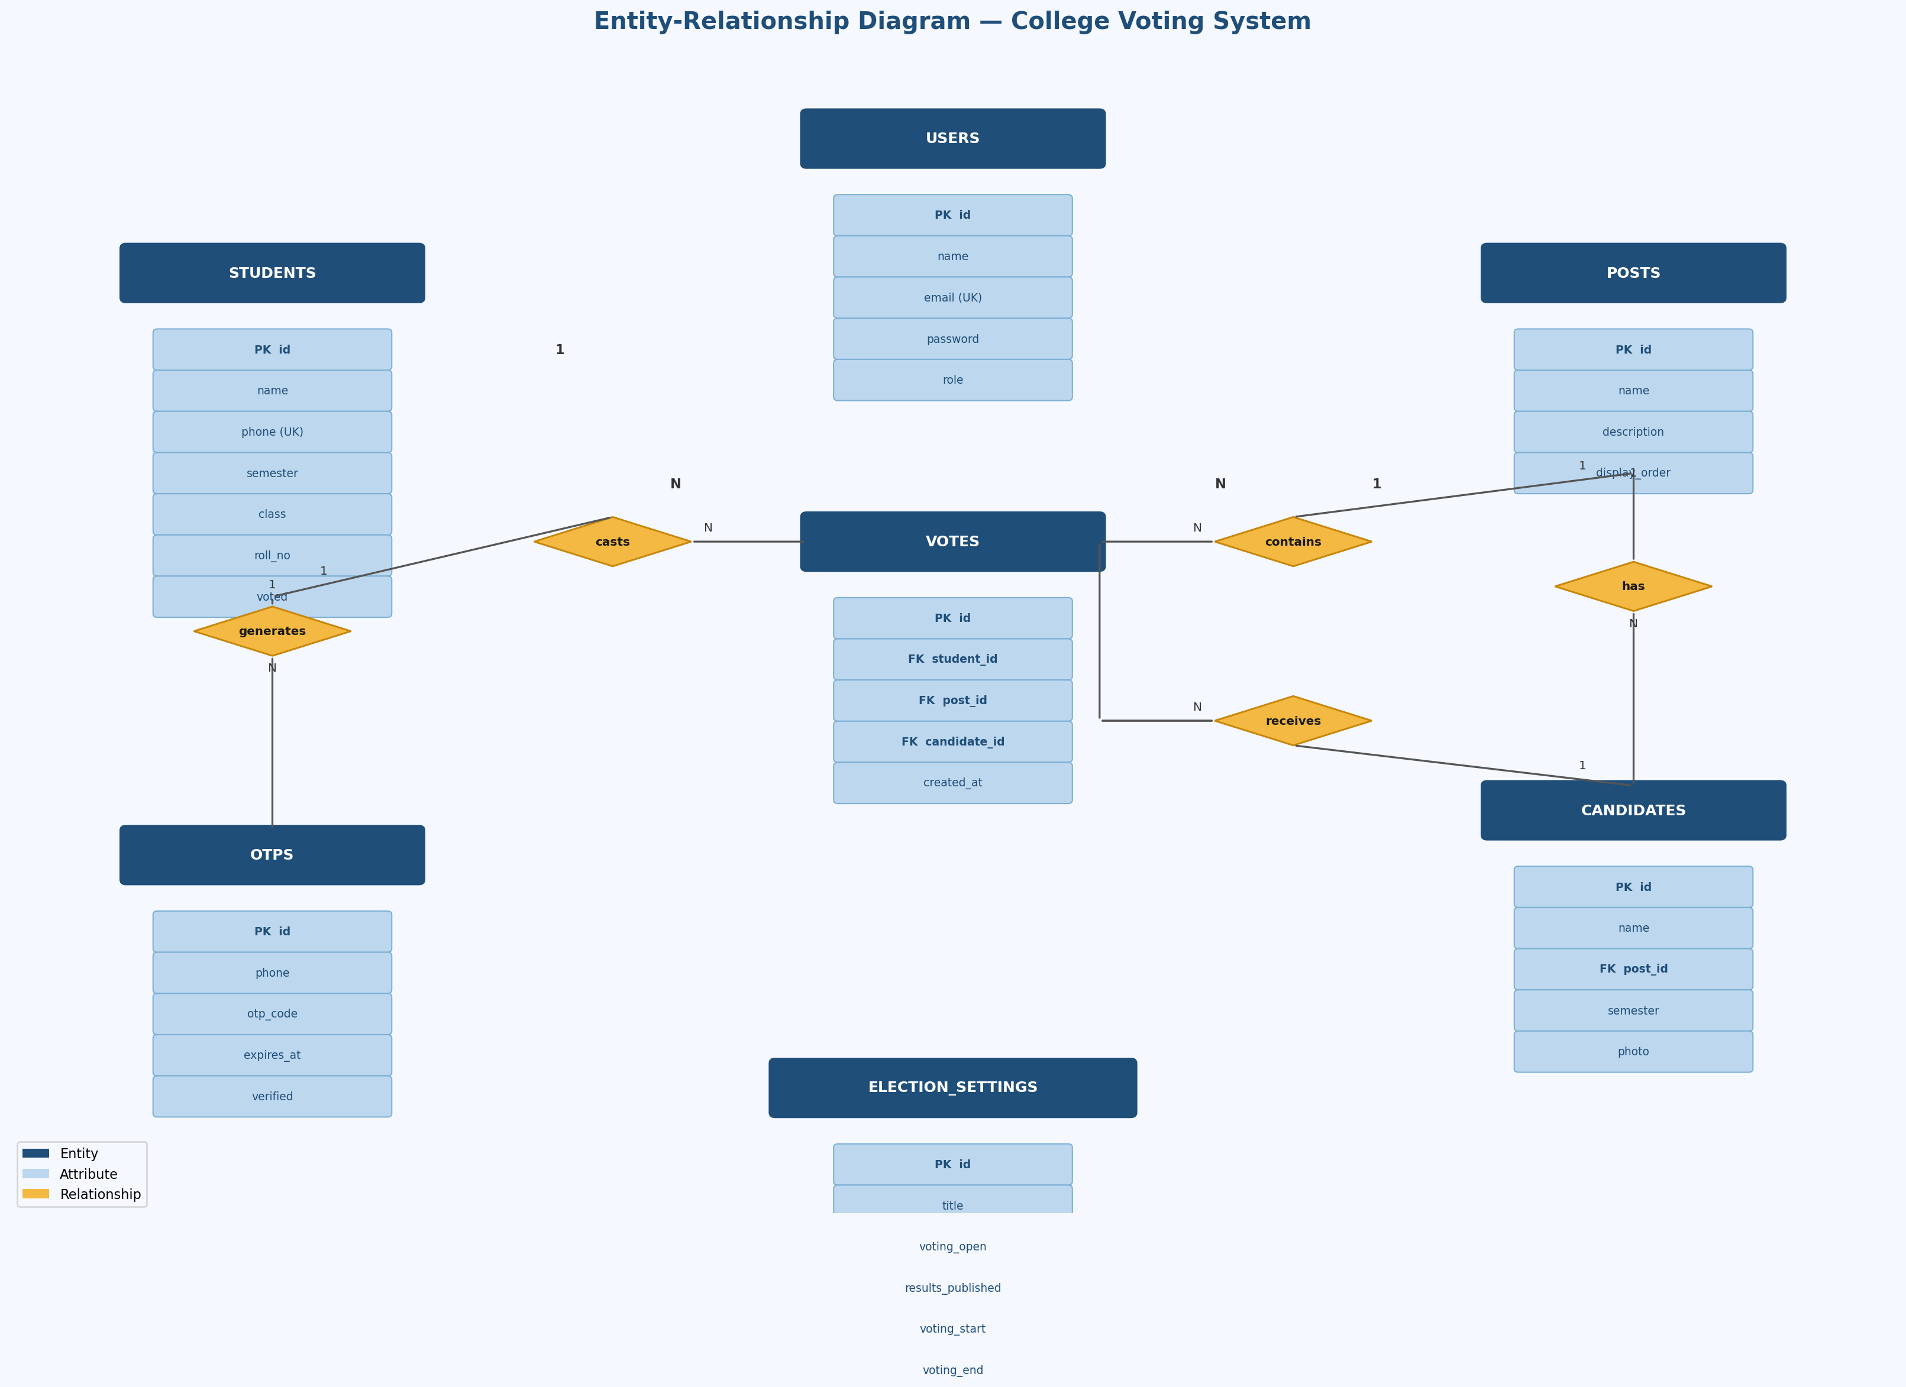
Figure 1: Entity-Relationship Diagram — College Voting System

Entity | Related To | Relationship | Constraint
Posts | Candidates | One-to-Many | A post can have many candidates
Candidates | Votes | One-to-Many | A candidate can receive many votes
Students | Votes | One-to-Many | A student can cast votes for multiple posts
Posts | Votes | One-to-Many | Each vote belongs to one post
Students | OTPs | One-to-Many (via phone) | A student can request multiple OTPs

7.6 Data Flow — Student OTP Login
The flowchart below illustrates the complete OTP authentication process from credential entry to session creation.

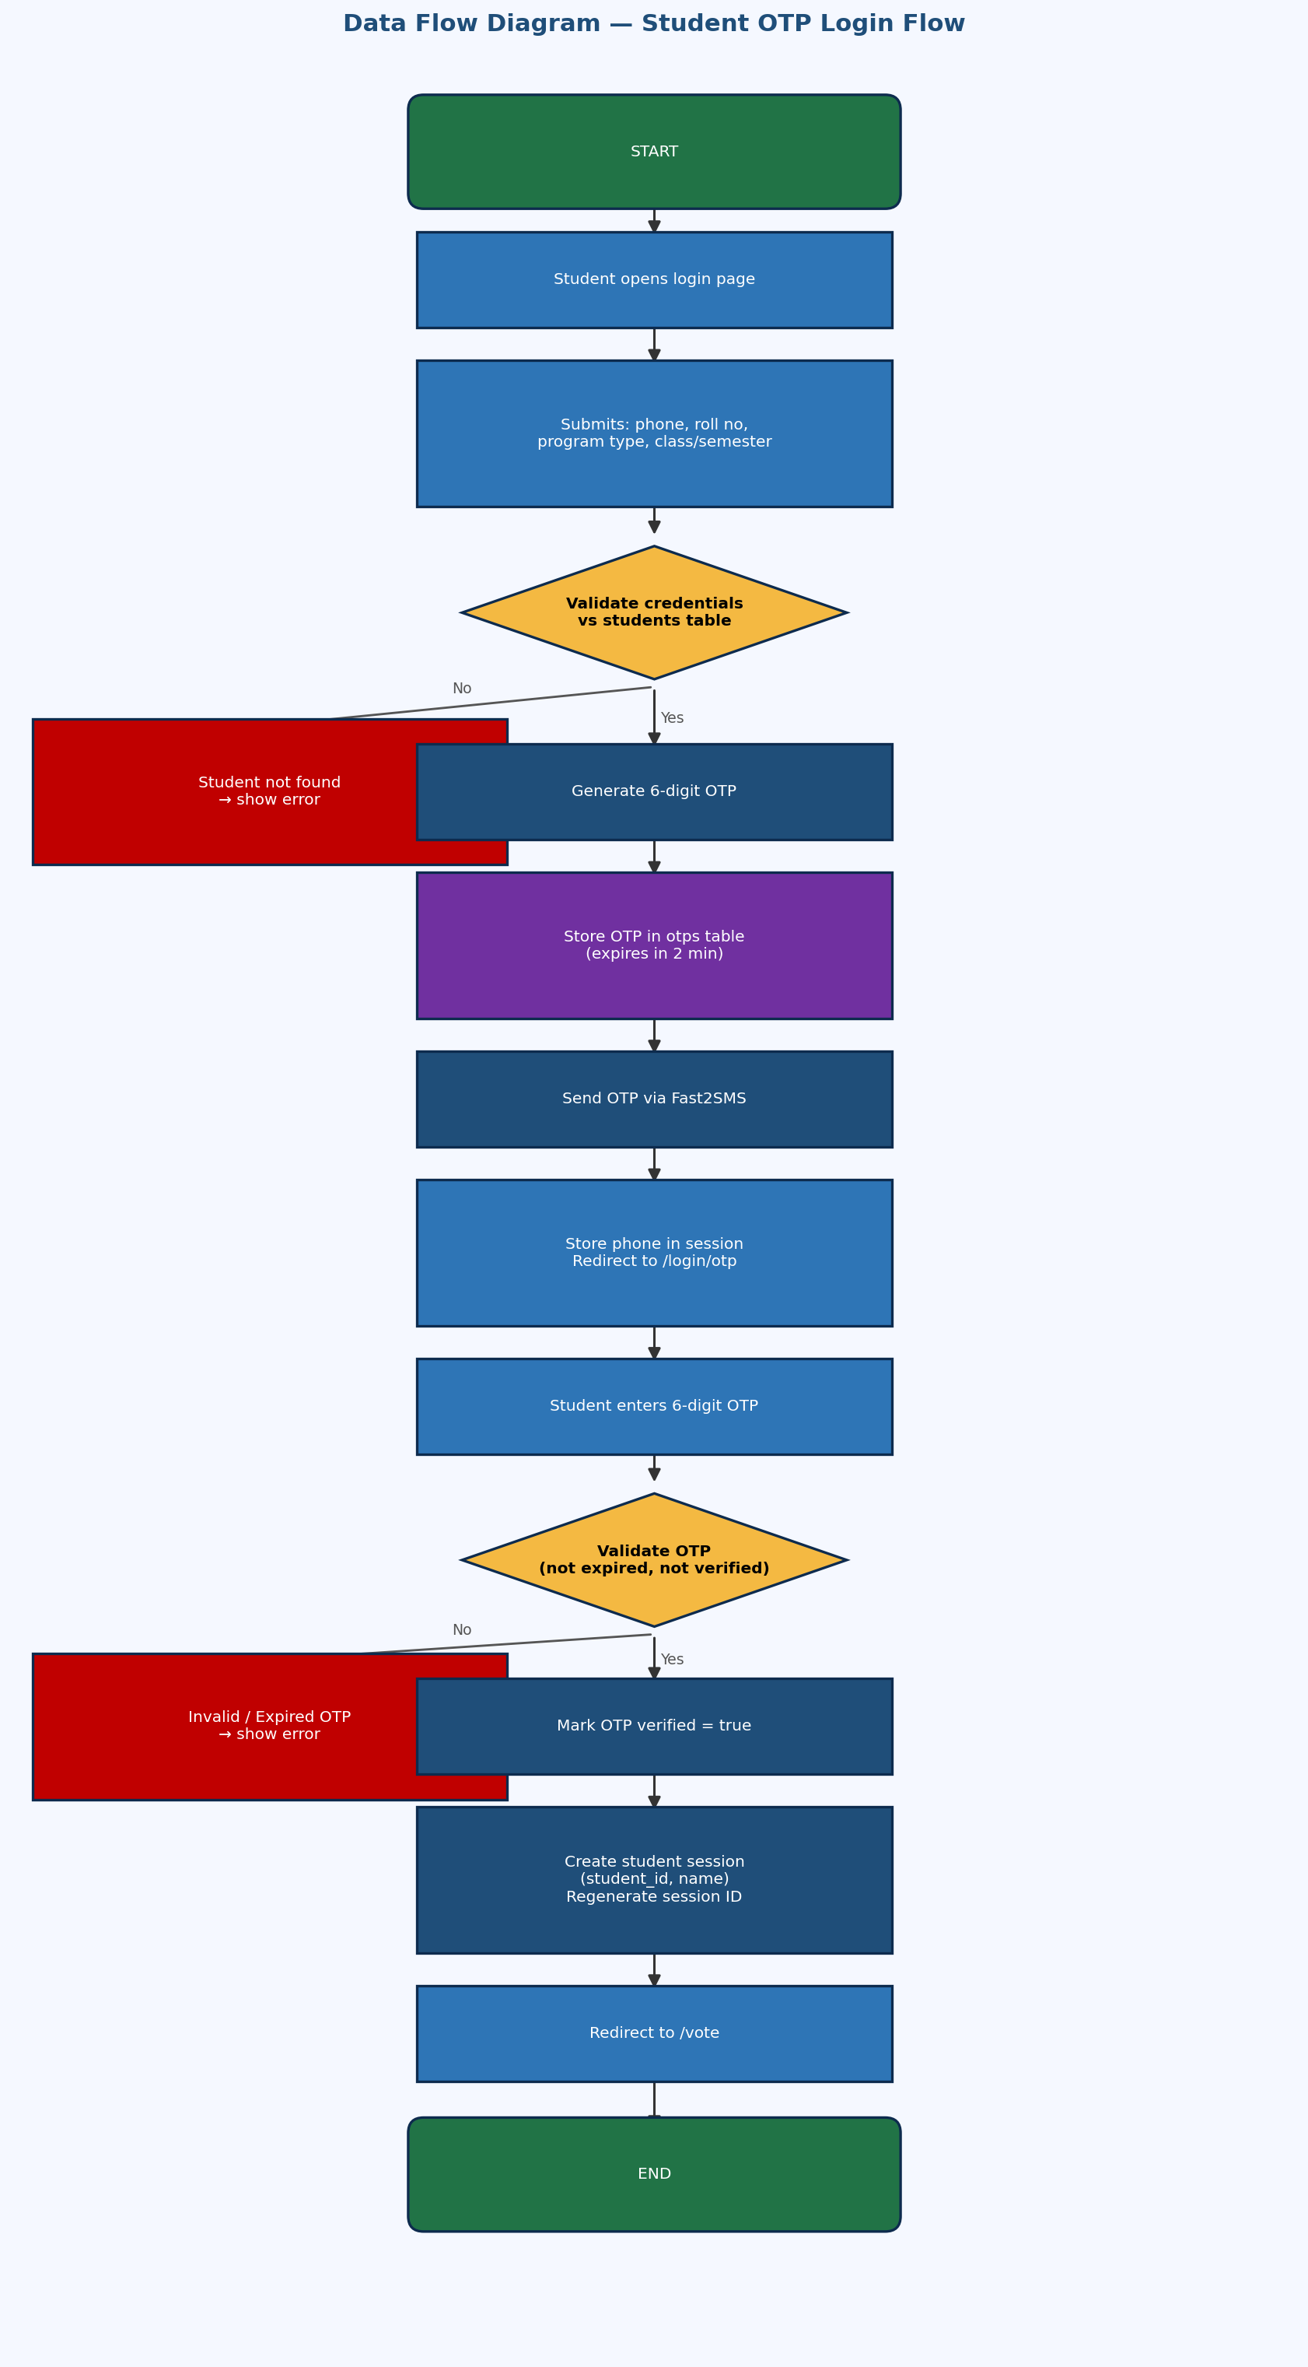
Figure 2: Data Flow Diagram — Student OTP Login Flow

7.7 Data Flow — Voting
The diagram below illustrates the complete voting workflow from page access through ballot submission.

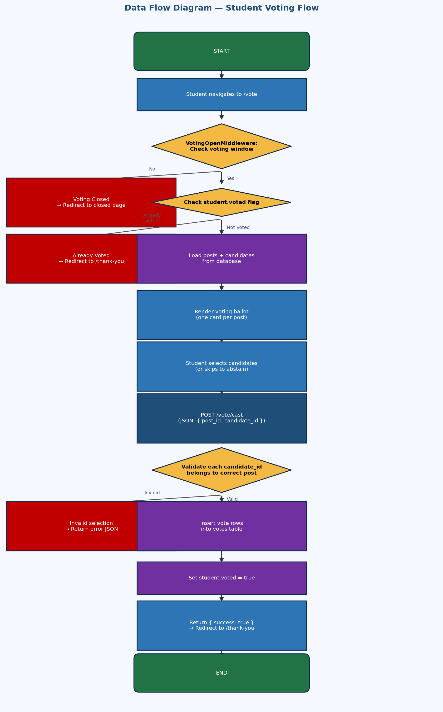
Figure 3: Data Flow Diagram — Student Voting Flow

8. Design Document

8.1 System Architecture
The application follows the MVC architectural pattern as implemented by Laravel.

Layer | Technology | Responsibility
Presentation (View) | Blade Templates + Vanilla JS + Tailwind CSS | Render HTML; handle user interactions
Application (Controller) | Laravel Controllers + Middleware | Process requests; enforce business rules
Data (Model) | Eloquent ORM + MySQL | Database access; relationships; validation
Routing | routes/web.php | Map URLs to controllers; apply middleware
SMS | Fast2SmsService | Deliver OTPs to student mobile numbers

8.2 Directory Structure

Path | Purpose
app/Http/Controllers/Admin/ | Admin panel controllers
app/Http/Controllers/Auth/ | Authentication controllers for admin and student
app/Http/Controllers/Student/ | Student voting and results controllers
app/Http/Middleware/ | AdminMiddleware, StudentMiddleware, VotingOpenMiddleware
app/Models/ | Eloquent models: User, Student, Post, Candidate, Vote, Otp, ElectionSetting
app/Services/ | Fast2SmsService — SMS delivery driver
app/Contracts/ | SmsServiceInterface — abstract SMS contract
app/Imports/ | StudentsPreviewImport — Excel/CSV bulk import logic
resources/views/ | Blade templates (admin, auth, student, layouts)
routes/web.php | All application routes with middleware assignments

8.3 Admin Election Lifecycle
The diagram below shows the complete administrative workflow from login through result publication.

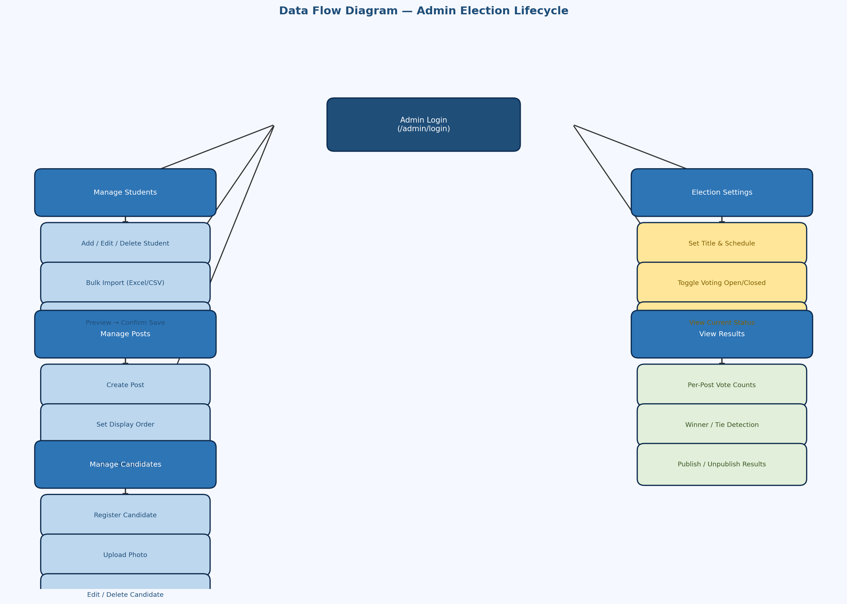
Figure 4: Data Flow Diagram — Admin Election Lifecycle

8.4 Database Design
The system uses seven custom tables alongside Laravel's internal tables (cache, sessions, jobs).

Table | Key Columns | Purpose
users | id, name, email, password, role | Admin account credentials
students | id, name, phone (UK), roll_no, semester, class, voted | Student voter registry
posts | id, name, description, display_order | Election positions
candidates | id, name, post_id (FK), semester, photo | Candidates per post
votes | id, student_id (FK), post_id (FK), candidate_id (FK) | Ballot records (unique: student+post)
otps | id, phone, otp_code, expires_at, verified | OTP records for student authentication
election_settings | id, title, voting_open, results_published, voting_start, voting_end | Election lifecycle control (singleton)

8.5 Database Screenshots
The following screenshots show the database tables as seen in the database management tool.

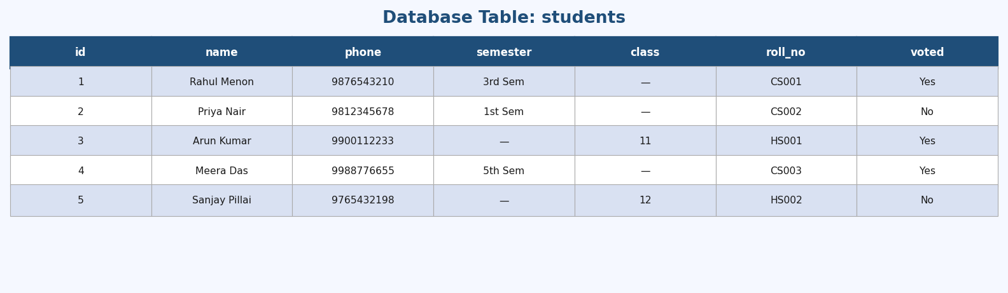
Figure 5: students table
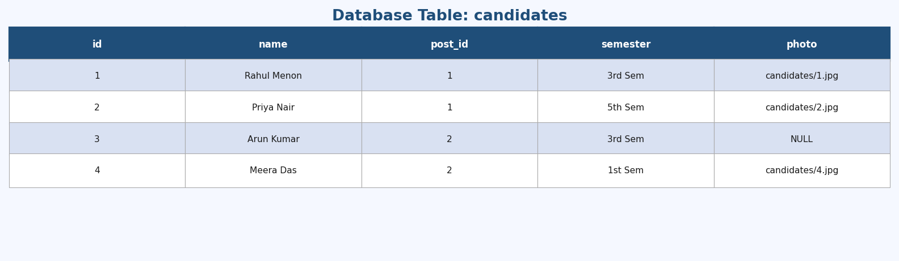
Figure 6: candidates table
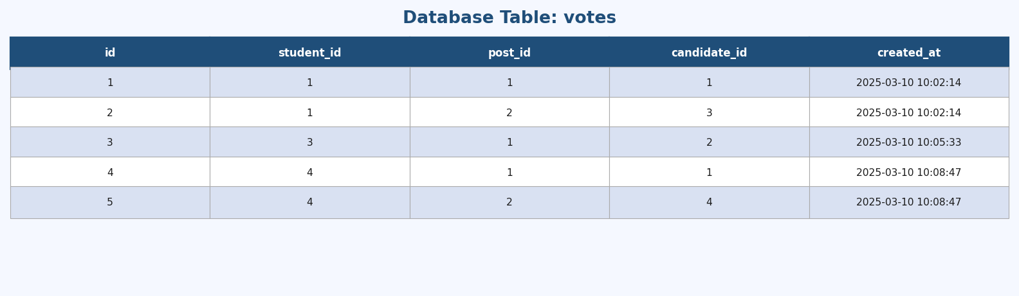
Figure 7: votes table
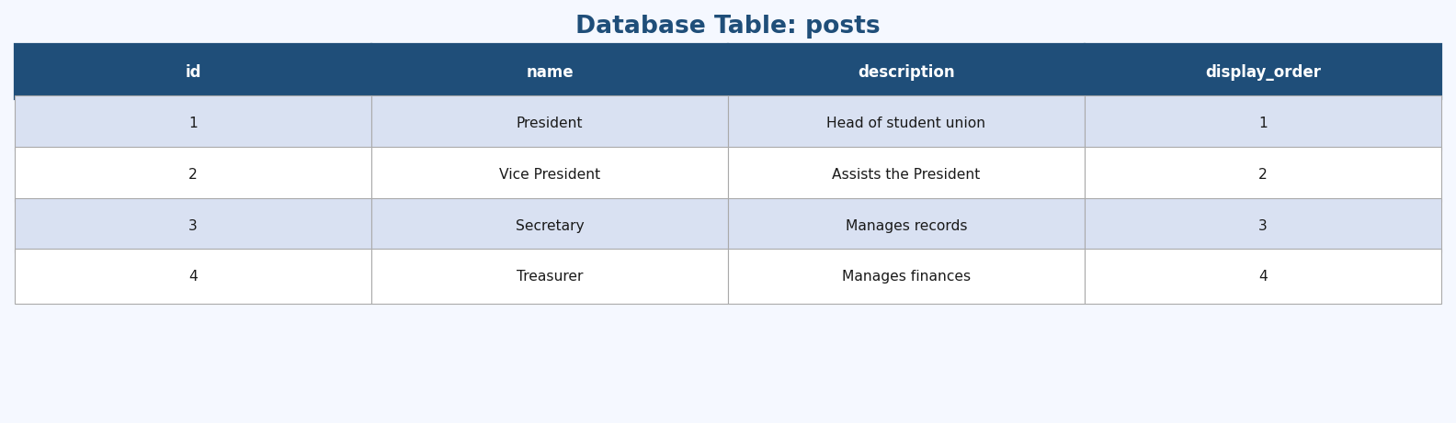
Figure 8: posts table
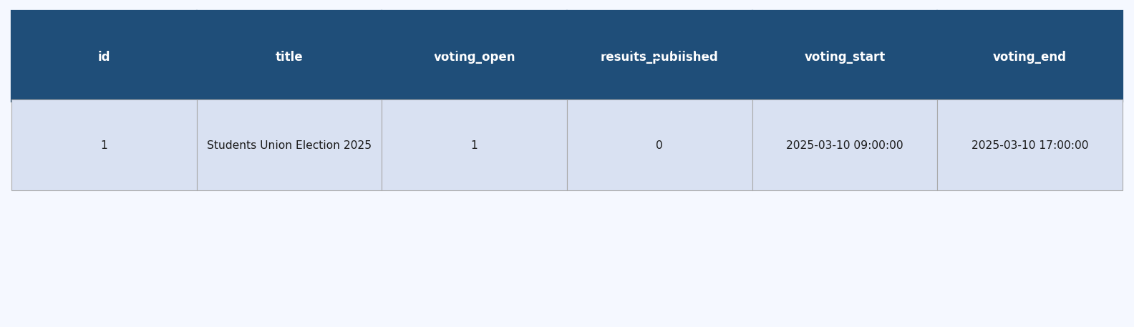
Figure 9: election_settings table

8.6 Middleware Design

Middleware | Applied To | Purpose
auth | All admin routes | Laravel built-in session authentication check
admin | All admin routes | Verifies logged-in user has role = 'admin'
student | All student portal routes | Verifies session contains a valid student_id
voting.open | Vote routes | Checks voting_open flag and datetime window

8.7 SMS Service Design
The SMS system uses an interface-based pattern. SmsServiceInterface defines a send(phone, message) method. The service provider binds Fast2SmsService to this interface. Fast2SMS is used for all SMS delivery in both development and production.

9. Testing

9.1 Overview
The College Voting System was subjected to comprehensive manual testing across all functional modules to verify correctness, usability, and security. Testing covered standard workflows as well as adversarial inputs to validate the system's resilience.

9.2 Functional Test Cases

Test Case | Module | Expected Outcome | Result
Admin login with valid credentials | Admin Auth | Redirect to dashboard | Pass
Admin login with invalid password | Admin Auth | Error message displayed | Pass
Create a new election post | Post Management | Post saved and listed | Pass
Add a candidate with photo upload | Candidate Management | Candidate saved with photo | Pass
Bulk import students via Excel | Student Import | Students previewed and saved | Pass
Student login with valid credentials | Student Auth | OTP sent; redirect to OTP page | Pass
Student login with incorrect roll number | Student Auth | Error: student not found | Pass
OTP verification with correct OTP | Student Auth | Session created; redirect to vote | Pass
OTP verification with expired OTP | Student Auth | Error: OTP expired | Pass
Student casts vote for all posts | Voting | Votes saved; thank-you page shown | Pass
Student attempts to vote again | Voting | Redirect to thank-you; no duplicate vote | Pass
Access voting page when election closed | Voting | Redirect to voting-closed page | Pass
Admin toggles voting open/closed | Election Settings | Voting window updated immediately | Pass
Admin publishes results | Results | Students can view results | Pass
Admin unpublishes results | Results | Results hidden from students | Pass
Winner detection (one candidate leads) | Results | Winner badge displayed | Pass
Tie detection (equal votes) | Results | Tie badge displayed | Pass

9.3 Security Test Cases

Test Case | Attack Vector | Expected Outcome | Result
Submit SQL injection payload in login fields | SQL Injection | Eloquent ORM uses parameterised queries; injection has no effect | Pass
Submit XSS payload in student name field | XSS | Blade {{ }} escaping renders payload as plain text; no script executes | Pass
Submit form without CSRF token | CSRF | Laravel returns HTTP 419 Page Expired; request rejected | Pass
Request OTP repeatedly in quick succession | OTP Rate Limiting | Existing unverified OTP is invalidated and replaced; prevents enumeration | Pass
Attempt to vote for same post twice (concurrent requests) | Duplicate Vote | DB unique constraint on (student_id, post_id) rejects second insert | Pass
Upload non-image file as candidate photo | Invalid File Upload | Controller validation rejects non-image MIME types; error shown | Pass
Access admin dashboard without session | Unauthorised Access | Redirect to admin login page | Pass
Access /vote without student session | Unauthorised Access | Redirect to student login page | Pass
Submit vote with candidate_id from a different post | Ballot Tampering | Controller validates candidate belongs to stated post; rejected | Pass
Reuse an already-verified OTP | OTP Replay | OTP.verified flag is true; rejected with 'Invalid or expired OTP' | Pass

10. Input & Output Screens

10.1 Student Login Screen
Input: Phone number, roll number, program type, class/semester. Output: OTP sent confirmation; redirect to OTP verification. Design: Glassmorphism card with gradient background; program type toggle shows dynamic fields.

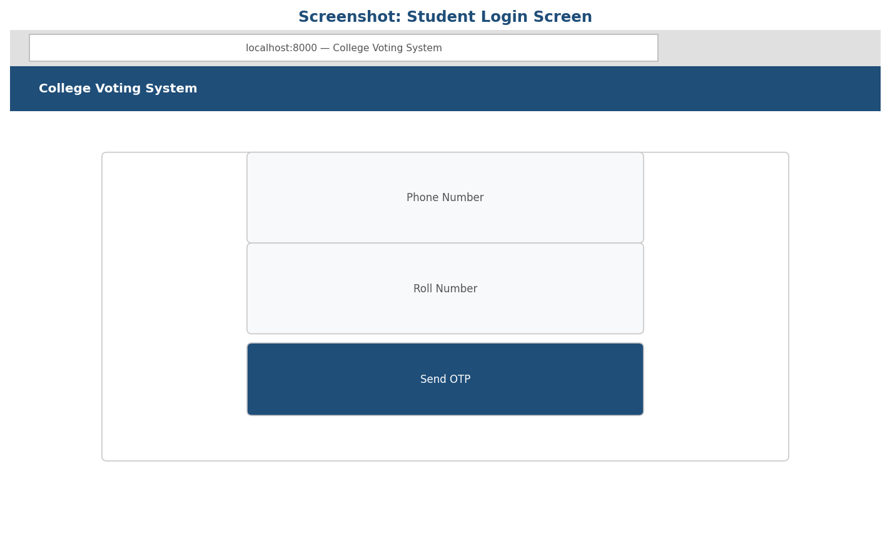
Figure 10: Student Login Screen

10.2 OTP Verification Screen
Input: Six individual digit fields for the OTP code. Output: Session created and redirect to ballot on valid OTP; error message with resend option on invalid/expired OTP. Features: Auto-focus advances between fields; resend generates a new 5-minute OTP.

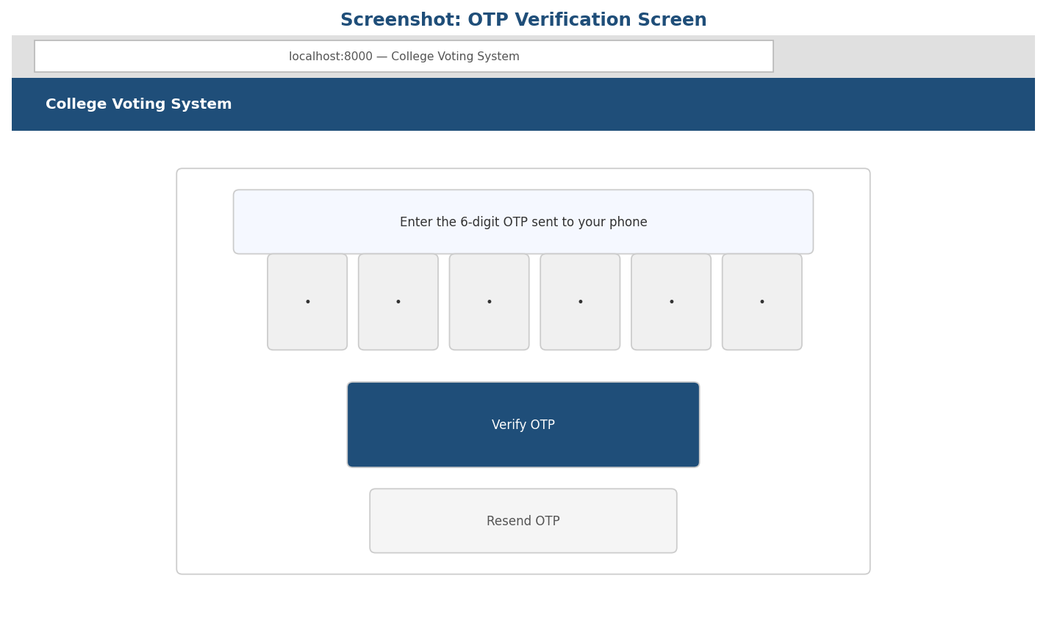
Figure 11: OTP Verification Screen

10.3 Admin Dashboard
Output: Four summary cards (Students, Posts, Candidates, Votes), current election status, and quick-action buttons.

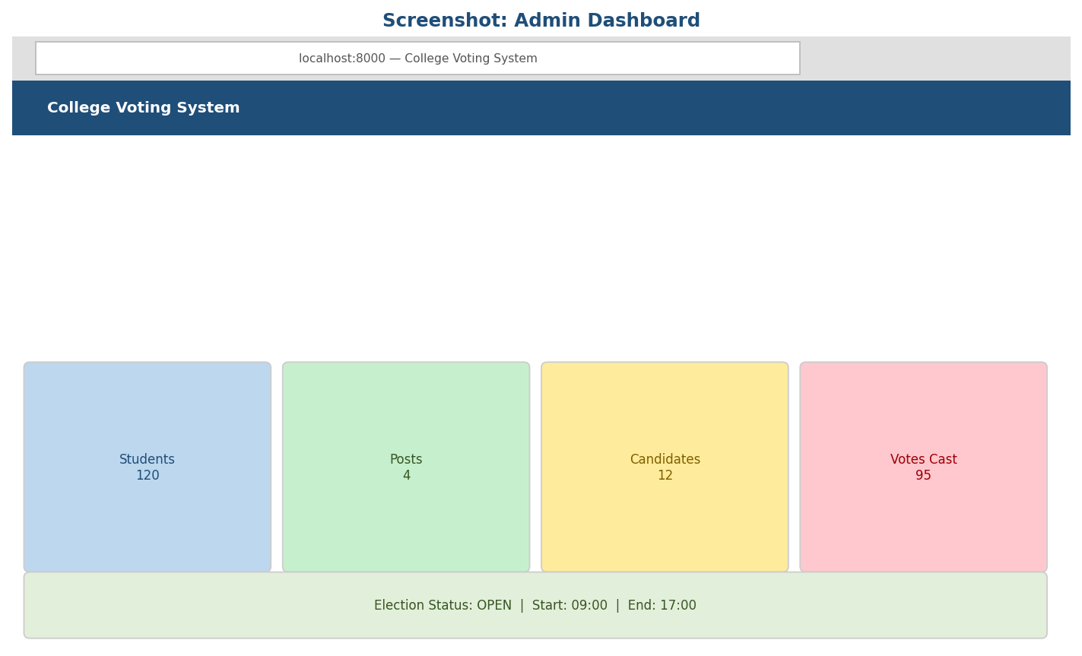
Figure 12: Admin Dashboard

10.4 Student Management Screen
Input: Search term, class/semester filter. Output: Paginated table of students with create, edit, delete, and bulk-delete options. Includes a Bulk Import button.

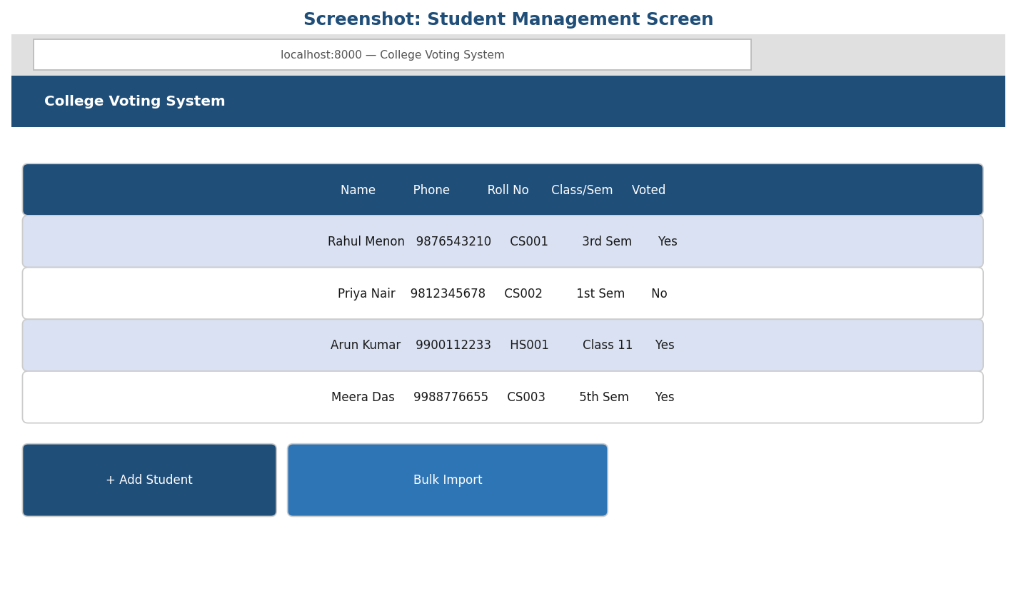
Figure 13: Student Management Screen

10.5 Candidate Management Screen
Input: Candidate name, post, semester, optional photo. Output: Filterable table with photo thumbnails, edit, and delete options.

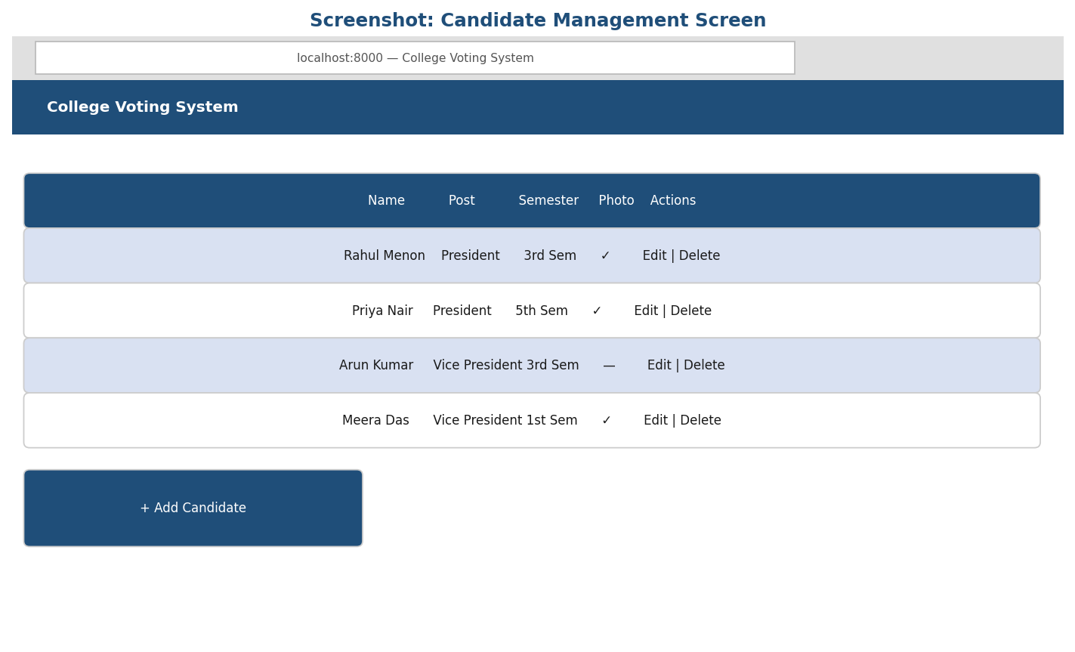
Figure 14: Candidate Management Screen

10.6 Voting Ballot Screen
Output: A ballot card per election post showing candidates with photos. Input: One selection per post (or abstain). On submission: votes saved and redirect to thank-you page.

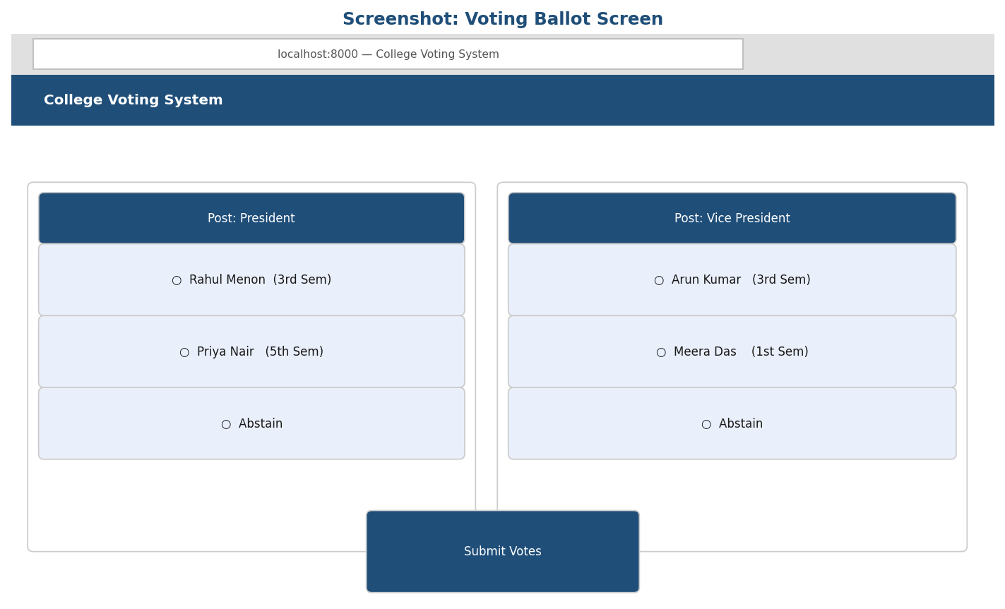
Figure 15: Voting Ballot Screen

10.7 Election Results Screen
Output: Per-post results with progress bars, vote counts, percentages, and Winner/Tie badges. Visible to students only after admin publishes results.

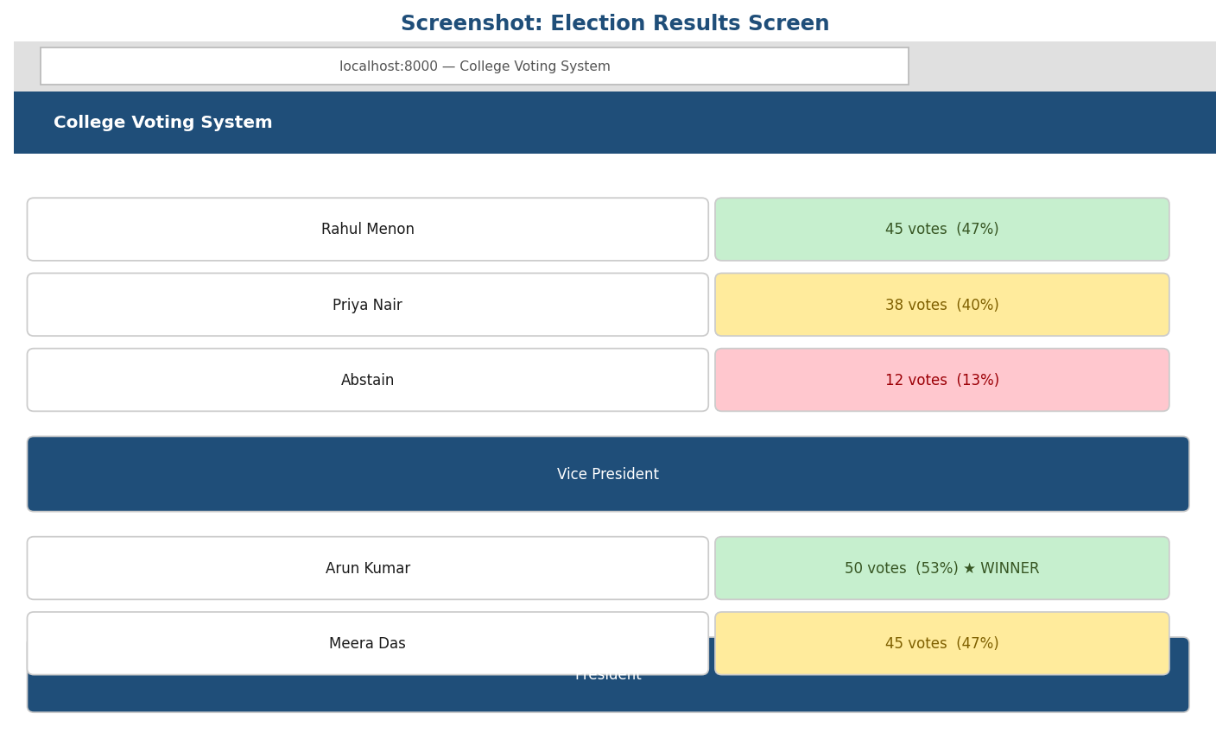
Figure 16: Election Results Screen

10.8 Thank You Screen
Output: Confirmation that votes have been recorded. Link to return to login page.

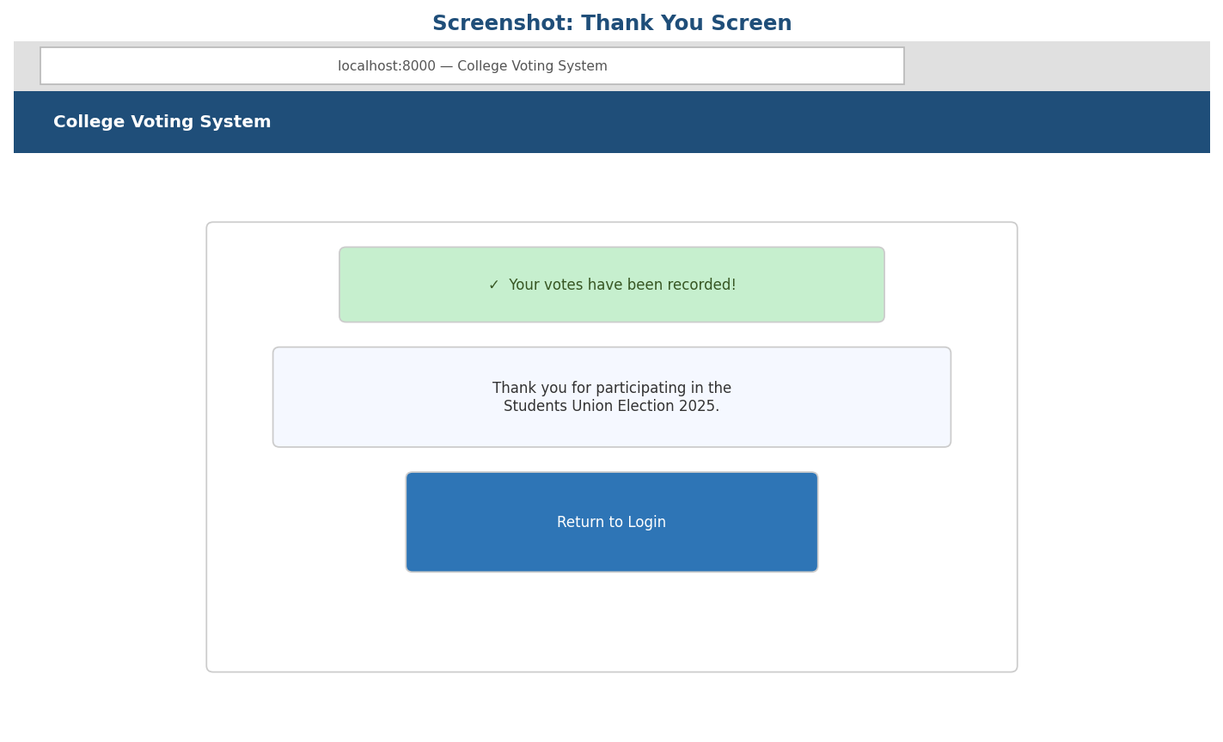
Figure 17: Thank You Screen

11. Implementation of Security

11.1 Authentication Security
Admins authenticate using Laravel's Auth facade, which validates email and bcrypt-hashed passwords. Students authenticate via OTP: credentials are validated against the database, a 6-digit OTP is generated and sent via Fast2SMS, and login requires the correct code within the validity window.

11.2 SQL Injection Prevention
All database queries use Laravel's Eloquent ORM or the Query Builder, both of which use PDO parameterised statements internally. User-supplied values are never interpolated directly into SQL strings. This prevents SQL injection attacks regardless of the input content.

11.3 XSS (Cross-Site Scripting) Prevention
All output rendered in Blade templates uses the {{ }} double-curly-brace syntax, which automatically HTML-encodes values before they are written to the page. This prevents reflected and stored XSS attacks. The {!! !!} (unescaped) syntax is avoided entirely for user-controlled data.

11.4 CSRF Protection
All POST, PUT, and DELETE forms include a @csrf Blade directive, which embeds a unique per-session CSRF token. Laravel's middleware verifies this token on every state-changing request. Requests missing or carrying an incorrect token receive a 419 Page Expired response.

11.5 bcrypt Password Hashing
Admin passwords are stored as bcrypt hashes using Laravel's Hash::make() function with a cost factor of 12 by default. Plain-text passwords are never stored in the database. The change-password screen requires verification of the current password before accepting a new one.

11.6 OTP Security & Rate Limiting
- OTPs are 6-digit random numbers generated using PHP's rand(100000, 999999).
- Each OTP is stored with an expires_at timestamp (2 minutes for initial login; 5 minutes for resend).
- A verified flag prevents OTP reuse — once validated, the same code cannot be accepted again.
- On each resend request, the previous unverified OTP for the phone number is invalidated before a new one is generated, preventing code accumulation and enumeration attacks.

11.7 File Upload Validation
Candidate photo uploads are validated by the controller to accept only image MIME types (jpeg, png, gif, webp). File size limits are enforced by Laravel's validation rules. Uploaded files are stored in the server's storage directory with randomised filenames, preventing direct path guessing.

11.8 Session Security

Measure | Implementation
Session driver | Database — sessions stored in DB table, not browser-only cookies
Session regeneration | PHP session ID regenerated on every login and logout to prevent session fixation
Admin–student isolation | Separate session keys; an admin cookie cannot authenticate a student request
CSRF protection | All state-changing forms protected with Laravel's CSRF middleware

11.9 Voting Integrity
- Unique DB constraint on (student_id, post_id) in the votes table prevents duplicate voting at the database level.
- The students.voted flag provides an application-level guard before the ballot is rendered.
- Vote submission validates that each candidate_id belongs to the specified post_id, blocking ballot stuffing with forged references.

12. Limitations Of The Project

- The system currently supports a single election at a time. Running multiple simultaneous elections is not supported without architectural changes.
- Student authentication relies on SMS OTP delivery. Poor mobile coverage or Fast2SMS unavailability will prevent affected students from logging in.
- Bulk student import accepts Excel and CSV files but does not perform deep data validation beyond structural checks.
- The application does not currently support multi-language interfaces. All screens are presented in English only.
- There is no dedicated mobile application. Although the web interface is responsive, a native app would provide a better mobile experience.
- The system does not maintain a detailed audit trail of administrative actions. Changes to candidates, posts, or students are not logged with actor information.
- Candidate photos are stored on the server's local filesystem, requiring distributed file storage for cloud or load-balanced deployments.
- Email notifications are not implemented. Students and the admin receive no email confirmation of actions taken.

13. Future Scope

- Multi-Election Support: Extend the system to manage multiple concurrent elections for different departments or programmes, with separate voting windows and results for each.
- Email Notifications: Integrate email alerts for election announcements, result publications, and OTP delivery as a fallback channel.
- Native Mobile Application: Develop Android and iOS apps to provide a more seamless voting experience with push notifications.
- Detailed Audit Logging: Implement a comprehensive audit trail recording every administrative action with timestamps and user identification.
- Multi-Language Support: Add internationalisation (i18n) to support regional languages and make the platform accessible to a wider student population.
- Cloud File Storage: Migrate candidate photo storage to a cloud service (e.g., Amazon S3) to support distributed deployments.
- Candidate Profiles and Manifestos: Allow candidates to submit a manifesto displayed on the voting ballot to help students make informed choices.
- Live Result Dashboard: Develop a real-time results view using WebSockets (Laravel Echo + Pusher) so vote counts update live without page refresh.
- Biometric or College ID Integration: Explore biometric or college ID card verification to further strengthen student authentication.
- Automated Scheduling: Fully automate opening and closing of the voting window, eliminating the need for manual administrator intervention.

14. Conclusion
The College Voting System successfully digitizes college elections by providing a secure, efficient, and user-friendly platform for the entire election lifecycle — from candidate registration to result publication. The system addresses the key shortcomings of traditional paper-based elections: manual counting errors, susceptibility to tampering, weak voter verification, and high administrative overhead.

By implementing OTP-based student authentication through Fast2SMS, the system ensures that only eligible, registered students can cast votes. The combination of database-level constraints (unique vote per student per post), application-level guards (the voted flag), and security controls (Eloquent ORM for SQL injection prevention, Blade escaping for XSS prevention, CSRF middleware, bcrypt hashing, and session regeneration) provides robust protection against both accidental and malicious threats.

The administrative interface gives college staff complete control over the election process — managing students, posts, and candidates, scheduling the voting window, monitoring real-time results, and publishing outcomes — all from a single web dashboard. The bulk import facility reduces data entry effort, while the automated result computation with winner and tie detection eliminates manual counting entirely.

The project demonstrates a practical application of the Laravel MVC framework, MySQL relational database design, and modern front-end practices using Tailwind CSS and Vanilla JavaScript. The system is scalable, maintainable, and well-positioned for future enhancements such as multi-election support, native mobile applications, and real-time result streaming.

In summary, the College Voting System improves the integrity, efficiency, and accessibility of college elections while significantly reducing administrative effort — making it a valuable contribution to institutional governance.

15. Bibliography

- Laravel, Inc. (2024). Laravel 12.x Documentation. Retrieved from https://laravel.com/docs/12.x
- Taylor Otwell. (2011). Laravel: The PHP Framework for Web Artisans. https://github.com/laravel/laravel
- Maatwebsite. (2024). Laravel Excel Documentation. Retrieved from https://laravel-excel.com/
- Fast2SMS. (2024). Fast2SMS Developer API Documentation. Retrieved from https://docs.fast2sms.com/
- Tailwind CSS. (2024). Tailwind CSS v4 Documentation. Retrieved from https://tailwindcss.com/docs
- Vite. (2024). Vite 7 Documentation. Retrieved from https://vite.dev/
- MDN Web Docs. (2024). JavaScript Reference (ECMAScript 6+). Mozilla. Retrieved from https://developer.mozilla.org/en-US/docs/Web/JavaScript
- Oracle Corporation. (2024). MySQL 8.0 Reference Manual. Retrieved from https://dev.mysql.com/doc/refman/8.0/en/
- Pressman, R. S., & Maxim, B. R. (2019). Software Engineering: A Practitioner's Approach (9th ed.). McGraw-Hill Education.
- Sommerville, I. (2016). Software Engineering (10th ed.). Pearson Education.
- OWASP Foundation. (2024). OWASP Top Ten Web Application Security Risks. Retrieved from https://owasp.org/www-project-top-ten/

