1 How are we going to connect front end and back end?

2 Which are the files you coded? Are there excess files we don’t need?

3 Struts+spring+mybatis?

4 How do we set up the database? Setting up sql on local?

5 What have you already done?

6 What are you working on?

7 What still needs to be done?

8 And of that, what do we need to do? And what will you work on?

9 How are we putting our website onto the adnature.ca domain? Do we need to do 10 that, or is that your responsibility?

11 Should we be using a framework?

12 How to reference java in html?   
13 How to send user input to database? ^^^

14 Also – maybe premature but site translation?

15 For Renata - suggestion: having user reviews on website?

Re8: Firstly, get used to the back end structure, including which file is in which place.

Secondly, put HTML CSS JS and image in the right place in project. Also you need to change the some url of CSS, JS and image like /style/css/….

Thirdly, learn how to send request and get response for HTML and JAVA

Lastly, try to use service function in portalweb. I will offer developed service module and DAO module for you. Later, if you learn how the service module works, you can add or change the function in service module according to portalweb.

Re9: computer is a server after setting up Tomcat, so you can visit website on other computer by **visit** **IP/index.htm rather than localhost/index.htm.** For further use, we’d better rent a server or find server service online, then setup environment, and upload source code on that just like what you did on your computer, also **combine the domain and server ‘s IP**

## Architecture

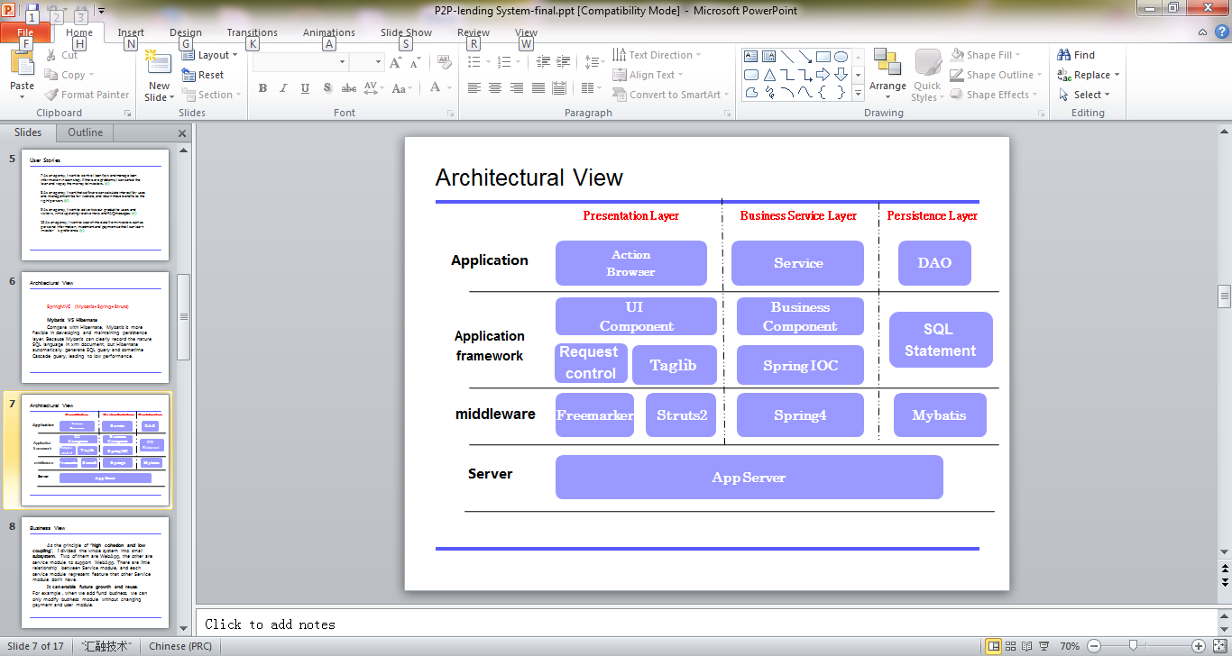

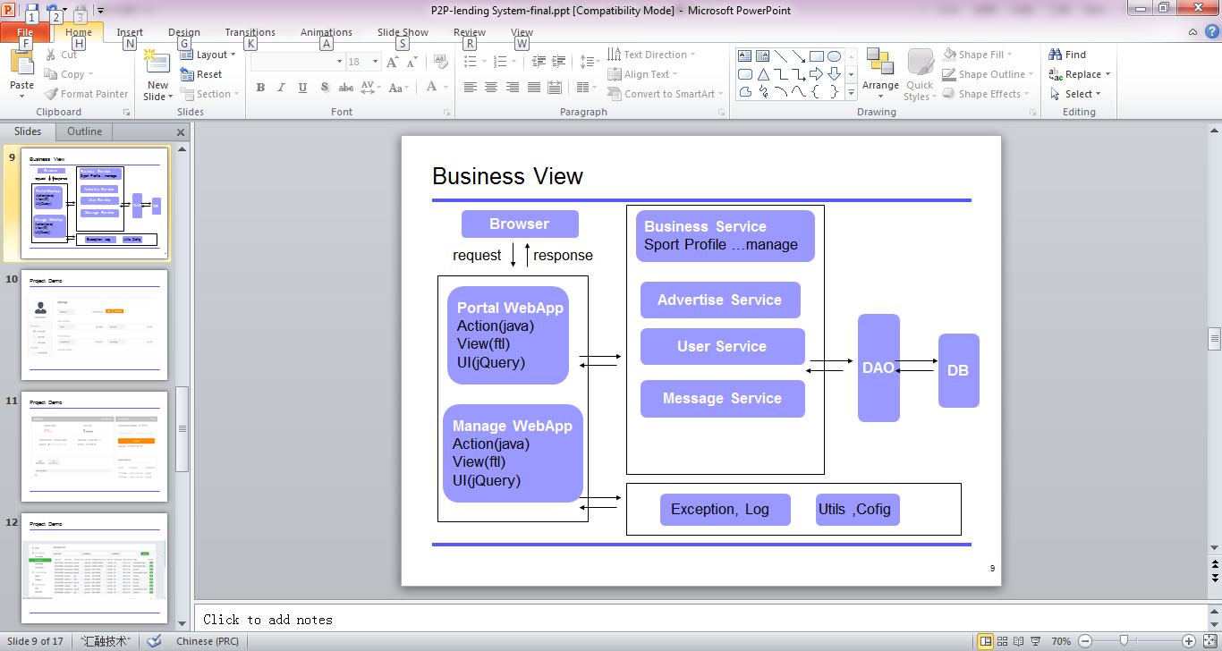

common(//-): UI control(button, checkbox….), Exception, Log

corebiz: main business(sport, profile…..) **service**

domain: main business(sport, profile…..) **DAO**

framework(//-): Utils tools(DateUtils, StringUtils…….)

mgrweb(//+): the **back WebApp** to manage website info

portalweb: the **front WebApp** to see info

cms(//-): advertisement(indexPage,article…) **service and DAO**

security: user(login,signup,password….) **service and DAO**

message(//+): message(email, alert, notice……..) **service and DAO**

Note: service module contains businness logic function for portalweb to call

DAO module contains SQL logic function for service module to call

//- means the module maybe deleted if not useful for development

//+ means the module should be added

## Eclipse and Debug:

1 try to use git in eclipse , but I have to say that It is not working on my computer. If you have same problem. Just write code in eclipse and push code by command line is ok.

2 Learn how to debug in eclipse will be helpful, add stop point to see what is in variable, just like below

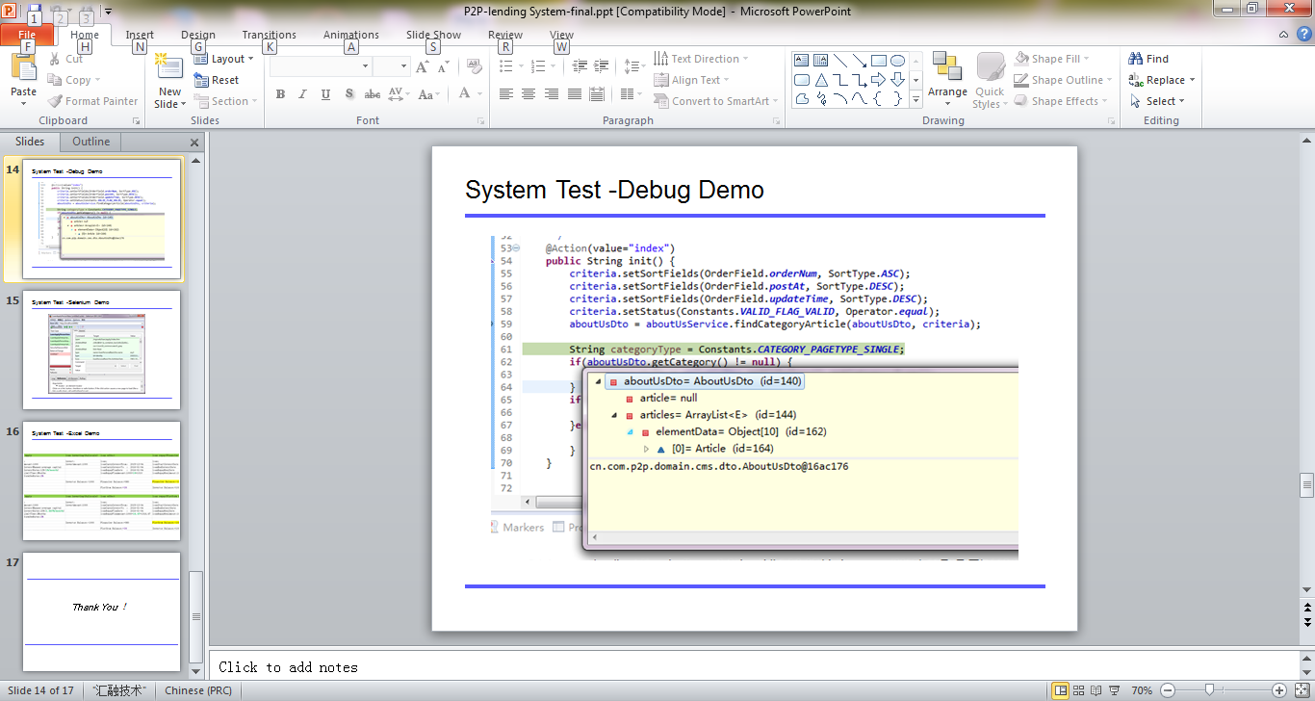

## Demo