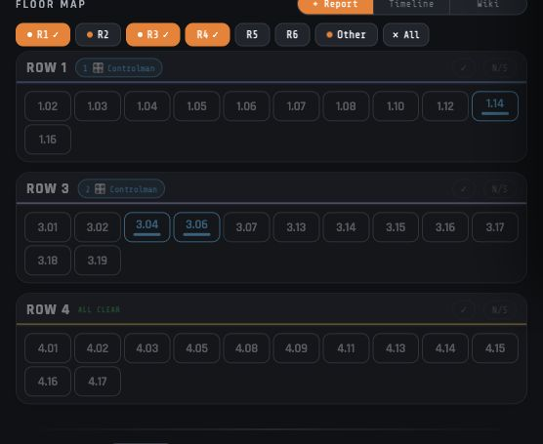

AP Tracker UI Element Naming Guide
Illustrated terminology for the main Operations Dashboard |  | Prepared by AP Tracker  July 2026

Contents

Executive summary 2
At a glance 2
Introduction 2
Key findings 3
Context and conditions 3
Patterns in the evidence 3
Implications 3
Recommendations 4
Conclusion 4
Appendix 5
Notes 5
Source placeholders 5

Executive summary
The AP Tracker main page is best described as an Operations Dashboard: it combines a live floor-oriented overview with a detailed issue-management feed. This guide establishes a concise, repeatable vocabulary for discussing its visible interface.
The terminology below is based on the signed-in production dashboard viewed on July 30, 2026. It names interaction regions, controls, and status indicators without changing their functional meaning.

At a glance
- The App Header provides product identity, quick tools, and the active user context.
- The Filter Bar narrows the operational view by date, ownership, status, machine, shift, and search query.
- The page’s two primary work regions are the Floor Map and the Issue Log.

Introduction
Consistent UI names make support conversations, design reviews, documentation, and future enhancements more precise. The terms in this report favor what a floor user sees and does over implementation details.
Use these labels consistently in product copy, training materials, issue reports, and internal specifications. More specific names such as "Machine Tile" remain useful when the discussion is within the Floor Map.

Key findings
The main page has a deliberate operational hierarchy: global navigation and filters establish context; the Floor Map offers spatial awareness; and the Issue Log provides the detailed record and actions.

Context and conditions
The screen presents time and issue-scope controls above a status summary. It then shows the floor by row, where individual machines can be scanned quickly for highlighted issues or clear status.
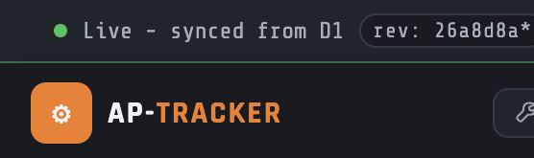
Figure 1. App Header and dashboard filter controls on the AP Tracker Operations Dashboard.

Patterns in the interface
Repeated controls make the naming system easy to learn: row selectors choose a map region, machine tiles represent individual presses, and issue cards represent the detailed work item associated with those machines.

Key takeaway. Call the overall page the Operations Dashboard; call its main regions the Floor Map and Issue Log.

Implications
A shared naming system reduces ambiguity. For example, "the issue highlight on machine tile 3.06" is clearer than "the blue one in Row 3," and "Issue Log view toggle" distinguishes Cards/List from scope filters such as Active Rows.
Theme | Observation | Implication
Region | Floor Map / Issue Log | Use for the two main work areas.
Selector | Row selector / scope tabs | Use for controls that change the visible subset.
Item | Machine tile / Issue card | Use for the individual unit of information or action.

Recommendations
Adopt the following labels in UI copy, product discussions, and acceptance criteria.
- Use Operations Dashboard for the complete main page, and retain Floor Map and Issue Log as the primary regional headings.
- Use Machine Tile (or Press Tile where plant language favors it) for each numbered machine control; use Issue Highlight for its colored active state.
- Use Issue Card, Issue Metadata, and Action Rail for the detailed issue representation and its associated controls.

Conclusion
The recommended vocabulary is compact enough for daily floor communication while being structured enough for technical documentation. It also mirrors the visual hierarchy users encounter on the dashboard.
These names are descriptive rather than prescriptive: they can coexist with existing domain language such as press, row, shift, and issue status.

Appendix: visual glossary

Issue Log
The Issue Log is the detailed issue feed beneath the Floor Map. Its View Toggle switches between Cards and List; its scope tabs include View All, Active Rows, and Resolved.
Each Issue Card includes a Machine Badge, category and subcategory badges, issue metadata, and an Action Rail for notifications, acknowledgement, tools, and completion.
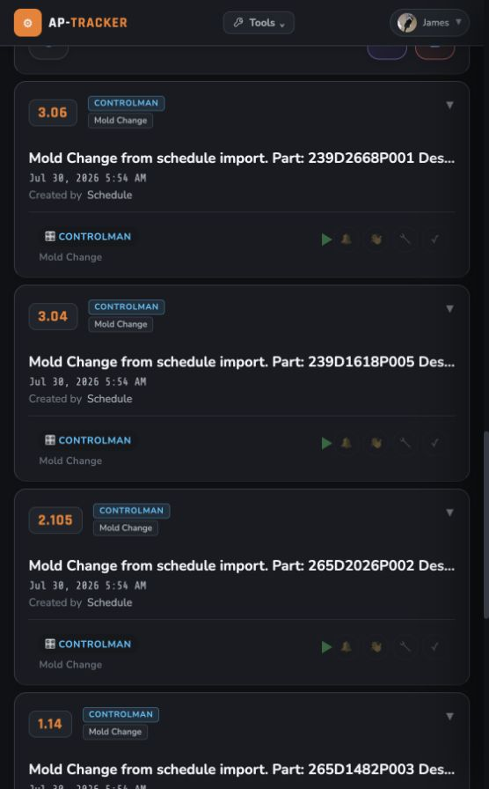
Figure 2. Issue Log, showing Issue Cards with metadata and action controls.

Floor Map
- The Map Toolbar contains Report, Timeline, and Wiki. The Row Selector chooses a logical floor grouping such as R1 or R3.
- Each Machine Row contains Machine Tiles. A Row Status Badge summarizes conditions for that row, while an Issue Highlight draws attention to a machine requiring attention.
- Supplementary UI terms: App Header, Filter Bar, Status Summary, Map Toolbar, Row Selector, Machine Row, Machine Tile, Issue Highlight, Issue Log, View Toggle, Issue Scope Tabs, Issue Card, Issue Metadata, and Action Rail.
- Visual sources: live AP Tracker main page screenshots captured July 30, 2026.

This guide is an internal naming reference for the AP Tracker main Operations Dashboard.

