***VAN LANG UNIVERSITY***

***FACULTY OF INFORMATION TECHNOLOGY***



***SOFTWARE ARCHITECTURE***

***AND DESIGN***

*FINAL PROJECT*

*ARCHITETURE DESIGN*

***TEAM 04 – BROTHERHOOD***

***05/04/2016***

***Version 1.0***

# ***REVISION HISTORY***

|  |  |  |  |
| --- | --- | --- | --- |
| ***DATE*** | ***AUTHOR*** | ***VERSION*** | ***DESCRIPTION*** |
| 12/28/2016 | Minh Nguyen  Loc Ngo | 1.0 | Create document |

***TABLE OF CONTENTS***

***REVISION HISTORY*** 2

***TABLE OF CONTENTS*** 4

***I.*** ***INTRODUCTION*** 5

***1.*** ***Purpose*** 5

***2.*** ***Scope*** 5

***3.*** ***Intended Audience*** 5

***4.*** ***References*** 5

***5.*** ***Glossary*** 5

***II.*** ***SYSTEM CONTEXT*** 6

***III.*** ***PHYSICAL PERSPECTIVE*** 7

***IV.*** **Static Perspective** 10

**1.** **Level 1** 10

# ***INTRODUCTION***

## ***Purpose***

This document contains all architecture information about CRM & Chat system.

In this document, we will document three key perspectives of the system: Physical, Dynamic, Static and the relations among them.

## ***Scope***

This document describes the system context and the high-level architectural design of the system.

## ***Intended Audience***

|  |  |
| --- | --- |
| ***Intended Audience*** | ***Reading suggestions*** |
| Mentor | All section document |
| Team develop | All section document |
| Architecture Leader | All section document |
| Project Manager | All section document |

## ***References***

* Architecture Driver Document
* Software Requirement Specification.

## ***Glossary***

|  |  |
| --- | --- |
| ***Terms*** | ***Description*** |
| LAN | Local Area Network |
| TCP/IP | Internet protocol suite or IP suite |
| HTTP | Hypertext Transfer Protocol |

# ***SYSTEM CONTEXT***

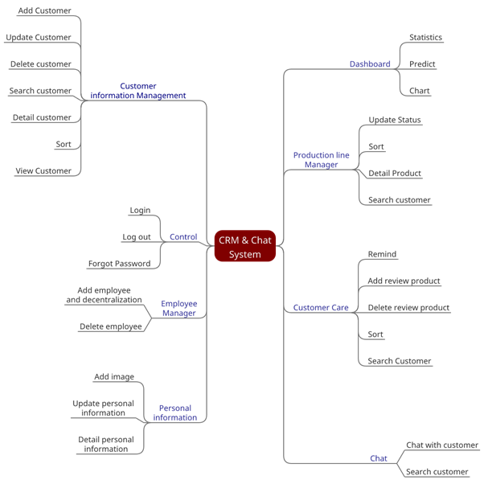

# ***PHYSICAL PERSPECTIVE***

* + - 1. ***Physical Design***

1. ***Level 0***

Physics lv0.png

***Figure 1:*** Physical View Level 0

1. ***Level 1***

PhysicView.png

***Figure 2:*** Physical View Level 1

* + - 1. ***Element Catalogue***

|  |  |  |  |
| --- | --- | --- | --- |
| ***ID*** | ***Name*** | ***Properties*** | ***Responsibilities*** |
| PH- 01 | Server Machine | OS: Windows Server 2014  Internet information system  .Net framework 5.0  ASP.Net MVC 5.001 | Run CRM & Chat website |
| PH- 02 | Database server | It‘s a database run in database management system SQL server 2014 | Contains all general data of CRM & Chat system. |
| PH- 03 | Web Application | It is web application | Handle all functions of CRM & Chat. |
| PH-04 | Customers PC/ Employee PC | OS: Windows XP, 7,8 or higher  CPU: Intel core 2 duo or higher  RAM: 1Gb or higher  Web Browsers | Provide information to CRM & Chat system and receive information from CRM & Chat system and present it to user. |
| PH- 04 | Internet | Internet | Communication between client and server. |
| PH- 05 | Router |  | Connect multiple network |
| PH- 06 | IIS7.0 |  | Is a web server application. When a request comes from client to server, IIS takes that request and process it and send response back to clients |
| PH- 07 | Firewall |  | Help to keep network secure, control the incoming and outgoing network traffic to secure database server of system. |
|  | LAN |  | A system for connecting a number of computer systems to form a local area network, with protocols to control the passing of information. |

* + - 1. ***Rationale***

|  |  |  |
| --- | --- | --- |
| ***ID*** | ***Description*** | ***Rationale*** |
| QA-S1 | System checks the authentication of users when login | Only authorized users can access to system  **Tactics:**  Authorize users  **Trade Off:**  Security (+) vs. Performance (-) |
| QA-S2 | The Web Server which connected to Head Office Database Server will have a communication protocol called HTTPs | User can’t read the message are being sent between Head Office Database and Website  **Tactics:**  HTTPs  **Trade Off:**  Security (+) |
| QA-P1 | User login to website | The system will display data into the screen  **Tactic:**  Local Database  **Trade Off:**  Performance(+) |
| QA-P2 | Customer log out of the website | show all payment  **Tactic:**  Maintain multiple copies of either data or computations  **Trade Off:**  Performance (+) vs. Cost (+) |
| QA-P3 | The response time of the sales operations must be fast | Complete processing information and display new information on the screen.  **Tactic:**  Maintain multiple copies of either data or computations  **Trade Off:**  Performance (+) vs. Cost (+) vs. Security (-) |

# **Static Perspective**

## **Level 1**