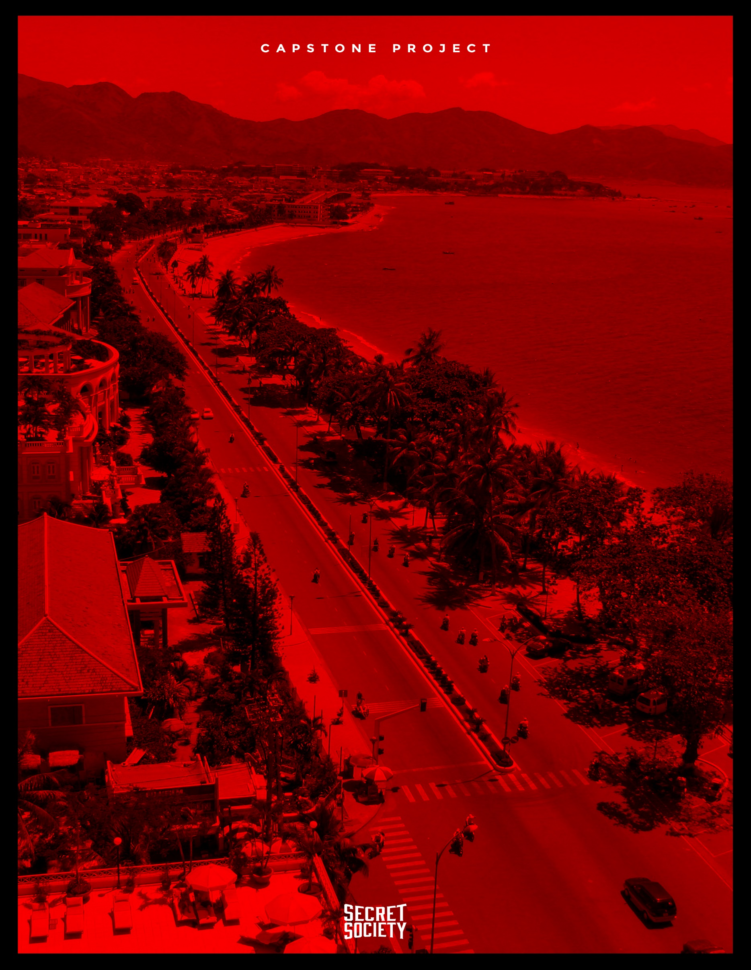

***DATABASE ANALYSIS AND DESGIN***

***SECRET SOCIETY***

***03/04/2017***

***VERSION 1.2***

# *REVISION HISTORY*

|  |  |  |  |
| --- | --- | --- | --- |
| ***DATE*** | ***AUTHOR*** | ***VERSION*** | ***DESCRIPTION*** |
| 02/15/2017 | Minh Nguyen  Nguyen Le  Hung Nguyen | 1.0 | Create document |
| 02/17/2017 | Minh Nguyen | 1.1 | Edit information |
| 03/04/2017 | Minh Nguyen | 1.2 | Edit information |

***TABLE OF CONTENTS***

***REVISION HISTORY*** 2

***TABLE OF CONTENTS*** 3

***I.*** ***INTRODUCTION*** 4

***II.*** ***PROJECT DESCRIPTION*** 5

***III.*** ***ERD*** 6

***IV.*** ***DATABASE SCHEMA*** 7

***V.*** ***LOGIC DATA DIAGRAM*** 8

1. ***INTRODUCTION***
2. ***Vision***

The CRM & Chat system is a web application that will for customer can management more detail and easily unlike current website. Our product allow employee can tracking status of customer, statistics and communication with customer more easily.

1. ***Scope***

Only applicable in the Company HNF

1. ***PROJECT DESCRIPTION***

This system was developed as a system HNF&CRM Chat. It has the ability to management more detail, it can be statistics and create communication tool between customer and employee.

* Management information of customer.
* Management customer care.
* Management order process.
* Statistics.
* Predict
* Function chat between customer and employee.

1. *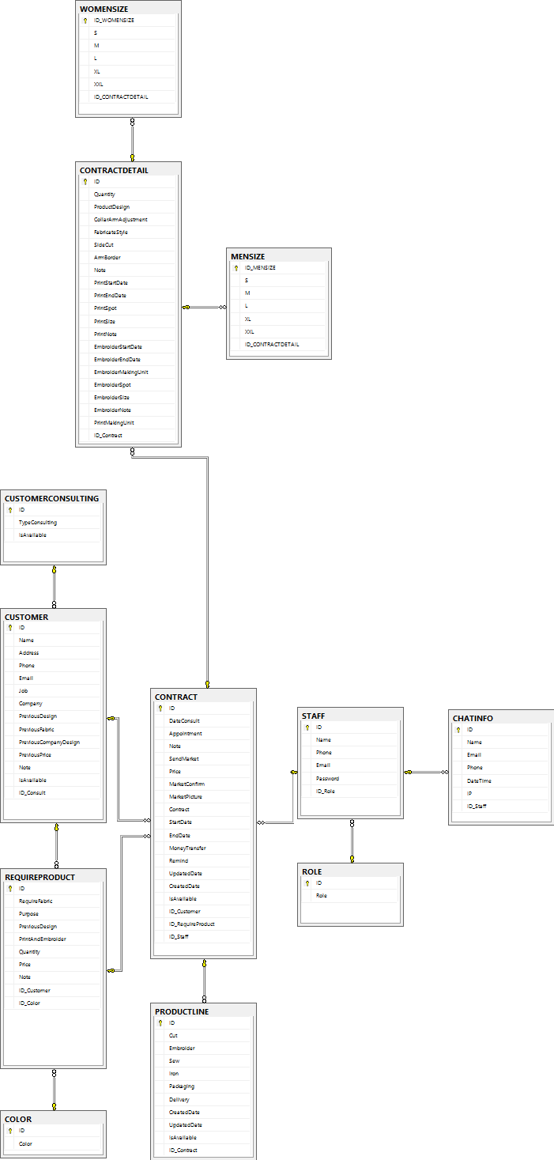****ERD***
2. ***DATABASE SCHEMA***
3. ***CUSTOMER (ID, Name, Job, Company, Address, Email, Phone, PreviousDesign, PreviousFabric, PreviousCompany, PreviousPrice, Note, IsAvailable, ID_Consult)***
4. ***CUSTOMERCONSULTING (ID, TypeConsulting, IsAvailable)***
5. ***REQUIREPRODUCT (ID, Quantity, Purpose, PreviousDesign, Price, RequireFabric, PrintAndEmbroider, Note, ID_Customer, ID_Color)***
6. ***COLOR (ID , Color)***
7. ***CONTRACT (ID , DateConsult, EndDate, MoneyTransfer, MarketPicture, Appointment, Remind, SendMarket, MarketConfirm, StartDate, Note, CreatedDate, UpdatedDate, IsAvailable, ID_Customer, ID_RequireProduct, ID_Staff )***
8. ***CONTRACTDETAIL (ID, ArmpitBorder, SideCut, Quantity, Fabric, ProductDesign, CollarArmAdjustment, EmbroiderStartDate, EmbroiderSpot, EmbroiderDetail, EmbroiderEnđate, EmbroiderNote, EmbroiderMakingUnit, PrintDetail, PrintSpot, PrintStartDate, PrintEndDate, PrintNote, PrintMakingUnit, CreatedDate, UpdatedDate, IsAvailable, ID_Contract)***
9. ***WOMENSIZE (ID, S, M ,L ,XL, XXL, ID_ContractDetail)***
10. ***MENSIZE (ID, S, M ,L ,XL, XXL, ID_ContractDetail)***
11. ***PRODUCT LINE (ID, Sew, Cut, Emboirder, Packaging, Iron, Delivery, CreatedDate, UpdatedDate, IsAvailable, ID_Contract)***
12. ***STAFF (ID, Email, Password, Name, Phone, ID_Role)***
13. ***ROLE (ID, Role)***
14. ***CHATINFO (ID, IP, DateTime, Name, Email, ID_Staff)***
15. ***LOGIC DATA DIAGRAM***

## *CONTRACTDETAIL*

|  |  |  |  |  |
| --- | --- | --- | --- | --- |
| ***No*** | ***Name*** | ***Description*** | ***Type*** | ***Note*** |
| 1 | ID | Identification number | int | Not Null |
| 2 | Quantity | Quantity | int | Null |
| 3 | ProductDesign | Product Design | Nvarchar(15) | Null |
| 4 | CollarArmAdjustment | Collar Arm Adjustment | Nvarchar(30) | Null |
| 5 | FabricateStyle | Fabricate Style | Nvarchar(30) | Null |
| 6 | Fabric | Fabric | Nvarchar(30) | Null |
| 7 | SideCut | Side Cut | Boolean | Null |
| 8 | ArmBorder | Arm Border | Boolean | Null |
| 9 | Notes | Notes | Nvarchar(Max) | Null |
| 10 | PrintStartDate | Print Start Date | Date | Null |
| 11 | PrintEndDate | Print End Date | Date | Null |
| 12 | PrintSpot | Print Spot | Nvarchar(30) | Null |
| 13 | PrintDetail | Print Detail | Nvarchar(30) | Null |
| 14 | PrintNote | Print Note | Nvarchar(Max) | Null |
| 15 | EmbroiderStartDate | Embroider Start Date | Date | Null |
| 16 | EmbroiderEndDate | Embroider End Date | Date | Null |
| 17 | EmbroiderMakingUnit | Embroider Making Unit | Nvarchar(30) | Null |
| 18 | EmbroiderSpot | Embroider Spot | Nvarchar(30) | Null |
| 19 | EmbroiderSize | Embroider Size | Nvarchar(30) | Null |
| 20 | EmbroiderNote | Embroider Note | Nvarchar(Max) | Null |
| 21 | CreatedDate | Created Date | Datetime | Null |
| 22 | UpdatedDate | Updated Date | Datetime | Null |
| 23 | IsAvailable | Status | Bit | Null |
| 24 | ID_Contract | Identification number | int | Not Null |

## *MENSIZE*

|  |  |  |  |  |
| --- | --- | --- | --- | --- |
| ***No*** | ***Name*** | ***Description*** | ***Type*** | ***Note*** |
| 1 | ID | Identification number | int | Not null |
| 2 | S | Size | int | Null |
| 3 | M | Size | int | Null |
| 4 | L | Size | int | Null |
| 5 | XL | Size | int | Null |

## *WOMENSIZE*

|  |  |  |  |  |
| --- | --- | --- | --- | --- |
| ***No*** | ***Name*** | ***Description*** | ***Type*** | ***Note*** |
| 1 | ID | Identification number | int | Not null |
| 2 | S | Size | int | Null |
| 3 | M | Size | int | Null |
| 4 | L | Size | int | Null |
| 5 | XL | Size | int | Null |

## *COLOR*

|  |  |  |  |  |
| --- | --- | --- | --- | --- |
| ***No*** | ***Name*** | ***Description*** | ***Type*** | ***Note*** |
| 1 | ID | Identification number | int | Not null |
| 2 | Color | Color | Nvarchar(50) | Null |

## *STAFF*

|  |  |  |  |  |
| --- | --- | --- | --- | --- |
| ***No*** | ***Name*** | ***Description*** | ***Type*** | ***Note*** |
| 1 | ID | Identification number | int | Not null |
| 2 | Phone | Phone | Nvarchar(13) | Null |
| 3 | Name | Name | Nvarchar(35) | Null |
| 4 | Email | Email | varchar(30) | Null |
| 5 | Password | Password | Nvarchar(30) | Null |

## *ROLE*

|  |  |  |  |  |
| --- | --- | --- | --- | --- |
| ***No*** | ***Name*** | ***Description*** | ***Type*** | ***Note*** |
| 1 | ID | Identification number | int | Not null |
| 2 | Role | Role | Nvarchar(30) | Null |

## *CONTRACT*

|  |  |  |  |  |
| --- | --- | --- | --- | --- |
| ***No*** | ***Name*** | ***Description*** | ***Type*** | ***Note*** |
| 1 | ID | Identification number | int | Not null |
| 2 | DateConsult | Date Consult | DateTime | Null |
| 3 | Appointment | Appointment | DateTime | Null |
| 4 | Note | Note | Nvarchar(Max) | Null |
| 5 | SendMarket | Send Market | varchar(100) | Null |
| 6 | Price | Price | float | Null |
| 7 | MarketConfirm | Market Confirm | Boolean | Null |
| 8 | MarketPicture | Market Picture | varchar(100) | Null |
| 9 | Contract | Contract | varchar(100) | Null |
| 10 | StartDate | Start Date | DateTime | Null |
| 11 | EndDate | End Date | DateTime | Null |
| 12 | MoneyTransfer | Money Transfer | Boolean | Null |
| 13 | Remind | Remind | char(3) | Null |
| 14 | CreatedDate | Created Date | Datetime | Null |
| 15 | UpdatedDate | Updated Date | Datetime | Null |
| 16 | IsAvailable | Status | Bit | Null |
| 17 | ID_RequireProduct | Identification number | int | Not Null |
| 18 | ID_Customer | Identification number | int | Not Null |
| 19 | ID_Staff | Identification number | int | Not Null |

## *REQUIREPRODUCT*

|  |  |  |  |  |
| --- | --- | --- | --- | --- |
| **No** | **Name** | **Description** | **Type** | **Note** |
| 1 | ID | Identification number | int | Not null |
| 2 | RequireFabric | Require Fabric | Nvarchar(30) | Not null |
| 3 | RequireDesign | Require Design | Nvarchar(30) | Null |
| 4 | Purpose | Purpose | Nvarchar(55) | Null |
| 5 | PreviousDesign | Previous Design | Boolean | Null |
| 6 | PrintAndEmbroider | Print And Embroider | Nvarchar(15) | Null |
| 7 | Quantity | Quantity | int | Null |
| 8 | Price | Price | float | Null |
| 9 | Note | Note | Nvarchar(Max) | Null |
| 10 | CreatedDate | Created Date | Datetime | Null |
| 11 | UpdatedDate | Updated Date | Datetime | Null |
| 12 | IsAvailable | Status | Bit | Null |
| 13 | ID_Customer | Identification number | int | Not Null |
| 14 | ID_Color | Identification number | Int | Not Null |

## *CUSTOMER*

|  |  |  |  |  |
| --- | --- | --- | --- | --- |
| ***No*** | ***Name*** | ***Description*** | ***Type*** | ***Note*** |
| 1 | ID | Identification number | int | Not null |
| 2 | Name | Name | Nvarchar(35) | Not null |
| 3 | Phone | Phone | varchar(13) | Null |
| 4 | Email | Email | varchar(100) | Null |
| 5 | Job | Job | Nvarchar(55) | Null |
| 6 | Company | Company | Nvarchar(55) | Null |
| 7 | Address | Address | Nvarchar(100) | Null |
| 8 | Comment | Comment | Nvarchar(Max) | Null |
| 9 | PreviousDesign | Previous Design | Nvarchar(30) | Null |
| 10 | PreviousFabric | Previous Fabric | Nvarchar(35) | Null |
| 11 | PreviousCompany | Previous Company | Nvarchar(50) | Null |
| 12 | Interested In | Interested in | Nvarchar(max) | Null |
| 13 | PreviousPrice | Price | Nvarchar(10) | Null |
| 14 | Notes | Notes | Nvarchar(Max) | Null |

## *CHATINFO*

|  |  |  |  |  |
| --- | --- | --- | --- | --- |
| ***No*** | ***Name*** | ***Description*** | ***Type*** | ***Note*** |
| 1 | ID_Chat | Identification number | int | Not null |
| 2 | Name | Name | Nvarchar(35) | Not null |
| 3 | Email | Email | varchar(30) | Null |
| 4 | Phone | Phone | varchar(13) | Null |
| 5 | DateTime | DateTime | DateTime | Null |
| 6 | IP | IP | varchar(50) | Null |
| 7 | ID_Staff | Identification number | int | Not Null |

## *CUSTOMERCONSULTING*

|  |  |  |  |  |
| --- | --- | --- | --- | --- |
| ***No*** | ***Name*** | ***Description*** | ***Type*** | ***Note*** |
| 1 | ID_Consult | Identification number | int | Not null |
| 2 | TypeConsulting | Type Consulting | Nvarchar(30) | Null |

## *PRODUCTLINE*

|  |  |  |  |  |
| --- | --- | --- | --- | --- |
| ***No*** | ***Name*** | ***Description*** | ***Type*** | ***Note*** |
| 1 | ID | Identification number | int | Not null |
| 2 | Cut | Cut | boolean | Null |
| 3 | Embroider | Embroider | boolean | Null |
| 4 | Sew | Sew | boolean | Null |
| 5 | Iron | Iron | boolean | Null |
| 6 | Packeting | Packaging | boolean | Null |
| 7 | Delivery | Delivery | boolean | Null |
| 8 | CreatedDate | Created Date | Datetime | Null |
| 9 | UpdatedDate | Updated Date | Datetime | Null |
| 10 | IsAvailable | Status | Bit | Null |
| 11 | ID_Contract | Identification number | Int | Null |

1. ***PHYSICAL DATA DIAGRAM***

