

***FUNCTION LIST***

***SECRET SOCIETY***

***12/05/2016***

***VERSION 1.2***

|  |  |  |  |
| --- | --- | --- | --- |
| ***DATE*** | ***AUTHOR*** | ***VERSION*** | ***DESCRIPTION*** |
| 17/11/2016 | Minh Nguyen  Huy Diep | 1.0 | Create document |
| 22/11/2016 | Minh Nguyen  Huy Diep | 1.1 | Update information |
| 05/12/2016 | Minh Nguyen  Huy Diep  Loc Ngo  Thuan Nguyen | 1.2 | Update information |

# ***REVISION HISTORY***

***TABLE OF CONTENTS***

***REVISION HISTORY*** 2

***TABLE OF CONTENTS*** 3

***DOCUMENT APPROVAL*** 4

***I.*** ***Introduction*** 5

***II.*** ***Function list*** 5

***a.*** ***List*** 5

***b.*** ***Description*** 6

# ***DOCUMENT APPROVAL***

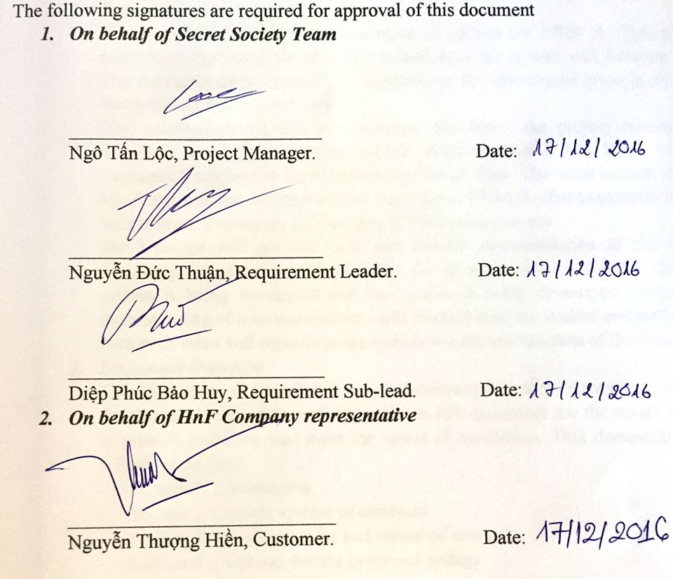

1. ***Introduction***

This is a list of all features which is listed by development team from the document that HNF customer provide us and from the discussion with customer about developing a totally new application for HNF company.

1. ***Function list***
2. ***List***

|  |  |  |  |  |  |
| --- | --- | --- | --- | --- | --- |
| ***Feature ID*** | ***Feature*** | ***Function ID*** | ***Function*** | ***Priority*** | ***Frequency of use*** |
| CM | Customer Management | 01 | Add new customer | High | Always |
| 02 | Delete customer | High | Rarely |
| 03 | Edit customer | High | Usually |
| 04 | Search customer | High | Always |
| 05 | Filter | High | Always |
| 06 | View detail personal information | High | Usually |
| 07 | Add new Contract | High | Usually |
| 08 | Edit Contract | High | Usually |
| 09 | Notification | Low | Sometimes |
| 10 | Edit Product Detail Design | High | Sometimes |
| EM | Employee Management | 01 | Add new employee | Medium | Usually |
| 02 | Authorize for employee | Medium | Usually |
| 03 | Delete employee | Medium | Rarely |
| 04 | View detail employee information | Medium | Usually |
| PLM | Product Line Management | 01 | Update status | High | Always |
| 02 | Search product | High | Usually |
| 03 | Filter | High | Usually |
| CC | Customer Care | 01 | Add new feedback | Low | Sometimes |
| 02 | Edit feedback | Low | Sometimes |
| 03 | Search customer care | Low | Sometimes |
| 04 | Filter | Low | Sometimes |
| S | Statistics | 01 | Monthly report | Medium | Sometimes |
| 02 | Yearly report | Medium | Rarely |
| D | Dashboard |  | Display information | High | Always |
| P | Predict |  | Predict VIP customer base on quantity | Low | Sometimes |
| CO | Control | 01 | Log in | Medium | Always |
| 02 | Log out | Medium | Sometimes |
| PIM | Personal Information Management | 01 | Edit personal information | Medium | Rarely |
| 02 | View detail personal information | Medium | Rarely |
| 03 | Change password | Medium | Rarely |
| CH | Chat |  | Chat with customer | Low | Sometimes |

1. ***Description***

* Development team analyzed and defined CRM & Chat application will have 10 features include 34 functions.
* All of features will be developed from 01/09/2016 – 04/23/2016.
* This document will be delivered to HNF customer to review and give the status for each function following the scale: High, Medium, Low. Development team will develop them base on the status that the customer has given before.
* Customer also give the status for each function following the scale: Always, Usually, Sometimes, Rarely, to review frequency that the customer use for each function.
* According the meeting occur on 11/17/2016, customer give the highest level for Customer Information Management and Product Line Management features.
* After the review has done, customer will sign below the document to make sure all function is right and has no change.