EquipShare-Hub

Trusted Institutional Resource & Equipment Sharing Platform

PROJECT DOCUMENTATION
- Problem Statement: Unlock Underused Equipment and Spaces
- PROJECT OVERVIEW:
EquipShare Hub is a resource-sharing platform designed to connect people who have underused equipment and spaces with those who need them. The platform aims to make resource discovery and booking more accessible while encouraging responsible usage, transparency, and accountability.
Submitted By:
Team Name: Codesaheli1111
Team Members:
Name: Supreeti Moulick
College: Brainware University
Name: Barsa Sen
College: Sanaka Educational Trust's Group of Institutions
Name: Sneha Kumari Mahato
College: Sanaka Educational Trust's Group of Institutions
Submitted For: CodeHack India 2026
Academic Year: 2026–2027
Submission Date: 30 October 2026
GitHub Link: EquipShare-Hub

TABLE OF CONTENTS

1. Abstract
2. Problem Statement and Research
3. Proposed Solution
4. Target Users and Use Cases
5. System Workflow
6. Features and Modules
7. Technology Stack and System Architecture
8. Database Design
9. Privacy, Security, Trust and Fairness
10. Implementation and Testing
11. Limitations and Future Scope
12. Team Contributions
13. Disclosure of Templates, Libraries, and Pre-Existing Components

ABSTRACT

EquipShare Hub is a resource-sharing platform designed to improve access to underutilized equipment, spaces and technical resources. Colleges, laboratories, makerspaces and community organizations often have resources that remain unused, while students, researchers and small teams may face difficulties accessing these resources due to cost or limited availability.

The proposed platform aims to connect resource owners with eligible users through a structured process of resource discovery, booking requests and approval management. Resource owners can list available resources and specify their availability and usage conditions. Users can search for suitable resources and submit booking requests for review.

The system is designed to support better resource utilization, responsible sharing and accountability through booking records and resource-condition reporting.

The project is currently under development, beginning with the

Problem Statement , Research and Existing Challenges:

- Problem Statement:
Many colleges, laboratories, makerspaces and community organizations own equipment and spaces that remain underutilized. At the same time, students, researchers and small teams often need these resources for academic projects, experiments and creative activities but may not be able to afford them.

Finding available resources and arranging access can be difficult when information is scattered across departments or managed through manual processes. Manual booking may also lead to scheduling conflicts, unclear usage conditions and insufficient records of resource usage.

Furthermore, some resources require prior training, supervision or institutional approval. Resource owners need a reliable way to review booking requests, track usage and record the condition of equipment before and after use.

Therefore, there is a need for a structured platform that makes resource discovery, booking, approval and accountability easier to manage.
frontend interface. Additional functionality will be documented according to the actual implementation status.
- Research and Existing Challenges:

Resource management and booking platforms can help organizations manage facilities, equipment and reservations. However, the requirements of resource sharing vary across institutions and resource types.

The main challenges considered in this project are:

1. Resource Discovery: Users may not know which resources are available or where they are located.
2. Availability Management: Users need accurate availability information to plan their activities.
3. Booking Conflicts: Multiple users may request the same resource for overlapping time periods.
4. Access and Eligibility: Certain equipment may require training, supervision or permission.
5. Usage Accountability: Owners need records of bookings, returns and resource condition.
6. Fair Access: A sharing system should discourage repeated monopolization and provide transparent booking procedures.

EquipShare Hub proposes a unified workflow to address these challenges through resource listings, booking requests, approval management and usage records.
Proposed Solution ,Project Objectives and Scope

- Proposed Solution:
EquipShare Hub is a proposed resource-sharing platform that connects resource owners with people who need access to underutilized equipment, facilities and technical resources.

The platform aims to provide a centralized interface where owners can list available resources, specify usage conditions and manage booking requests. Users can browse resources, check availability and request access for their academic, research or project-related activities.

Authorized owners or managers can review booking requests and approve or reject them according to resource availability and applicable requirements. The proposed system also considers booking conflict prevention, usage tracking and condition reporting to encourage responsible resource sharing.

By bringing resource discovery, booking management and accountability into a unified workflow, EquipShare Hub aims to improve the utilization of existing resources and make access more organized and transparent.

- Project Objectives
The main objectives of EquipShare Hub are:
1. Centralized Resource Discovery: Provide a common platform for finding available equipment and spaces.
2. Efficient Booking: Allow users to submit resource booking requests through a structured process.
3. Availability Management: Help owners manage resource availability and reduce scheduling conflicts.
4. Controlled Access: Support resource-specific eligibility requirements, approvals and usage conditions.
5. Improved Accountability: Maintain booking and usage records to support responsible resource handling.
6. Condition Reporting: Support documentation of equipment condition before and after use.
7. Fair Resource Sharing: Encourage transparent access and discourage repeated monopolization of shared resources.
8. Better Resource Utilization: Help institutions and communities make more effective use of resources they already possess.

- Project Scope:

The initial scope of EquipShare Hub focuses on resource listing, resource discovery, booking requests and owner approval. The proposed workflow can be extended to include eligibility checks, check-in/check-out records, condition reporting and incident management.

The platform is intended for use cases involving educational institutions, laboratories, makerspaces and community organizations. Its design aims to support different types of shared resources while allowing owners to define appropriate access conditions.

Advanced capabilities such as intelligent recommendations, automated notifications and multi-institution resource sharing may be considered for future development.

The exact scope of the working prototype will depend on the features implemented and tested during the hackathon.

Target User , Example and Expected Benefits

- Target Users

EquipShare Hub is designed for the following user groups:

Students: Students who need equipment or spaces for academic projects and practical work.
Faculty Members and Researchers: Individuals who require access to shared facilities or technical resources.
Laboratory Managers: People responsible for managing equipment availability and access.
Educational Institutions: Colleges and departments that want to improve the utilization of existing resources.
Makerspaces and Community Organizations: Organizations that share tools, workspaces and technical facilities.
Small Project Teams: Teams that need temporary access to specialized equipment.

- Example Use Case

Consider a college student who needs a DSLR camera for an academic project but cannot afford to purchase one.

1. The student opens EquipShare Hub.
2. The student searches for an available camera.
3. The student reviews its availability and usage conditions.
4. The student submits a booking request for the required time period.
5. The authorized resource owner reviews the request.
6. If approved, the student can collect and use the camera according to the applicable conditions.
7. The resource is returned, and its condition can be recorded.
8. The booking history provides a record of the transaction.

This use case illustrates how a structured resource-sharing process could help users access existing equipment while allowing owners to maintain oversight and accountability.

- Expected Benefits

- Easier discovery of available resources.
- More organized booking procedures.
- Improved visibility of resource availability.
- Better accountability for shared equipment.
- Potentially lower resource-access costs for users.
- More effective utilization of underused equipment and spaces.

Workflow
- System Workflow
EquipShare Hub follows a structured resource-sharing workflow that connects resource owners with users seeking access to equipment and spaces. The proposed process includes resource listing, resource discovery, booking requests, owner approval, resource usage and return.
The workflow is designed to make resource access more organized while supporting availability management, eligibility requirements and accountability.

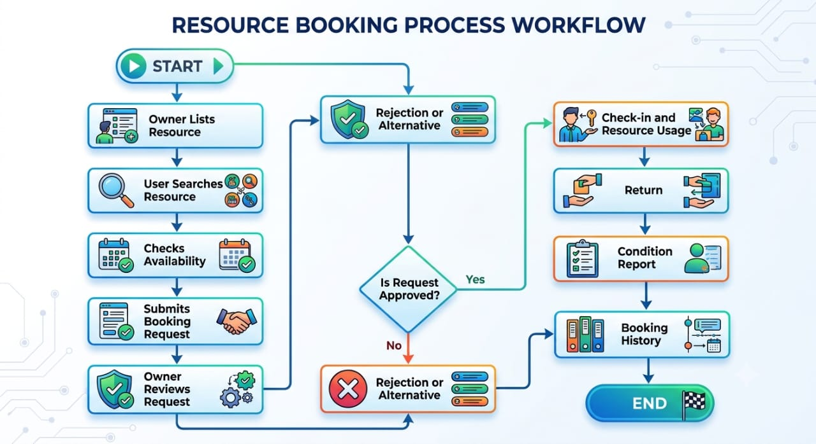

Workflow Explanation

1. Resource Listing: The resource owner provides information about the equipment or space, including its availability and usage conditions.
2. Resource Discovery: Users browse or search for resources that match their requirements.
3. Availability Check: The system checks whether the requested resource is available for the selected time period.
4. Booking Request: The user submits a request specifying the intended usage period.
5. Validation: Applicable availability and eligibility requirements are checked.
6. Owner Approval: The authorized owner or manager reviews the request and approves or rejects it.
7. Resource Usage: Following approval and any required check-in procedure, the user accesses the resource according to the defined conditions.
8. Return and Condition Reporting: The resource is returned, and its condition may be documented.

Features and Implementation Details

- Main Features
EquipShare Hub is designed around a set of modules that support the resource-sharing lifecycle. Each module addresses a specific requirement, from discovering available resources to managing bookings and maintaining usage records.
The modules described below represent the proposed system design. Their implementation status will be identified separately according to the working prototype.

- Implementation Status
The EquipShare Hub prototype is currently under development, with frontend development underway. The implementation status of each module will be recorded as development progresses.
Features will be classified as:
- Implemented: Developed and verified through testing.
- In Progress: Development has started but is not yet complete.
- Planned: Included in the proposed design but not yet implemented.

Technical Stack and Architechture
Frontend & UI Framework: Python Streamlit (for rapid, interactive web-based UI rendering across student and manager portals).
Data Processing & Manipulation: Pandas library (for managing structured tabular data, state transitions, and filtering requests).
Backend Runtime & Core Language: Python 3.x (handling form validation, regex checks, and conditional logic).
Storage & Persistence Layer:
Local CSV file (requests.csv) for persistent state management.
Local file directory (uploads/) for storing mandatory condition-proof media (photos and videos).
Deployment Platform: Streamlit Cloud / GitHub version control integration.

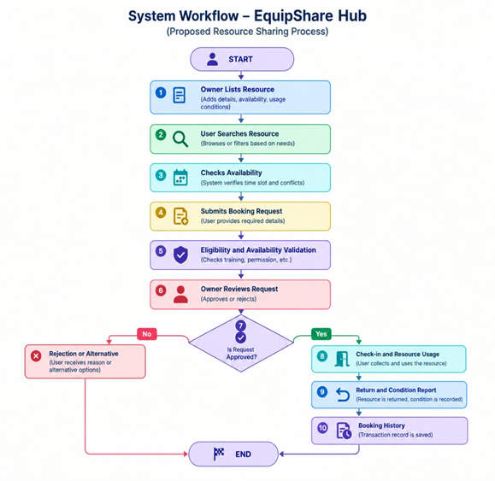
Database Design
Database Table
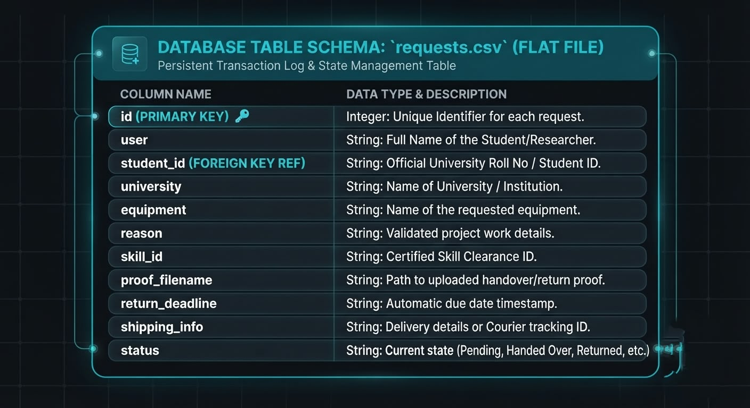
Database relationship
Since the application uses a lightweight, file-based persistence model (requests.csv) rather than a heavy relational SQL database for the prototype, the relational mapping is handled logically within the Pandas runtime:
One-to-Many Relationship (Student to Requests): One unique student_id can have multiple historical or active booking requests (id) stored in the CSV log.
Inventory to Request Mapping: The live inventory stock is dynamically calculated by querying the CSV and subtracting active items where status is in ["Approved", "Handed Over", "Dispatched via Courier", "Return Requested".
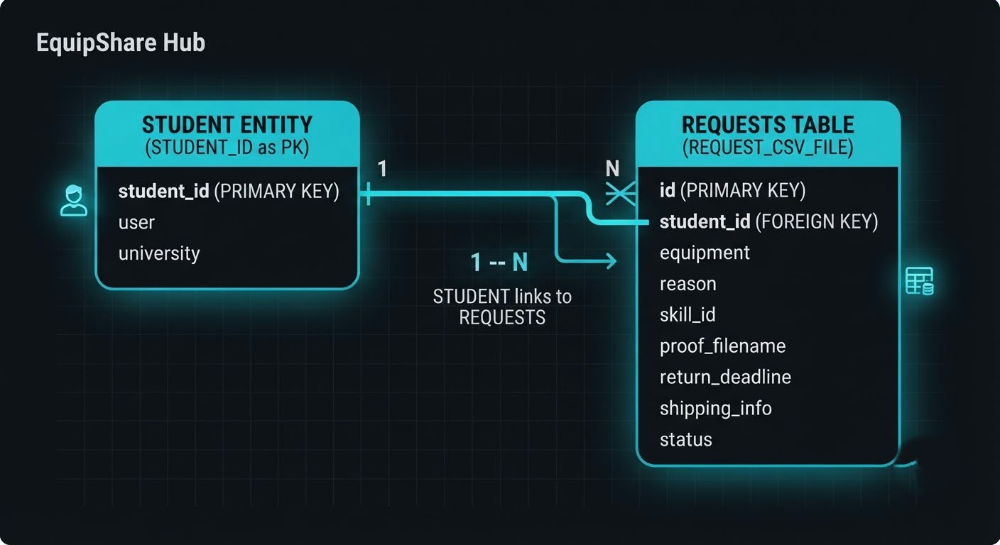
Privacy,Security,Trust and Fairness
- Introduction
Trust, privacy and safety are important for a resource-sharing platform. EquipShare Hub is designed to support responsible resource access while considering the needs of resource owners and users.
The proposed system considers role-based permissions, booking validation, access requirements and usage records to reduce the risk of unauthorized access, scheduling conflicts and resource misuse.
Security and fairness measures will be implemented and tested according to the capabilities of the working prototype. Important decisions involving access restrictions, damage reports or disputes should remain reviewable by an authorized person.
- Security Measures
1. Role-Based Access Control: Users and resource owners should have permissions appropriate to their roles.
2. Booking Validation: The backend should validate booking requests and reject conflicting reservations where applicable.
3. Resource Access Conditions: Resources requiring training, supervision or institutional permission should have their requirements clearly specified.
4. Input Validation: User-submitted information should be validated to reduce invalid or unexpected data.
5. Secure Authentication: If user accounts are implemented, authentication and session management should follow appropriate security practices.
6. Transaction Records: Booking and approval records can help authorized personnel review resource usage and resolve disputes.
7. Error Handling: Errors should be handled without exposing sensitive system information.
- Privacy Protection

EquipShare Hub should collect only the personal information necessary to support resource discovery, booking and accountability.
The platform should consider the following privacy practices:
- Limit the collection of personal information to what is necessary.
- Restrict access to booking and user records according to assigned permissions.
- Avoid exposing private user details to unauthorized users.
- Protect stored information against unauthorized access.
- Define appropriate retention and deletion practices for personal data.
- Use fictional or anonymized information in demonstrations and testing.

- Trust, Safety and Fairness
Trust and Accountability: Booking records and condition reports can help owners and users maintain a clear history of resource transactions.
Fair Allocation: Availability information and transparent booking procedures can help reduce confusion and support fairer access. Future versions may introduce usage limits or allocation policies to discourage repeated monopolization.
Safe Resource Usage: Owners should be able to specify training, supervision and other conditions for resources that require additional precautions.
Human Review: Reports of damage, misuse or disputes should be reviewed by an authorized person before penalties or access restrictions are imposed.
Conflict Management: Booking conflicts should be handled through clear rules, with relevant booking information available to authorized reviewers.

Implementation and Testing
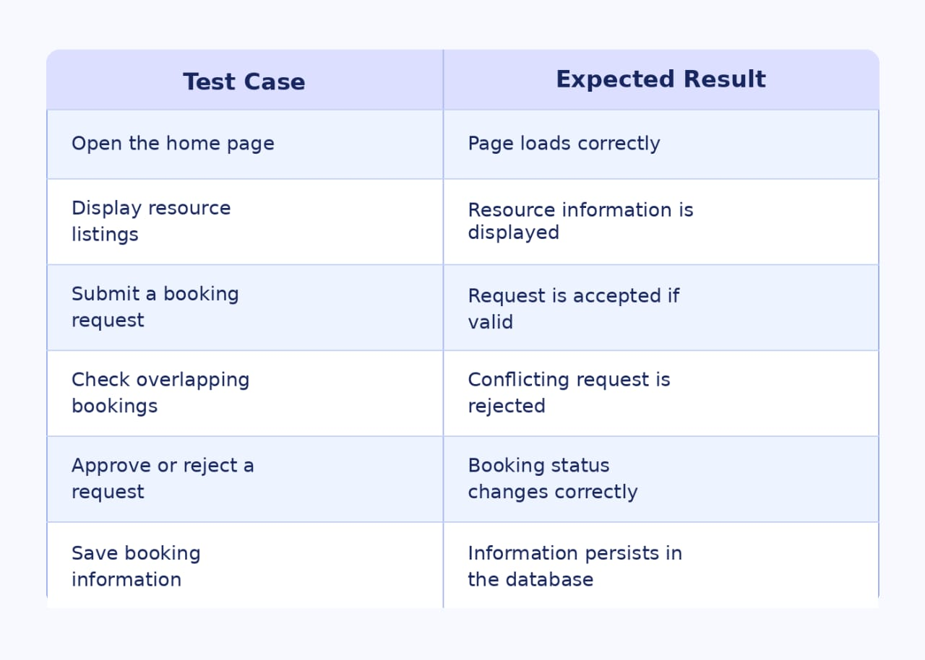
Testing Approach
1. UI Testing: Checks pages, buttons, forms, and navigation.
2. Functional Testing: Verifies resource listing, discovery, and booking features.
3. Input Validation: Checks required fields and invalid inputs.
4. Booking Validation: Checks resource availability and conflicting bookings.
5. Database Testing: Verifies data storage and retrieval, if implemented.
6. End-to-End Testing: Checks the complete user workflow.
7. Error Handling: Verifies appropriate responses to invalid inputs and errors.
Limitations and Future Scope
- Limitations
- The availability of features depends on the current development stage.
- Resource information may require manual updates by authorized users.
- Access verification may depend on the information and processes supported by the application.
- Advanced notifications and calendar integration may not be available in the initial version.
- The platform may initially focus on a limited set of resource-sharing use cases.
- The effectiveness of booking management depends on the application's implemented validation rules.
- Future Scope
1. QR-Based Check-in and Check-out: Simplify the recording of resource collection and return.
2. Automated Notifications: Notify users about booking approvals, upcoming reservations and overdue returns.
3. Calendar Integration: Help users and owners manage availability and schedules.
4. Intelligent Recommendations: Suggest suitable resources based on user requirements and availability.
5. Usage Analytics: Provide insights into resource utilization and booking patterns.
6. Multi-Institution Sharing: Extend the platform to support resource sharing across multiple institutions.
7. Enhanced Incident Management: Improve the documentation and review of damage reports and booking disputes.
8. Fair-Use Policies: Introduce configurable booking limits and allocation rules to encourage equitable access.

- Team Contributions

The development of EquipShare Hub involves collaboration among team members, with responsibilities distributed across different areas of the project. Each member contributes to the design, development, implementation, or testing of the application.
Team Member| Role| Responsibilities:
- Sneha Kumari Mahato (Lead Developer & System Architect)
Designed the core application logic and system architecture using Python and Streamlit.
Developed the role-based access control (RBAC) mechanism separating the Student Portal and Lab Manager Control Center.
Implemented data persistence layers (requests.csv), automated return-deadline calculators, and validation filters.
- Supreeti Moulick (UI/UX & Workflow Integration Lead)
Co-designed the institutional asset-sharing process flow and interactive Streamlit UI layouts.
Tested and verified the live inventory stock tracking system and dynamic availability counters.
Structured the user notification states and condition-proof media verification queue.
- Barsa Sen (Documentation & Quality Assurance Lead)
Managed the project documentation, technical stack mapping, and system architecture schema design.
Formatted the database schema details, entity relationship diagrams (ERD), and compliance log requirements.
Handled testing for authentication flows, error handling, and final presentation readiness.
Disclosure of Templates, Libraries, and Pre-Existing Components

- UI & Web Framework (Open-Source Library):
Streamlit — Used for building the interactive web-based graphical user interface and managing session state without writing custom HTML/CSS/JS templates from scratch.
- Data Processing & Analytics (Standard Library):
Pandas — Used for handling tabular data structures, filtering data frames, and maintaining the flat-file database (requests.csv).
- Built-in Python Standard Libraries:
os, re, datetime — Used for directory management, path normalization for uploaded media, regular expression form validation, and deadline date calculations.
- Pre-Existing Templates & Third-Party Code:
None. No external website templates, boilerplates, or third-party pre-existing code repositories were copied or used. All workflow logic, role-based portals, anti-junk text validation, and verification routines were custom-coded specifically for EquipShare Hub.

Database relationship diagramXxAugugtyo7t
R

