Digital System 1, Homework #4
Leonard Blam
900086
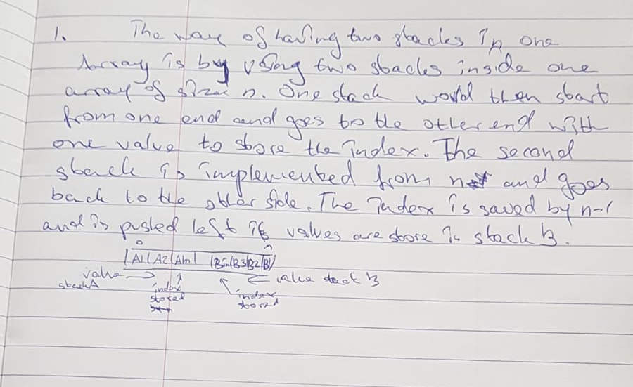

2.
class-stack
{
queue Q;
int size;
void push(int x)
{
Q.enqueue(x);
for(int i = 0; i< size; i++)
{
Q.enqueue(Q.dequeue());
}
size++;
}
int p()
{
if(isEmpty())
{
throw “Stack is Empty”;
}
size--;
return Q.dequeue;
}
bool isEmpty()
{
if(size==0){
return true;
}
return false;
}

3a.
void b(queue& Q1, queue Q2)
{
int size1 = Q1.size() ;
int temp ;
for(int i=0 ; i < size1; i++)
{
temp = Q1.dequeue();
if (search(Q2, temp))
{
Q1.enqueueJ(temp);
}
}
}
bool search(queue Q, int num)
{
for( int I = 0; I < Q.size(); i++)
{
if(x == Q.dequeue())
{
return true;
}
}
return false;
}

b.
complexity is O(n*m), because the complexity in search is O(m) and in b, search is run num times→ so o(m*n)

