Leonard Blam
900086
Data Structure 1
Homework 7

Q1.
a.
node* rotateRR(note* p) {
node* n1 = p;
node* n2 = n1 -> right;
node* n3 = n2 -> left;
n2 ->left = n3->right;
if (n2 -> left){
n1 = n2->right;
}
n1 -> right = n3 -> left;
if (n1->right){
n1->right->parent = n2;
}
n3 -> left = n2;
n1 -> parent = n3;
}

b.
node* rotateRL(note* p) {
node* n1 = p;
node* n2 = n1 -> right;
node* n3 = n2 -> left;
n2 ->left = n3->right;
if (n2 -> left){
n2->left -> parent = n2;
}
n1 -> right = n3 -> left;
if (n1->right){
n1->right->parent = n1;
}
n3 -> left = n1;
n1 -> parent = n3;
}

2.
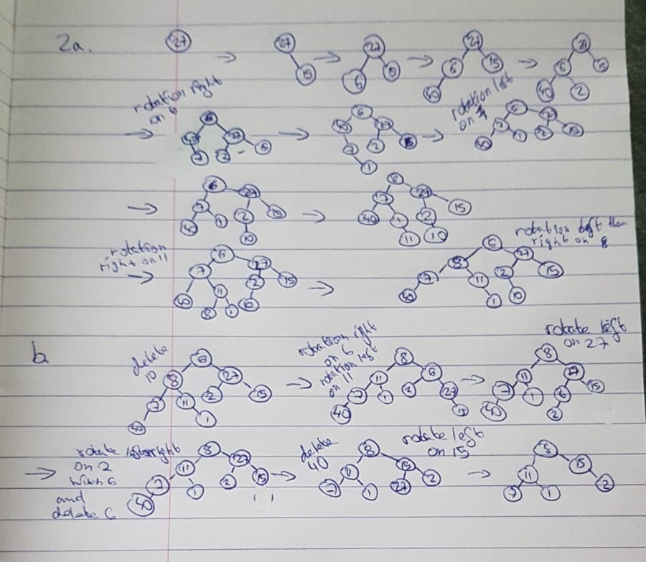

4a.
Maximum nodes in AVL tree of height h is achieved in a full binary tree.
In a full binary tree, each level l has 2^L nodes, so in h levels, there are
b.
Yes, start from the lowest leaves traversing the tree upwards, rotating any unbalanced nodes with a balance factor +- 2. If a balance factor >2 or <-2 is found traverse the tree down from the unbalanced node down the other direction until a +- 2 is found, balance that, then traverse upwards from there. Repeat until balanced.

