Game Design Document

Fill up the following document

1. Write the title of your project.

The Sceptre

1. What is the goal of the game?

To regain the staff and end Nox’s rule…permanently.

1. Write a brief story of your game.

The Realm of Luxia is a grim place, ripe with misfortune and darkness as it continues to be ravaged by Nox, the self-proclaimed Master of Darkness who created this nightmarish reality for all within his borders, and even beyond them. Many fear a mere mention of his name, and all dread the day he knocks down their door. The Sceptre of Elements, given to the first mage when the Elementals were still young and the stars were yet to be born. The realm as the mortals knew it was soon to change, for better or for worse, and so, the Elementals gifted the Sceptre to humanity, in hopes of bettering their situation in the New World. A world where evil roamed in search of fresh new victims. A world where you were never certain which breath would be your last. Earth took his brightest, strongest silver, and Fire heated it until it was glowing red-hot in her very own forge. Water, with her gentle and nimble fingers, shaped the staff into existence, embedding the most precious of gems hidden deep within her realm into it. And just like how Air breathed life into the first mortal, so did he breathe the very same life into the Sceptre. And all gave their own blood to bathe the Sceptre, cleansing it and beginning it anew, mixing their power in a vast storm of magical energy and imbuing it with the Spirit. And somehow, the Master of Darkness found it. And now, he has shrouded Luxia’ light with shadow and darkness, engulfing it with a power only he can control, with a fire-like grip. Only those of magic can withstand the force of his power, and only they can over-throw the mad king. But he made sure that would never happen, killing all magical beings he found, until only a few remained, unwilling to ever enter Luxia again. But now, a new hope dawns upon us, for you, Moon, are the first mage, in centuries. Find friends, make enemies, do whatever it takes to destroy this tyrant. But beware, for you may find yourself losing your own heart in the process…

1. Which are the playing characters of this game?

* Playing characters are the ones who respond to the user based on the input from the user.
* Cars, monkeys, dinos, wizards, etc., are the playing characters in the game.

|  |  |  |
| --- | --- | --- |
| Number | Character Name | What can this character do? |
| 1 | Moon | This character is the player, and the only mage in Luxia. Abilities include:-  1. The ability to use the Sceptre of Elements  2. Magic (Sun and Moon)  Albeit skilled in the mystic arts, Moon was never taught basic martial skills, and thus, is quite weak when it comes to physical combat. Also very impatient and slightly cynical |
| 2 | Nox | The Dark Ruler. The Master of Darkness. This mad-man has many names. Each more terrible than the last. Abilities include:-  1. The ability to use the Sceptre of Elements  2. Magic (Sun and Moon)  He is cruel and unforgiving, and loathes traitors, along with liars. However, he is also easily angered. |
| 3 | The Voice | The Voice is a powerful, yet unseen helper of the main character for reasons that it chooses to not disclose…yet  But can it really be trusted? |
| 4 |  |  |
| 5 |  |  |
| 6 |  |  |
| 7 |  |  |
| 8 |  |  |

1. Which are the Non-Playing Characters of this game?

* Non-Playing characters are the ones that don't have an action or behavior when the user interacts with the game.
* Hurdles, stones, bananas, coins, etc., are non-playing characters in the game.

|  |  |  |
| --- | --- | --- |
| Number | Character Name | What can this character do? |
| 1 | Fire Blast | Damage opponents when cast (requires 3 energy). Damage is 5%  Sun Magic |
| 2 | Ghost | Can only Damage (requires 5 energy). Damage is 7%.  Moon Magic |
| 3 | Oceanid | Can either damage or heal (requires 5 energy for both)  Damage is 7% while healing is 5%. Moon Magic |
| 4 | Water Sphere | A rotating sphere of water that can damage opponents and put out fires. Damage is 10% and energy cost is 7 |
| 5 | Light Orb | Can illuminate a small area and cost is 1. Sun Magic |
| 6 | Windows | Normal windows that show day and night. Depending on this cycle, certain spells will be more or less powerful, or even impossible. |
| 7 |  |  |
| 8 |  |  |

Draw your imagination of this game. What does this game look like?

* Draw the game either on your computer or on paper.
* Add images of the game scenes to show each of the playing and non-playing characters at least once.

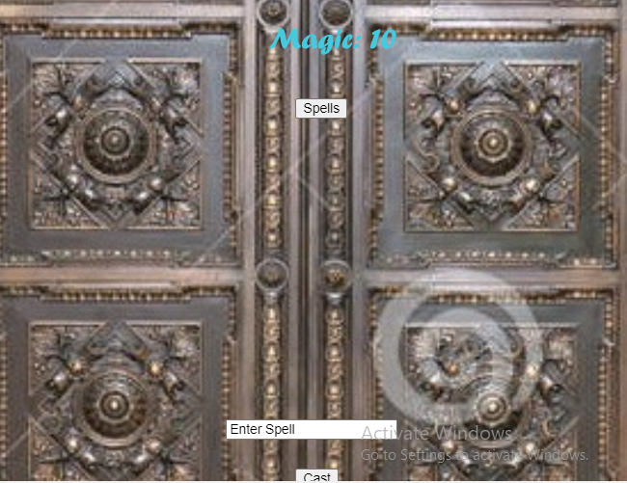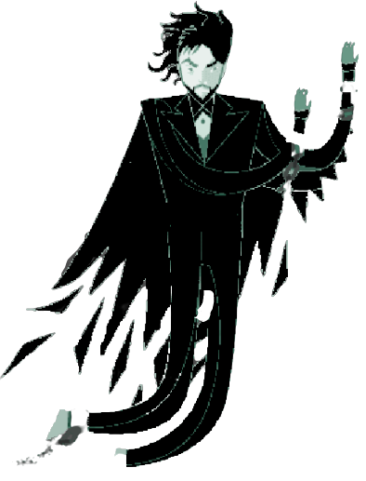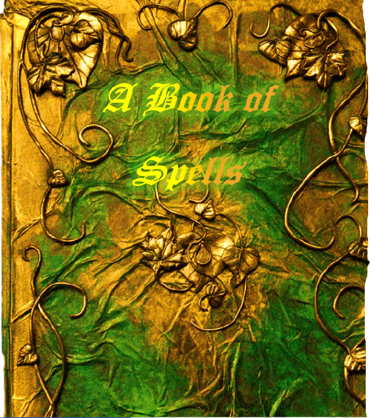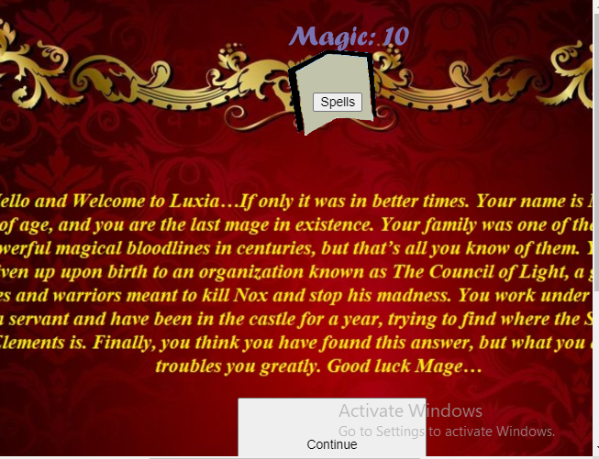

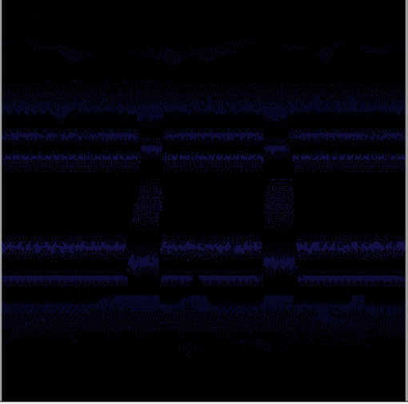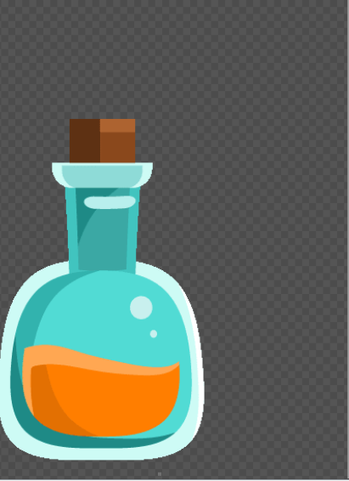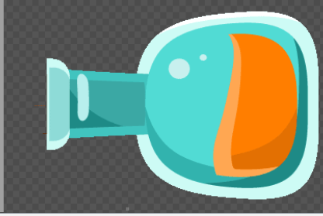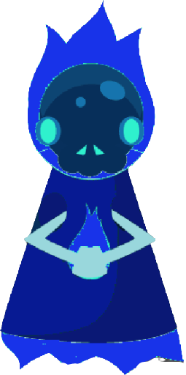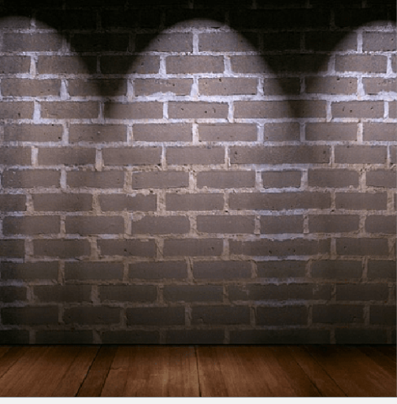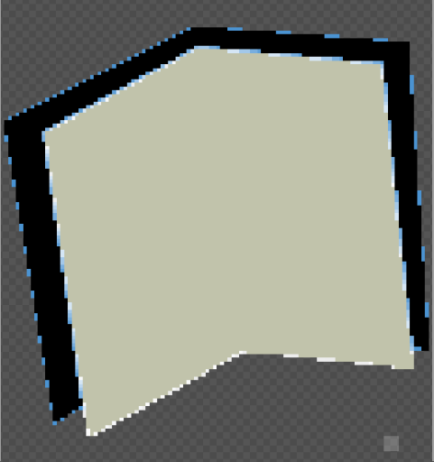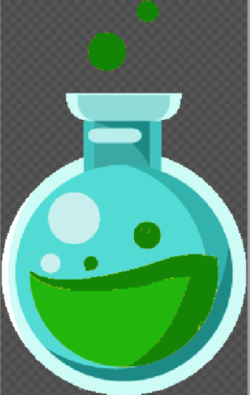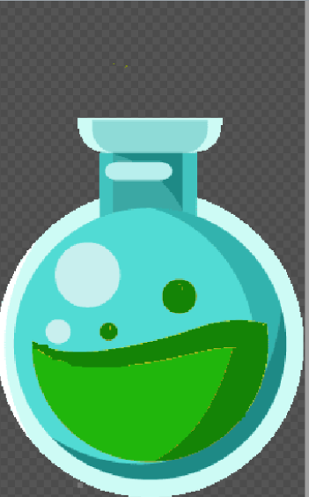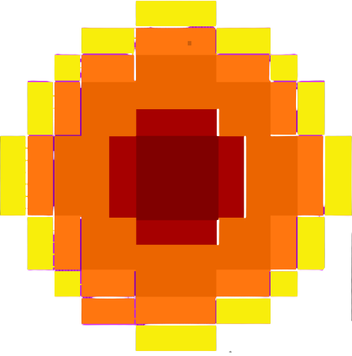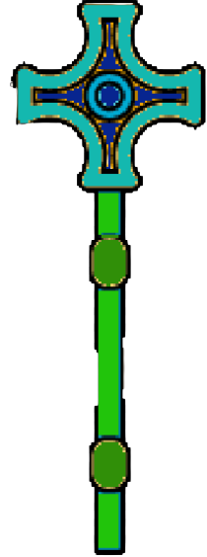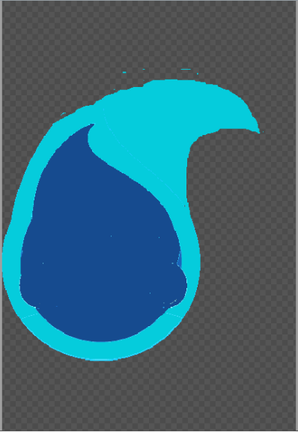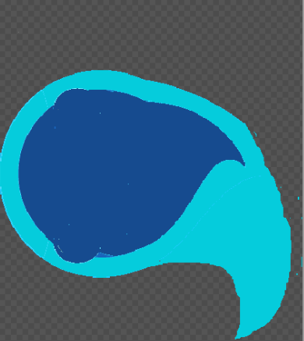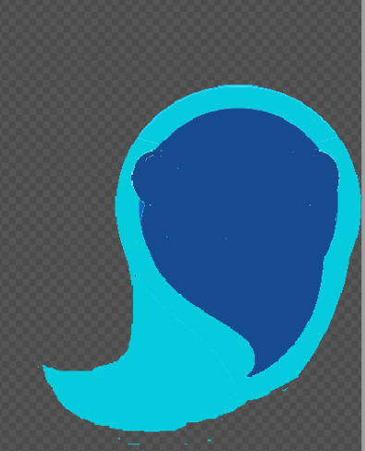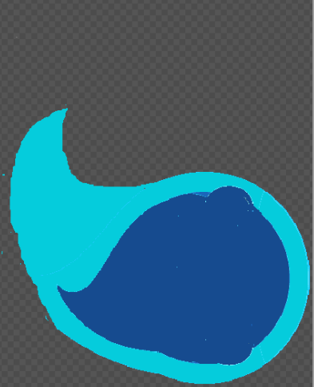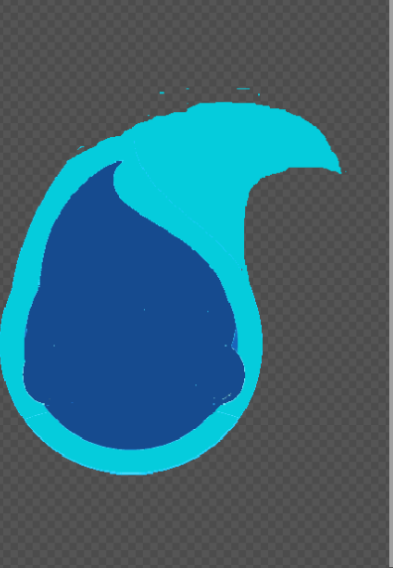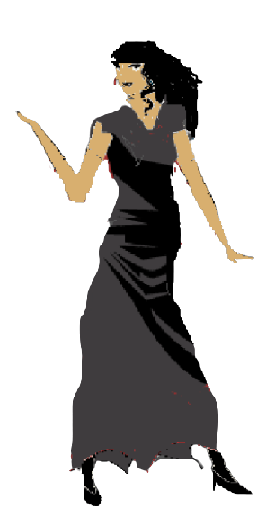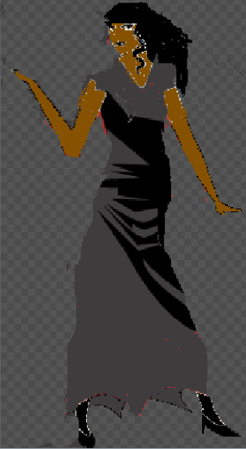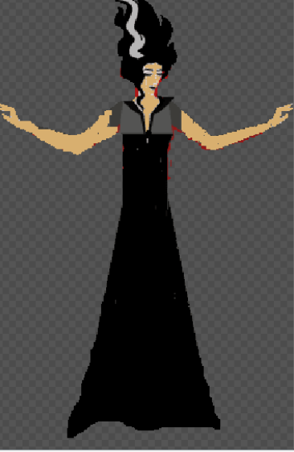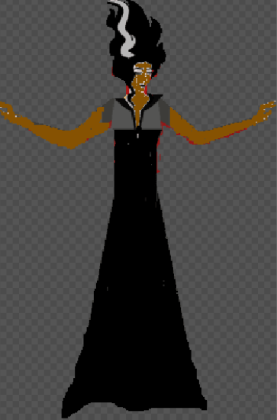

How do you plan to make your game engaging?

By allowing players to make their own choices in-game. Every choice, no matter how small, will make some difference. There is also a very interesting storyline along with many twists and turns.