### Welcome to your project!

* Brush up on Markdown: <http://daringfireball.net/projects/markdown/basics>
* Learn about Penflip: [penflip.com/help](http://www.penflip.com/help)
* Talk to a person: [support@penflip.com](mailto:support@penflip.com)

# SHS May High Flier

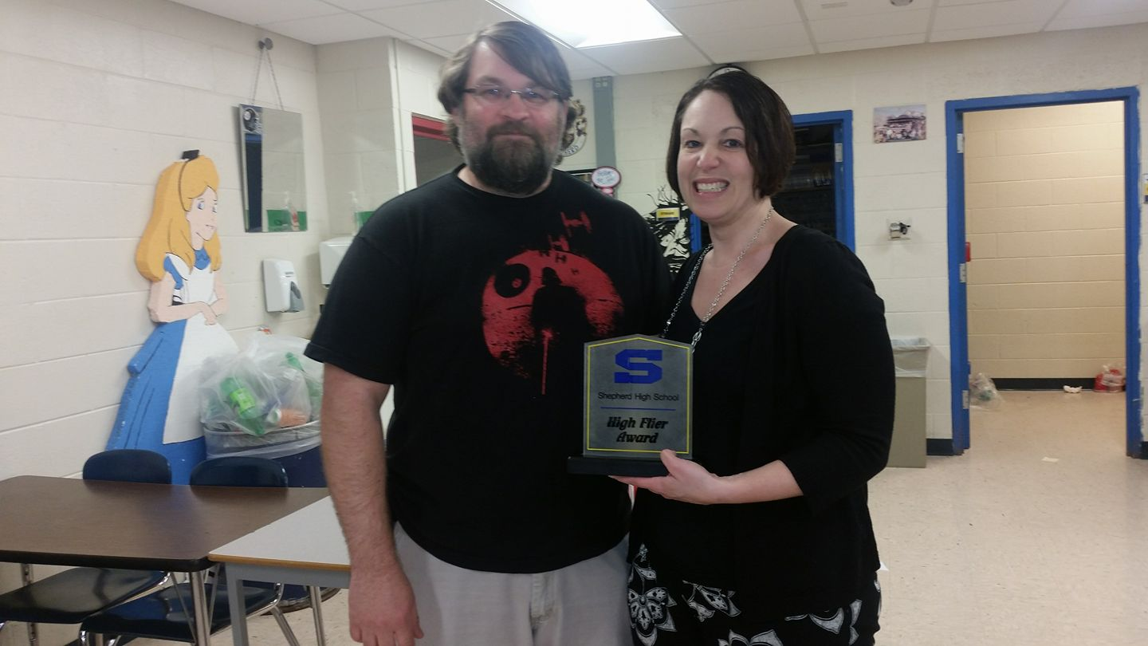

**Shepherd HIgh School:** Congratulations to Heather Wolf for being nominated as the May High Flier. Heather was nominated by our tech guru Mr. Corey Grim.