You can complete this practical even if you have never used Neo4j before. I'll guide you from opening the software to creating the graph, running queries, taking screenshots, and preparing for the oral questions.
Practical 51: Social Network Graph in Neo4j
Big Data Analytics — NoSQL / Graph Database
Aim: To create a social network graph in Neo4j with five users connected through FRIEND and FOLLOW relationships and retrieve the friends of a specific user.
1. Understand what you are building
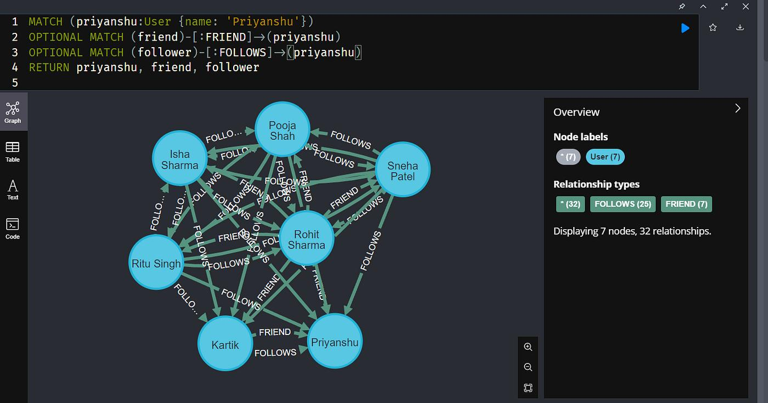
medium.com
Your graph will contain:
- 5 nodes: users named Ayesha, Rahul, Junaid, Sara, and Imran.
- Relationships: FRIEND and FOLLOW.
- Properties: each user will have an ID, name, and age.
- Query: find all friends connected to Junaid.
For example:
(Junaid)-[:FRIEND]->(Rahul)
This means Junaid has a FRIEND relationship directed toward Rahul.
2. Open Neo4j
For a first-time user, the easiest approach is Neo4j AuraDB Free, which runs in your browser without requiring a local database installation.
- Open Neo4j Aura.
- Sign in or create an account if required.
- Look for the option to create a database or instance.
- Select the free option if available.
- Give the instance a name such as SocialNetwork.
- Create it and wait until its status indicates that it is ready.
- Open the provided query interface, usually called Query or Query tool.
If your college lab already has Neo4j Desktop or Neo4j Browser installed, use that instead. The Cypher queries below work in both environments.
Keep the database password safe if the setup provides one. You may need it to connect.
3. Create the five user nodes
In the query editor, copy the following Cypher code and click Run.
UNWIND [
{id: 1, name: 'Ayesha', age: 21},
{id: 2, name: 'Rahul', age: 22},
{id: 3, name: 'Junaid', age: 21},
{id: 4, name: 'Sara', age: 20},
{id: 5, name: 'Imran', age: 23}
] AS data

MERGE (u:User {id: data.id})
SET u.name = data.name,
u.age = data.age;
What this code does:
- UNWIND processes the five user records one by one.
- MERGE creates each user node if it doesn't already exist.
- :User is the node label.
- id, name, and age are properties stored on each node.
- SET assigns the properties.
Expected result: five user nodes created or matched.
4. Create FRIEND and FOLLOW relationships
Run the following query next.
MATCH (a:User {name: 'Junaid'}),
(b:User {name: 'Rahul'})
MERGE (a)-[:FRIEND]->(b);

MATCH (a:User {name: 'Junaid'}),
(b:User {name: 'Ayesha'})
MERGE (a)-[:FRIEND]->(b);

MATCH (a:User {name: 'Rahul'}),
(b:User {name: 'Sara'})
MERGE (a)-[:FRIEND]->(b);

MATCH (a:User {name: 'Sara'}),
(b:User {name: 'Imran'})
MERGE (a)-[:FRIEND]->(b);

MATCH (a:User {name: 'Ayesha'}),
(b:User {name: 'Imran'})
MERGE (a)-[:FOLLOW]->(b);

MATCH (a:User {name: 'Imran'}),
(b:User {name: 'Junaid'})
MERGE (a)-[:FOLLOW]->(b);
Expected graph:
Relationship | Connections
FRIEND | Junaid → Rahul
FRIEND | Junaid → Ayesha
FRIEND | Rahul → Sara
FRIEND | Sara → Imran
FOLLOW | Ayesha → Imran
FOLLOW | Imran → Junaid
MERGE prevents these particular relationships from being duplicated when you run the query again.
5. Display the complete social network
Run this query:
MATCH (u:User)-[r]->(v:User)
RETURN u, r, v;
Expected output: a graph visualization showing the five users and six relationships. Switch to the Graph view if the interface initially shows a table.
To display only the five users, use:
MATCH (u:User)
RETURN u;
To count the users and relationships:
MATCH (u:User)
WITH count(u) AS totalUsers
MATCH ()-[r]->()
RETURN totalUsers, count(r) AS totalRelationships;
Expected output: totalUsers = 5, totalRelationships = 6.
6. Find all FRIEND connections of Junaid
This is the most important query in your practical.
MATCH (u:User {name: 'Junaid'})-[:FRIEND]-(friend:User)
RETURN DISTINCT friend.name AS Friend;
Expected result:
Friend
Rahul
Ayesha
The query uses an undirected pattern, -[:FRIEND]-, so it finds connections whether the stored FRIEND relationship points toward or away from Junaid.
If your examiner specifically asks for only outgoing friendships, use:
MATCH (u:User {name: 'Junaid'})-[:FRIEND]->(friend:User)
RETURN friend.name AS Friend;
Both queries return Rahul and Ayesha for the graph created above.
7. Enhancement: Recommend friends using shared interests
Your examiner may ask how you would improve the model by adding user interests.
First, add interests to the five users:
MATCH (u:User {name: 'Junaid'})
SET u.interests = ['AI', 'Gaming', 'Music'];

MATCH (u:User {name: 'Rahul'})
SET u.interests = ['AI', 'Gaming', 'Cricket'];

MATCH (u:User {name: 'Ayesha'})
SET u.interests = ['Music', 'AI', 'Reading'];

MATCH (u:User {name: 'Sara'})
SET u.interests = ['Dance', 'Music'];

MATCH (u:User {name: 'Imran'})
SET u.interests = ['Cricket', 'Gaming'];
Now recommend users who share at least one interest with Junaid but aren't already his friends:
MATCH (u:User {name: 'Junaid'}),
(candidate:User)
WHERE candidate <> u
AND any(interest IN u.interests
WHERE interest IN candidate.interests)
AND NOT EXISTS {
MATCH (u)-[:FRIEND]-(candidate)
}
RETURN candidate.name AS RecommendedFriend,
[interest IN u.interests
WHERE interest IN candidate.interests]
AS SharedInterests;
Expected recommendations:
- Sara — Music
- Imran — Gaming
This is a basic recommendation model. A real application could rank candidates by the number of shared interests, mutual friends, or other preferences.
8. Save screenshots and prepare your practical document
Your uploaded exam instructions require a preparation document containing the aim, dataset, steps, results, screenshots, and a conclusion. They specify Google Docs and the filename format RollNo_Name_PracticalNo.
Take these screenshots while performing the practical:
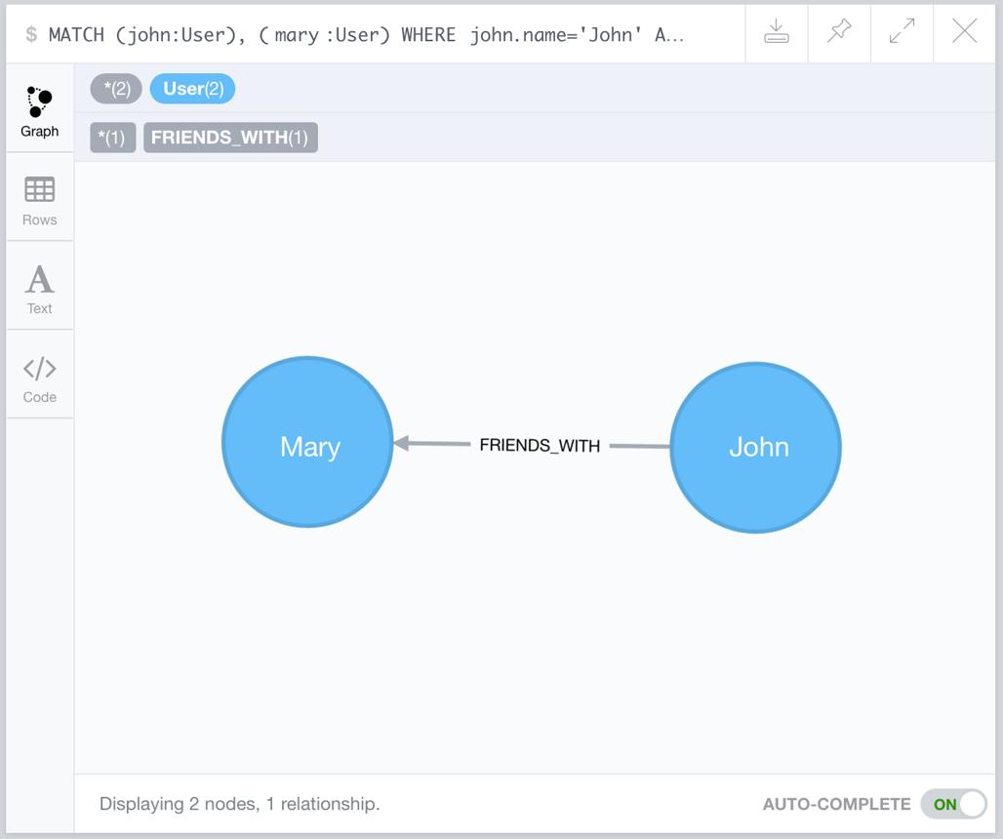
Screenshot 1 — User nodes
Show the five users created and their properties.
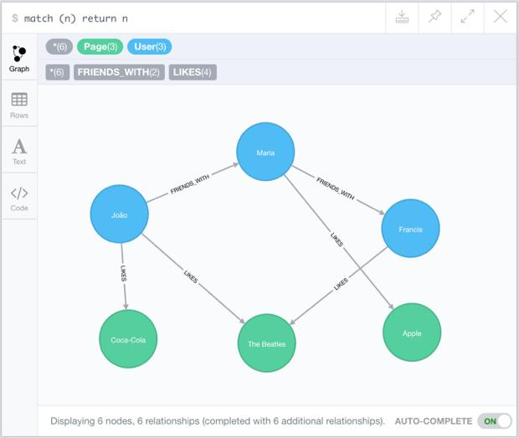
Screenshot 2 — Complete graph
Show the users connected through FRIEND and FOLLOW.
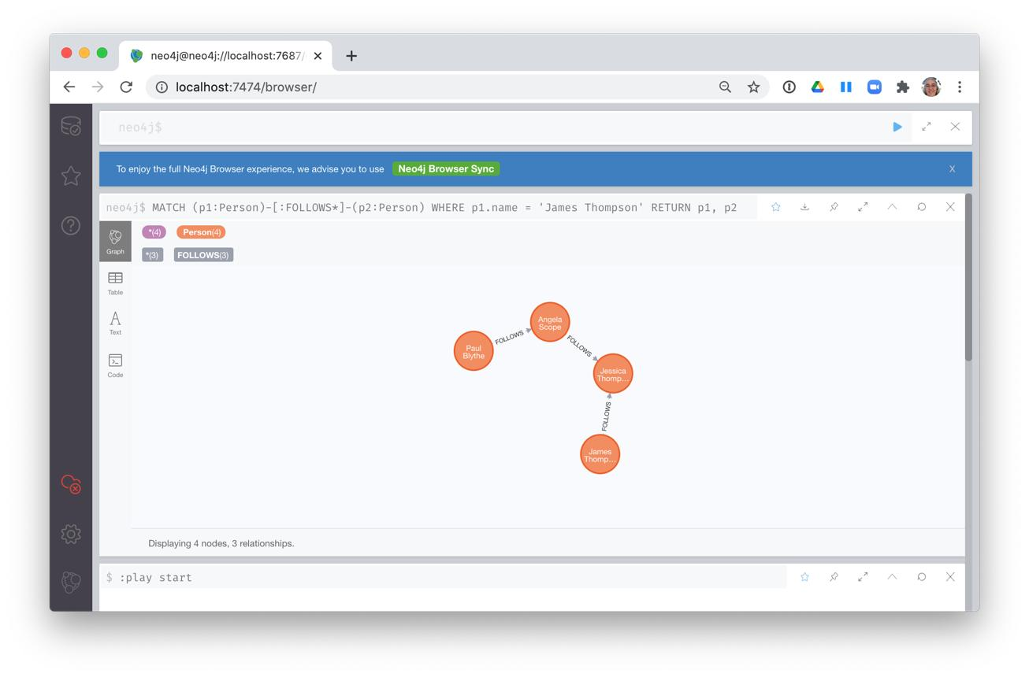
Screenshot 3 — FRIEND query
Show the query and the result containing Rahul and Ayesha.
These images are illustrative references, not screenshots of your actual results. Capture your own screenshots from the running database.
What to write in the document
Aim: To implement a social network graph using Neo4j and Cypher.
Objective: To create five user nodes, establish FRIEND and FOLLOW relationships, and retrieve the friends of a specific user.
Dataset: A manually created sample dataset containing five users. No external dataset file is required.
Procedure: Create user nodes, insert relationships, visualize the graph, execute the friendship query, and record the results.
Result: Five user nodes and six relationships were created. The friendship query for Junaid returned Rahul and Ayesha.
Conclusion: Neo4j successfully represents users as nodes and social connections as relationships. Cypher queries retrieve connected users efficiently. User interests can also be incorporated to support friend recommendations.
9. Prepare for the five knowledge questions
Q1. Difference between nodes and relationships in Neo4j
- Nodes represent entities such as users and store properties like name and age.
- Relationships connect nodes, have types such as FRIEND and FOLLOW, and possess direction and optional properties.
Q2. How does Neo4j efficiently handle graph traversal?
Neo4j stores relationships as explicit connections between nodes. It can follow these connections directly instead of repeatedly performing expensive table joins, making connected-data queries efficient.
Q3. Advantages and limitations compared with relational databases
Advantages | Limitations
Efficient relationship traversal | Requires learning Cypher
Suitable for social networks and recommendations | Not ideal for every tabular or reporting workload
Flexible graph structure | Large distributed graphs require careful architecture
Relationships can have properties | Deployment and scaling choices can add complexity
Relational databases may be preferable for structured transactional applications and workloads dominated by SQL joins, aggregates, and tabular reporting.
Q4. Propose an enhancement using interests
Add an interests property to each user node, or represent interests as separate nodes connected by INTERESTED_IN relationships. Recommend users with shared interests who are not already friends, then rank them by shared interests and mutual friends.
Q5. Compare Neo4j, Amazon Neptune, and ArangoDB
Feature | Neo4j | Amazon Neptune | ArangoDB
Database model | Graph-focused | Managed graph service | Multi-model
Query languages | Cypher | Gremlin, openCypher support varies by engine/version | AQL
Strength | Graph traversal and developer tooling | AWS-managed graph workloads | Graph, document, and key-value data
Scalability | Clustering and deployment dependent | Managed AWS scaling and availability options | Distributed deployment options
Best suited for | Social networks and recommendations | AWS-based connected-data applications | Applications needing multiple data models
Actual performance depends on data size, query patterns, indexes, configuration, and deployment. There is no universal fastest database.
10. Last-minute checklist for tomorrow
- Open Neo4j and confirm the database is ready.
- Create the five users.
- Create the six relationships.
- Display the complete graph.
- Run the Junaid FRIEND query and verify Rahul and Ayesha.
- Capture your own screenshots.
- Practise explaining nodes, relationships, and MATCH, MERGE, and RETURN.
- Prepare the document in Google Docs and follow your faculty's submission instructions.
Important: If the query editor rejects multiple Cypher statements in one submission, run each statement or user/relationship block separately. If you rerun the practical, MERGE helps avoid duplicate nodes and relationships in this example.

