**PRELIMINARY USER’S GUIDE**

Home page

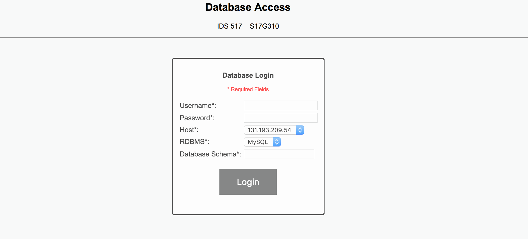

* This is the very first page that appears when the user runs the server.
* Enter the login credentials and then click on the “login” button.

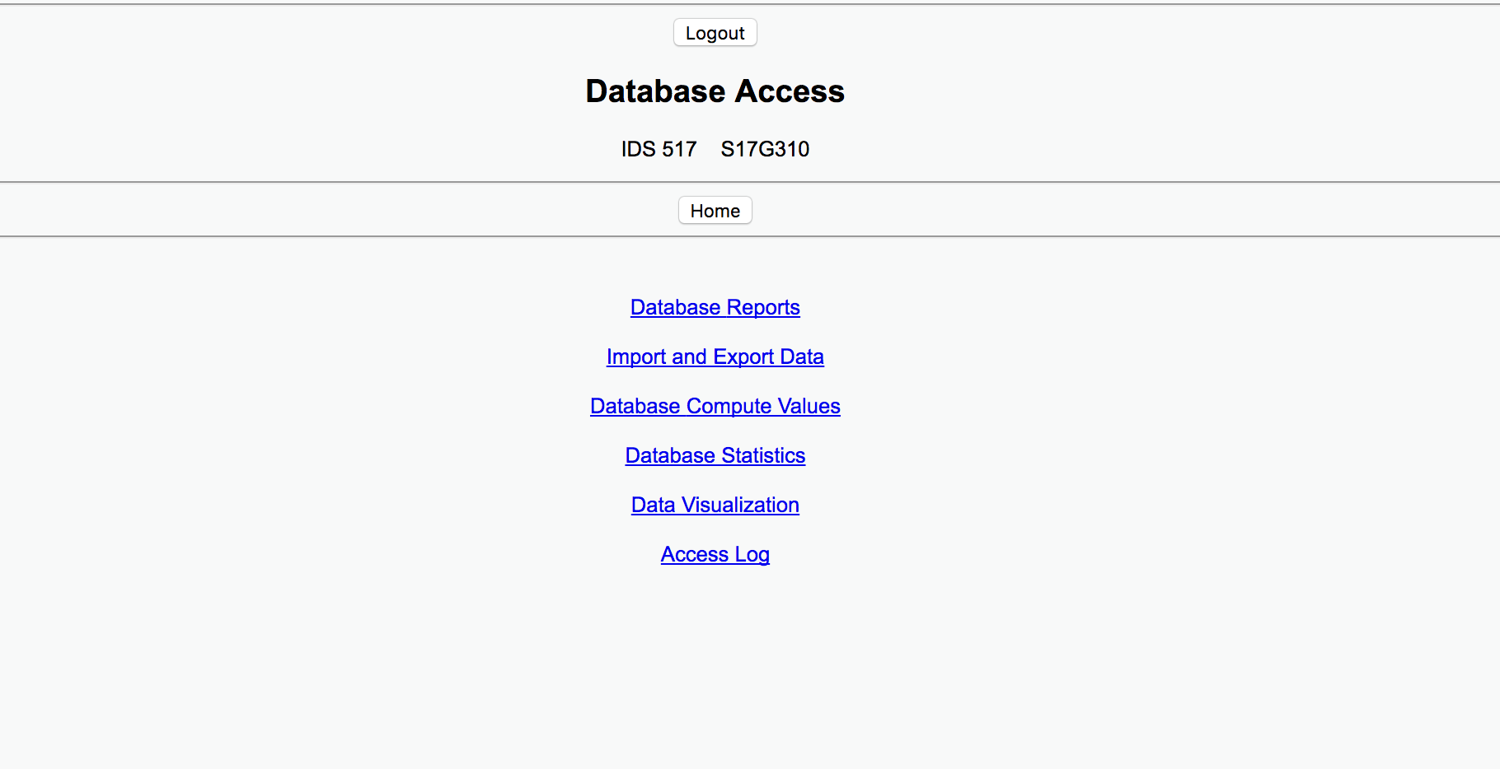

* This is the page that appears after the user has logged in.
* It has five operations that the user can perform. Clicking on anyone of the operation leads to the user to the corresponding page.
* The “Home” button helps the user to return to this page from the current page of the user.
* The “Logout” button helps the user to log out and end the session.

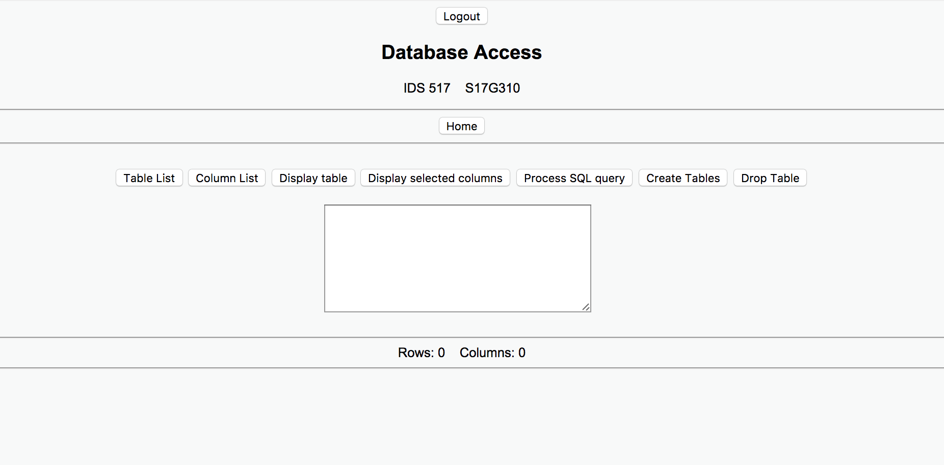

* If the user selects “Database reports” it leads the user to this page.
* Here the user select the table and column from the table list and column list.
* After selecting the table and the column the user can perform the “Display Table”, “Display selected columns”, “Create Tables” and “Drop Table” by selecting the corresponding button and then clicking on the “Process SQL query” to complete the operation.

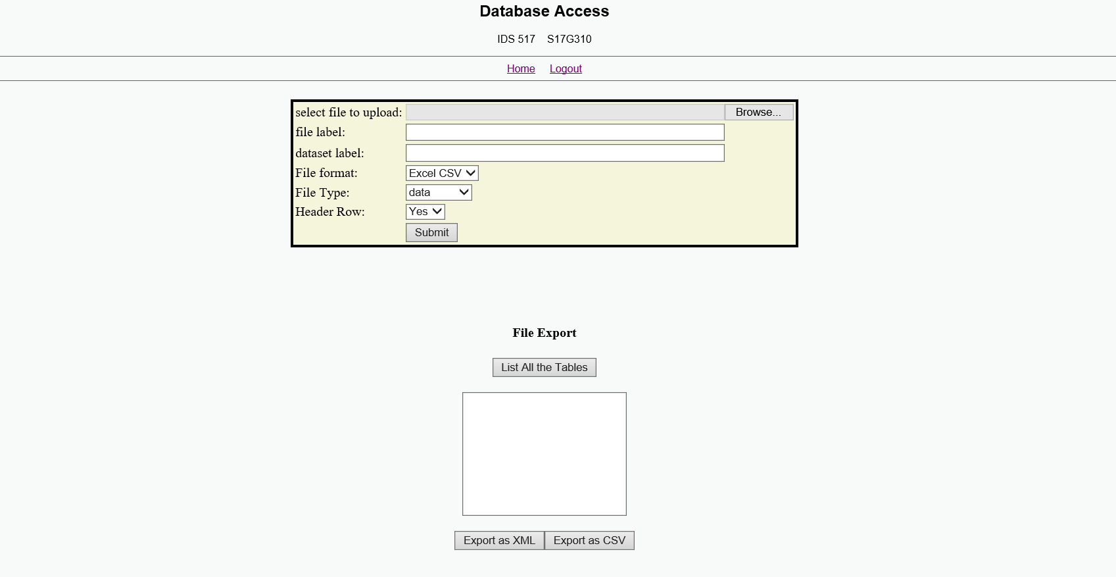

* If the user selects the “Import and Export Data” in the main page than it directs the user to this page.
* Here the user can either upload any file to the database and can also download any table that is already present in the database.

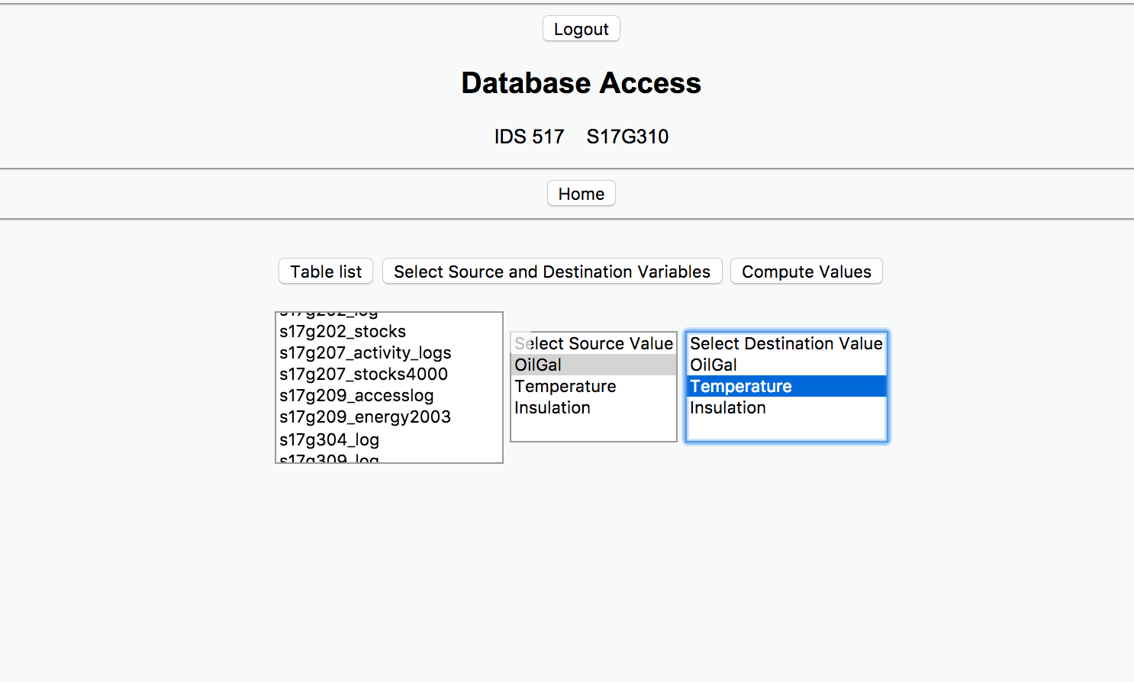

* If the user selects “database compute values” option in the main menu page than the user is directed to this page.
* Here the use needs to select the table on which the user wants to compute values
* After selecting the table the user needs to select the source and destination values.

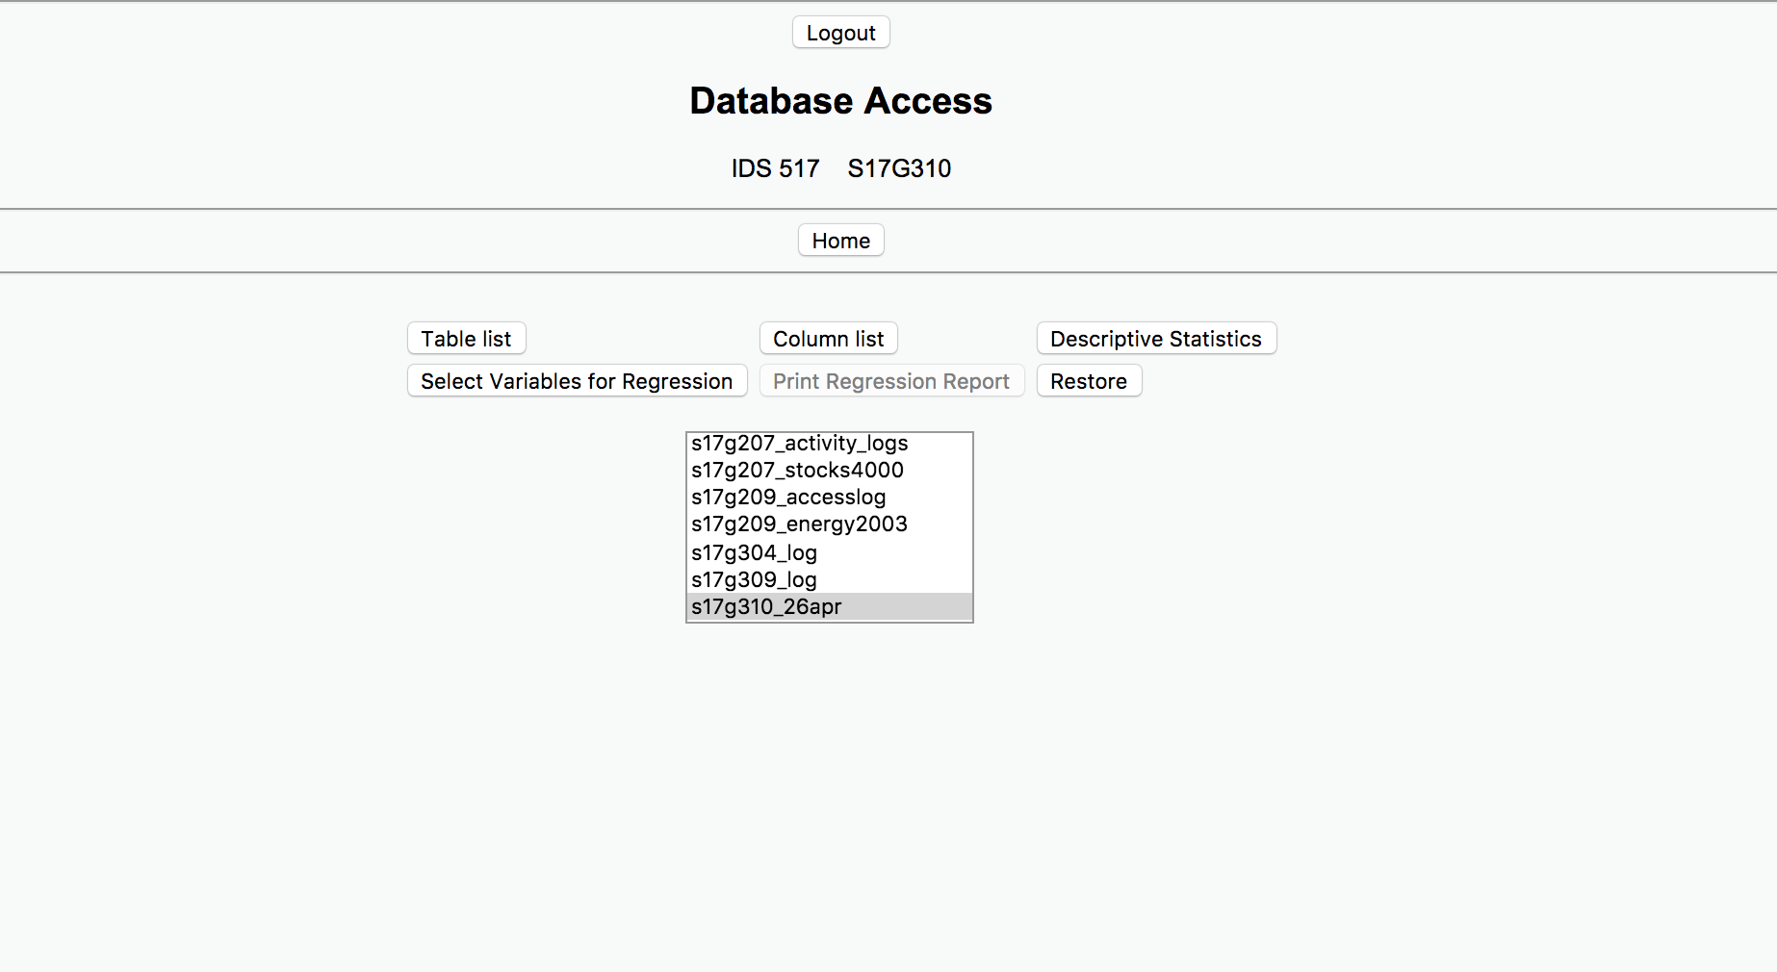

* If the user selects the “Database statistics” option on the main menu page the user is directed to this page.
* Here the user first needs to select a table and then he should select the column on which the user is planning to perform the descriptive statistics. Finally, on selecting the table and the column the user can see the report by selecting the Descriptive statistics button.
* For the regression analysis, it follows the same steps as for the descriptive statistics but here the user needs to select two columns that is one being the predictor variable and the other column being the response.

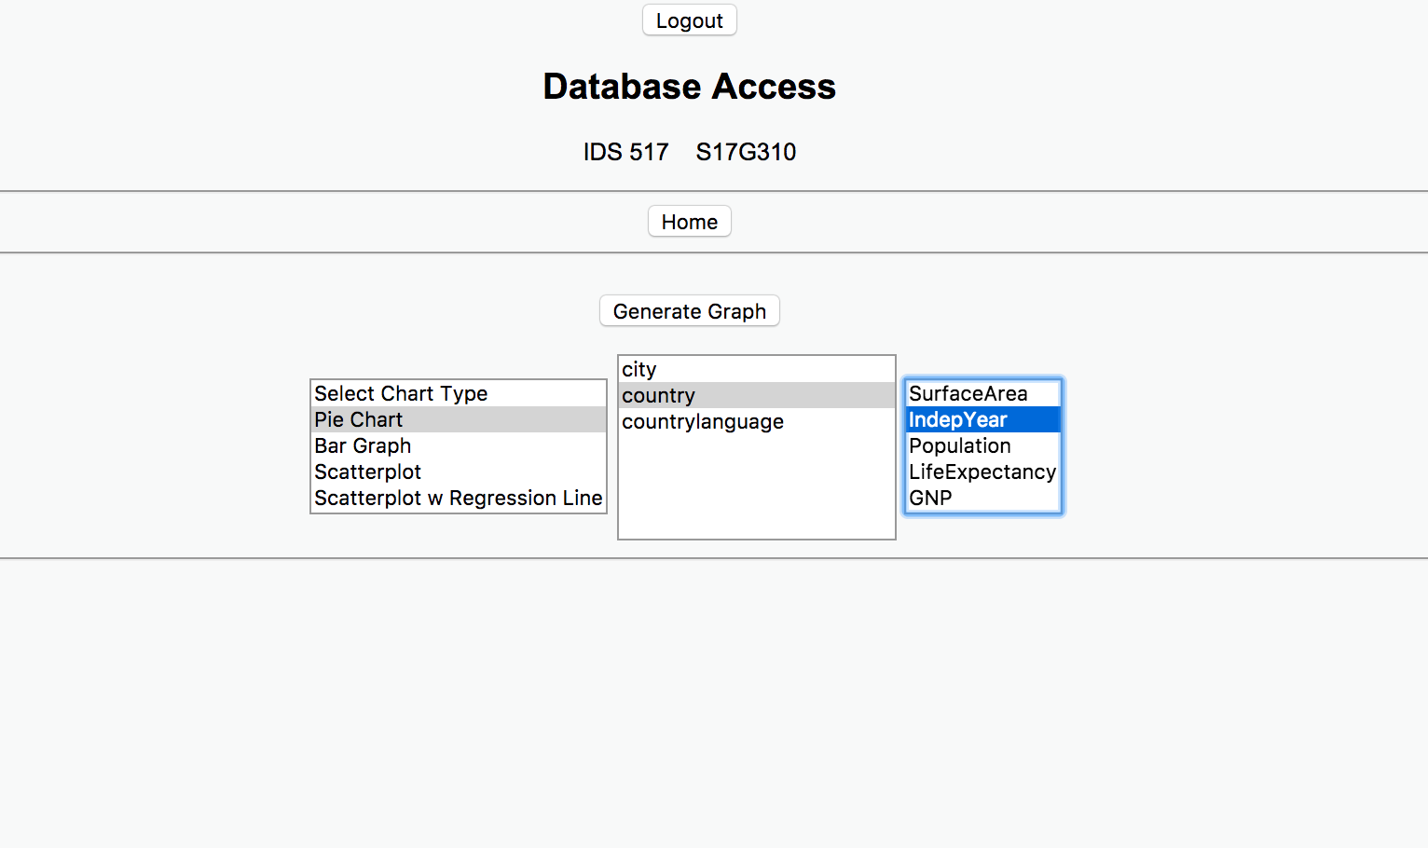

If the user decides to perform “data visualizations” on the main menu than he is directed to this page.

Here the user first should select the chart type followed by the table name and the column name.

Once the user selects the above options the user needs to click on the “Generate graph button” to generate the graph.

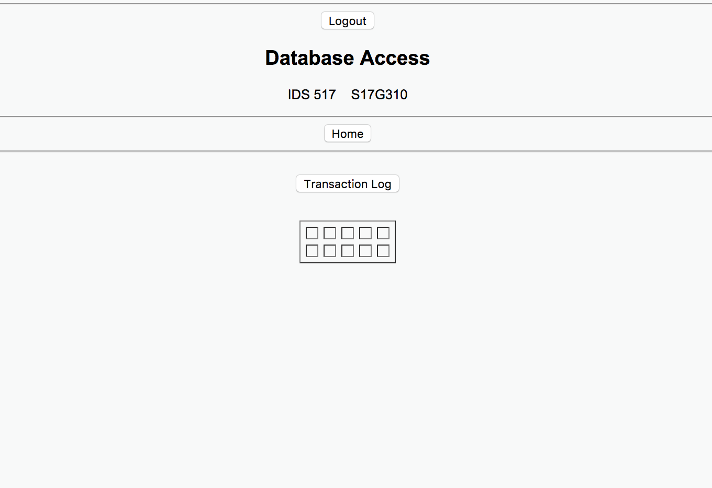

* And if the user decides to see the “transaction log” in the main menu page then he is directed to this page.
* On selecting the transaction log button, the transaction log table is displayed.

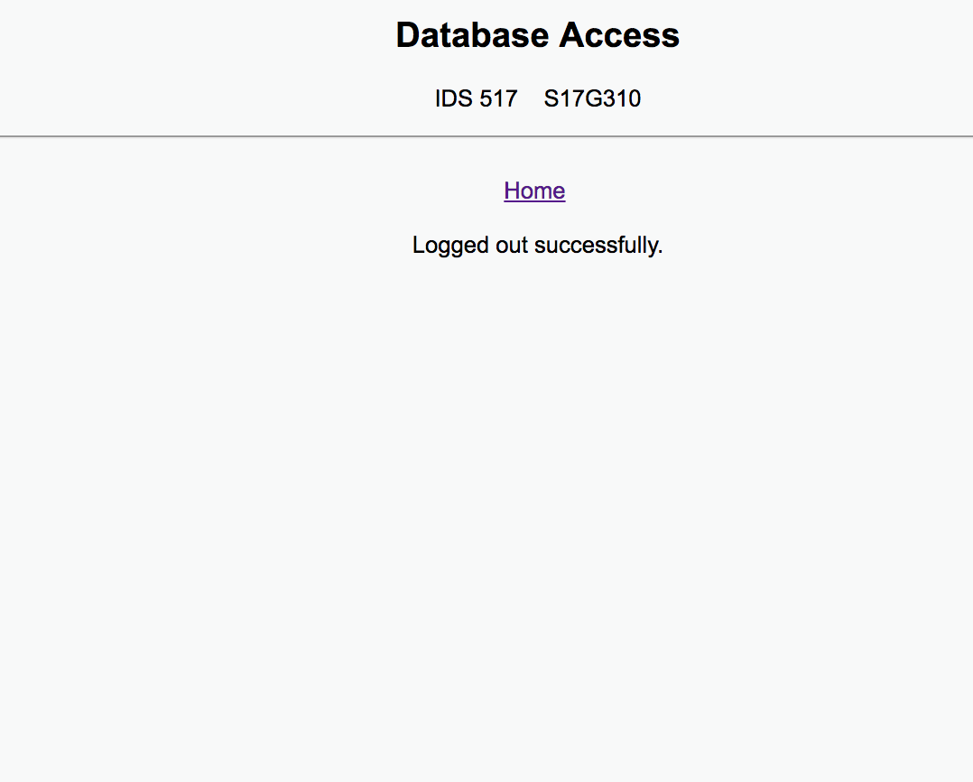

* On clicking the “logout” on any page redirects the user to this page.
* And the session would have ended.
* For the user to continue accessing the database, the user needs to login again.