Pretest WDA

Developing a Web Application with user interfaces and implements functions as the following:
- Cretate a database named SaleManager consists a table named tbEmployee [EmpID int, EmpDoB datetime, EmpName varchar(30), EmpAddress varchar(30), EmpEmail varchar(30)].
2. Create an ASP.Net Core Web Application with the following web pages:
Create ViewEmployeeList page show employees list from tbEmployee table ( Figure 1 ). When user clicks “View Details” link redirect to “EditOrDeleteEmployee” page (Figure 2). On this page, user can update or detele an employee into tbEmployee table and show a message after executed. User clicks “Back to list” link to return ViewEmployeeList page.
- When user clicks “Create Employee” link, redirect to “AddNewEmployee” page to add a new employee into tbEmployee table and show a confirm message. (Figure 3). After added, user clicks “View employee list” to return ViewEmployeeList page.
- Validation is required for pages: All fields not blank and changed label for all fields.
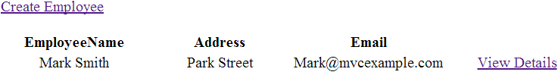

Figure 1. ViewEmployeeList page

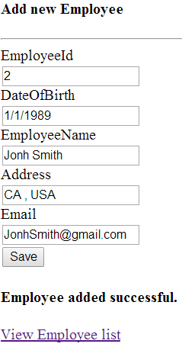
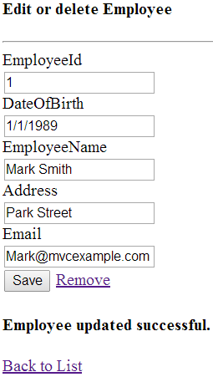

Figure 3: AddNewEmployee page
Figure 2: EditOrDeleteEmployee page

---o0o---

