SETUP PROFILE
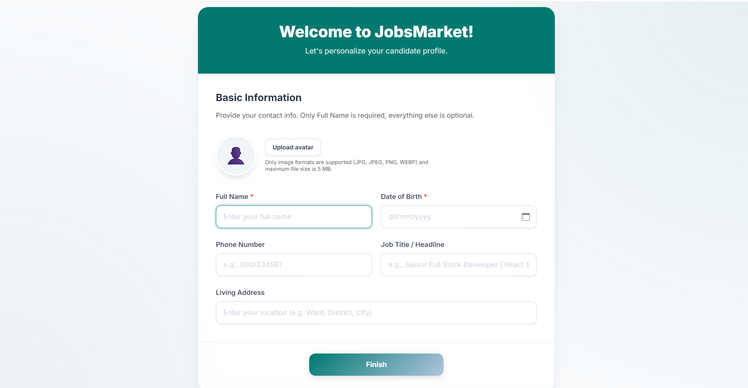
BASIC INFORMATION
- This section is intended for new candidates to complete their profile information after creating an account.
- The default full name will be taken from the “Full Name" field entered during registration.
- Upload an avatar image. Only image files with a maximum size of 5 MB are supported. This field is optional.
- Phone number must contain exactly 10 digits and follow a valid phone number format. This field is optional.
- The Date of Birth field is required.
- Job Title / Headline may contain only letters and spaces. Numbers and special characters are not allowed. This field is optional.
- Living Address may contain only letters, numbers, and spaces. Special characters are not allowed. This field is optional.
- Click "Finish" to continue.

CANDIDATE PROFILE
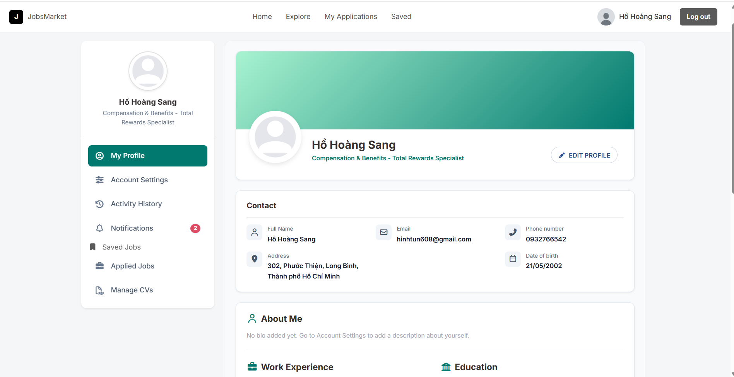
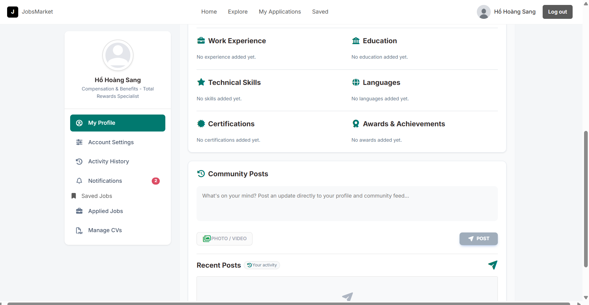
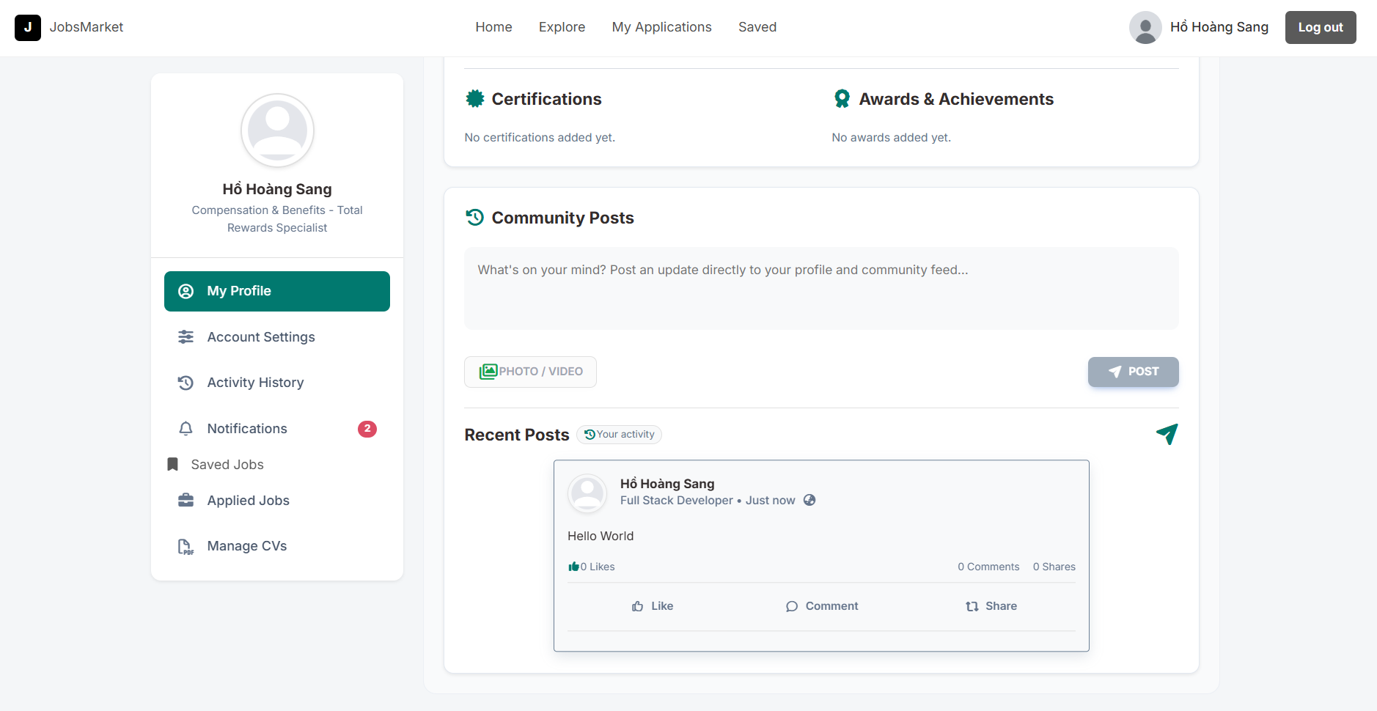
My Profile (Candidate Portfolio / Resume Builder)
- Personal Information Display: Showcases key biographical details including Full Name, Display Name, Job Title / Headline, Date of Birth, Gender, Address, and Nationality.
- About Me (Summary): A text block allowing candidates to write a concise professional introduction.
- Education History Management:
  - Users can add, edit, or remove multiple academic milestones.
  - Inputs include School/Institute Name, Degree/Field of Study, Start Date, Graduation Date (or marked as "Present"), and Description.
- Work Experience Management:
  - Tracks career history with details on Company Name, Job Title/Role, Start Date, End Date (or "Present"), and Job Description.
- Skills Profile & Level Tuning:
  - Allows adding key technical/soft skills.
  - Features a proficiency level selector represented by a percentage bar (0% - 100%).
- Social & Professional Links:
  - Connects candidate profiles with external portfolios: GitHub, LinkedIn, Personal Blog, Facebook, and X (formerly Twitter).
ACCOUNT SETTING
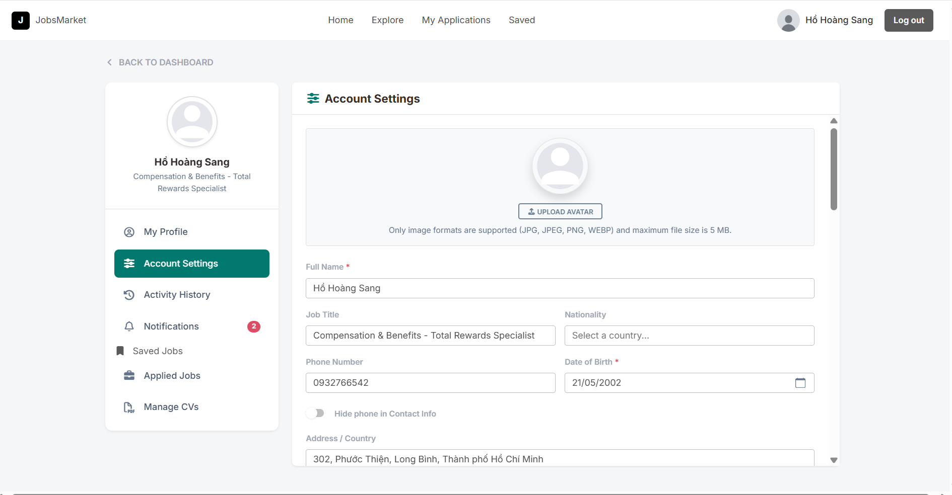

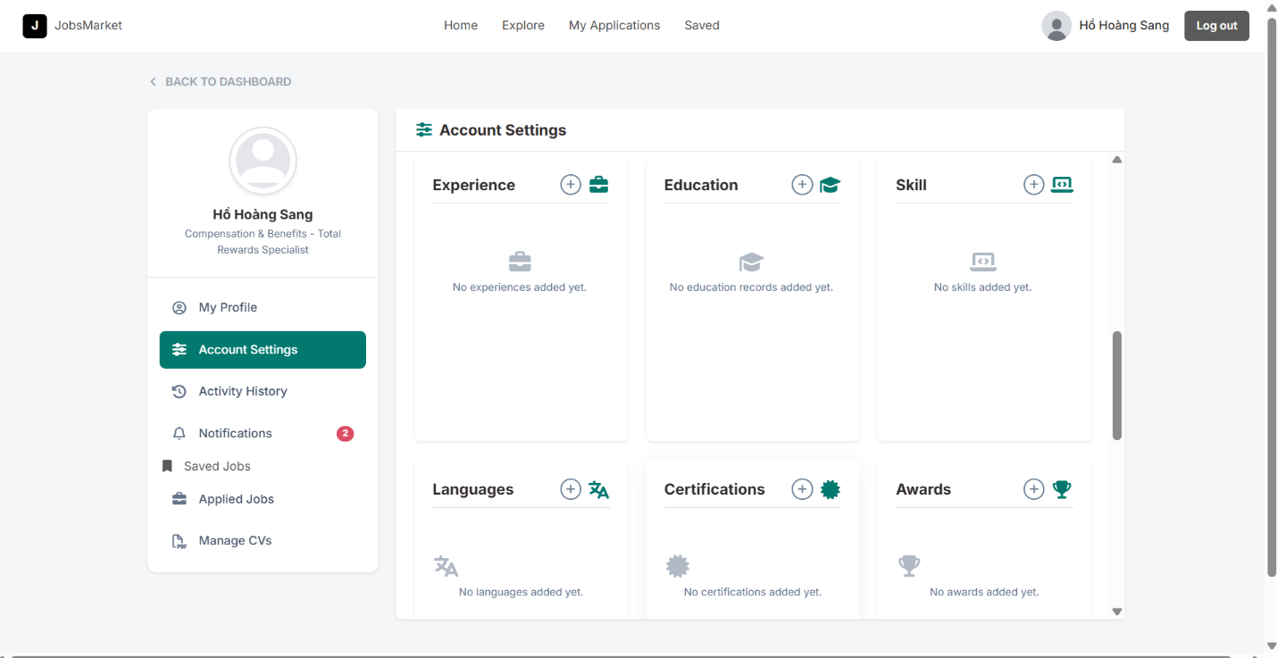
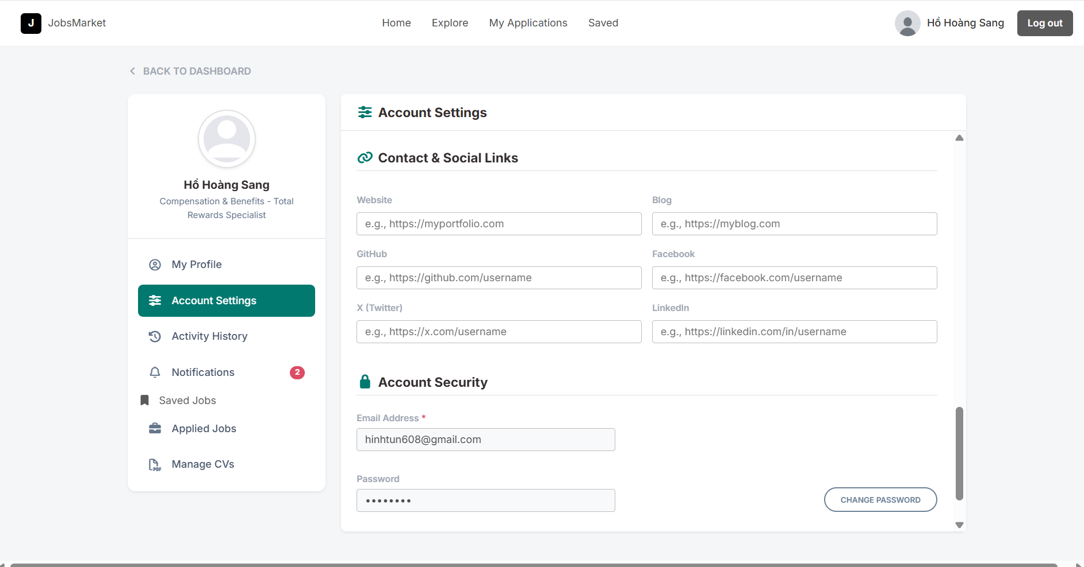
- Profile Credentials: Fields to update full name, phone number, address, and headline with input validation filters.
- Manage Resume: Field to Experience, Education, Skill, Languages, Certifications, Awards
- Change Password: A secure form to verify the old password and update to a new password.
- Email & Communication Preferences: Allows updating the primary email address and managing email subscription permissions.

ACTIVITY HISTORY
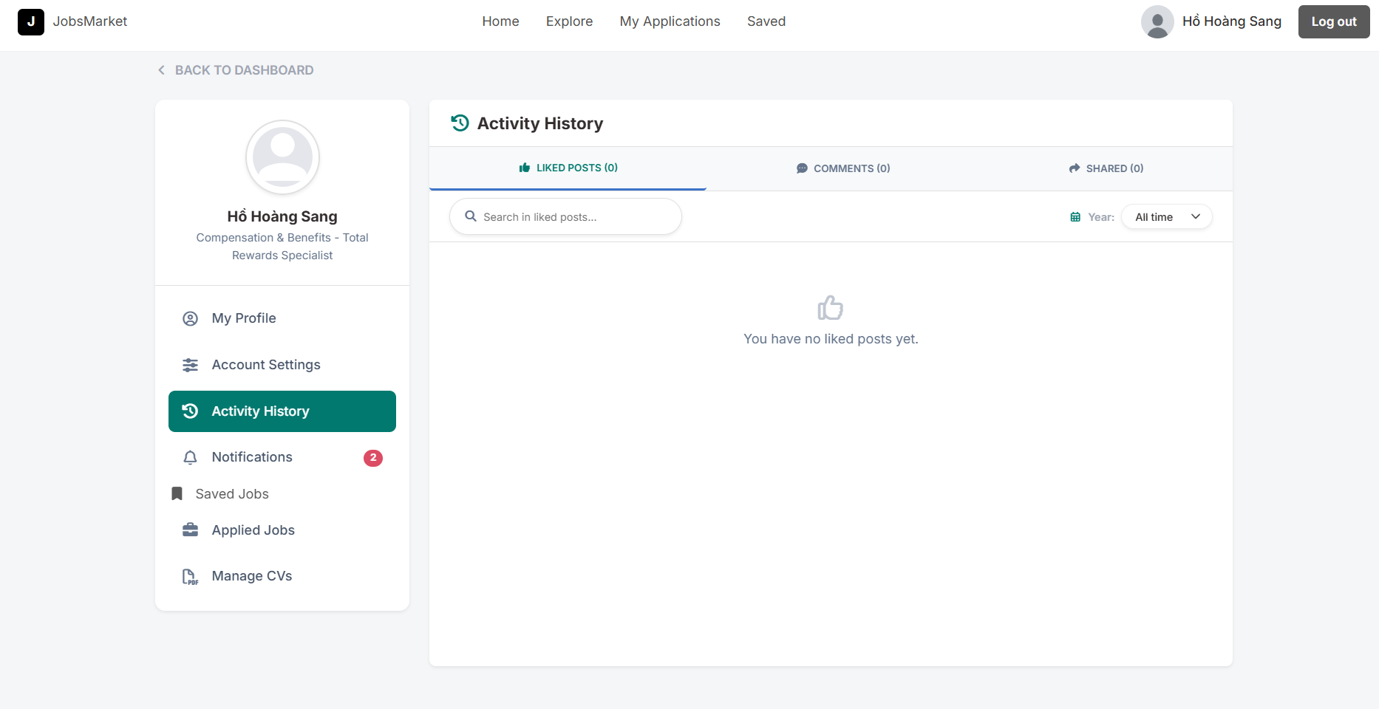
- Audit Trail: Logs user activities on the portal.
- Community Logs: Shows a historical feed of the candidate’s community activity, such as liked, commented, or shared posts.

APPLIED JOBS
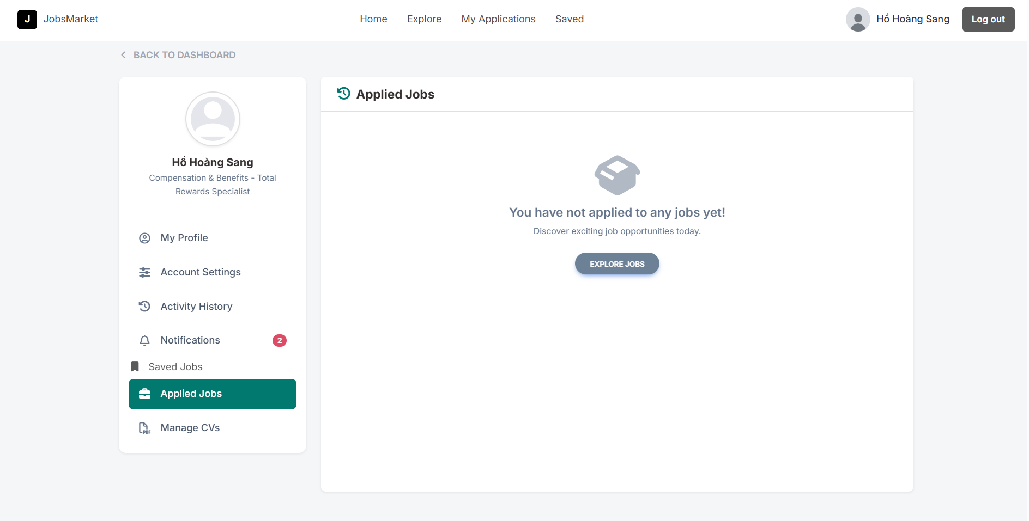

NOTIFICATIONS
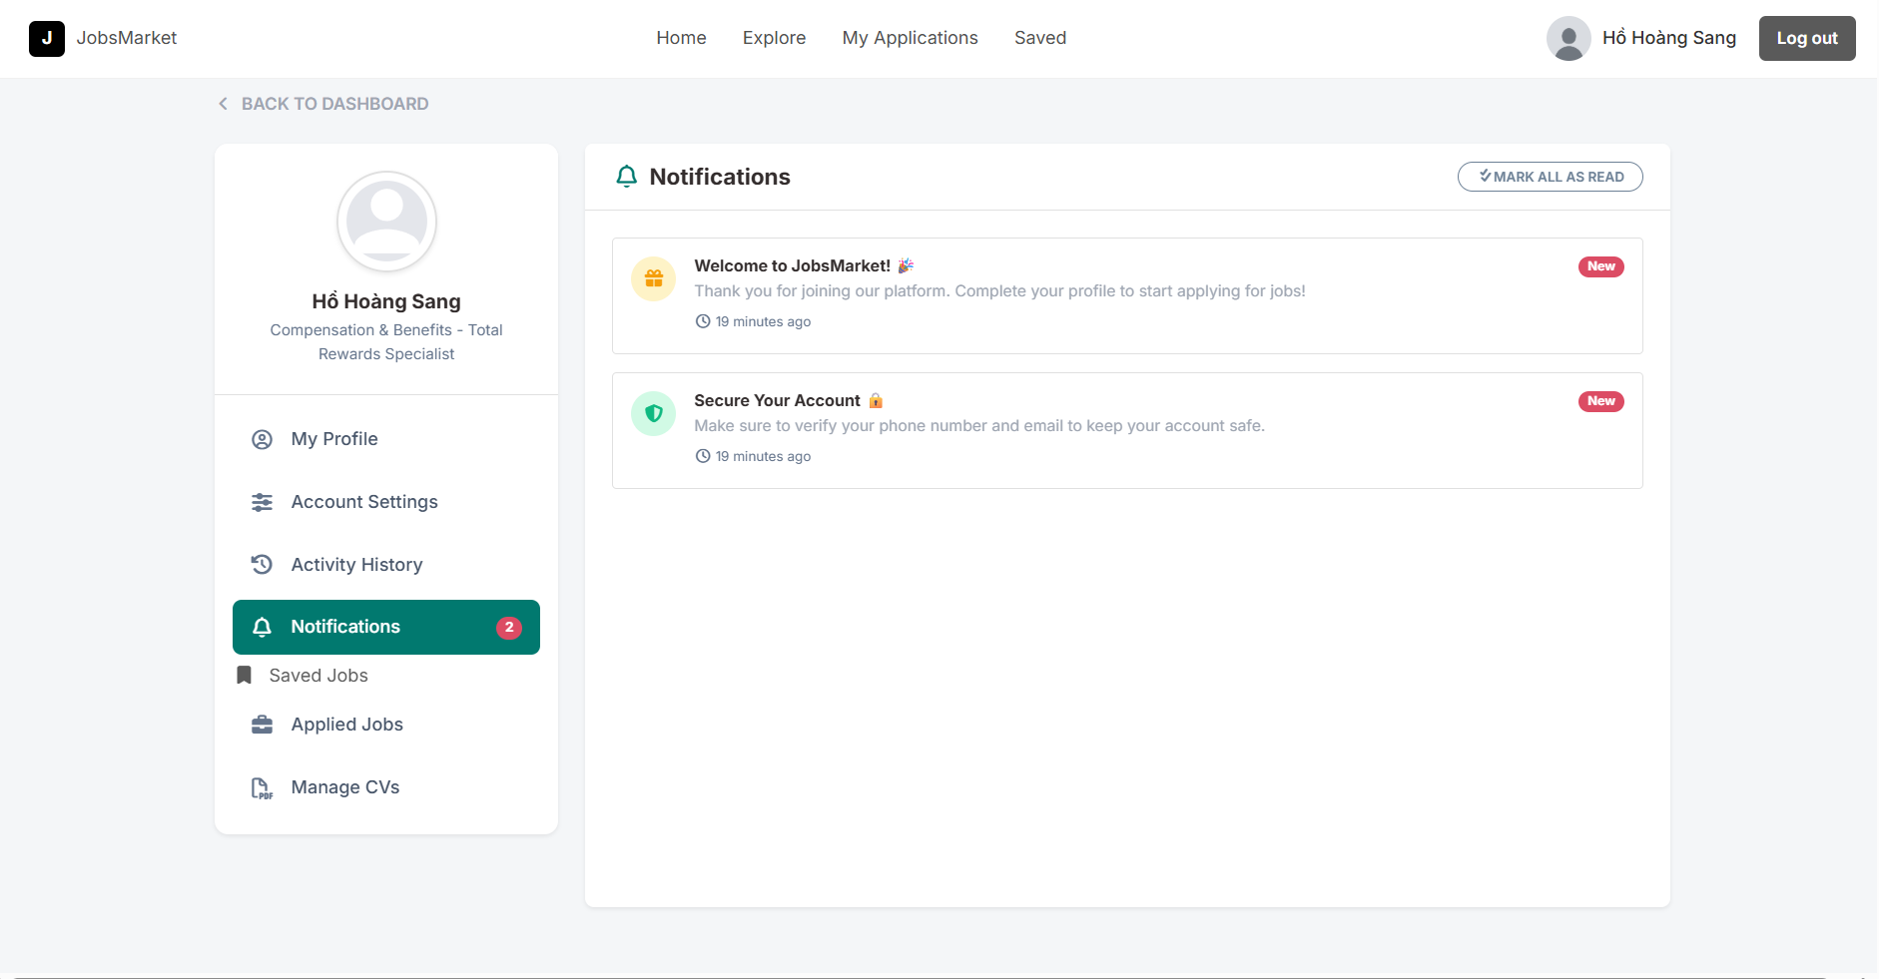
A notification is displayed when the HR updates the status of the candidate's job application.

MANAGE CVs
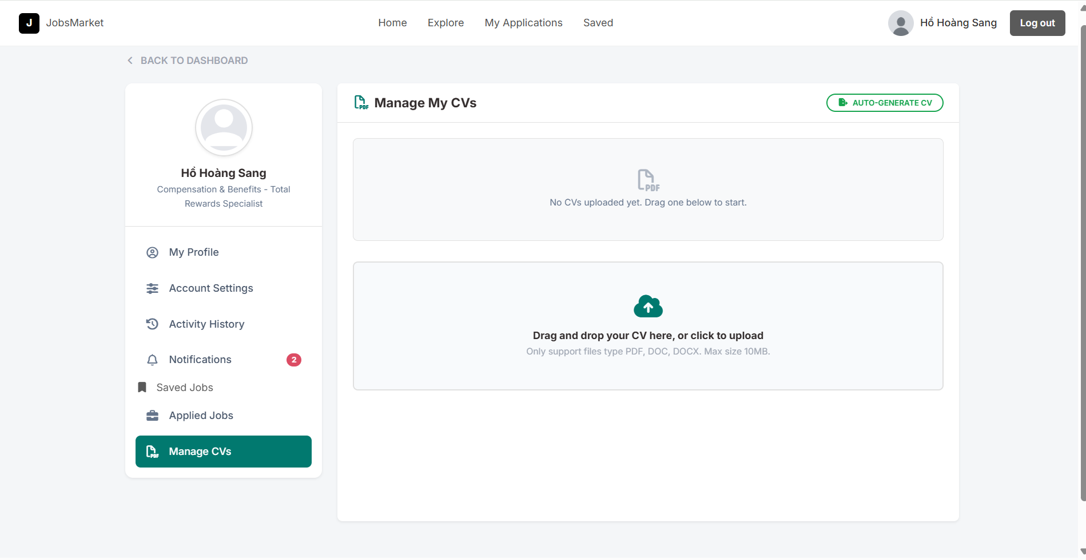
- CV Uploading: Supports uploading resumes in PDF and DOCX formats (up to a 5MB file size limit).
- Multiple CV Storage: Candidates can upload and name multiple CV variations targeted at different industries or roles.
- Default Resume Setting: Allows selecting a primary/default CV for quick job applications.
- Download & Preview: Options to download the uploaded resumes directly from the portal.

MY WALLET(Company Role)
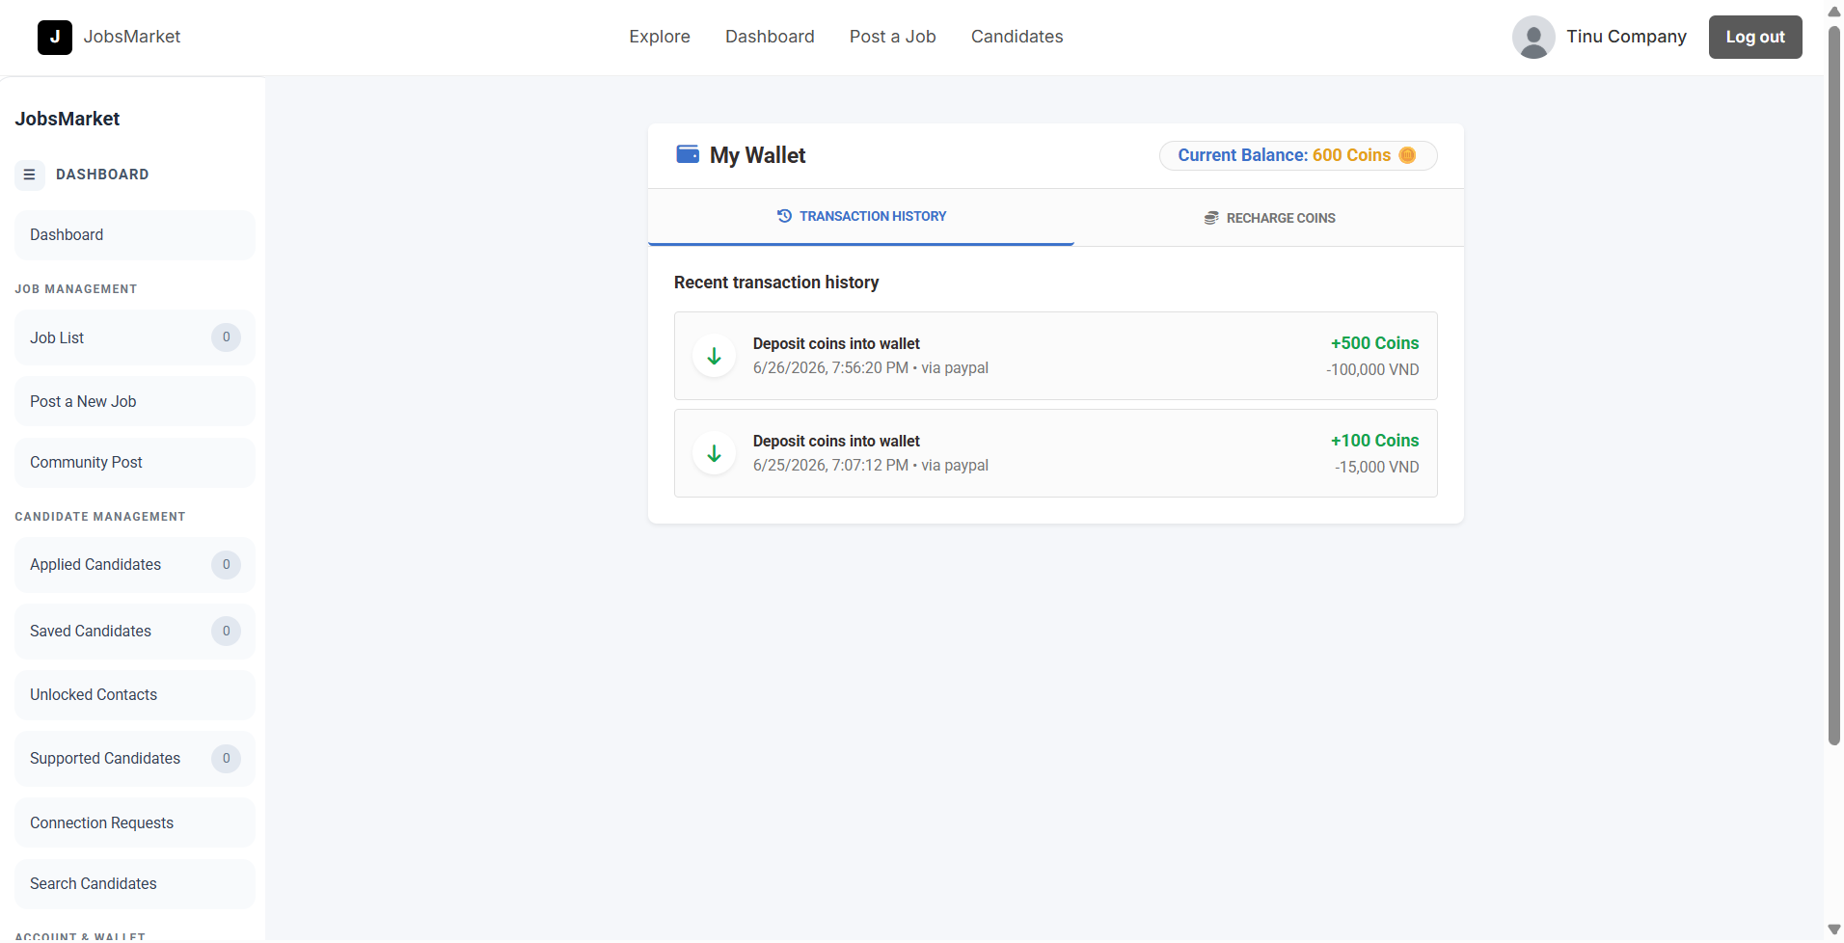
- Coin Balance: Displays the user's virtual coin balance.
- Transaction Ledger: Lists financial records such as coin deposits (top-up) and spending.

COMMUNITY POSTS
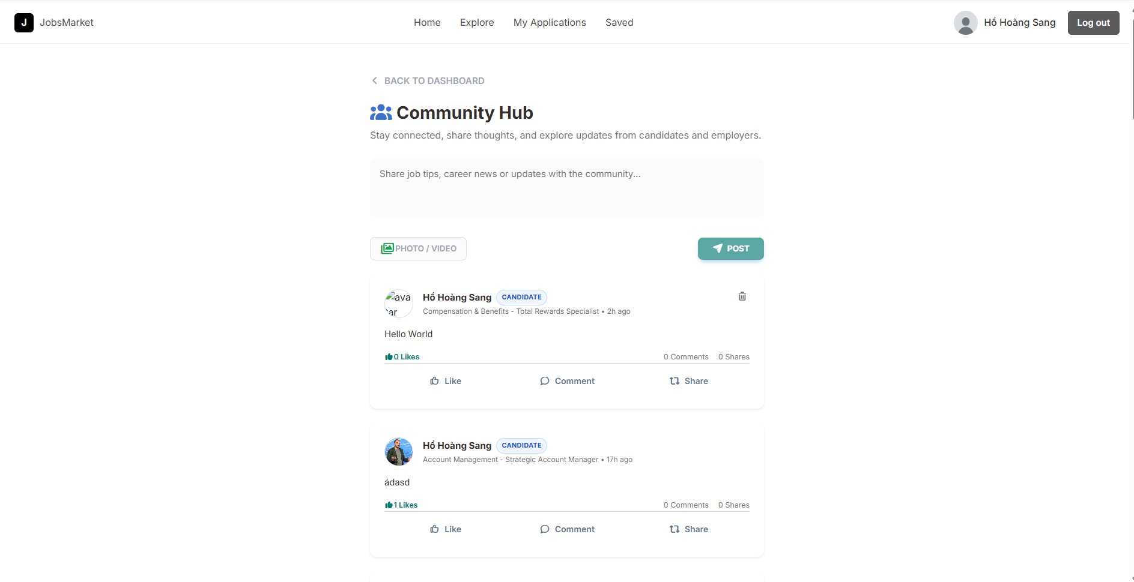
- Personal Blog & Feed: Displays posts, articles, and status updates published by the candidate and company in the JobsMarket Community.
- Social Engagement stats: Shows statistics of Likes, Comments, and Shares generated on the candidate's shared content.

JOB POSTING PLAN
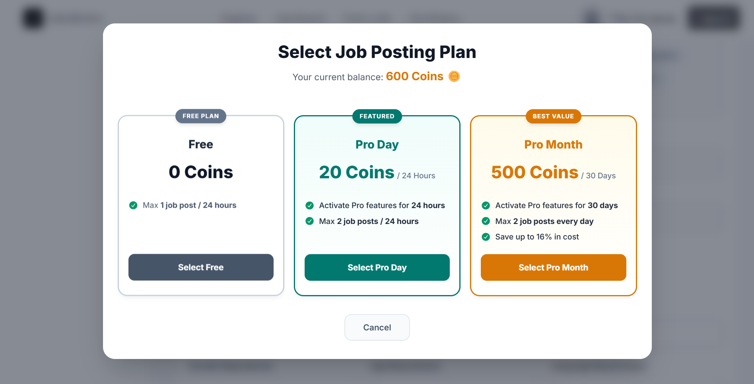
- Monetization & Posting Limits: Implements a subscription tier and pay-as-you-go model that regulates how frequently employers can publish job vacancies.
- Dual-Tier System: Categorized into Free Accounts and Pro Accounts, with the latter purchased using virtual platform currency (Coins).
- Interactive Plan Selector: When creating a new job posting, recruiters are prompted with a modal to choose their pricing tier or leverage their active Pro plan benefits.

COIN FEES
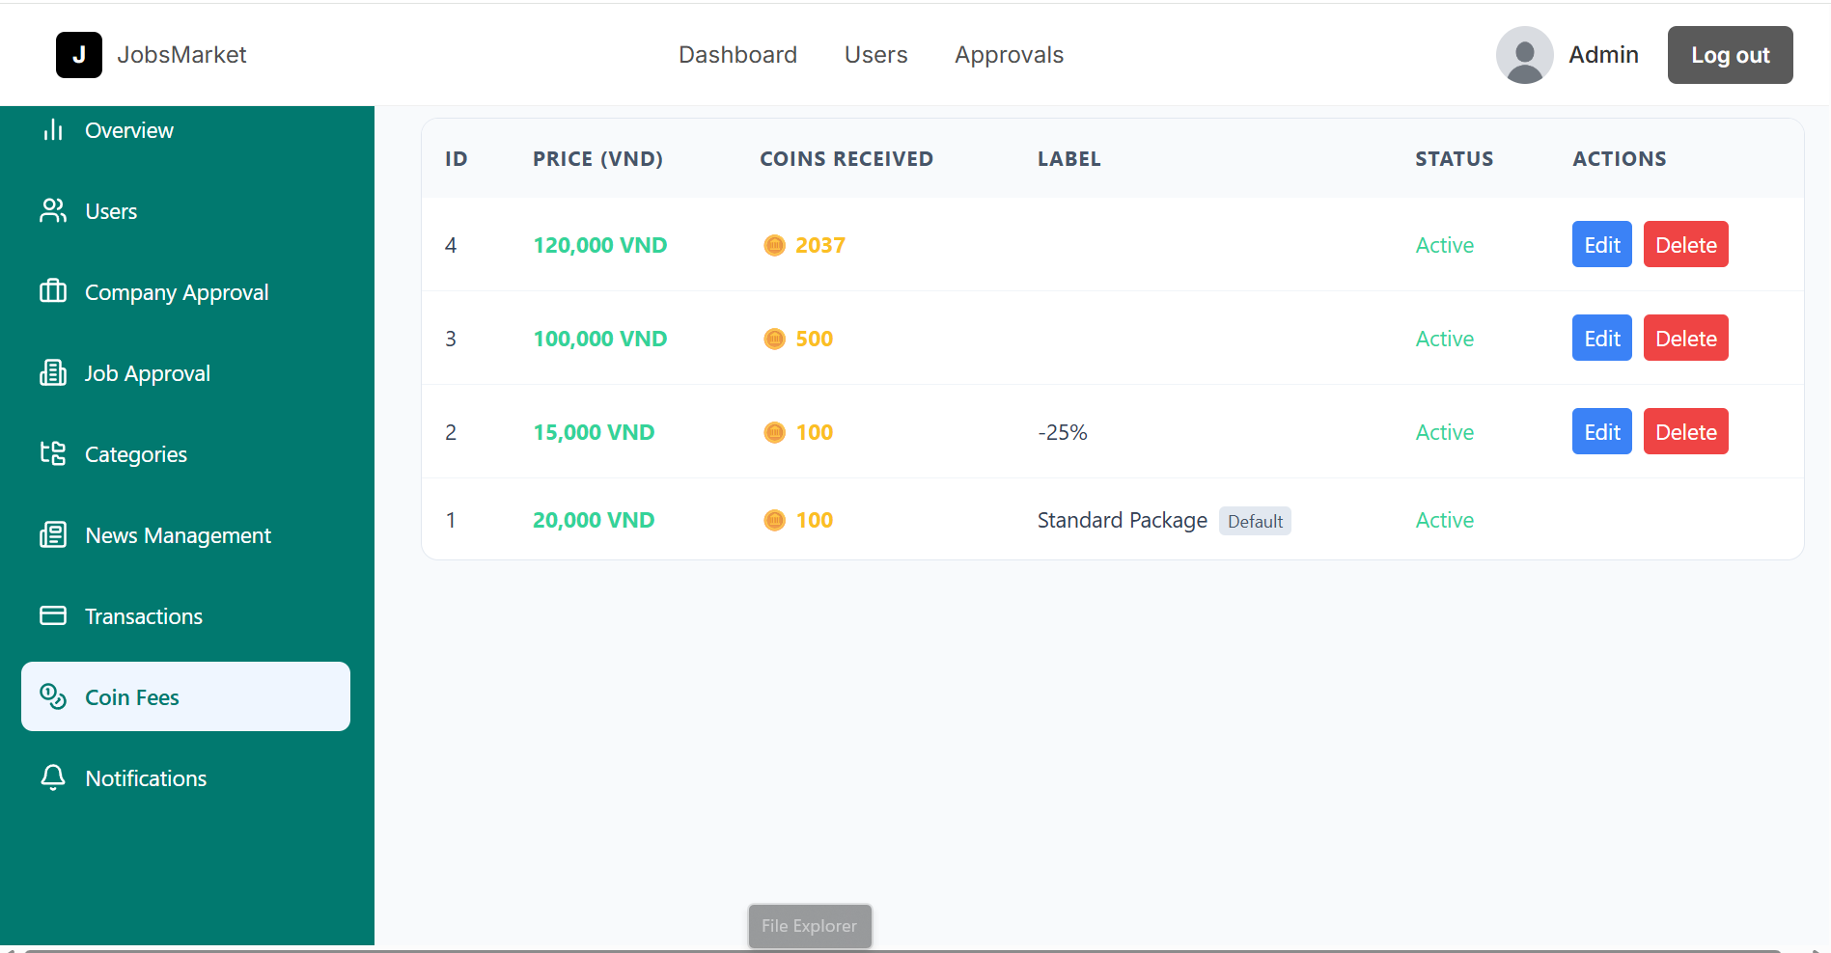
- Overview: Allows platform administrators to configure the virtual currency pricing tiers (coin exchange rates) that recruiters use to top up their accounts.
- Package Attributes:
  - Price (VND): The fiat money equivalent required to purchase the package.
  - Coins Received: The amount of virtual coins credited to the user's wallet upon purchase approval.
  - Label: A short title/tag for display (e.g., "Popular", "Super Saver").
  - Description: Explanatory text summarizing package details.
  - Status (Active/Hidden): Toggles the availability of the package on the client-facing top-up interface.
- CRUD Capabilities:
  - Create: Adds new pricing packages with defined sort orders.
  - Read: Fetches and displays a tabular listing of all packages.
  - Update: Modifies pricing details or hides/activates active packages.
  - Delete: Removes custom coin packages from the system (default packages are protected from deletion).

TRANSACTIONS
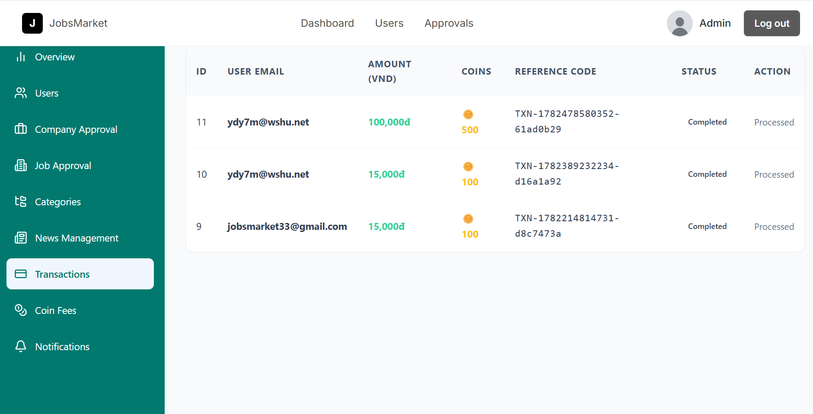
- Overview: Serves as the central clearinghouse for checking, approving, or denying fiat-to-coin deposits submitted by users.
- Real-time Synchronization (Polling): Configured with automatic client-side updates (polling the backend server every 5 seconds) to ensure admin screens stay updated with newly pending transaction requests.
- Deposit Verification Flow:
  - Pending Status: When a user deposits funds (e.g., bank transfer), a transaction is generated in a pending state with a reference code and upload proof.
  - Approval Handling: The admin reviews the reference code and verified payment status. They can then select:
    - Approve (completed): Triggers an atomic transaction that updates the transaction record state and automatically increments the user's wallet with the purchased amount of coins (coins = coins + deposit_amount).
    - Reject (failed): Sets the transaction status as failed/cancelled without affecting the user's wallet balance.
  - Data Integrity Assurance: Utilizes database transactions (beginTransaction and FOR UPDATE lock locks) to ensure coins are only credited once per transaction and prevent double-spending anomalies.

