Joshua Leger
Fred Kneeland
April 30, 2016
Senior Team Portfolio
Section 1: CSCI 468, source code included in compiler folder.
Section 2:
Team member 1: Team member 1 wrote the lexer and code generation.
Team member 2: Team member 2 wrote the parser and symbol table.
Each team member did 50% of the work.
Section 3: Our project did not use any design patterns.
Section 4: The technical document is included as report.pdf.
Section 5:
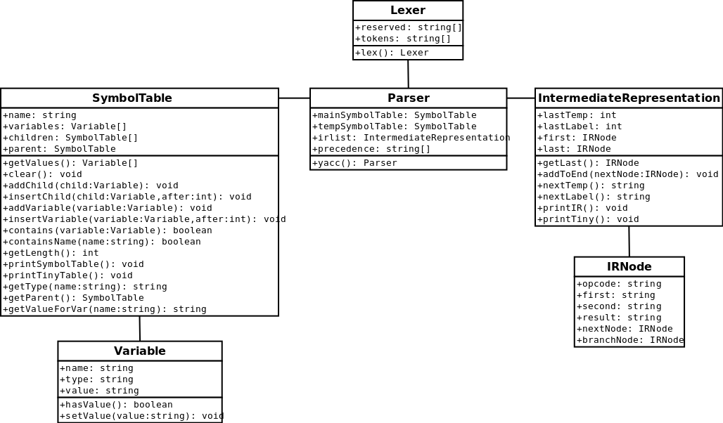
Section 6: The main design trade-off our team had was in what language and library to use. We chose python with PLY because it was the recommended solution and easy to use, even though it was not the most efficient choice.
Section 7: We used an agile development cycle with 4 sprints to complete the 4 parts of our project. It was helpful in letting each other know what our progress on the project was throughout development.

