LoreSmith
Final Course Project Report
Agile Software Development Methods (605.607)
Johns Hopkins University
May 2026
GitHub Repository: https://github.com/TheSirLancelot/loresmith
Project Board: https://github.com/users/TheSirLancelot/projects/3
Production Site: https://loresmith.streamlit.app/

Contents
Executive Summary 4
Rubric Crosswalk 4
1. Project Overview 4
1.1 Project Objective 4
1.2 Project Description 4
1.3 System Overview 5
1.4 Team Structure 5
2. User Role Modeling 5
2.1 Roles Considered and Final Role 5
3. Product Backlog, User Stories, and Prioritization 5
3.1 Backlog Tooling 5
3.2 User Story Format 5
3.3 Prioritization Strategy 5
3.4 Backlog Summary 5
4. Agile Approach and Definition of Done 6
4.1 Agile Approach 6
4.2 Definition of Done 6
5. Release Plan 7
6. Metrics and Velocity 7
7. Iteration Breakdown 9
7.1 Sprint 0: Project Initialization 9
Stories Included 9
Key Deliverables 9
7.2 Sprint 1: NPC Core Vertical Slice 9
Stories Included 9
Key Deliverables 9
Notes and Adjustments 9
7.3 Sprint 2: Location Entity and NPC Enhancements 9
Stories Included 9
Key Deliverables 10
Notes and Adjustments 10
7.4 Sprint 3: Factions, Session Tracking, and NPC Navigation 10
Stories Included 10
Key Deliverables 10
Notes and Adjustments 10
7.5 Sprint 4: Visualization and Cross Entity Linking 10
Stories Included 10
Key Deliverables 10
Notes and Adjustments 10
8. Burnup and Progress Tracking 11
9. Simple Domain Model 12
10. Reviews, Retrospectives, and Adaptation 14
11. Reflections 14
12. Conclusions 15
Appendix A: Story Point and Business Value Table 15
Appendix B: Project Artifact Links 17

Executive Summary
LoreSmith is a web based campaign management application designed to help Dungeon Masters create, organize, and retrieve tabletop roleplaying game information during preparation and live play. The project was developed using a Scrum style iterative process supported by GitHub Issues, GitHub Projects, milestones, pull requests, and sprint retrospectives.
The project has completed three full development sprints following Sprint 0 initialization, and Sprint 4 is currently underway. The delivered product has evolved from a single entity NPC management vertical slice into a broader campaign management tool with NPCs, locations, factions, session logs, and cross entity navigation. The final submission focuses on the application of Agile methods and artifacts rather than the code itself.
The main corrective actions taken from the course project checkup are explicit in this report: a formal release plan has been added, burnup chart placeholders are included for direct image insertion, and a rubric crosswalk is provided so required artifacts are easy to locate.

Rubric Crosswalk
This crosswalk is included to make each required Agile artifact easy to locate during grading.
Rubric Element | Location in Report
Project objective | Section 1: Project Overview
User role modeling | Section 2: User Role Modeling
User stories and acceptance criteria | Section 3: Product Backlog, User Stories, and Prioritization
Themes / milestones | Section 3 and Section 5: Release Plan
Estimation and prioritization | Section 3 and Section 6: Metrics and Velocity
Definition of Done | Section 4: Agile Approach and Definition of Done
Product backlog | Section 3 and Appendix A
Sprint backlogs | Section 7: Iteration Breakdown
Team velocity | Section 6: Metrics and Velocity
Product backlog burnup / burndown | Section 8: Burnup and Progress Tracking
Sprint burnup / burndown | Section 8: Burnup and Progress Tracking
Release plan | Section 5: Release Plan
Simple model | Section 9: Simple Domain Model
Reviews and retrospectives | Section 10: Reviews, Retrospectives, and Adaptation
What I learned and conclusions | Section 11 and Section 12

1. Project Overview

1.1 Project Objective
The objective of LoreSmith is to provide Dungeon Masters with a simple and reliable tool for managing campaign content. The project focuses on reducing the overhead associated with tracking NPCs, locations, factions, and session notes so that Dungeon Masters can focus more on storytelling and gameplay.

1.2 Project Description
LoreSmith is a Streamlit based web application backed by persistent database storage. The initial release delivered NPC management as a vertical slice. Later iterations expanded the product to include locations, factions, session logs, search, sorting, filtering, and cross entity relationships.

1.3 System Overview
The application uses Streamlit for the user interface, Python for application logic, and Supabase for hosted database storage. The repository uses a dev branch for active sprint work and a main branch for production ready releases. Completed sprint increments are merged from dev to main at sprint close.

1.4 Team Structure
The project is developed by a two person team. I acted as project manager and primary developer, coordinating backlog management, sprint planning, process artifacts, and implementation. A second contributor supported development work across NPC, location, faction, and navigation features.

2. User Role Modeling

2.1 Roles Considered and Final Role
Several potential user roles were considered during planning: Dungeon Master, player, and administrator. The Dungeon Master role was selected as the primary role for the semester scope because the DM creates, updates, organizes, and retrieves the majority of campaign information. Player facing access and administrative concerns were deferred to future iterations to keep the semester project focused on delivering meaningful working software.
This role decision helped constrain scope. Instead of trying to support every possible campaign participant, the team concentrated on workflows that matter most to DMs: creating records, retrieving records quickly, connecting records to campaign context, and maintaining information as a campaign changes.

3. Product Backlog, User Stories, and Prioritization

3.1 Backlog Tooling
The product backlog is maintained in GitHub Issues and organized through a GitHub Projects board. Issues represent user stories, bugs, or future iteration items. Milestones serve as themes by grouping related functionality into major capability areas such as Core Campaign Management, Factions & Relationships, Session Tracking, Visualization, Infrastructure, and Future Iterations.

3.2 User Story Format
User stories follow the course required format: As a [role], I want [functionality], so that [value is achieved]. Each user story includes acceptance criteria that define conditions of satisfaction for that story. These acceptance criteria are separate from the project wide Definition of Done.

3.3 Prioritization Strategy
Prioritization was driven by business value and dependency ordering. The team first prioritized the smallest useful vertical slice: persistent NPC CRUD. Once that foundation was stable, priority shifted to locations, then factions and session tracking, and finally visualization and cross entity linking. Future iteration items such as authentication, multi campaign support, caching, search enhancements, exports, and tests were intentionally deferred to protect the committed semester scope.

3.4 Backlog Summary
Milestone / Theme | Stories Done | Stories Open | Status
Core Campaign Management | 13 | 0 | Complete
Session Tracking | 3 | 0 | Complete
Factions & Relationships | 3 | 1 | Sprint 4 in progress
Infrastructure | 1 | 1 | Sprint 4 in progress
Visualization | 0 | 3 | Sprint 4 in progress
Future Iterations | 0 | 8 | Deferred

Figure 1: Kanban Screenshot (Done column continues)
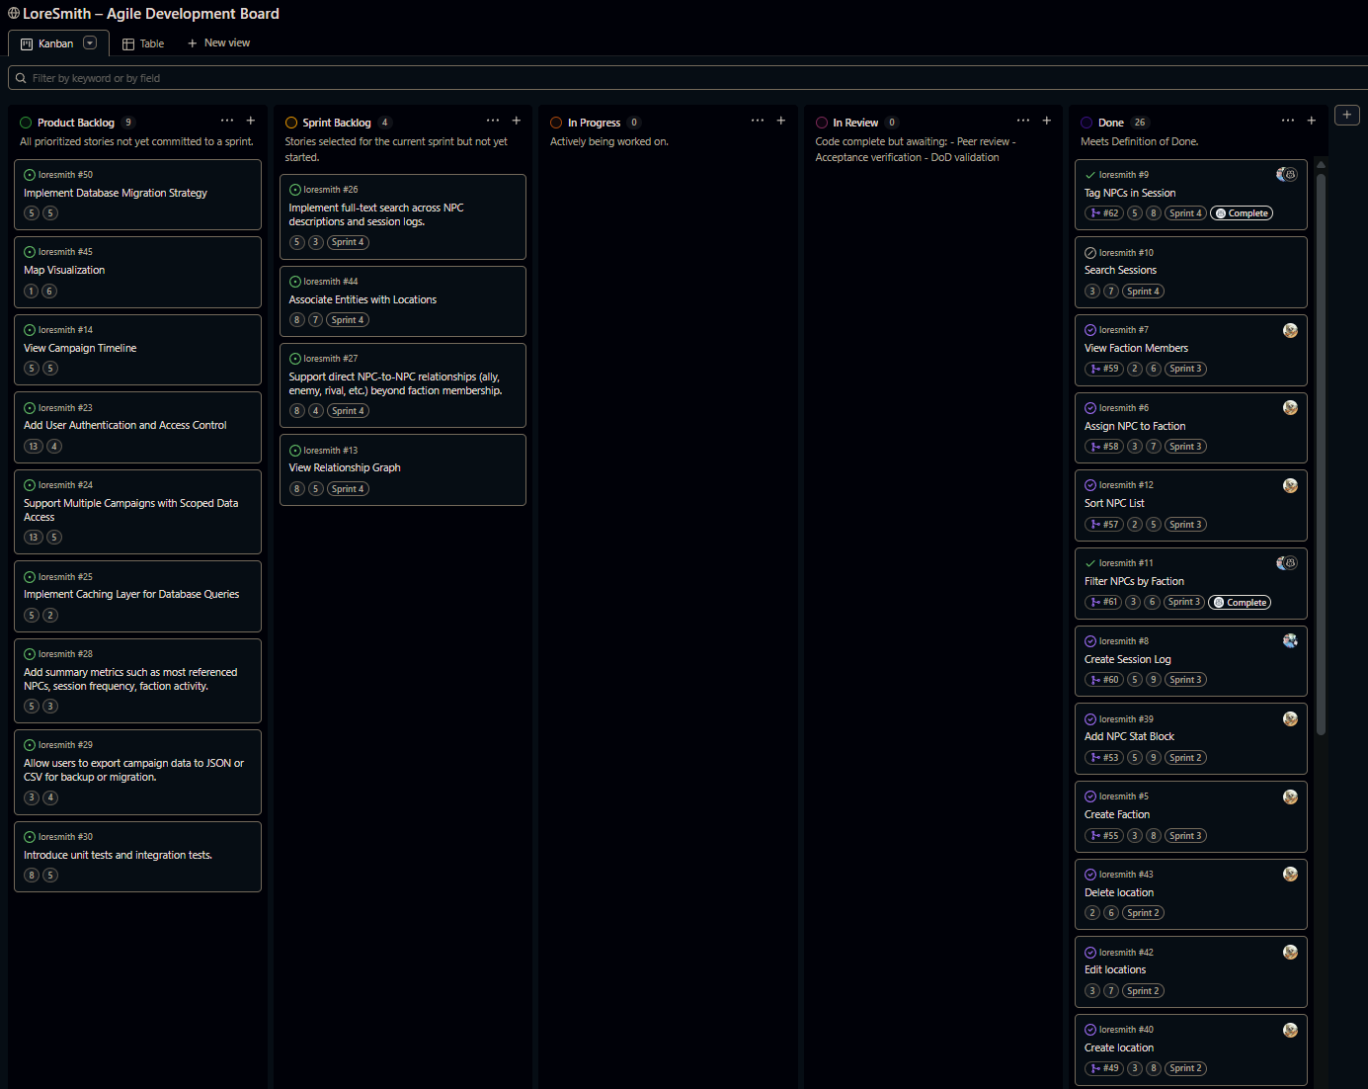

4. Agile Approach and Definition of Done

4.1 Agile Approach
The team used a lightweight Scrum style approach. Work was planned into sprints, implemented through feature branches, reviewed through pull requests, and closed by merging dev into main at the end of each sprint. GitHub Projects provided the visible board for backlog and sprint tracking. GitHub milestones acted as themes. Sprint planning, sprint review, and retrospective notes were maintained as repository documentation.

4.2 Definition of Done
A story was considered done when all of the following were true:
- The feature works from the user perspective.
- Required frontend, backend, and database changes are integrated.
- Data persists correctly when the story requires persistence.
- Acceptance criteria for the story are satisfied.
- The work is submitted through a pull request.
- The pull request is reviewed and merged into the sprint development branch.
- The corresponding GitHub issue is closed or moved to done on the project board.
- Completed sprint work is merged from dev into main at sprint close.

5. Release Plan
The release plan maps each iteration to the themes, stories, and product capability delivered. This table directly addresses the checkup feedback that the release plan needed to be made more explicit.
Iteration | Theme | Stories | Outcome | Status
Sprint 0 | Infrastructure setup | Repository, project board, backlog, architecture planning, Streamlit skeleton, initial database setup | Working development environment and initial backlog | Complete
Sprint 1  Feb 17 to Mar 2 | Core Campaign Management; Infrastructure | #1 Create NPC; #2 View NPC List; #3 Edit NPC; #4 Delete NPC; #15 Persist Data; #31 and #34 bug fixes | Full NPC CRUD system with persistent database storage | Complete, about 18 SP
Sprint 2  Mar 4 to Apr 21 | Core Campaign Management | #38 Add NPC Image; #39 Add NPC Stat Block; #40 Create Location; #41 View Locations; #42 Edit Locations; #43 Delete Location | Location CRUD plus NPC image and stat block support | Complete, about 24 SP
Sprint 3  Apr 21 to May 1 | Factions & Relationships; Session Tracking | #5 Create Faction; #6 Assign NPC to Faction; #7 View Faction Members; #8 Create Session Log; #9 Tag NPCs in Session; #10 Search Sessions; #11 Filter NPCs by Faction; #12 Sort NPC List | Faction system, session tracking, NPC tagging, sorting, and filtering | Complete, about 32 SP
Sprint 4  May 1 to present | Visualization; Factions & Relationships; Infrastructure | #44 Associate Entities with Locations; #13 Relationship Graph; #14 Campaign Timeline; #45 Map Visualization; #50 DB Migration Strategy | Visualization layer, cross entity location links, and migration tooling | In progress
Future Iterations | Deferred scope | #23 Authentication; #24 Multi campaign; #25 Caching; #26 Full text search; #27 NPC relationships; #28 Metrics; #29 Export; #30 Tests | Post semester enhancements intentionally kept outside committed scope | Deferred

6. Metrics and Velocity
Velocity is measured as completed story points per sprint. Story point estimates were tracked directly within the GitHub Project board and used to calculate velocity for each iteration. The team completed 18 story points in Sprint 1, 24 story points in Sprint 2, 32 story points in Sprint 3, and 34 story points in Sprint 4.
This steady increase in velocity reflects growing familiarity with the codebase, reduced integration overhead, and more efficient development practices over time. As the system matured, the team was able to deliver more complex functionality within each iteration.
While Sprint 4 includes a projected total based on committed work, the overall trend demonstrates consistent improvement in delivery capability. Velocity is used here as a trend indicator to understand team performance over time rather than as a strict planning constraint.
Sprint | Duration | Stories Completed | Velocity | PRs Merged | Notes
Sprint 1 | 14 days | 5 user stories + 2 bugs | ~18 SP | 9 | Baseline sprint delivering NPC CRUD
Sprint 2 | ~7 weeks | 6 user stories | ~24 SP | 7 | Extended due to human factors
Sprint 3 | 10 days | 8 user stories | ~32 SP | 7 | Highest throughput; included AI assisted implementation
Sprint 4 | In progress | 5 committed stories | ~34 | TBD (1 so far) | Visualization and final integration focus

Figure 2: Sprint Velocity Over Time
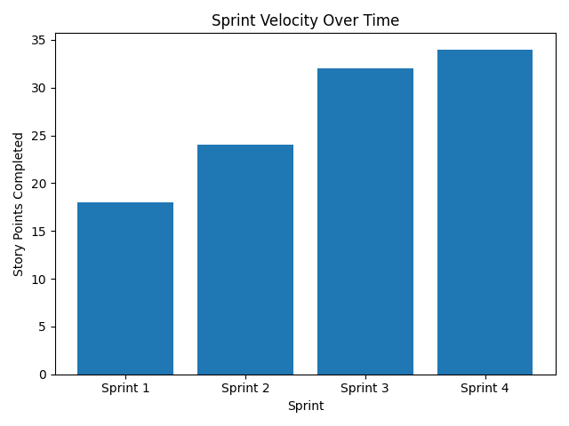

7. Iteration Breakdown

7.1 Sprint 0: Project Initialization
Period: Early February 2026
Sprint Goal: Establish the development environment, architecture, project board, and initial backlog.

Stories Included
- Repository and project board created.
- Initial milestones and backlog created.
- Architecture selected: Streamlit, Python, Supabase.
- Initial Streamlit skeleton merged to dev.

Key Deliverables
Sprint 0 created the infrastructure needed to begin feature development in Sprint 1.

7.2 Sprint 1: NPC Core Vertical Slice
Period: Feb 17, 2026 to Mar 2, 2026
Sprint Goal: Deliver complete NPC CRUD backed by persistent storage.

Stories Included
- #15 Persist Data
- #2 View NPC List
- #1 Create NPC
- #4 Delete NPC
- #3 Edit NPC
- #31 Default ID schema bug
- #34 requirements.txt install error bug

Key Deliverables
Sprint 1 produced the initial working MVP: a functional NPC management system with create, view, edit, delete, and database persistence.

Notes and Adjustments
No major scope change occurred. Two defects were discovered and resolved within the sprint boundary.

7.3 Sprint 2: Location Entity and NPC Enhancements
Period: Mar 4, 2026 to Apr 21, 2026
Sprint Goal: Add location management and enrich NPC records with image and stat block support.

Stories Included
- #38 Add NPC Image
- #40 Create Location
- #41 View Locations
- #42 Edit Locations
- #43 Delete Location
- #39 Add NPC Stat Block

Key Deliverables
Sprint 2 added Location as a second first class entity and improved NPC usefulness through visual references and flexible system agnostic stat blocks.

Notes and Adjustments
Sprint 2 was extended due to human factors. The team chose to preserve quality and finish committed work rather than close the sprint with incomplete stories.

7.4 Sprint 3: Factions, Session Tracking, and NPC Navigation
Period: Apr 21, 2026 to May 1, 2026
Sprint Goal: Implement faction management, session tracking, NPC tagging, sorting, and filtering.

Stories Included
- #5 Create Faction
- #6 Assign NPC to Faction
- #7 View Faction Members
- #8 Create Session Log
- #9 Tag NPCs in Session
- #10 Search Sessions
- #11 Filter NPCs by Faction
- #12 Sort NPC List

Key Deliverables
Sprint 3 transformed LoreSmith from a basic CRUD application into a cross referenced campaign management tool. Factions and session logs created meaningful relationships between campaign records.

Notes and Adjustments
GitHub Copilot was used for selected PRs in Sprint 3. This is documented as a process adaptation that helped increase throughput while preserving review through the normal pull request process.

7.5 Sprint 4: Visualization and Cross Entity Linking
Period: May 1, 2026 to present
Sprint Goal: Deliver visualization features, entity location associations, and database migration tooling.

Stories Included
- #44 Associate Entities with Locations
- #13 View Relationship Graph
- #14 View Campaign Timeline
- #45 Map Visualization
- #50 Implement Database Migration Strategy

Key Deliverables
Sprint 4 is intended to close the visualization portion of the committed semester scope and strengthen maintainability through migration tooling.

Notes and Adjustments
TBD

8. Burnup and Progress Tracking
Burnup charts are used to visualize completed work over time while also making changes in total scope visible. Unlike burndown charts, which focus on remaining work, burnup charts clearly show both progress and any adjustments to the overall backlog. This makes them particularly useful for understanding how work evolves across iterations rather than assuming a fixed scope.
The following burnup charts illustrate the cumulative story points completed during each sprint. They highlight steady progress across iterations and provide visibility into how the team delivered working increments over time. These charts reinforce the observed increase in velocity and demonstrate that work was completed consistently while maintaining alignment with sprint goals.
Figure 3: Sprint 1
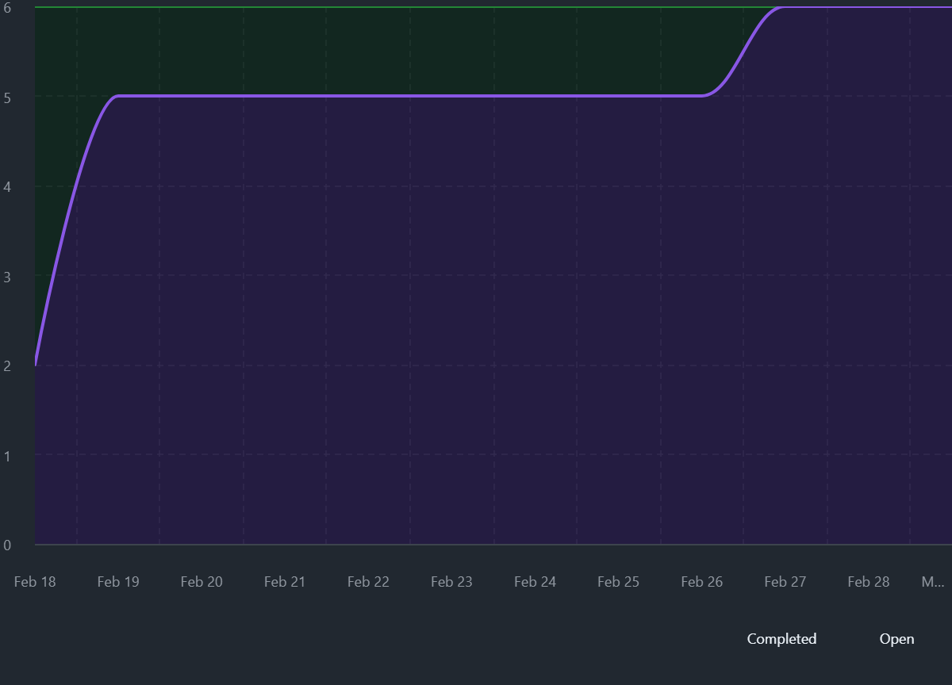
Figure 4: Sprint 2
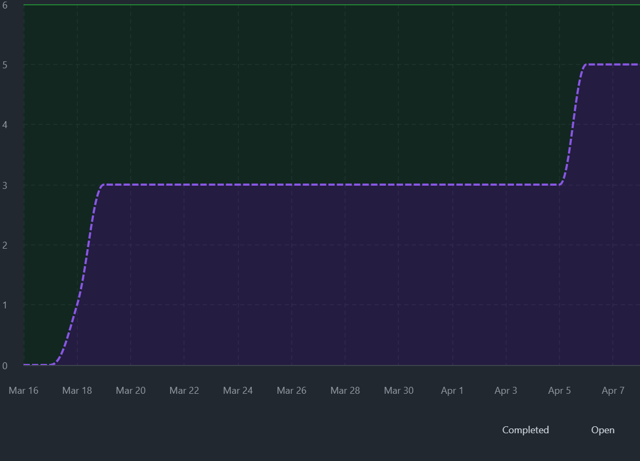
Figure 5: Sprint 3
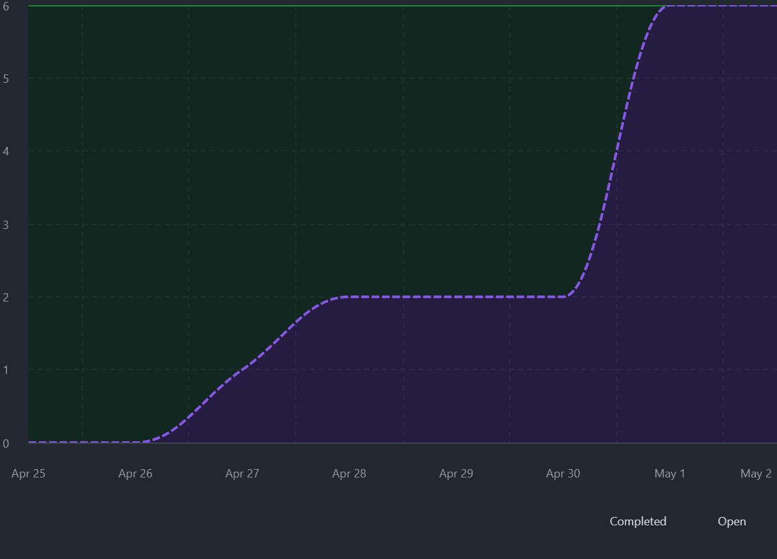
Figure 6: Overall
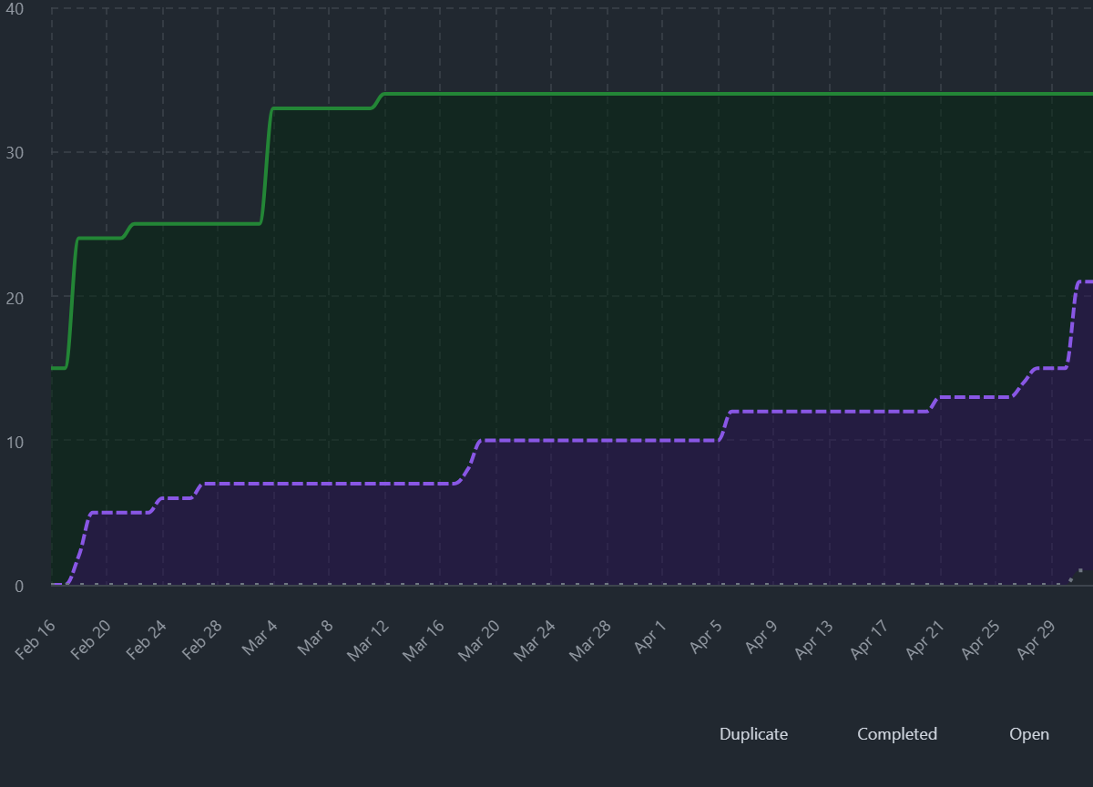
The burnup pattern shows a steady Sprint 1, an extended Sprint 2 with a mid sprint plateau caused by complexity and availability constraints, and a back loaded Sprint 3 where dependent work converged near sprint close. The burnup format is appropriate for this project because it shows both completion and changing total scope.

9. Simple Domain Model
The simple model for LoreSmith focuses on the product domain rather than low-level technical implementation details. Since the primary stakeholder is the Dungeon Master, the model is intended to communicate how campaign information is organized from the user’s perspective. It shows the main entities managed by the application, including NPCs, locations, factions, and session logs, along with the relationships between them.
This model helped clarify how the system evolved from a single-entity NPC manager into a broader campaign management tool. It also provided a shared reference for understanding future work, such as linking entities to locations, visualizing relationships, and expanding campaign-level organization.
Figure 7: LoreSmith Domain Model
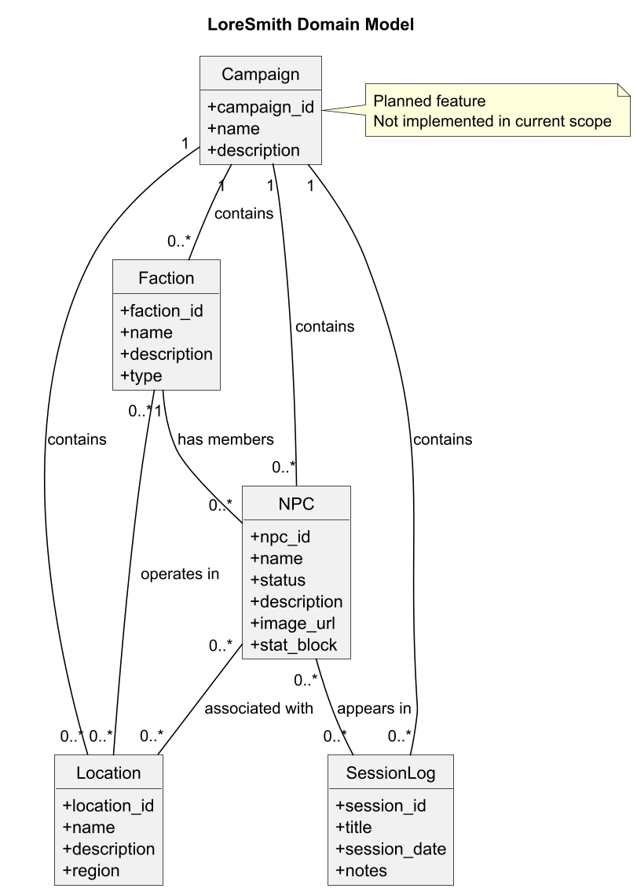

10. Reviews, Retrospectives, and Adaptation
Sprint review and retrospective activity is evidenced through repository updates, sprint closing pull requests, and the evolution of the project backlog across iterations. At the end of each sprint, completed work was reviewed in the context of a working increment rather than in isolation, allowing the team to validate that delivered functionality met the intended user needs.
Retrospectives focused on both process and execution. For example, Sprint 2 highlighted the impact of real-world constraints on delivery timelines, which led to a more deliberate approach to scope management and planning in subsequent iterations. By Sprint 3, the team demonstrated improved throughput and coordination, reflecting both increased familiarity with the codebase and adjustments made based on earlier feedback.
These review and retrospective activities directly influenced backlog refinement and sprint planning. Instead of treating the backlog as static, the team continuously adjusted priorities and scope based on what was learned from each iteration. This reinforced the Agile principle of inspection and adaptation, ensuring that each sprint built on the outcomes of the previous one rather than following a fixed plan.
Sprint | Review Finding | Retrospective / Adaptation
Sprint 1 | NPC vertical slice demonstrated that the architecture worked across UI, backend, and database. | Feedback and reflection led to Sprint 2 items such as NPC image, stat block, and Location CRUD.
Sprint 2 | Location CRUD and NPC enhancements were delivered after an extended sprint. | The sprint extension was treated as an adaptation to human factors rather than a process failure.
Sprint 3 | Factions, session tracking, tagging, sorting, and filtering substantially improved campaign management value. | GitHub Copilot was introduced for selected work, increasing throughput while retaining PR review discipline.
Sprint 4 | Final review pending. | Final review pending.

11. Reflections
This project reinforced that Agile methods are only valuable when they are used intentionally. Simply having user stories, a board, or sprint structure does not create value on its own. What mattered in this project was how those artifacts created visibility, enabled feedback, and enforced a level of discipline that would not have existed otherwise. The GitHub project board, issues, and pull requests were not just course requirements. They served as a shared source of truth that made work transparent and traceable across iterations, even with a small team.
One of the most important technical lessons was the value of establishing a working vertical slice early. Sprint 1 focused entirely on delivering NPC CRUD with persistence, even though it would have been easy to start designing a more complete system upfront. That decision paid off immediately. Once a stable end-to-end workflow existed, additional features such as locations, factions, and session tracking could be layered in with far less uncertainty. This aligns directly with the idea of delaying commitment until the last responsible moment. Instead of guessing what the system should look like in its final state, the design evolved based on working software.
At the same time, this project highlighted that Agile is not a silver bullet, especially in small teams or mixed-responsibility environments. In my own experience managing operational and development work simultaneously, maintaining an accurate backlog requires consistent discipline. The same challenge appeared here in a smaller form. If work is not captured, it does not exist from a process perspective, which can lead to a false sense of progress. Agile requires active participation to remain effective. It does not enforce itself.
Sprint 2 provided a clear example of human factors impacting execution. The sprint extended well beyond its original timeline, not because the work was poorly defined, but because real-world constraints affected availability. Instead of forcing completion or cutting scope arbitrarily, the team adapted by maintaining quality and completing the committed work before closing the iteration. This reflects a key reality that Agile often gets oversimplified in theory. Timeboxes are useful, but they should not come at the expense of delivering a working increment. The more important outcome was preserving integrity of the system and using the experience to inform future planning.
Sprint 3 demonstrated the opposite effect. Once the team had familiarity with the codebase and introduced better tooling, including AI-assisted development, velocity increased significantly. This was not just a matter of working faster. It reflected reduced cognitive overhead, improved confidence in the architecture, and more efficient integration practices. It also highlighted that velocity is not a static metric. It is influenced by experience, tooling, and system maturity, which makes it more useful as a trend indicator than a strict planning tool.
Compared to traditional Waterfall approaches that I have worked with in operational environments, the biggest difference was how risk was managed. In those environments, there is often pressure to define everything upfront, even when uncertainty is high. This project took the opposite approach. Instead of committing to a full system design early, it focused on delivering small, working increments and using each iteration to reduce uncertainty. That made the project more resilient and kept development aligned with actual user value rather than assumptions.

12. Conclusions
I would absolutely work this way again, particularly in environments where requirements are evolving or not fully understood at the outset. The combination of user stories, backlog prioritization, sprint execution, and retrospectives provided enough structure to maintain discipline without introducing unnecessary overhead. That balance is critical. Too little structure leads to chaos, while too much process can slow down delivery without improving outcomes.
The practices that proved most valuable in this project were vertical slice delivery, prioritizing work based on business value, maintaining visible progress through metrics, and using retrospectives to continuously refine the process. Pull request based integration was also particularly effective, as it created a natural checkpoint for code quality and ensured that all work was traceable back to specific user stories.
At the same time, this project reinforced that Agile practices must be scaled appropriately to the context. In a small team, the challenge is not coordination overhead, but maintaining discipline and ensuring that all work is visible. In larger or more constrained environments, such as the operational contexts I have worked in previously, the challenge shifts toward balancing Agile flexibility with external requirements like formal testing and approval processes. The underlying principles remain useful, but the implementation must adapt.
LoreSmith does not need to be a fully complete or production-ready system to demonstrate the value of Agile methods. The more important outcome is that the project made steady, visible progress across multiple iterations, and that each iteration resulted in a working increment that reduced uncertainty. The use of Agile artifacts was not just for organization, but for enabling inspection and adaptation throughout the lifecycle of the project. That is the key takeaway I will carry forward into future work.

Appendix A: Story Point and Business Value Table
The following table summarizes the story point estimates and business value assigned to each user story. These values were tracked directly within the GitHub Project board and used to support both estimation and prioritization throughout development.
Story points were used as a relative measure of effort and complexity, allowing the team to plan work across sprints without relying on precise time estimates. Business value was used to prioritize features based on their importance to the end user, ensuring that the most impactful functionality was delivered first.
Together, these metrics made trade-offs visible and supported more informed sprint planning decisions. By balancing effort against value, the team was able to maintain a focus on delivering meaningful increments of functionality while managing workload across iterations.
Issue # | Title | Status | Story Points | Business Value | Milestone
1 | Create NPC | Done | 3 | 10 | Core Campaign Management
2 | View NPC List | Done | 2 | 10 | Core Campaign Management
3 | Edit NPC | Done | 3 | 9 | Core Campaign Management
4 | Delete NPC | Done | 2 | 8 | Core Campaign Management
11 | Filter NPCs by Faction | Done | 3 | 6 | Core Campaign Management
12 | Sort NPC List | Done | 2 | 5 | Core Campaign Management
31 | Default ID schema fix | Done | 1 | 8 | Core Campaign Management
38 | Add NPC Image | Done | 5 | 8 | Core Campaign Management
39 | Add NPC Stat Block | Done | 5 | 9 | Core Campaign Management
40 | Create Location | Done | 3 | 8 | Core Campaign Management
41 | View Locations | Done | 2 | 7 | Core Campaign Management
42 | Edit Locations | Done | 3 | 7 | Core Campaign Management
43 | Delete Location | Done | 2 | 6 | Core Campaign Management
5 | Create Faction | Done | 3 | 8 | Factions & Relationships
6 | Assign NPC to Faction | Done | 3 | 7 | Factions & Relationships
7 | View Faction Members | Done | 2 | 6 | Factions & Relationships
44 | Associate Entities with Locations | Sprint Backlog | 8 | 7 | Factions & Relationships
23 | User Authentication and Access Control | Product Backlog | 13 | 4 | Future Iterations
24 | Multiple Campaigns with Scoped Data Access | Product Backlog | 13 | 5 | Future Iterations
25 | Caching Layer for Database Queries | Product Backlog | 5 | 2 | Future Iterations
26 | Full-text search across NPCs and sessions | Sprint Backlog | 5 | 3 | Future Iterations
27 | Direct NPC-to-NPC relationships | Sprint Backlog | 8 | 4 | Future Iterations
28 | Summary metrics (NPC refs / session frequency) | Product Backlog | 5 | 3 | Future Iterations
29 | Export campaign data to JSON/CSV | Product Backlog | 3 | 4 | Future Iterations
30 | Unit and integration tests | Product Backlog | 8 | 5 | Future Iterations
15 | Persist Data | Done | 8 | 10 | Infrastructure
50 | Implement Database Migration Strategy | Product Backlog | 5 | 5 | Infrastructure
8 | Create Session Log | Done | 5 | 9 | Session Tracking
9 | Tag NPCs in Session | Done | 5 | 8 | Session Tracking
10 | Search Sessions | Done | 3 | 7 | Session Tracking
13 | View Relationship Graph | Sprint Backlog | 8 | 5 | Visualization
14 | View Campaign Timeline | Product Backlog | 5 | 5 | Visualization
45 | Map Visualization | Product Backlog | 1 | 6 | Visualization

Appendix B: Project Artifact Links
- GitHub Repository: https://github.com/TheSirLancelot/loresmith
- GitHub Project Board: https://github.com/users/TheSirLancelot/projects/3
- Production Site: https://loresmith.streamlit.app/
- Agile artifacts document: docs/agile_artifacts.md in the repository
- Sprint planning and retrospective notes: docs folder in the repository

